Requirements for a CML (Conceptual Modeling Language)

Sjir Nijssen

Summary
This is a report of the ftf meeting of the OMG CM WG held on March 16, 2016, 5PM-6PM. During the ftf 8 requirements for a CML were discussed at length
Everybody of the attendees is invited to add to, or correct this report. Please with tracking ON.
I have added some illustrating examples and questions that were not discussed during the ftf.

Is there a need in the market for an OMG CML?
Ron Ross, a member of the OMG WG CM has discussed by email to the group why there is a clear need in a market, he knows very well, for a Conceptual Modeling Language (CML), in an email of 2015-Sep-27:
“The second reason [for a CML] is highly pragmatic and hugely important. The industry has historically focused on information exchange (and therefore data models). But equally or more important are all the business communications that business is based on. (Think acts, laws, statutes, regulations, contracts, MOUs, agreements, terms & conditions, deals, bids, deeds of sale, warranties, prospectuses, citations, certifications, receipts, notices … and business policies.) Those must be interpreted and disambiguated. Why aren't computers helping people with that problem?! That problem is about natural language ... i.e., what people say about the world. It's a hard problem. It's a huge problem. [Emphasis added] I make my living helping people deal with it. I need help. But more importantly THEY need help.”
Sjir Nijssen has expressed he observes the same need in the market he is involved in.

What is a Conceptual Modeling Language?
In the discussion in the OMG WG CM there is consensus on a proposal by Ed Barkmeyer (see Requirement 1 and 2 hereafter) that there is a need of both formal definitions of concepts as well as primitive concepts, i.e. concepts that cannot be defined in terms of other concepts.
Well, let us for the time being accept the following primitive description:
A Conceptual Model is a model is
- describes the problem space, (EdB)
- is consistent,
- is complete with respect to the intension,
- is understandable to the relevant stakeholders, (Sjir, Ron)
- is formal, (EdS)
- is independent of any IT and (Evan, Sjir, Ron)
- is independent of any specific system (Cory) and
- is enclosed with a specific context.(Cory)

Requirements

Requirement 1
A Conceptual Modeling Language should have functionality to formally define a concept.

Requirement 2
A Conceptual Modeling Language should have functionality to describe primitive concepts, i.e. concepts that cannot be defined in terms of other concepts.
EdB: A sequence of letters becomes a term when it has been given a meaning hence a formal or primitive concept definition.
? Every term is at least within one context.

Requirement 3
A Conceptual Modeling Language should have functionality to specify a context.
Proposed definition of context in the regulation world: a set of pieces of text from one or more regulations, in which a certain term has a specified meaning.
In many acts one finds the following statement: in this chapter the term X has the following meaning: bbb.
A context is a functionality that provides scope for the meaning. (FTF 16 March 2016)

Requirement 4
A Conceptual Modeling Language should have functionality to specify a context within a context.
For an example of nested contexts see 4.7 below.

Requirement 5
A Conceptual Modeling Language should have the functionality to specify a synonym term for a term that denotes a concept.
Ed Barkmeyer specifies in an email of 2016-Jan-08 “The point is that a model is a “linguistic expression”. There is a language involved and a form of expression, with all its benefits and drawbacks. … And whatever the purpose may be, the act of representation itself is critical to that purpose. (That is why we talk about “communication”.”
Cory Casanave expresses his agreement with Ed on this point in an email of 2016-Jan-08.
Hence we specify the next requirement:

Requirement 6
A Conceptual Model for the purposes of an OMG specification is expressed in a Conceptual Modeling Language.

Requirement 7

Relationships between concepts (Pete)
A Conceptual Modeling Language should have the functionality to specify a pattern for an n-ary fact. The underlying mathematical construct of an n-ary fact type is a relation.

Requirement 8
Reification
A Conceptual Modeling Language should have the functionality to specify a reification for any relation.
Relationship instance (fact instance): John Kennedy married Jacqueline Bouvier.
Reification: The marriage of John Kennedy and Jaqueline Bouvier resulted in 3 children.

Requirement 9
A Conceptual Modeling Language should have the functionality to specify a typing mechanism.

Requirement 10
A Conceptual Modeling Language should have the functionality to specify a subtype mechanism.

Requirement 11 (proposed by Sjir)
A Conceptual Modeling Language should have the functionality to use roles and variables, and their mapping.

Requirement 12 (proposed by Sjir)
A Conceptual Modeling Language should have the functionality to specify all integrity rules.

Concrete examples added as a basis for further discussion and clarification questions

ALL THINGS
Below is presented a diagram with 7 different things. This is in the world of things.
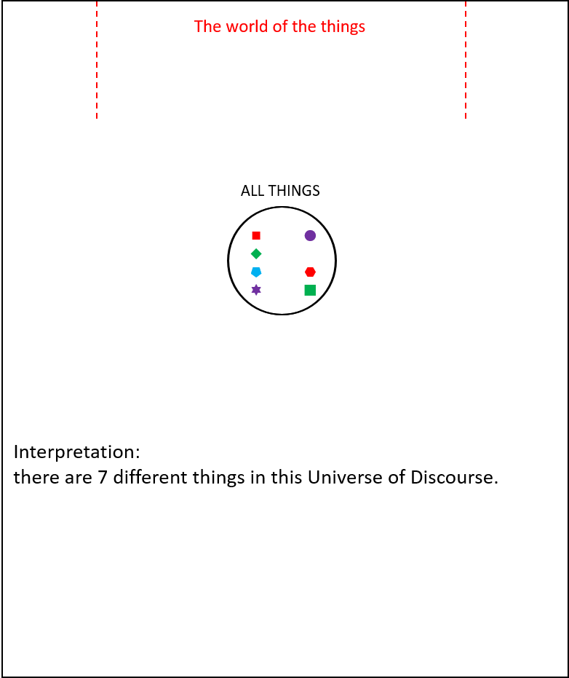
Do we want to say: there are 7 different concepts in this UoD?

Typing of concepts (things)
The 7 different things of the previous diagram are classified or typed in the diagram below as elements of PRESIDENT or STATE.

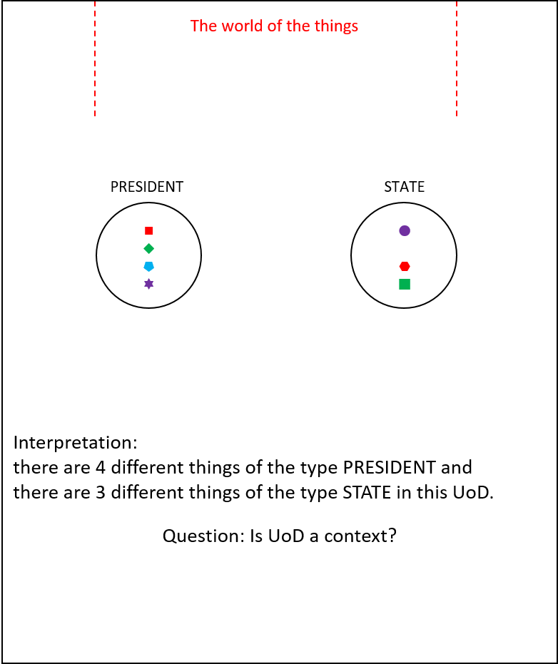

Question: Can we say that UoD is a synonym for context? If not please specify why not.
Question: How many concepts do you see in the diagram above?

Relationships

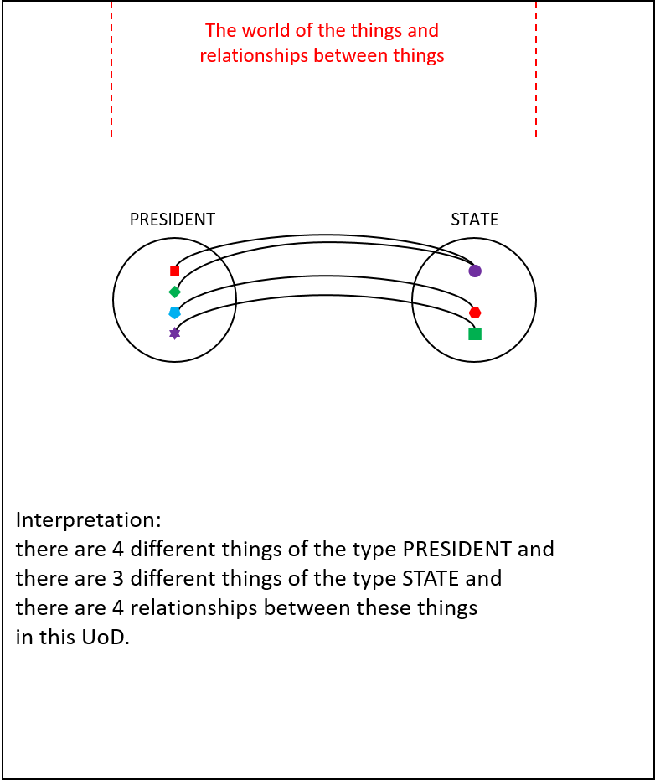

Mathematically speaking we have here a relation with 4 tuples. But as we will see shortly hereafter, there are more mathematical relations.

Relationships (revisited)

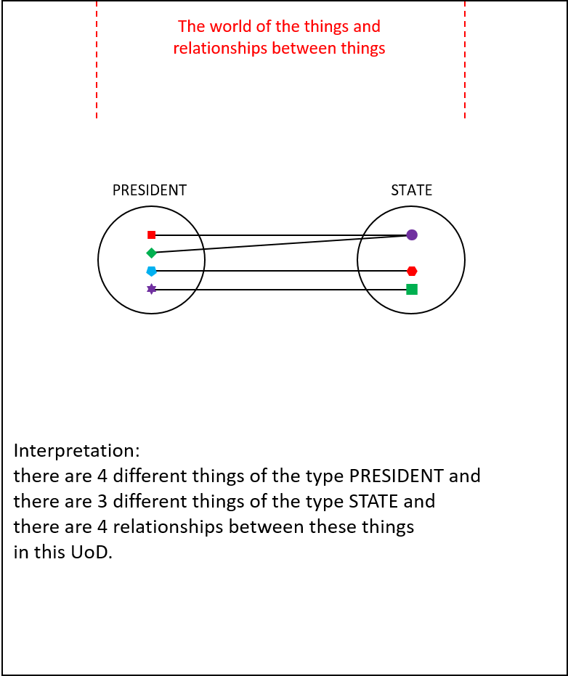

Making all typing explicit
In the diagram below we see that we have 4 instances of the type PRESIDENT. They can mathematically speaking be seen as 4 instances of a unary relation. In this case the unary relation has been given the code 7. The unary relation has the role P.
The reification of unary relation 7 is the type PRESIDENT.
Also in that diagram we see the abstract binary fact type (called Idea) between PRESIDENT and STATE. I expect Pete to say that there is a binary relationship between PRESIDENT and STATE.

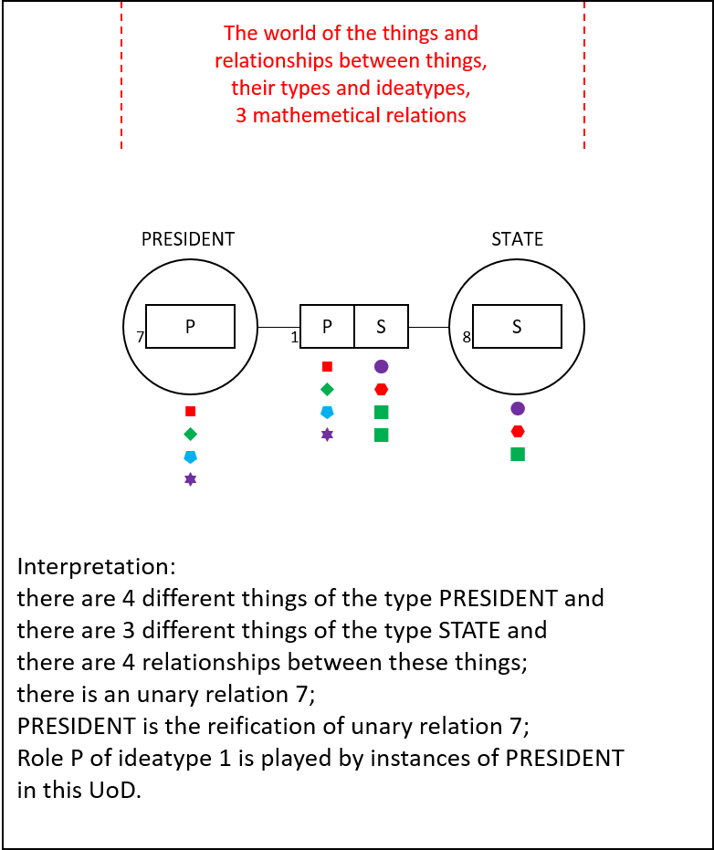

TYPE and RELATION are mathematically both a relation
In the diagram below we assert that an instance of a unary relation, reified to the type PRESIDENT is of the same structure as an instance of the binary Idea, be it that the arity is different.

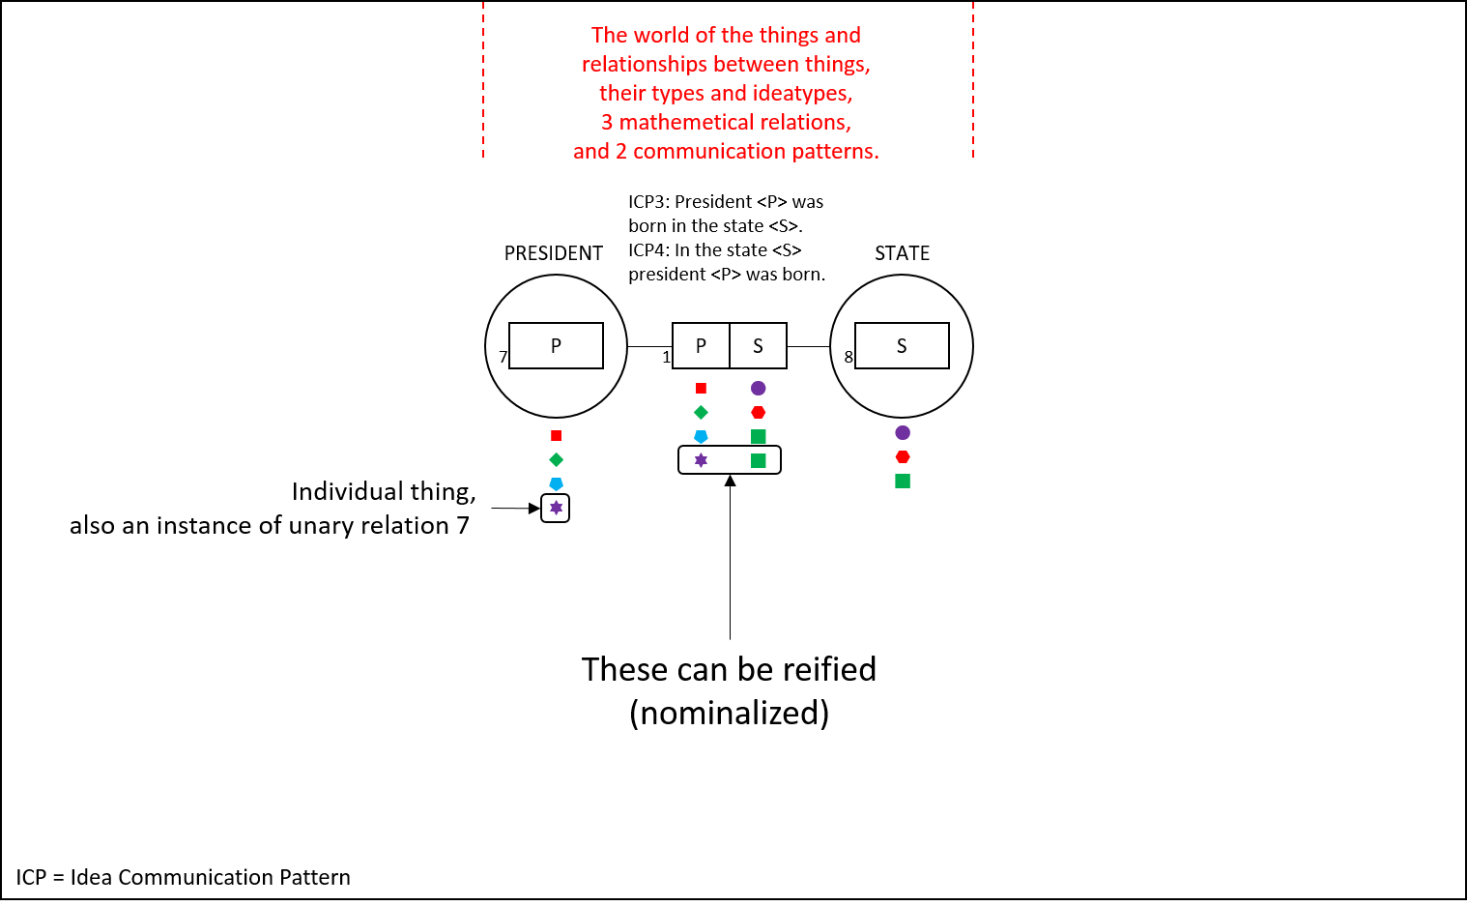

Examples of nested contexts
Below we see three examples of context.
Context 1 has as scope the relations 2, 3, 5, 10, 11.
Context 2 has as scope the relations 1, 7, 8.
Context 3= context 1 + context 2 + relations 4, 5, 6.
Hence we see how contexts can be re-used in other contexts.
If needed, one can make the type part of context 1 a specific context.

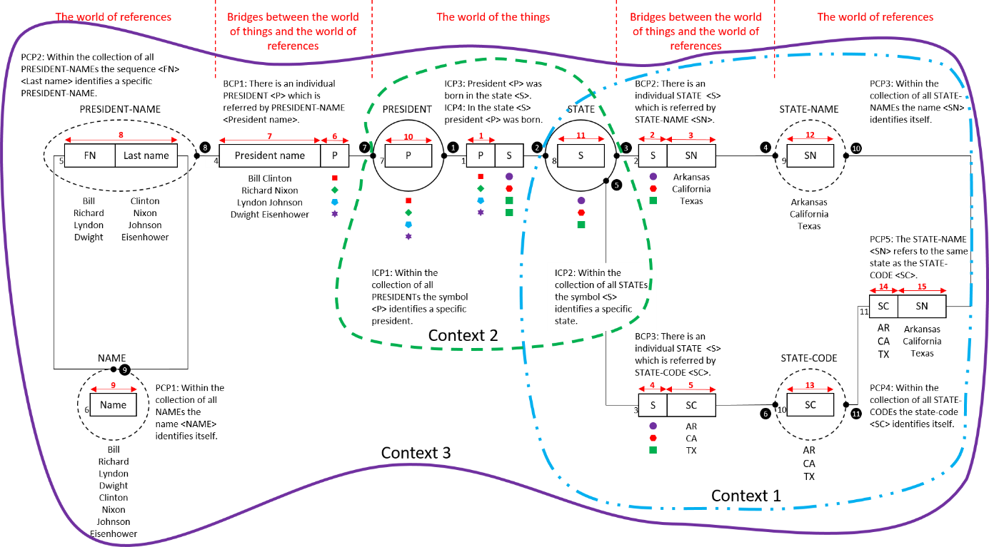

Summary and suggestions for further work
This paper contains a summary of the work performed by the members of the OMG WG Conceptual Modeling since the spring of 2015 and the discussion held ftf on March 16, 2016.
The requirement for a Conceptual Modeling Language has been recognized by the majority of the experts that are member of the OMG WG Conceptual Modeling.
Some next steps are necessary.
How can the Conceptual Modeling Language provide a BPMN-kind of perspective, a DMN perspective, a CMMI perspective as well as a UML, OWL and RDF perspective?
How to validate the CML and make the validation publicly available such that future users of the CML can rely on this validation?
Make a description that can be used as a solid tutorial for the CML.

References
- Barkmeyer, Edward, Slides and Next Steps (Conceptual Modeling), E-mail to OMG WG CM, 2015-Dec-24
- Barkmeyer, Edward, What is a concept (A model is a representation of a concept system), E-mail to OMG WG CM, 2016-Jan-08
- Barkmeyer, Edward, What is a concept? (A concept should have a definition), E-mail to OMG WG CM, 2016-Jan-09
- Brattinga, Marco, Nijssen, Sjir, A Sustainable Architecture for Durable Modeling of Laws and Regulations and Main Concepts of the Durable Model, paper presented at the FBM 2015 Workshop of the OnTheMove 2015 Conference, Rhodos, Greece, October 29-30, 2015, Proceedings by Springer
- Casanave, Cory, Business Architecture Standards, A review and view, OMG La Jolla, 7 December 2015
- Casanave, Cory, Slides and Next Steps (Scope), E-mail-to OMG WG CM, 2015-Dec-15
- Casanave, Cory, Slides and Next Steps (Federation of representations of concepts), E-mail to OMG WG CM, 2015-Dec-15
- Casanave, Cory, What is a concept (A model is a representation of a concept system), E-mail to OMG WG CM, 2016-Jan-08
- Corbin, Arthur, Legal Analysis and Terminology, Yale Law School, 1919
- Corbin, Arthur, Jural Relations and Their Classification, Yale Law School, 1921
- Dulfer, Diederik, Lokin, Mariette, Nijssen, Sjir, Developing and maintaining durable specifications for law or regulation based services, paper presented at the FBM 2015 Workshop of the OnTheMove 2015 Conference, Rhodos, Greece, October 29-30, 2015, Proceedings by Springer
- Engers, T.M. van, Nijssen, S., Bridging Social reality with Rules, Paper presented at IRIS2014, Das Internationale Rechtsinformatik Symposion, Salzburg, Austria, 21 February 2014
- Engers, T.M. van, Nijssen, S., Connecting People: Semantic-Conceptual Modeling for Laws and Regulations, Paper presented at and included in the proceedings of the IFIP EGOV2014 Conference, held in Dublin, Ireland, September 1-4
- Engers, T.M. van, Nijssen, S., From Legislation towards Service Development – An Approach to Agile Implementation of Legislation, paper presented at EGOVIS 2014 in München, September 1-5 and included in the proceedings
- Hohfeld, Wesley Newcomb, Fundamental Legal Conceptions as Applied in Judicial Reasoning, edited by Walter Wheeler Cook, ISBN-13: 978-1-58477-162-3, 2010
- ISO TR9007, Concepts and terminology for the Conceptual Schema and the Information Base, ISO Technical Report, 1987
- Kleemans, Floris, Saton, Johan, Developing the Uniform Economic Transaction Protocol A Fact Based Modeling approach for creating the economic internet protocol, paper presented at the FBM 2015 Workshop of the OnTheMove 2015 Conference, Rhodos, Greece, October 29-30, 2015, Proceedings by Springer
- Lemmens, Inge, Pleijsant, Jan Mark, Arntz, Rob, Using Fact-Based Modeling to Develop a Common Language - a use case, paper presented at the FBM 2015 Workshop of the OnTheMove 2015 Conference, Rhodos, Greece, October 29-30, 2015, Proceedings by Springer
- Lemmens, Inge, Koster, Jean-Paul, Valera, Serge, Achieving Interoperability at Semantic Level, paper presented at the FBM 2015 Workshop of the OnTheMove 2015 Conference, Rhodos, Greece, October 29-30, 2015, Proceedings by Springer
- Moberts, Roel, Nieuwland, Ralph, Janse, Yves, Peters, Martijn, Bouwmeester, Hennie, Dieteren, Stan, Business Object Model: a Semantic-Conceptual Basis for Transition and Optimal Business Management, paper presented at the FBM 2015 Workshop of the OnTheMove 2015 Conference, Rhodos, Greece, October 29-30, 2015, Proceedings by Springer
- Nijssen, G. M., A Framework for Discussion in ISO/TC97/SC5/WG3, 78.09/01, 1978
- Nijssen, S., Valera, S. (2012), An Architecture Ecosystem for the Whole Systems Perspective, Including System Dynamics, Based on Logic & Set Theory and Controlled Natural Languages, Working paper for the OMG Architecture Ecosystem SIG.
- Nijssen, Sjir, Piprani, Baba, 1975-2015: Lessons Learned with Applying FBM in Professional Practice, paper of the FBM 2015 Workshop of the OnTheMove 2015 Conference, Rhodos, Greece, October 29-30, 2015, Proceedings by Springer
- Ross, Ron, Individual concept, e-mail 2015-Sep-27 to OMG WG CM
- Seidewitz, Ed, What is a concept (Strip signifiers and add them back in), E-mail to OMG WG CM, 2016-Jan-09
- Straatsma, Peter, en Dulfer Diederik, Wendbare Wetsuitvoering, paper presented at DREAM (Dutch Requirements Engineering And Management) 2014
- Wallace, Evan, Slides and Next Steps (We all responded to the term Conceptual Modeling, not the term Concept), E-mail to OMG WG CM, 2015-Dec-15
- Wallace, Evan, Slides and Next Steps (The set of 5 questions), E-mail to OMG WG CM, 2015-Dec-29
- Wallace, Evan, Next Steps (I hoped that each participant in this group would provide answers to question 1 with enough details to allow the group (with some discussion) to collectively answer question 2), E-mail to OMG WG CM, 2016-Jan-05

