2020 Digital Engineering Information Exchange (DEIX) Challenge
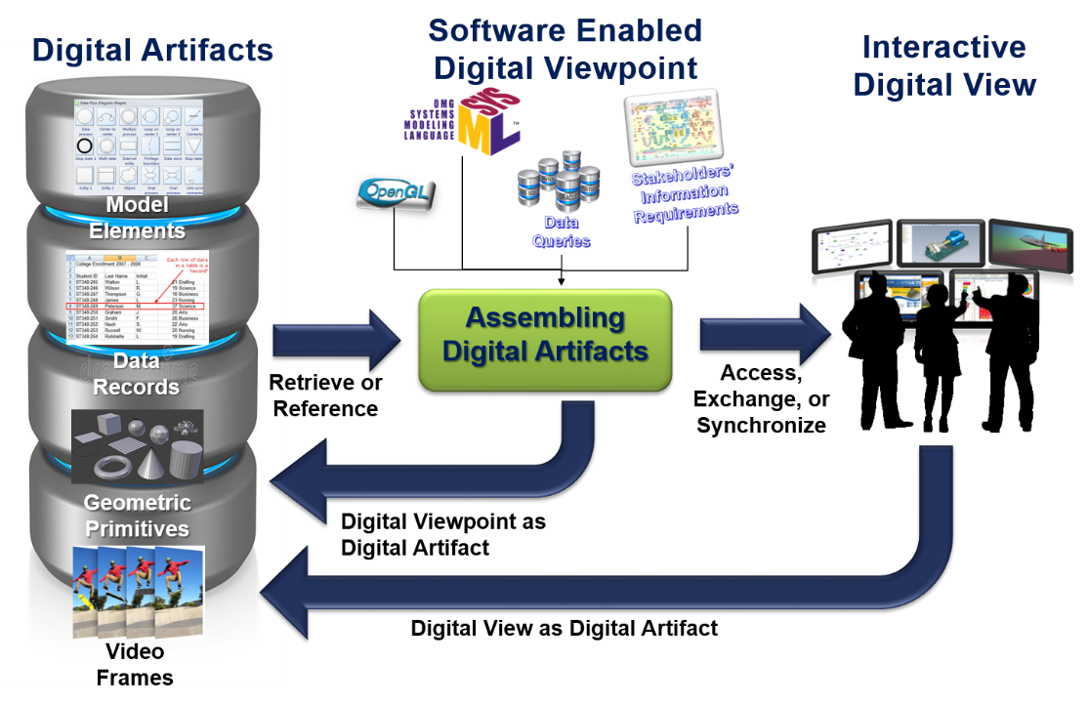

What is the DEIX Challenge?
As the industry migrates into Digital Engineering, the amount of data that must be managed, correlated, and exchanged easily overwhelms. In order for the transformation to Digital Engineering to be worth the cost, actionable knowledge has to be synthesized from various kinds of models and other sources of digital information.

The INCOSE/NDIA Digital Engineering Information Exchange Working Group (DEIXWG) is soliciting participants for its Digital Engineering Information Exchange Challenge kicking off in July 2020 and culminating in the outbrief of challenge results at the Virtual 2020 NDIA Systems and Mission Engineering Conference. The DEIX Challenge is an opportunity for anyone (groups or individuals) interested in Digital Engineering/Transformation from across Government, Industry, and Academia to help shape the future of Digital Engineering.

The DEIXWG is asking for DEIX Challenge submissions to build upon a DEIXWG-provided, conceptual “Digital Viewpoint Model” and to propose one or more digital views that could be used for providing and consuming digital information pulled from multiple digital artifacts. Examples of digital artifacts could include Systems Modeling Language (SysML) models for MBSE, MATLAB performance models, Mechanical Computer-Aided Design (MCAD) 3D models, Finite Element Analysis (FEA) models, and much more. The content, form, and function of the proposed digital views should be documented in a concept model provided by the Challenge participants as part of their submission.

Challenge Objective
The DEIX Challenge is not a competition between participants, but a challenge to everyone in the community to advance the practice of Digital Engineering by coming up with scenarios in which they need to exchange digital views of information that support their real-world needs. These scenarios will provide context for why the information is being exchanged, the authoritative source for each piece of information, and how each piece of information relates to one another. The results of the DEIX Challenge will serve to provide insight to the entire community on where additional work is needed to mature tools, standards, infrastructure, and languages to support the identified needs.

Participants will submit:
At a minimum, Challenge Participants are asked to propose one or more conceptual Digital Views that provide a self-consistent, authoritative view of Digital Information culled from a varied set of Digital Artifacts. Additionally, we will accept Challenge proposals that include prototype Digital Views implemented using the tool(s) of their choice, but this is not a requirement.
Submissions will include two Scenarios or User Stories involving the exchange of one or more Digital Views between identified Stakeholders with specified needs (or Perspectives). The first scenario will involve exchange of Digital Views during an early system development phase of development, while the second scenario should involve exchange of Digital Views during a later, mature system development phase. Challenge Participants are also asked produce a proposed conceptual Platform Specific Digital Viewpoint Model (PS-DVM) (modeled in SysML, LML, or whatever concept modeling language they wish) that extends the concepts in the DEIXWG-provided Platform Independent Digital Viewpoint Model (PI-DVM) and conceptually models the specific types of Digital Artifacts, Digital Information, Stakeholders, Perspectives, and Digital Views represented in their scenarios.
For example, a DEIX Challenge Submission might conceptually describe a scenario in which:
- A Digital View is required by a Systems Engineer (“Discipline” concept extension) representing a Prime Contractor (“Acquirer” concept extension).
- The Systems Engineer needs to Assess Safety and Reliability (“Perspective” concept extension) of a subsystem being developed by a Subcontractor (“Supplier” concept extension) when exposed to repeated mechanical shock and vibration.
- The Digital View should provide a dynamic, interactive dashboard (“Digital View” and “Concrete Syntax” concept extensions) that lists the elements of the subsystem, whether those elements are compliant with safety standards and satisfy their reliability requirements, and how much by how much margin those requirements are satisfied, as a result of a range of applied mechanical shocks and vibrations.
- The Digital View should pull Digital Information regarding: affected structural elements, their material properties, their interfaces, their functionality, their related requirements, and their mechanical stress performance as a function of applied mechanical load, and the traceability and dependencies between those pieces of Digital Information (all are “Digital Information” concept extensions).
- The Digital Information is pulled from a variety of Digital Artifacts which may or may not represent the Authoritative Source of Truth for that Digital Information. These Digital Artifacts might include: a SysML model, a 3D mechanical CAD model, a 3D electrical CAD model, a Finite Element Analysis model, a MATLAB mechanical performance model, a DOORS model of the system requirements (all are “Digital Artifact” concept extensions).

In this example of a DEIX Challenge Submission, the above concepts would be captured in a conceptual Platform Specific Digital Viewpoint Model (which can be modeled using SysML, UML, LML, or whatever concept modeling language you wish) that extends the basic concepts (like “Digital Artifact”) found in the DEIXWG-provided Platform Independent Digital Viewpoint Model.

For each Scenario, Participants will choose:
Decision Points: Choose two decision points from different system development phases (listed below), one for early development and one for mature design, in order to frame the context for their proposed Challenge scenarios:
- Architecture Development
- System Design and Analysis
- Integration and Synthesis
- Validation and Verification
- Deployment Readiness
- Sustainment Operations

Perspectives: Choose two different perspectives (examples listed below) to provide context for the needed information exchange during the two chosen phases:
- Mission Assurance
- Interface Design Compliance
- Total Ownership Cost Assessment
- Cybersecurity and Resiliency
- Human Systems Engineering
- Reliability, Availability, Maintainability and Safety

Stakeholder: Choose two Stakeholders (examples listed below) for each scenario that will be exchanging the information.
- Defense Contractor
- Commercial Contractor
- Prime/Integrator
- Government Agency
- OEM
- Subcontractor
- Regulator (Federal Aviation Administration, Nuclear Regulatory Commission, etc.)

Contents of Participant Submissions:
- Platform Specific Digital Viewpoint Model (PS-DVM) specifying:
  - Proposed extensions to the concepts specified in the DEIXWG-provided Platform Independent Digital Viewpoint Model (PI-DVM)
  - Types of Stakeholders and Perspectives involved in the exchange of the Digital Views
  - Types of Digital Artifacts (e.g. SysML models, SQL databases, MATLAB models, etc.) that contain the Digital Information (e.g. SysML instances, SQL query results, MATLAB model output parameters, etc.) used to generate the Digital Views
  - Identification of the Authoritative Source of Truth (ASOT) for Digital Information (i.e. which Digital Artifact) and specification of related ASOT metadata:
    - Baseline, Provenance, Trustworthiness
  - Required formats and any standards employed for the exchange of Digital Views to occur

- Proposed Digital View(s), including information for each view regarding:
  - Form, Function, and Purpose of their proposed Digital View
  - Digital Information represented by Digital View
  - Traceability to Digital Artifacts providing Digital Information
  - Standards used to feed and create the Digital View
  - Tool Chain used to feed and create the Digital View

- Scenarios/User Stories providing the story for the problem solution
  - Who is the Stakeholder?
    - What is their Perspective (e.g. Interface Design Compliance)?
    - What is their Discipline (e.g. Systems Engineering)?
  - What does the Stakeholder wish to do with the Digital View?
    - What kinds of decisions and analyses do they need to do?
  - What is the level of maturity (Decision Point) of the product design during which the exchange of the Digital View is occurring?

Submissions may be emailed to:
Sean McGervey, Chairperson, INCOSE DEIXWG (Sean.McGervey@jhuapl.edu)

Challenge Schedule
July 24, 2020 | DEIX Challenge Posted on the DEIXWG Page on the OMG MBSE Wiki
August 14, 2020 | Kickoff of Biweekly DEIX Challenge Virtual Q&A Zoom Sessions
October 30, 2020 | Deadline for Submission of DEIX Challenge Submissions
November 10-13, 2020 | Challenge Outbrief at Virtual 2020 NDIA SME Conference

Glossary of Key Terms
Digital Artifact | A digital artifact is any combination of professional data, information, knowledge, and wisdom (DIKW) expressed in digital form and exchanged within a digital ecosystem (see DEIXPedia).
Digital View | A digital view is a visual presentation on an electronic display device of one or more processed digital artifacts, enabling the consumption of digital artifact content according to stakeholders’ unique activities at any phase or step in the system life cycle (see DEIXPedia).
Digital Viewpoint | A design of a digital view that uses conventions, formalisms and standards to define the systematic procedures to select, compile, layout, and present digital artifacts in a digital ecosystem such that is meets stakeholders’ unique needs (see DEIXPedia).
Platform Independent Model | A model of a software system or business system that is independent of the specific technological platform used to implement it (see Wikipedia).
Platform Specific Model | A model of a software or business system that is linked to a specific technological platform (e.g. a specific programming language, operating system, document file format or database) (see Wikipedia).

Appendix A: References
Glossary of Key DEIX Terms | DEIX Topical Encyclopedia Entries (DEIXPedia)
Digital Engineering | Digital Engineering References on the OMG MBSE Wiki Page
DEIXWG on OMG MBSE Wiki | OMG Wiki Page for DEIXWG
INCOSE DEIXWG Page | INCOSE WG Page for DEIXWG

Appendix B: System Phases (correlated to the INCOSE SE Handbook v4e)
Architecture Development | Based on Concept Stage (3.3.1):  Defining product concept based on customer based on stakeholder needs
System Design and Analysis | Based on Concept (3.3.1) and Development (3.3.2) Stages:  The development of the system based on analysis of overall performance and design within overall system constraints
Integration and Synthesis | Based on Concept (3.3.1) and Development (3.3.2) Stages  Integration planning of subsystems and supplied parts through production of initial units for integrated testing
Validation and Verification | Based on Concept (3.3.1) and Development (3.3.2) Stages:  Early validation done in the concept stage through final verification of the system to the customer
Deployment Readiness | Based on Development (3.3.2) and Production (3.3.3) Stages:  Proof to stakeholders the readiness of a system to fully enter into service (can be from LRIP to full production rate)
Sustainment Operations | Based on Utilization (3.3.4) and Support (3.3.5) Stages:  Operations for maintenance and upgrade as part of system sustainment

