FDTF DLT WG Call
27 March 2018

Attendees
Name | Affiliation
Robert Nehmer | Oakland University
Pete Rivett | Adaptive
Bobbin Teegarden | NoMagic
Mike Bennett | EDM Council
Nick Stavros | Jackrabbit Consulting
Dan Webb | Higher Upstream

Meeting Notes
The exercise today was to identify, for each element potentially posted to the ‘Block’ or elsewhere (each piece of variable data), what qualifying terms are needed in order that what is posted is a self-contained XML document or RDF graph, whereby each element of data is accompanied by the terms necessary to understand its context.
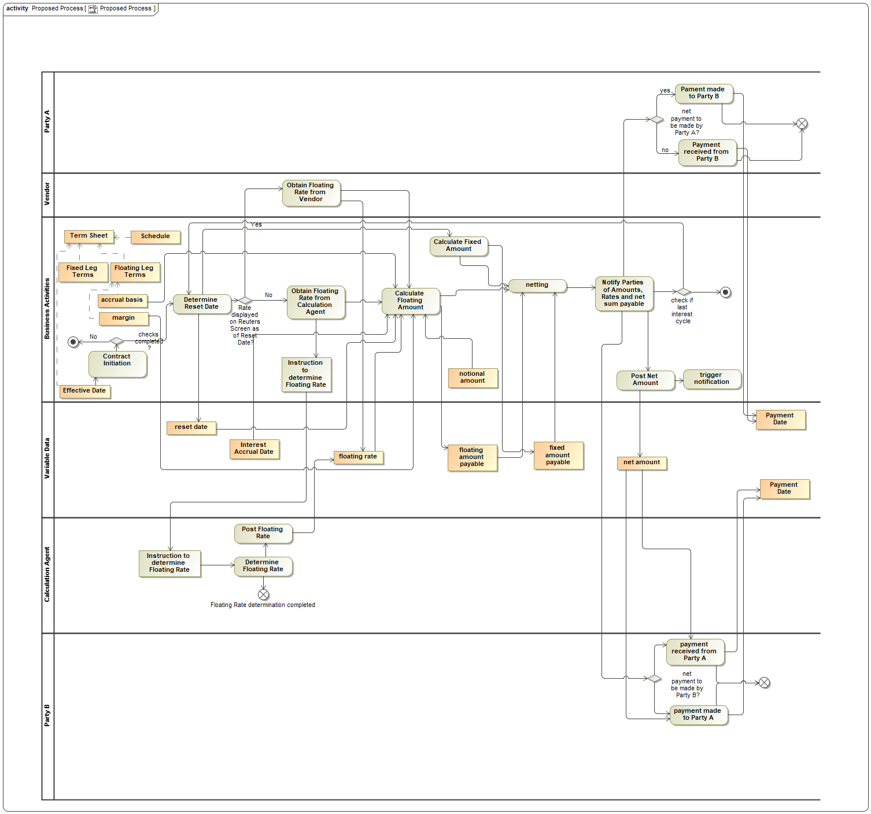

Qualifying Data for Each Variable Data Posting

Reset date

Discussion: What this is
Is this an actual date or a date + 90 or something? Hard date or relative date?
e.g. if it were 90 days offset from the previous reset date.
Provenance and pedigree. Need to know what the last one is.

Schedules

FpML Schedule
Schedules may be Parametric or Explicit.
Assume Parametric.
Contract as a whole rather than one or other Leg.

Reset Date Qualifying Terms
- Contract ID

Schedules: Date adjustment rules
There are 2 kinds of date adjustment rule
Rule 1: Date roll rule - when the date returned by the parametric specification of a date, is a non working day.
Depends on 2 things:
- Weekend dates
- Holidays - specify a Business Calendar.
Business Center: e.g. Frankfurt, London, the EU.
The Date Roll Rule determines what to do when a specified date falls on a non working day (as specified in the Business Calendar).
Rule 2: Month End Roll back Rule.

Qualifying Reset Date:
1. Identify the contract.
Contract type (UPI) + Parties + Effective Date.
Contract Type: IR Swap, USD / Basis etc.
UPI = Unique Product Identifier

Discussion
What if 2 more identical deals on same date between same parties.
Need a way to refer to the exact instance.
Possible workaround: exact timestamp.
The fixed stuff - doesn't that a unique hash or something? Some unique identity on the BlockStuff.
This gets a Unique ID.
Therefore this (Blockthing specific) unique ID needs to accompany the Reset Date.
Don’t' also need the Effective Date for the Parties as these are covered by that Unique ID.
Terms v Conditions - can segregate these. FIBO combines these as ‘Terms Sets’ or more accurately, descriptions of Commitments (these include conditions that qualify these commitments).
Term = Commitment
Condition = something that is continually evaluated.

Interest Accrual Date

Assume
Reset date specified parametrically.
Interest Accrual Date specified relative to Reset Date.
Reset date specified typically Day + Month + Frequency
Quarterly it would say e.g. 28/1 28/4 28/7 28/11
gMonthDay
Frequency = Quarterly.
Returns a particular day.
Assume: specified relative to Reset Date. Reset Date +2 days

Interest Accrual Date Qualifying terms:
- Reset Date
- Contract ID
This date is used as input to Interest Accrual Amount calculations.

Floating Rate

Qualifying terms are:
- Reset date
- Contract ID
LIBOR? Redundant so no (identified in the Terms and Conditions)

Discussion
Does it need Lifecycle (validity)?
What qualifies the Rate?
- Tenor
- Calculation Agent
- Date / Time of instruction to Calculation Agent
- Currency
- Publisher etc. (in this case LIBOR)

Suggestion: we don't need to replicate in the posted data element qualifiers, the things that are already given in the Terms and Conditions.
Therefore:

Floating Rate Qualifying Terms
- Contract ID
- Reset Date (identifies which quarterly cycle this belongs to)
- Date / Time of instruction to Calculation Agent

Floating Amount Payable
What it depends on v what we need to actually post somewhere...

What it depends on
- Interest Accrual Date (directly or via Reset Date + Offset in schedule)
- Interest Rate
  - Underlying (LIBOR (in Terms Sheet)
  - Underlying Value = read from Calculation Agent = Floating Rate
- Margin (in the terms sheet) = 50bp
- Principal (or Notional) amount (Number + Currency)
- Notional Amount (in Terms Sheet, so implied via Contract ID)

Floating Amount Payable Qualifying Terms
- Contract ID
- Something to identify the quarter in which it applies (Reset date OR Interest Accrual Date)

No cardinality needed in this example since this is specifically an IR Swap.

Fixed Amount Payable

Qualifying Terms
- Contract ID
- Something identifying the quarter (Reset Date)

Netted Amount

Depends on:
- Fixed Amount Payable
- Floating Amount payable
- Payment Date
- Contract ID (to reference the schedule).

Netted Amount Qualifying Terms
Removing terms that are identified via the Contract ID
- Contract ID (to reference the schedule)
- Reset Date to identify the quarter
- Payment Date (redundant? Returned by Schedule in the Term Sheet, for a given quarter as identified by the Reset Date)
- Currency

