FDTF Call Notes
3 August 2021

Attendees
- Rob Nehmer
- Bobbin Teegarden
- Mike Bennett
- Pete Rivett
- Juergen Boldt

Agenda
- Ontology of Money
  - The Money Flower
  - Taxonomy
  - Differentiae
- OMG QM Plans for September
  - In person or virtual?

Meeting Notes

Ontology of Money
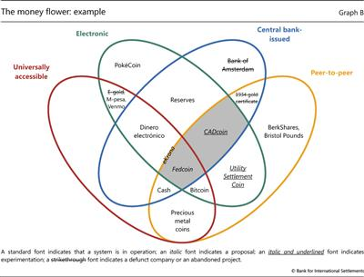
Fig 1: The Money Flower

Comments
Caption: 'standard font indicates a system is in operation' etc. for different fonts versus 'projects'.
From this we can ask is this exhaustive given it is quite dated?
For the things not listed, is there likely to be a higher level category to which those might belong?
Also for instance whether cryptocurrency fits neatly here.
Also more fundamentally: are these all 'currency' as we understand it (or what to define it) or are there more fundamental categories of thing?
Let's list the categories of Thing:

Yellow category:
Has an additional label 'eKrona'

eKrona:
https://ekrona.com/
Claim: to be adopted by the EU this year??
(or by that EU member state that does not use the Euro)
This one sounds like a scam. Cryptocurrency specifically with crypto-based growth projections.
Later: It seems it is a scam, spoofing off the real Swedish thing. See
https://topnasdaq.com/e-krona-considered-to-be-highest-potential-return-investment-study-finds/
includes links to the real thing but it isn't that.
So, unpacking the meanings of things might help people understand what's real and what's not.
Official one:
https://www.riksbank.se/en-gb/payments--cash/e-krona/
This one is official (and exploratory): to be issued by the Riksbank (central bank of Sweden).

More on Sweden (current)
https://www.bloomberg.com/news/articles/2021-04-07/sweden-s-central-bank-reveals-first-study-of-digital-currency
Good diagram:
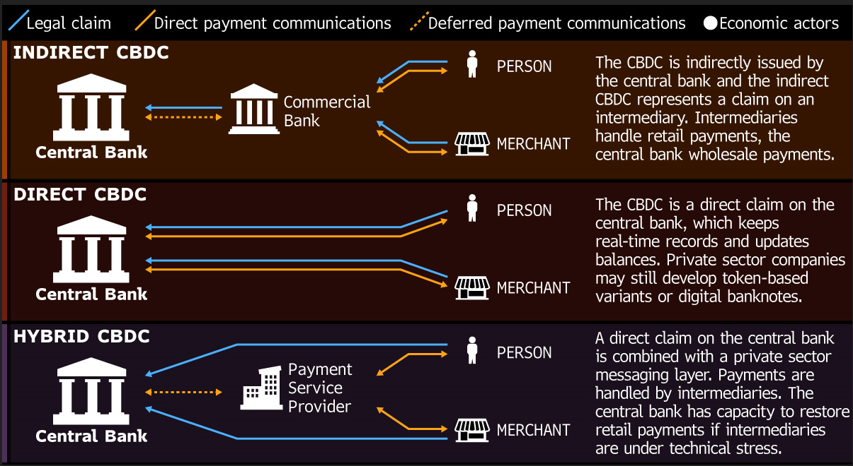

Hybrid model
From the article above, penultimate para:
For now, the Riksbank is focusing on a so-called two-tier model, in which it would be responsible for the issuance and redemption of a CBDC. In such a framework the so-called participants, such as banks or payment firms, would have direct contact with the end-user, according to Micael Lindgren, the technical project manager at the Riksbank.

Map
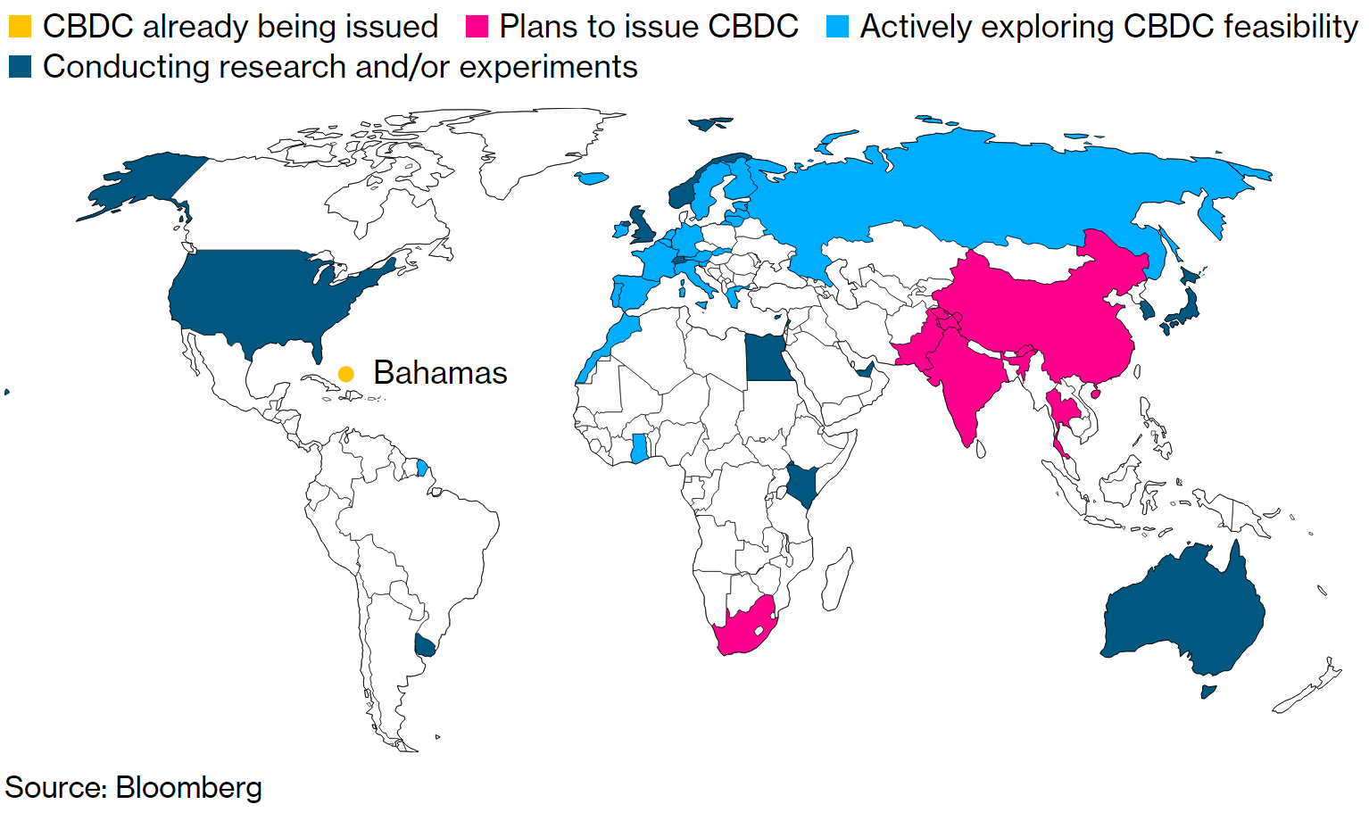

Money Flower Picture
So, whence the original Money Flower picture?
https://www.bis.org/publ/qtrpdf/r_qt1709z.htm
is where we got this version of the image from.
Date: 17 September 2017
Was from BIS.
Other currencies / money types mentioned:
PokéCoin (as in Pokemon)
Not traded since 2018. Current price more or less 0.
Fedcoin: Not been endorsed
So this is all vaporware - exploratory suff.
Also BIS paper references eKrona whereas the real one is now e-Krona so likely due to copyrighting or branding issues.

Other observations on the specifics of this paper:
Why is Bank of Amsterdam crossed out?
Means that the proposed project is no longer active (as of 2017).
Not all are currencies e.g. MPesa is a payment system not a currency.

Conclusions:
The examples are all out of the date but the concepts represented in the petals may be useful for starting our ontology.
But noting again that some of the categories like Cash should be more fundamental.

Cash
'Cash' should be a higher level category.
Also legally / historically there is a fundamental difference between coins and notes:
- Coins: issued by the mint of a given country
- Notes: issue by the central bank
These have different legal standing. Both are 'Tokens'.

Categories
Top level in the 'flower':
- Peer to Peer
- Central bank issued
- Electronic
- Universally accessible
4 categories, all overlapping (not disjoint) and also not exhaustive.
Is there one category of Thing? Are there:
- Kinds of 'money'
- Kinds of payment arrangement
What we do see are examples of community currencies? E.g. Bristol Pounds.
Pokecoin is also a community currency – community is the pokemon community – involves various activities that pokemon participants can carry out.

In-game Coins
'In game coins' is a useful category
Also e.g. Linden Dollar – is an in-environment coin.
Exchangeable – e.g. Linden Dollar – people wanted to buy and sell them – all that takes is a social media space to find buyers. 'A Marketplace'.
- how is that not a form of barter?
It is. Any market is where someone chooses to exchange a thing for another thing.
Definition of Barter is narrower: 'Exchange of goods or services'. Exclusive of currency.
Taxonomic:
- [wordless thing]
  - Barter
  - Monetary exchange
So the word barter implies not money. But with no definition of what is or it money, that's an empty set. That is, anything 'can be' money.
So really Money is a 'relative' thing.
Conversely, and for the same reason, as soon as people see no value in a thing it ceases to have exchange value i.e. ceases to be usable as currency or as 'money'. That is, it ceases to have 'currency'.
e.g. if the Linden Dollar is not valued it becomes not exchangeable (i.e. no market)
These were not physical – they were the in-house currency for Second Life.
Whereas with crypto there are exchanges where you can swap USD (via Tether) for e.g. Bitcoin.
Between here and there, you get to a point of v low liquidity.
When it's dead there's no liquidity.
As with language there is the word 'currency' which means something that is current – as a means of exchange in the case of money, as a means of communication in the case of words.
Then an ontological definition of 'currency' is more useful as 'anything can perform the role of money'. That is for monetary currency specifically (one can also refer to words or ideas as having currency).

In Game Currencies general
See
https://www.gimitheapp.com/en/news/the-in-game-currency-guide
in game currency can be regarded as a kind of Proof of Work. Once you have the coins they are currency – you can exchange them for what you like regardless of how you came by them.
Abstraction for crypto: Proof of work it more general than crypto PoW.
Likewise Proof of Stake and the rest.

See also Virtual Economy:
https://en.wikipedia.org/wiki/Virtual_economy
This also lists 'types of currency'.
Are those useful taxa for us?
- Standard Currency
- Premium Currency
- In game membership items
- Cosmetic items
- Player driven currency systems
See article for definitions.

Grand Theft Auto
Also e.g. GTA ways of earning currency (can be things that are usually illegal by virtue of the nature of the game):
https://gamerant.com/grand-theft-auto-5-ways-earn-money-best-worst/
A KYC system using words and not concepts might mistake an in game 'illegal' activity for a real-world illegal activity.

Exchanging In / out of game
Can have an 'off game' transaction where someone pays you money outside the and gift it to your character in game.
That's the other side of exchanging in a marketplace outside the game or environment
- Outward: turning in game currency or benefit into real world cash
- Inward: turning real world money into in-game money or benefits
2 potential scenarios:
- Here's $10 for your sword
  - In game purchase (with out-game currency)
- Here's $10 for in-game 100 ducats
  - And here's 50 ducats for your sword
In principle both can happen.

Abstractions
Abstracting this out we have:
- Marketplaces
  - Where 'exchanges' (verb) happen
- Exchanges (trades) i.e. the verb 'exchange'
  - In game
  - In world
  - Across worlds
- Exchange (places)
  - Currency exchanges e.g. in Crypto
  - Versus informal exchange in social media spaces or in in-game rooms
    - Incidentally similar to how also much underground / criminal activity takes place in spaces within games

Quarterly Meeting Plans
Whether MB is able to travel – still unclear.
- hoping I can attend; unclear yet
- Need to confirm usable / electronic version of vaccination proof / certificate (not got)
- Other test / entry requirements
Who is intended to go in person from here?:
- Rob: No
- Pete: probably will (65%)
- Bobbin: on the fence
- Mike: hope to, unconfirmed
Are they letting people into the US and are there limitations for specific countries?
No official changes. Last week the Biden admin decided not to change the rules for people coming from Europe (EU?)
This week: 13 more countries added to the list of not allowed in, including Greece, Malta and others.
End of Sept is not far away from the PoV of anticipating the wave being over or being able to book a thing that is not cancelled.
UK rates and hospitalization rates are going down.
Blended: can we do that?
Assume: if it is in person then it will be blended. OMG needs to know if we need a physical room at all.
Propose: Say Yes – giving the point of presence for virtual people calling in and physical attendees being able to attend.
Conclusion: ask for a room anyway.

AoB
Nope.

