FDTF Distributed Ledger WG Call notes
3 April 2018

Attendees
Name | Affiliation
Bobbin Teegarden | NoMagic
Nick | Jackrabbit
Ralph Achkar | State Street
Rob Nehmer | Oakland University
Mike Bennett | EDM Council
Dan Webb | Higher Upstream

Agenda
- Review of last week’s notes
- Confirm / Identify qualifying data elements for variable terms
- Diagrammatic exploration of the FIBO IR Swaps model

Call Notes

IR Swaps PoC Process Model
Latest diagram is shown as Figure 1.
Last week’s minutes identify each of the data elements needed to quanlify each of the elements identified as Variabble Data (these are items that might be posted to the ‘Block’ or elsewhere dependieng on the architecture).
Assume also that the static contractual terms (shown in the main swimlane) would be posted to the block or some such source, again depending on the architecture. IT si to this that all subsequent data relates. As identified in last week’s notes, this material would need to have a unique identifier within the distributed immutable data application.
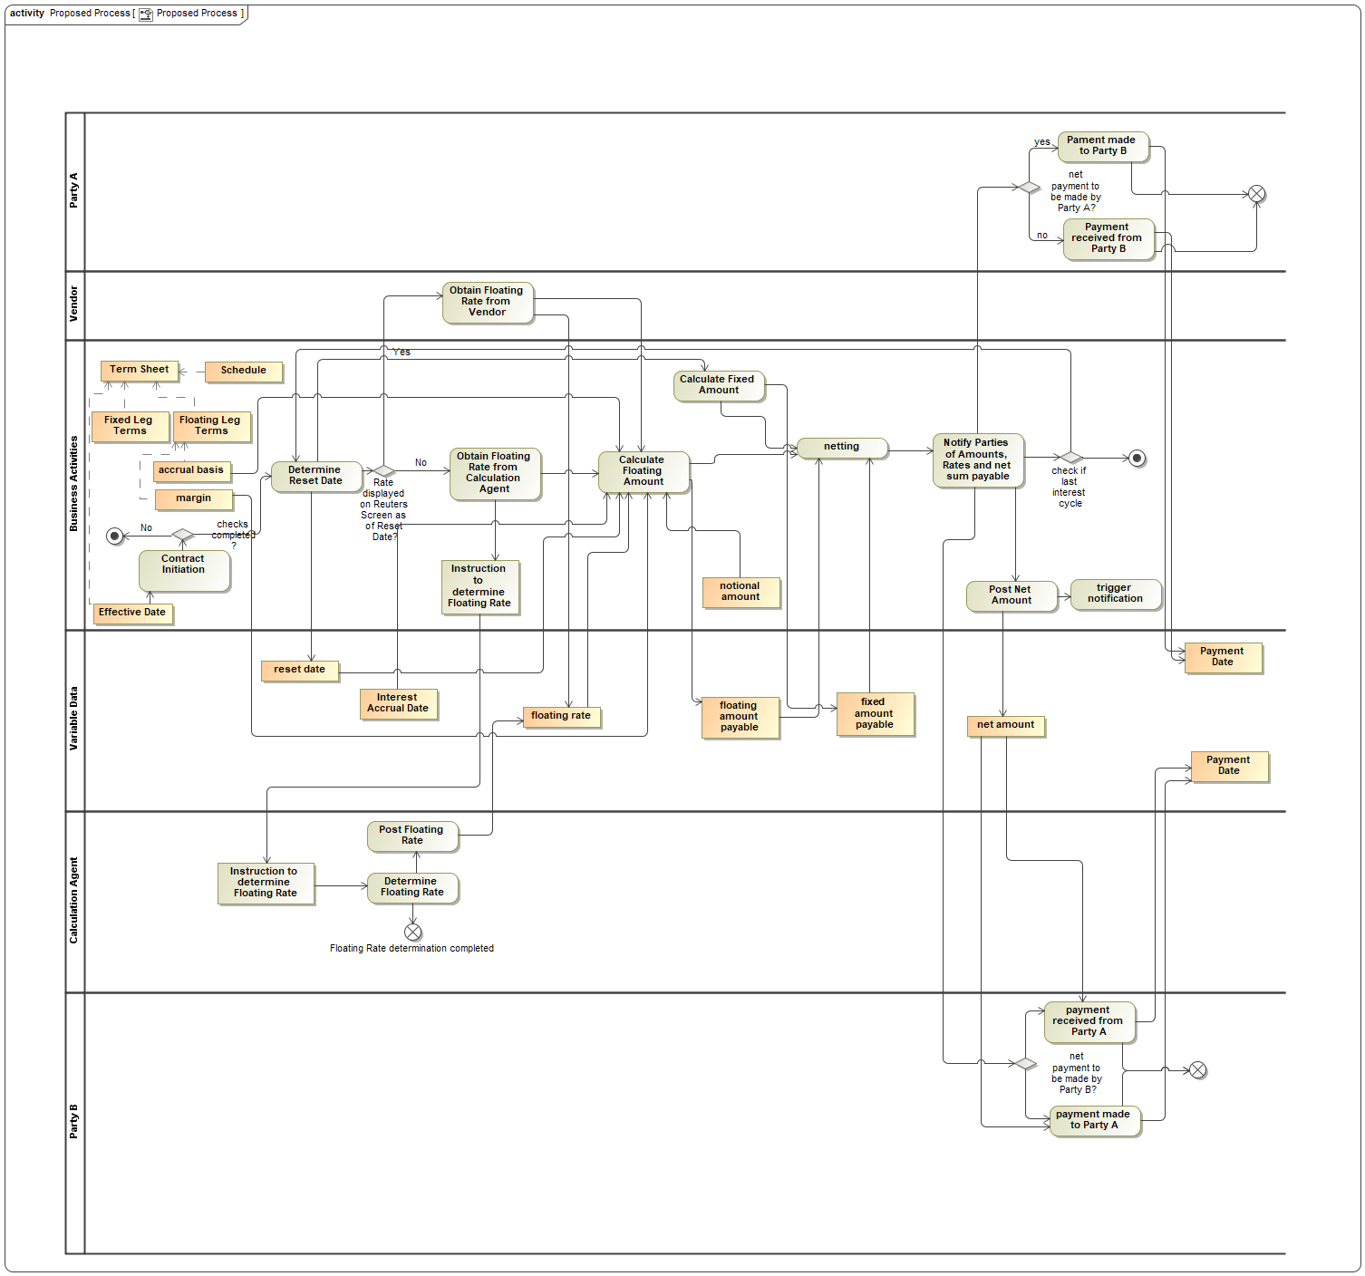
Figure 1: Process Model for IR Swaps and Variable Data

FIBO Master Teamwork Cloud CCM Repository
BT: 3 questions:
- Can I ingest OWL into the CCM TWC Project now?
  - No. It’s already ingested
- Do I need to have the right configuration still?
  - Yes you do
  - With that you can add diagrams etc. as identified in earlier email
- Can we edit the About files with this?
  - No, it does not support the ingestion of NamedIndividuals (or any Individuals) so you just see the ontology file UML package or (in one case at least) a single property of class Thing where used
  - Most metadata is against the Individual, so not supported in CCM.

FIBO and Terms Sheet
Q: Can we find Terms Sheet in FIBO?
Also the Parties. Are those part of the Term Sheet?
A: We found and demonstrated the hierarchy of Contract Terms. This is in Figure 2.
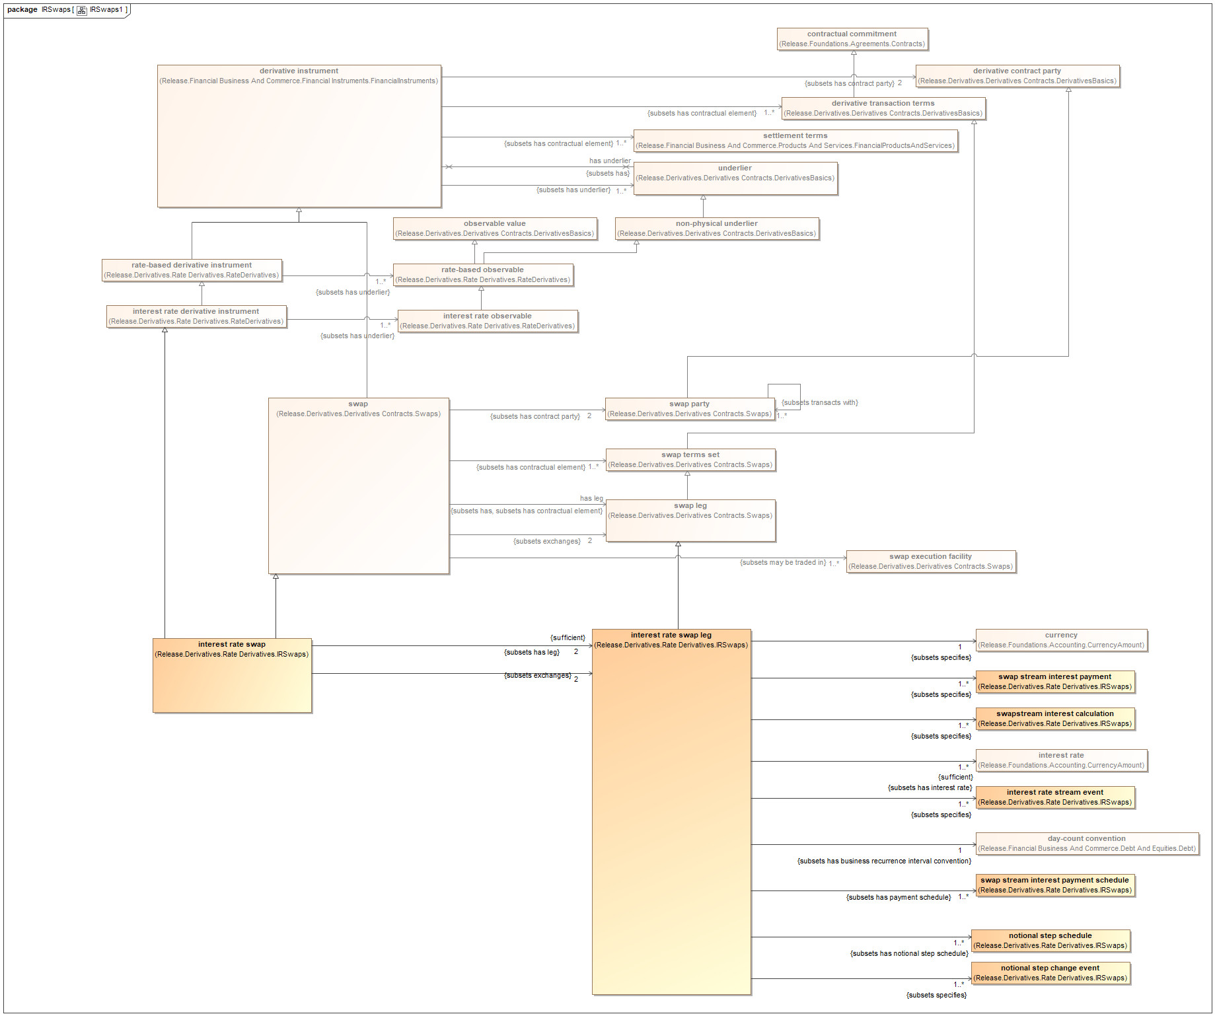
Figure 2: FIBO IR swaps Exploration

FIBO-Master CCM Model Review
Noted that Contract Terms Set is deprecated in favor of Contractual Commitment per work on Bonds. This has been carried forward to IR Swaps models (in Release) as shown, but seem to be retained elsewhere.
The top level Contractual Element subsumes Contractual Commitment (formerly Contract Terms Set) alongside other kinds of contractual element.
Also noted (per Nick’s email question) that in these Terms Sets (now contractual commitment) classes we don’t distinguish between Term and Conditions they are all properties of these Commitments and other elements.

Swap Legs
Swap Leg is a contractual commitment therefore its properties are the terms of the swap leg.
Swap Terms as a whole also exist as a class (see diagram). In addition, terms may be inherited from more general sets of derivative and contract terms.
So Terms Sheet is basically synonymous with Contract

Abbreviated terms Sheet
BT Suggestion: there may be a kind of abbreviated Terms Sheet that people are thinking of, with just the basics. This includes the Parties. In FIBO, these are Parties to the Contract as shown.
We will look at this idea next time. That is, what is the minimum set of terms that need to be posted to this kind of record, AKA the Terms Sheet in that sense?

