Date: October 2009

SysML-Modelica
Transformation Specification

Version Alpha 1

____________________________________________________
OMG Document Number: syseng/2009-12-01
Standard document URL: http://www.omg.org/spec/acronym/1.0/PDF
Associated File(s)*: http://www.omg.org/spec/acronym/200xxxxx
http://www.omg.org/spec/acronym/200xxxxx
____________________________________________________

Source document: syseng/2009-12-01
* Original file(s): Title (document number)

Copyright © 2009-2010, Deere & Company
Copyright © 2009-2010, EADS
Copyright © 2009-2010, Georgia Institute of Technology
Copyright © 2009-2010, Jet Propulsion Laboratory
Copyright © 2009-2010, Linköping University
Copyright © 2009-2010, Lockheed Martin Corporation
Copyright © 2009-2010, NoMagic Inc.
Copyright © 2009, Object Management Group, Inc.

USE OF SPECIFICATION - TERMS, CONDITIONS & NOTICES
The material in this document details an Object Management Group specification in accordance with the terms, conditions and notices set forth below. This document does not represent a commitment to implement any portion of this specification in any company's products. The information contained in this document is subject to change without notice.

LICENSES
The companies listed above have granted to the Object Management Group, Inc. (OMG) a nonexclusive, royalty-free, paid up, worldwide license to copy and distribute this document and to modify this document and distribute copies of the modified version. Each of the copyright holders listed above has agreed that no person shall be deemed to have infringed the copyright in the included material of any such copyright holder by reason of having used the specification set forth herein or having conformed any computer software to the specification.
Subject to all of the terms and conditions below, the owners of the copyright in this specification hereby grant you a fully-paid up, non-exclusive, nontransferable, perpetual, worldwide license (without the right to sublicense), to use this specification to create and distribute software and special purpose specifications that are based upon this specification, and to use, copy, and distribute this specification as provided under the Copyright Act; provided that: (1) both the copyright notice identified above and this permission notice appear on any copies of this specification; (2) the use of the specifications is for informational purposes and will not be copied or posted on any network computer or broadcast in any media and will not be otherwise resold or transferred for commercial purposes; and (3) no modifications are made to this specification. This limited permission automatically terminates without notice if you breach any of these terms or conditions. Upon termination, you will destroy immediately any copies of the specifications in your possession or control.

PATENTS
The attention of adopters is directed to the possibility that compliance with or adoption of OMG specifications may require use of an invention covered by patent rights. OMG shall not be responsible for identifying patents for which a license may be required by any OMG specification, or for conducting legal inquiries into the legal validity or scope of those patents that are brought to its attention. OMG specifications are prospective and advisory only. Prospective users are responsible for protecting themselves against liability for infringement of patents.

GENERAL USE RESTRICTIONS
Any unauthorized use of this specification may violate copyright laws, trademark laws, and communications regulations and statutes. This document contains information which is protected by copyright. All Rights Reserved. No part of this work covered by copyright herein may be reproduced or used in any form or by any means--graphic, electronic, or mechanical, including photocopying, recording, taping, or information storage and retrieval systems--without permission of the copyright owner.
DISCLAIMER OF WARRANTY

WHILE THIS PUBLICATION IS BELIEVED TO BE ACCURATE, IT IS PROVIDED "AS IS" AND MAY CONTAIN ERRORS OR MISPRINTS. THE OBJECT MANAGEMENT GROUP AND THE COMPANIES LISTED ABOVE MAKE NO WARRANTY OF ANY KIND, EXPRESS OR IMPLIED, WITH REGARD TO THIS PUBLICATION, INCLUDING BUT NOT LIMITED TO ANY WARRANTY OF TITLE OR OWNERSHIP, IMPLIED WARRANTY OF MERCHANTABILITY OR WARRANTY OF FITNESS FOR A PARTICULAR PURPOSE OR USE. IN NO EVENT SHALL THE OBJECT MANAGEMENT GROUP OR ANY OF THE COMPANIES LISTED ABOVE BE LIABLE FOR ERRORS CONTAINED HEREIN OR FOR DIRECT, INDIRECT, INCIDENTAL, SPECIAL, CONSEQUENTIAL, RELIANCE OR COVER DAMAGES, INCLUDING LOSS OF PROFITS, REVENUE, DATA OR USE, INCURRED BY ANY USER OR ANY THIRD PARTY IN CONNECTION WITH THE FURNISHING, PERFORMANCE, OR USE OF THIS MATERIAL, EVEN IF ADVISED OF THE POSSIBILITY OF SUCH DAMAGES.
The entire risk as to the quality and performance of software developed using this specification is borne by you. This disclaimer of warranty constitutes an essential part of the license granted to you to use this specification.

RESTRICTED RIGHTS LEGEND
Use, duplication or disclosure by the U.S. Government is subject to the restrictions set forth in subparagraph (c) (1) (ii) of The Rights in Technical Data and Computer Software Clause at DFARS 252.227-7013 or in subparagraph (c)(1) and (2) of the Commercial Computer Software - Restricted Rights clauses at 48 C.F.R. 52.227-19 or as specified in 48 C.F.R. 227-7202-2 of the DoD F.A.R. Supplement and its successors, or as specified in 48 C.F.R. 12.212 of the Federal Acquisition Regulations and its successors, as applicable. The specification copyright owners are as indicated above and may be contacted through the Object Management Group, 140 Kendrick Street, Needham, MA 02494, U.S.A.

TRADEMARKS
MDA®, Model Driven Architecture®, UML®, UML Cube logo®, OMG Logo®, CORBA® and XMI® are registered trademarks of the Object Management Group, Inc., and Object Management Group™, OMG™ , Unified Modeling Language™, Model Driven Architecture Logo™, Model Driven Architecture Diagram™, CORBA logos™, XMI Logo™, CWM™, CWM Logo™, IIOP™ , MOF™ , OMG Interface Definition Language (IDL)™ , and OMG SysML™ are trademarks of the Object Management Group. All other products or company names mentioned are used for identification purposes only, and may be trademarks of their respective owners.

COMPLIANCE
The copyright holders listed above acknowledge that the Object Management Group (acting itself or through its designees) is and shall at all times be the sole entity that may authorize developers, suppliers and sellers of computer software to use certification marks, trademarks or other special designations to indicate compliance with these materials.
Software developed under the terms of this license may claim compliance or conformance with this specification if and only if the software compliance is of a nature fully matching the applicable compliance points as stated in the specification. Software developed only partially matching the applicable compliance points may claim only that the software was based on this specification, but may not claim compliance or conformance with this specification. In the event that testing suites are implemented or approved by Object Management Group, Inc., software developed using this specification may claim compliance or conformance with the specification only if the software satisfactorily completes the testing suites.

OMG’s Issue Reporting Procedure

All OMG specifications are subject to continuous review and improvement. As part of this process we encourage readers to report any ambiguities, inconsistencies, or inaccuracies they may find by completing the Issue Reporting Form listed on the main web page http://www.omg.org, under Documents, Report a Bug/Issue (http://www.omg.org/technology/agreement.)

Table of Contents

1 Abstract 1
2 Scope 1
3 Conformance 2
4 Normative References 3
5 Terms and Definitions 3
6 Symbols 3
7 Additional Information 3
7.1 Changes to Adopted OMG Specifications [optional] 3
7.2 Acknowledgements 3
8 Integration Approach 4
8.1 Which SysML Elements are Best Suited for Modelica Concepts? 5
8.1.1 Modelica 7
8.1.2 SysML Internal Block Diagrams 7
8.1.3 SysML Parametric Diagrams 8
8.1.4 SysML Activity Diagrams 8
8.1.5 Selected Diagram: SysML Internal Block Diagram with Embedded Constraints 9
8.2 Illustrative Example 9

Preface
OMG
Founded in 1989, the Object Management Group, Inc. (OMG) is an open membership, not-for-profit computer industry standards consortium that produces and maintains computer industry specifications for interoperable, portable, and reusable enterprise applications in distributed, heterogeneous environments. Membership includes Information Technology vendors, end users, government agencies, and academia.
OMG member companies write, adopt, and maintain its specifications following a mature, open process. OMG’s specifications implement the Model Driven Architecture® (MDA®), maximizing ROI through a full-lifecycle approach to enterprise integration that covers multiple operating systems, programming languages, middleware and networking infrastructures, and software development environments. OMG’s specifications include: UML® (Unified Modeling Language™); CORBA® (Common Object Request Broker Architecture); CWM™ (Common Warehouse Metamodel); and industry-specific standards for dozens of vertical markets.
More information on the OMG is available at http://www.omg.org/.
OMG Specifications
As noted, OMG specifications address middleware, modeling and vertical domain frameworks. A Specifications Catalog is available from the OMG website at:
http://www.omg.org/technology/documents/spec_catalog.htm
Specifications within the Catalog are organized by the following categories:
OMG Modeling Specifications
- UML
- MOF
- XMI
- CWM
- Profile specifications
OMG Middleware Specifications
- CORBA/IIOP
- IDL/Language Mappings
- Specialized CORBA specifications
- CORBA Component Model (CCM)
Platform Specific Model and Interface Specifications
- CORBAservices
- CORBAfacilities
- OMG Domain specifications
- OMG Embedded Intelligence specifications
- OMG Security specifications
All of OMG’s formal specifications may be downloaded without charge from our website. (Products implementing OMG specifications are available from individual suppliers.) Copies of specifications, available in PostScript and PDF format, may be obtained from the Specifications Catalog cited above or by contacting the Object Management Group, Inc. at:

OMG Headquarters
140 Kendrick Street
Building A, Suite 300
Needham, MA 02494
USA
Tel: +1-781-444-0404
Fax: +1-781-444-0320
Email: pubs@omg.org
Certain OMG specifications are also available as ISO standards. Please consult http://www.iso.org
Typographical Conventions
The type styles shown below are used in this document to distinguish programming statements from ordinary English. However, these conventions are not used in tables or section headings where no distinction is necessary.
Times/Times New Roman - 10 pt.: Standard body text
Helvetica/Arial - 10 pt. Bold: OMG Interface Definition Language (OMG IDL) and syntax elements.
Courier - 10 pt. Bold: Programming language elements.
Helvetica/Arial - 10 pt: Exceptions

NOTE: Terms that appear in italics are defined in the glossary. Italic text also represents the name of a document, specification, or other publication.

Part I ̶̵̶ Introduction

Abstract
OMG SysMLTM is a standardized general purpose graphical modeling language for capturing complex system descriptions in terms of their structure, behavior, properties, and requirements. Modelica is a standardized general purpose systems modeling language for analyzing the continuous and discrete time dynamics of complex systems based on solving differential algebraic equations. Integrating the descriptive power of SysML models with the analytic and computational power of Modelica models provides a capability that is significantly greater than SysML or Modelica individually. The objectives of this document are to enable and specify a standardized bi-directional transformation between the two modeling languages that will support implementations to efficiently and automatically transfer the modeling information transfer between SysML and Modelica models without ambiguity.
The transformation approach is to specify first an extension to SysML called the SysML4Modelica profile to represent the Modelica constructs and then to specify the SysML-Modelica Transformation between the profile constructs and the Modelica language. Introducing the profile into the transformation approach is intended to simplify the transformation to Modelica and facilitate model reuse by more directly leveraging existing model libraries within Modelica. In this way, the user first creates the system model in a SysML modeling tool as they would normally do. The user then selects the part of the model to be analyzed by Modelica (e.g., a particular subsystem) and applies the SysML4Modelica profile to creates an analytic representation of that part of the model. The SysML modeling tool is expected to include this profile. The analytic representation expressed in the SysML4Modelica profile is then transformed to a Modelica model where it can be executed by a Modelica modeling tool.
The SysML-Modelica transformation leverages the fundamental concepts of the Model-Driven Architecture (MDA). Different transformation implementations can be applied to implement this specification such as the QVT and others. The transformation can leverage an XMI formatted static file transfer or other mechanisms such as API’s that support a dynamic interchange capability.
This specification is organized as follows:
Part I ̶̵̶ Introduction
Part II ̶̵̶ SysML4Modelica profile
Part III ̶̵̶ Modelica meta-model
Part IV ̶ SysML-Modelica mapping, a bidirectional mapping between the SysML4Modelica profile and the Modelica meta-model
Annex A – Robotic Sample Problem

Scope
OMG SysMLTM is a general-purpose systems modeling language that can be used to create and manage models of systems using well-defined, graphical constructs with underlying semantics. SysML reuses a subset of UML 2 constructs and extends them by adding new modeling elements and two new diagram types. These SysML diagrams are shown in Figure 1. The set of behavioral and structural diagrams combined with the requirements diagram and parametric diagram provide an integrated view of a system. But SysML represents much more than just a set of diagrams. Underlying the diagrams, there is an abstract syntax model repository that formally represents all the modeling constructs. The graphical model provides a mechanism to organize, enter, retrieve, and view the system-descriptive data contained in the model repository. The diagrams provide multiple views of the same system model; these multiple views can be maintained consistently due to the semantic underpinning of the modeling language. In the context of SysML, the structure view primarily refers to the hierarchy and interconnections among the parts of the system, and the interconnections between the system and its external systems. The behavior view describes the sequence of events and activities that the system must execute. The requirements diagram captures text requirements in the model, and enables them to be linked to other parts of the model, to provide unambiguous traceability between the requirements and system design. Parametrics provide the bridge between the system descriptive model in SysML and other simulation and engineering analysis models. While structure and behavior are heavily based on UML, both requirements and parametrics are unique to SysML. Through these extensions, SysML is capable of representing the specification, analysis, design, verification and validation of systems.
Figure 1: An overview of the SysML diagrams and their relation to UML diagrams.
As indicated above, the system behavior in SysML is captured through a combination of activity diagrams, state machine diagrams, and/or sequence diagrams and the associated semantics. The Foundational Subset of the UML specification provides the additional semantics to enable SysML activity diagrams to be executed in a standard way. In addition, SysML includes parametric diagrams to capture models of constraint-based behavior, such as continuous-time dynamics in terms of energy flow. However, the syntax and semantics of such behavioral descriptions in parametrics have been left open to integrate with other simulation and analysis modeling capabilities to support the execution of these models. Additional information on SysML can be found at http://www.omgsysml.org.
Modelica is an object-oriented language for describing differential algebraic equation (DAE) systems combined with discrete events. Such models are ideally suited for representing the flow of energy, materials, signals, or other continuous interactions between system components. It is similar in structure to SysML in the sense that Modelica models consist of compositions of sub-models connected by ports that represent energy flow (undirected) or signal flow (directed). The models are acausal, equation-based, and declarative. The Modelica Language is defined and maintained by the Modelica Association (www.modelica.org), which publishes a formal specification [Modelica Association, 2008] but also provides an extensive Modelica Standard Library, which includes a broad foundation of essential models covering domains ranging from (analog and digital) electrical systems, mechanical motion and thermal systems, to block diagrams for control. Finally, it is worth noting that there are several efforts within the Modelica community to develop open-source solvers, such as in the OpenModelica project (www.openmodelica.org).
In conclusion, SysML and Modelica are two complementary languages supported by two active communities. By integrating SysML and Modelica, we combine the very expressive, formal language for differential algebraic equations and discrete events of Modelica with the very expressive SysML constructs for requirements, structural decomposition, logical behavior and corresponding cross-cutting constructs. In addition, the two communities are expected to benefit from the exchange of multi-domain model libraries and the potential for improved and expanded commercial and open-source tool support.
The objective of this document is to provide a bi-directional mapping between SysML and Modelica to leverage the benefits from both languages. By integrating SysML and Modelica, SysML's strength in descriptive modeling can be combined with Modelica's formal executable modeling capability to support analyses and trade studies. The scope of this specification supports the objectives of the bi-directional mapping, and includes the SysML4Modelica profile, and the SysML-Modelica Transformation. Not all Modelica constructs will be represented in this profile. The focus is to include the Modelica language features that are most common and together cover the majority of the Modelica models in the standard library. When certain Modelica constructs are omitted, then this will be pointed out explicitly in this document. Changes to SysML and Modelica may be recommended as a result of this effort to enable the transformation, but these changes are subject to the adoption process for the respective specifications. Future changes could also include the introduction of additional SysML constructs into the Modelica Language or additional Modelica constructs in the SysML language; however, this is outside the scope of the current effort.

Conformance
The Conformance clause identifies which clauses of the specification are mandatory (or conditionally mandatory) and which are optional in order for an implementation to claim conformance to the specification.
  - Compliance with SysML4Modelica profile
  - Compliance with the SysML-Modelica mapping
Note: For conditionally mandatory clauses, the conditions must, of course, be specified.

References

Normative References
The following normative documents contain provisions which, through reference in this text, constitute provisions of this specification. For dated references, subsequent amendments to, or revisions of, any of these publications do not apply.
- Systems Modeling Language: Specification, version 1.2 (http://www.omg.org/spec/SysML/1.2)
- Modelica Specification, v.3.1 (http://www.modelica.org/index_html/documents/Modelica Spec31.pdf)

Non-normative References
Reference to MDA foundational spec
ormsc/09-02-01: MDA Foundation Model - Santa Clara AB initial comments draft http://www.omg.org/members/cgi-bin/doc?ormsc/09-02-01.pdf

Terms and Definitions
For the purposes of this specification, the following terms and definitions apply.

HOW SHOULD WE USE THIS SECTION. DO WE NEED IT OR SHOULD WE LEAVE IT BLANK.
SysML-Modelica Transformation Specification
Definition
SysML4Modelica profile
Definition
SysML-Modelica mapping
Definition

Symbols
List of symbols/abbreviations.

Additional Information

Changes to Adopted OMG Specifications [optional]The following are proposed changes to the SysML Specification and designated as required or desired in order to support this specification:
The following are proposed changes to the Modelica Specification and designated as required or desired in order to support this specification:

Acknowledgments
The following companies submitted this specification:
- NoMagic Inc.
The following companies supported this specification:
- Deere & Company
- EADS
- Georgia Institute of Technology
- Jet Propulsion Laboratory
- Linköping University
- Lockheed Martin Corporation
- NoMagic Inc.
The following people have contributed significantly to this document either directly or indirectly through discussions and feedback:
- Yves Bernard (EADS)
- Roger Burkhart (Deere & Co)
- Hans-Peter De Koning (ESA)
- Sanford Friedenthal (Lockheed Martin)
- Peter Fritzson (Linköping University)
- Nerijus Jankevicius (NoMagic Inc)
- Thomas Johnson (Georgia Tech)
- Alek Kerzhner (Georgia Tech)
- Chris Paredis (Georgia Tech)
- Russell Peak (InterCAx, Georgia Tech)
- Nicolas Rouquette (Jet Propulsion Laboratory)
- Wladimir Schamai (EADS, Linköping University)

Integration Approach
To develop a transformation between the SysML and Modelica languages, a formal, systematic approach is used. As is illustrated in Figure 2. the transformation approach is to specify first an extension to SysML called the SysML4Modelica profile which represents the most common Modelica language constructs. This allows the Modelica concepts to be expressed in an extension of SysML that supports round-trip transformation from SysML to Modelica and back. The profile extends the UML4SysML subset of UML and the SysML extensions to that subset that are required to capture the relevant Modelica concepts and enable the mapping between the two languages.
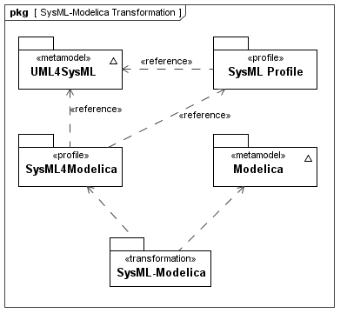Figure 2: The SysML-Modelica Transformation in relation to SysML and Modelica.
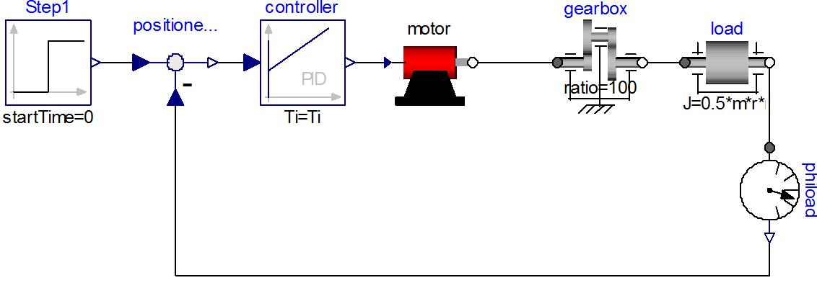Figure 3: A Modelica model of a motor controller consisting of component models and the connections between them. The connections include both causal signal connections (e.g., in and out of the controller) and acausal energy connections (e.g., the rotational mechanical energy connections of the gearbox).
To develop the SysML4Modelica profile in a systematic fashion, we start from the Modelica Language Specification and identify for each Modelica language construct an equivalent construct in SysML. If an equivalent construct does not exist, stereotypes are created to extend the SysML language. The following naming convention is used to define the Modelica construct in the SysML4Modelica profile: «modelicaConstruct» where Construct is the name of Modelica language construct as defined in the Modelica abstract syntax definition (see Chapter qq-insert ref after combining documents).
Even when an equivalent SysML construct exists, it is sometimes necessary to introduce a stereotype in order to distinguish the Modelica construct from the ordinary SysML construct when supporting round-trip transformation. In addition, the concrete syntax of Modelica often provides alternative representations to express the exact same semantics. In such cases, the intent is to avoid duplicating this redundancy in SysML4Modelica without loss of expressivity. For mapping purposes, one of the redundant representations is identified as the primary (most explicit) representation, and SysML4Modelica constructs are preferably mapped onto this primary representation. It should also be noted, that Modelica includes a graphical syntax using iconic representations of block diagrams that maps to its textual syntax. An example of the Modelica graphical syntax is shown in Figure 3 for a set of components connected together via Modelica connectors and connections.
Initially, the SysML-Modelica Transformation Specification provides a textual description of the mapping between Modelica and SysML4Modelica. However, it is the intent also to describe this mapping formally by defining a Triple Graph Grammar, linking the Modelica and SysML meta-models. Such a formal definition of the mapping has the additional advantage that meta-CASE tools (such as MOFLON) can be used to generate executable transformations between SysML and Modelica modeling tools (assuming they support some standardized interface such as JMI). An additional implementation of the mapping is being developed as part of the OpenModelica project.

Semantic Comparison between SysML and Modelica
Before focusing on the detailed modeling constructs, a high-level decision needs to be made regarding the choice of SysML elements to represent Modelica models. Although Modelica is a textual language, it also supports a graphical view through its annotation mechanism. This graphical view illustrates clearly the strong similarity that exists between SysML and Modelica. Both languages support the decomposition of systems (or behavioral models of systems) into subsystems or components and the interactions between them. For instance, the Modelica model of a motor controller (shown in Figure 1) contains subcomponents (such as motor, gearbox, and controller). The interactions between them are illustrated by edges connecting the interface locations (called connectors in Modelica) of the components. Such hierarchical compositions of Modelica models and the connections between them constitute the primary modeling approach in Modelica. Before considering the details of the language, it is thus important to consider carefully how these primary modeling constructs map to SysML.
As illustrated in Table 1, in SysML there are three types of diagrams that have a structure that is similar to the hierarchical, connector-based composition of Modelica models: the Internal Block Diagram (IBD), the Parametric Diagram, and the Activity Diagram. All three diagrams support some sort of "ports", some sort of connection of "port-based" objects through "port-connections", and hierarchical encapsulation through "port-delegation". In Sections 8.1.1 through 8.1.4, we use these three diagrams to discuss the main question: What are the SysML elements that match the Modelica semantics best? Table 1 shows in addition how the Block Definition Diagram (BDD) may provide an interesting complement to type definitions.
[Yves suggested the following modification to the table below:]
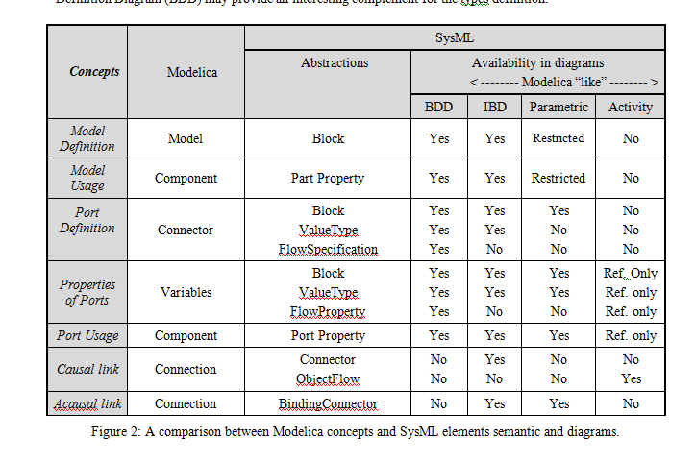

Table 1: A comparison between between Modelica concepts and SysML elements, semantics, and diagrams.
Diagram | Modelica | Internal Block | Parametric | Activity
Model Definition | Model | Block | Constraint Block | Activity
Model Usage | Component | Part Property | Constraint Property | Action
Port Definition | Connector | Block, Value Type, Flow Spec. | Value Type | Block, ValueType
Port Usage | Component | Flow Port | Parameter | Object Node
Edge | Connection | Connector | Binding Connector | Object Flow

Modelica
In Modelica, ports are called connectors and the edges between ports are called connections [Modelica Spec, Chapter 9]. The ports (connectors) can include four types of quantities: inputs, outputs, flows and non-flows. Inputs and output are used when the direction of the flow is known and fixed, as for instance in signals flowing in a control system. Flow and non-flow quantities are used to describe energy or material flow (they are also sometimes referred to as through and across variables, respectively). When connecting two Modelica connectors with a connection, the semantics for inputs and outputs are causal binding: the input is assigned the value of the output to which it is connected. Input and output connecters must therefore be used in conjugate pairs, and only one output can be connected to each input. For flow and non-flow variables, the connection semantics correspond to Kirchhoff's Laws, namely, the value of the flow variables add up to zero and the values of the non-flow variables are set equal (in an equation-based, acausal fashion). When more than one connection is made to a connector containing a flow variable, then an ideal, loss-less energy or material exchange is assumed by imposing that the values of flow variables of all connected connectors add up to zero. To impose the correct modeling of energy exchange, Modelica requires that the number of flow and non-flow quantities of a connector be equal.
In addition to connectors, Modelica models can contain variables and submodels (i.e., model usage in Table 1). Although Modelica does not explicitly distinguish between these three categories of “components” (i.e., connectors, variables, submodels), it may still be useful and desirable to distinguish explicitly among them when mapping to SysML.

SysML Internal Block Diagrams
The primary purpose of Internal Block Diagrams (IBD) in conjunction with block definition diagrams (BDD), is to express system structural decomposition and interconnection of its parts [SysML Spec, Chapters 8 and 9]. The SysML concepts used in the IBD/BDD viewpoints have quite flexible semantics and may be used to establish logical and conceptual decompositions, for instance, as in a context diagram [SysML Spec, Section B.4.2.1].] The Blocks in SysML are similar to Classes in Modelica (specifically the specialized class types of Model, Block, Connector, etc.). Blocks can be decomposed in the same way Modelica Classes can be decomposed.
The “ports” in IBDs are called Ports and the connections between ports are called Connectors. There are two kinds of ports: Flow Ports and Standard Ports. The Standard Ports are particularly geared towards service-based interactions by representing the interfaces (e.g., software methods) that are provided or required by a particular block. Such service-based interactions are not appropriate for modeling the connections found in Modelica. Flow Ports on the other hand do provide semantics that reflect Modelica connectors more closely. A Flow Port describes an interaction point through which input and/or output of items such as data, material, or energy may flow in and out of a block. For Modelica-type interactions, the "items" could be either signals (for input and output quantities) or energy/material (for flow and non-flow quantities). In Modelica these interactions are modeled as instances of Modelica Connector types. Such instances do not have a direction of flow associated with them directly, but should be interpreted as containing either inputs, outputs, or energy/material flows based on the definition of the Connector type of which they are an instance. This is similar to SysML nonatomic FlowPorts typed by FlowSpecifications, although one may argue that the combination of a flow and non-flow variable in a Modelica energy/material connector constitute one concept (i.e., one energy or material flow) and should therefore be modeled as an atomic rather than non-atomic flow port. In addition, the (acausal) connection between flow ports in SysML does not explicitly carry the Kirchhoff semantics as for energy/material connections in Modelica.
An additional subtle difference in semantics lies in the fact that, in SysML, the type of a flow property defined in a flow port specifies what can flow through that port; what actually flows must be defined by associating an Item Flow to a SysML Connector (the connection between the flow ports). In Modelica, no such differentiation between what can flow and what actually flows is made. This makes sense because Modelica describes the behavior of what actually happens (what flows) rather than a specification of an interface (what can flow).
In conclusion, although IBDs seem to have very similar constructs to Modelica, there are some subtle differences in semantics so that new stereotypes will have to be introduced to adequately capture the Modelica semantics of Connectors and Connections.

SysML Parametric Diagrams
The purpose of Parametric Diagrams is to express mathematical relationships between parameters. In Parametric Diagrams, the “ports” are Constraint Parameters and the “connections” are Binding Connectors. Inside a Constraint Block, mathematical relationships are defined constraining its Constraint Parameters. A Constraint Property is a usage of a Constraint Block. Its Constraint Parameters are then bound to other Constraint Parameters or to Properties of Blocks. The semantics of a Binding Connector indicate a mathematical equality between the (Block) Properties or Constraint Parameters being connected. This mathematical equality is an acausal relationship..
Although the Binding Connectors share the acausal nature of energy-connections in Modelica, they are currently missing the notions of a Modelica Flow variable and of causal inputs and outputs (Note: an issue has been submitted requesting the addition of causality specifications in parametrics to future versions of SysML). The equivalent of a Binding Connector does not actually exist in Modelica, but can be captured in a non-graphical fashion by introducing an equality equation between the two variables that are bound. Therefore, in order to capture the semantics of a Modelica connection, one would have to introduce a new SysML connector element that is equivalent to a Modelica Connector, and that reflects the semantics of Kirchhoff's laws. Another possibility would be to make the equations for Kirchhoff’s laws, which are implicit in Modelica connections, explicit as another SysML Constraint Property. This option is appealing because it makes the semantics very explicit, but has the disadvantage that it makes the models more cumbersome to create and more difficult to read.
Finally, unlike Blocks, Constraint Blocks do not have Value Properties that are not Constraint Parameters. As a result, (local) variables in Modelica would have to be represented as Constraint Parameters, making it difficult to distinguish them from “ports.”
In conclusion, the intent of Parametric Diagrams is similar to the intent of Modelica Models, and they therefore deserve consideration. However, the types of connections that exist in Modelica do not exist in Parametric Diagrams and vice versa. As a result, the use of Parametric Diagrams will require the introduction of additional constructs (stereotypes).

SysML Activity Diagrams
The purpose of an Activity graph in SysML is to specify the transformation of inputs to outputs through a controlled sequence of actions. An Activity decomposes into Actions. In activity graphs, the Object Nodes (i.e., Pins and Parameter Nodes) correspond to buffers to place input and output tokens. The connections between Object Nodes correspond to Object Flows. These flows typically represent the transfer of one or more objects at a discrete moment in time, although it is possible to specify a streaming flow that could be continuous, i.e., the time between arrival of tokens (or “objects”) is zero. It is this latter case that needs to be described in terms of differential equations and is also closest to the semantics of Modelica's flows. However, the strict notion of flows from output to inputs in Activity graphs, is not imposed in Modelica (Note: this flow direction would correspond to a constraint on the sign of a flow variable, but has nothing to do with mathematical causality).
In conclusion, only the special case of continuously streaming object flows seems to match the Modelica semantics of energy flow, and even for that case, the semantics are quite different. Activity graphs therefore seems to be the least appropriate for a mapping from Modelica Class, although they will be explored when mapping the Modelica Function and Algorithm to SysML4Modelica.

Selected Diagram: SysML Internal Block Diagram with Embedded Constraints
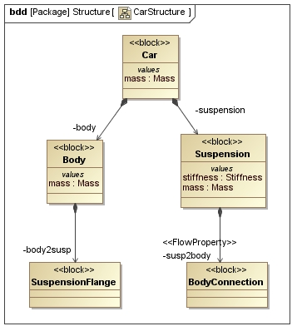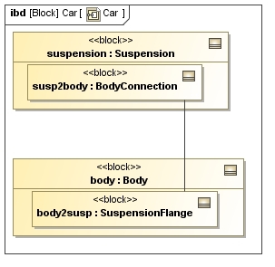Figure 4: Descriptive model of a car suspension visualized as a BDD and IBD.
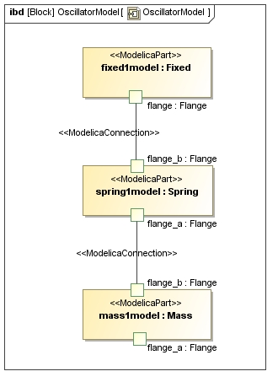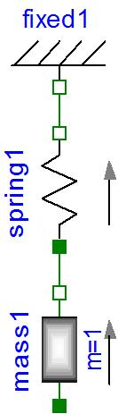Figure 5: Mass-Spring model for a car suspension, in Modelica (left) and SysML4Modelica (right).
It is clear from the discussion in the previous sections that there is not a single viewpoint that embeds the Modelica semantics perfectly. As a result, the use of more than one SysML viewpoint with multiple stereotypes will need to be defined to extend the SysML semantics.
Blocks, ConstraintBlocks, FlowPorts, classical Connectors and BindingConnectors can be used to map Modelica Models, Components, Connectors, and Connections to SysML, assuming an extension of connector is defined to support the Kirchhoff semantics. This could be expected since Constraint Blocks are restricted versions of regular Blocks. Actually, Constraint Blocks and Parametric Diagrams are too restricted. For instance, Constraint Blocks cannot have value properties (only constraint parameters), and the only connectors allowed in a Parametric Diagram are binding connectors, which have semantics of equality constraints and can thus not be further restricted to represent Kirchhoff’s laws as is needed for Modelica. Parametric Diagrams could be useful to capture the semantics of Modelica if one wants to make explicit the equations that are implicit in Modelica connections. This is illustrated in Section 8.2, but is not further pursued in the remainder of the document. From Chapter 9 forward, the focus will be exclusively on how to extend Blocks and Internal Block Diagrams to express the Modelica semantics.
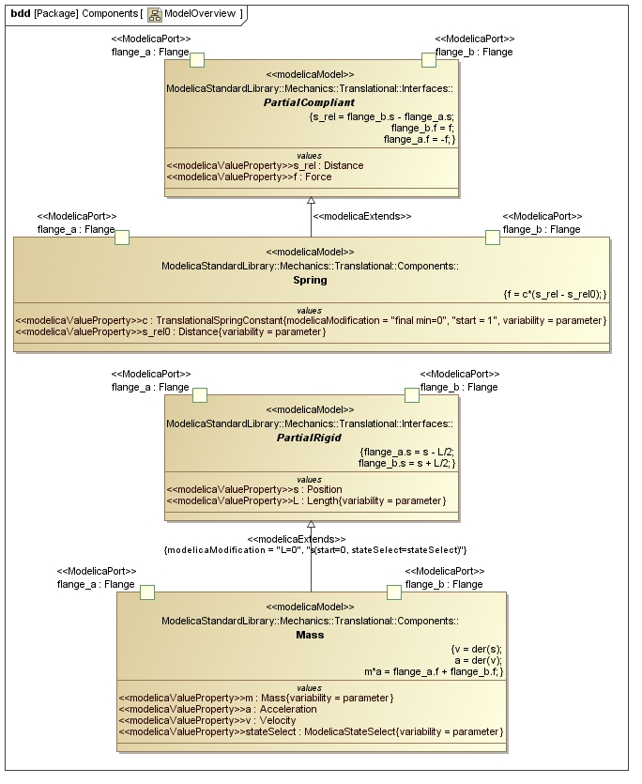Figure 6: Continuous dynamics models for Mass and Spring defined in the Modelica Standard Library.
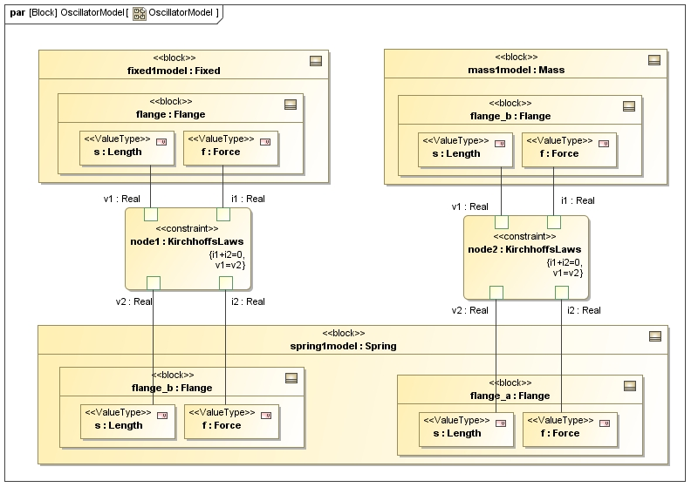Figure 7: Mass-Spring model as represented in a Parametric Diagram.
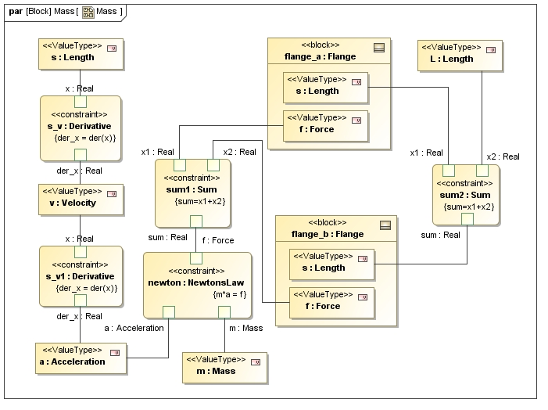Figure 8: Mass model as it could be represented in a Parametric Diagram.

Illustrative Example
The following example is intended to illustrate the concepts of how the transformation approach can be used to provide a context for the normative specification in Part II of this specification. Consider the design of a car suspension. As illustrated in Figure 4, the suspension can be described in the context of a car using a descriptive SysML model, expressed in a BDD and corresponding IBD.
Assume now that one needs to evaluate the dynamic response of the suspension by simulating the car body’s position as a function of time. A possible continuous dynamics model for such a simulation models the suspension as a linear spring and the car body as a point mass. This model is illustrated in Figure 5 in both Modelica and in SysML4Modelica profile which represents the corresponding Modelica constructs.. By stereotyping SysML ports and connectors, the semantics of Kirchhoff’s laws have been introduced into SysML.
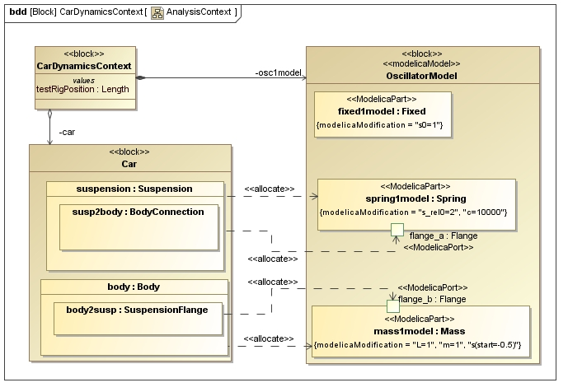Figure 9: The Block Definition Diagram for the Analysis Context of the continuous dynamics analysis.
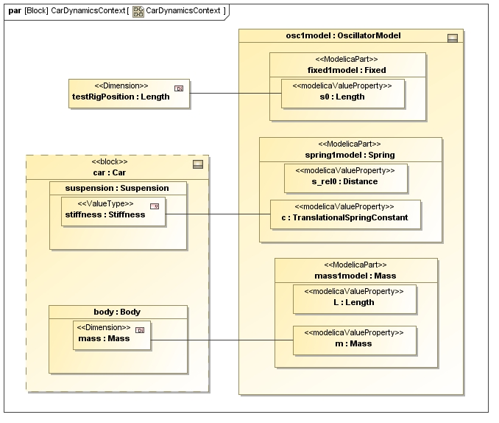Figure 10: The Parametric Diagram for the Analysis Context of the continuous dynamics analysis; the properties of the descriptive model are bound to the corresponding properties in the analysis model.
The SysML parts are stereotyped as «modelicaPart». (i.e., mass1model, spring1model, fixed1model), that correspond to usages of models from the Modelica Standard Library. For instance, as illustrated in Figure 6, the library Modelica.Mechanics.Translational.Components includes definitions of continuous dynamics models for a Spring and a Mass. Note that one could apply stereotypes in SysML that include icons equivalent to the elements from the Modelica library so that the SysML4Modelica representation in Figure 4 could be almost identical to the Modelica representation on the left.
In Figure 5, the usages of these models, stereotyped as «modelicaPart» are connected to each other at their «modelicaPort» by «modelicaConnection». These connections carry the semantics of Kirchhoff’s Laws (in this example—or, more generally, the same semantics as an equivalent Modelica connection). These semantics can be made more explicit by using a Parametric Diagram (Figure 8). But, as one can see by comparing Figure 8 and Figure 5, this comes at a cost of a much larger and less readable diagram. Similarly, one could have represented the internal equations of the Mass model in a Parametric Diagram, as is illustrated in Figure 7, but again, the more explicit semantics come at a cost of increased complexity. For this reason, only Blocks and Internal Block Diagrams are further used in the SysML4Modelica profile, but the parametrics still provides the underlying semantics for capturing the detailed equations. However, this complexity can often be abstracted and made not visible to the modeler.
Finally, it is worth illustrating how the SysML4Modelica continuous dynamics model in Figure 5 relates to the SysML descriptive model in Figure 4. Since both the descriptive and the continuous dynamics models are views of the same system, they cannot be independent of each other. Changes to the descriptive model are likely to require corresponding changes to the continuous dynamics model and vice versa. Such dependencies can be modeled in an analysis context — the context in which the analysis model (i.e., the continuous dynamic analysis in this case) is defined.
The analysis context is illustrated in Figure 9. It establishes the dependencies between the descriptive model components and their corresponding analysis models. In addition, the detailed bindings between the descriptive and analysis properties are defined in the Parametric Diagram illustrated in Figure 10.
For very simple problems, one could consider combining the descriptive and analysis views into one model; e.g., suspension and spring1model would be combined into one component that includes both the descriptive properties and the analysis constraints/equations. However, for larger problems in which more than one analysis perspective needs to be considered (e.g., mechanical, electrical, controls, manufacturing, different levels of abstraction, etc.), combining all such analyses into one model would be difficult to manage. One would likely encounter problems with naming conflicts or duplication of properties. In addition, combining all the models severely limits the opportunity for model reuse because models from libraries (such as the Modelica Standard Library) would have to be combined with descriptive models rather than just included in an analysis context.

Note that an instance in Modelica is similar to a usage in UML or SysML.

