Date: October 2009

SysML-Modelica
Transformation Specification

Version Alpha 1

____________________________________________________
OMG Document Number: dtc or ptc/200x-xx-xx
Standard document URL: http://www.omg.org/spec/acronym/1.0/PDF
Associated File(s)*: http://www.omg.org/spec/acronym/200xxxxx
http://www.omg.org/spec/acronym/200xxxxx
____________________________________________________

Source document: Title (document number)
* Original file(s): Title (document number)

List of issues to discuss:
- Name for SysML4Modelica → what is a better name? If we compare this to UML4SysML then it refers to a subset of UML, not a profile. → SysML2Modelica
- We discussed on10/21/09 that isFinal should be defined although isLeaf already exists with the same semantics. We decided to take the opposite approach for isAbstract which corresponds to the Modelica “partial” keyword. PROPOSAL: be consistent and use isLeaf rather than isFinal.
- When should a reference to a stereotype be capitalized? The definition is capitalized but an instance has the same name in lowercase...
- I'm struggling with our decision to make all restricted classes map to SysML blocks. Ultimately, we need to associate values with Modelica variables. Since all types that have values derive from the Modelica predefined types, the predefined types should somehow be able to have a value. In the current mapping, the predefined types derive from the SysML valueTypes Real, Integer, etc. However, if all restricted classes map to blocks, then this causes problems since blocks cannot specialize valueTypes.
Proposed solution: make the Modelica predefined types instances of «modelicaType» (which derives from «block»). Unlike other «modelicaType»'s (which can only modify existing types including predefined types), the predefined types themselves have value properties as defined previously in the mapping (Chapter 6). The only difference would be to add a value property called “value” rather than have the predefined type specialize the SysML valueType Real (or Integer, Boolean, etc.). This is consistent with the approach taken in Modelica. In Modelica, the predefined types also have a “value” property, but the compiler refers to that value automatically. That is, for a usage, myReal, of the type Real, one should refer to “myReal” rather than “myReal.value”.

- Related to the previous issue: rather than distinguishing between «modelicaPart», «modelicaPort» and «modelicaValueProperty», we could now drop «modelicaValueProperty». However, I propose that we keep «modelicaValueProperty» because some of the stereotype attributes are specific to «modelicaValueProperty»'s (i.e., flowFlag, variability, and declarationEquation).
- Review of the constraints – my inexperience in writing this kind of documents makes it difficult for me to judge whether the constraints are written in an appropriate form and whether they are complete. Any feedback would be welcome.
- Is a «modelicaConnection» a Property? If so, then it should be added in constraint [1] of «modelicaModel».

Notes:
include example section to overall document...
add annotations and comments throughout
Part II ̶̵̶ SysML4Modelica Profile
This part describes the mapping of Modelica constructs to SysML. This mapping is the foundation for the SysML4Modelica profile. It is organized according to the chapters of the Modelica 3.0 specification, skipping those chapters that are irrelevant to the SysML-Modelica mapping. When necessary, new stereotypes (extensions of SysML) and associated tags are introduced.

Class Definition

Overview
The class concept is the basic structural unit in Modelica. Classes provide the structure for objects and contain equations and algorithms, which ultimately are the basis for the executable simulation code. The most general class is “model”. Specialized classes such as “record”, “type”, “block”, “package”, “function” and “connector” have most of the properties of a “model” but with restrictions, which need to be preserved in SysML to support round-trip mapping.
The following production rules define the different specialized classes. The reference in parentheses on the right indicates the section of this document in which the particular language element is discussed in detail:
stored_definition:
[ within [ name ] ";" ] (5.2)
{ [ final ] class_definition ";" } (5.2)

class_definition :
[ encapsulated ] (5.2)
[ partial ] (5.2)
( class (5.2)
| model (5.3)
| record (5.4)
| block (5.5)
| [ expandable ] connector (5.6)
| type (5.7)
| package (5.8)
| function ) (5.9)
class_specifier

class_specifier :
IDENT string_comment composition (7)
| IDENT "=" base_prefix name [ array_subscripts ] (5.7)
[ class_modification ] comment (5.10)
| IDENT "=" enumeration "(" ( [enum_list] | ":" ) ")" comment (Error: Reference source not found)
| IDENT "=" der "(" name "," IDENT { "," IDENT } ")" comment (5.9)
| extends IDENT [ class_modification ] string_comment composition (5.10)
end IDENT
The following table lists the SysML stereotypes for representing the specialized Modelica classes. Using this approach the modeler only needs to apply the respective stereotype to indicate all the semantics and restrictions of the associated Modelica class. This information is represented graphically in Figure 1. In the following subsections, the details of each stereotype are described.

- : Mapping for the Modelica specialized classes.
Modelica Construct | SysML Base Class | SysML4Modelica
Modelica Construct | SysML Base Class | New Stereotype | Comments
Class | UML4SysML::Classifier | «modelicaClass» | See Section 5.2
Model | SysML::Blocks::Block | «modelicaModel» | See Section 5.3
Record | SysML::Blocks::Block | «modelicaRecord» | See Section 5.4
Block | SysML::Blocks::Block | «modelicaBlock» | See Section 5.5
Connector | SysML::Blocks::Block | «modelicaConnector» | See Section 5.6
Type | SysML::Blocks::Block  SysML::Blocks::ValueType  UML4SysML::Enumeration | «modelicaType», | See Sections 5.7 and Error: Reference source not found
Package | SysML::Blocks::Block | «modelicaPackage» | See Section 5.8
Function | UML4SysML::FunctionBehavior | «modelicaFunction» | See Section 5.9

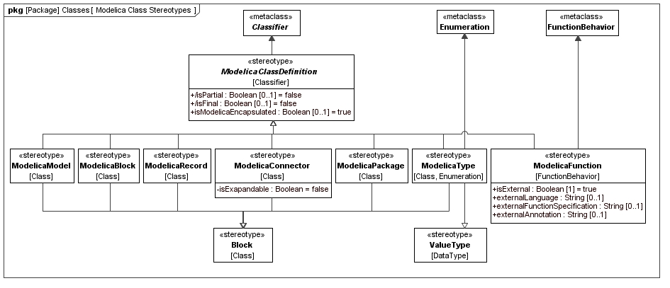
- : Package diagram with an overview of the stereotypes for Modelica Classes

«modelicaClassDefinition»

Stereotypes
- Classifier (from UML4SysML)

Abstract Syntax
- See Figure 1.

Description
A Modelica class is the basic structural unit in Modelica. However, because it lacks precise semantics, the class construct should never be used in Modelica. Without precise semantics, a Modelica tool cannot easily check whether any restrictions are violated. Therefore, the constructs that are specialized from Modelica class should be used instead.
In the context of the SysML4Modelica profile, the Modelica class construct is mapped to the stereotype «modelicaClass» which is abstract and thus cannot be instantiated directly. This choice has been made because it is desirable to have the additional semantics specified by the specialized classes. In addition, as clearly shown in See Figure 1, the stereotypes associated with the specialized classes derive from different SysML constructs and thus cannot be mapped to a single common construct for a Modelica class. The abstract stereotype «modelicaClass» serves the purpose of grouping the attributes that apply to all the Modelica specialized classes. It stereotypes UML::Classifier, which is a common generalization for the stereotypes of all the specialized classes.
Just like UML Classifiers, a «modelicaClass» can contain nested class definitions. Such nested definitions can be of any restricted class type derived from «modelicaNestedClass». For instance, a «modelicaConnector» can contain a «modelicaPackage».
Modelica classes are often defined using a short class definition syntax. For example, the type Force could be defined as:
type Force = Real[3](unit={"N.m","N.m","N.m"});
Rather than supporting such short class definitions explicitly, the SysML4Modelica profile supports only the longer (but equivalent) form (Note: in the Modelica abstract syntax the two forms are often represented identically):
type Force
extends Real[3](unit={"N.m","N.m","N.m"});
end Force;
In the remainder of this section, all the common attributes and associations for all the constructs specialized from Modelica class are described. In subsequent sections for the individual specialized constructs, only the constraints on these attributes and associations will be described in detail.

Attributes
- /isFinal : Boolean [0..1]
In Modelica, the definition of a class can be qualified to be final (Modelica Specification 7.2.6). This means that the declared class cannot be further modified through (local) type modifications. Note that this is identical to the UML attribute isLeaf for redefinable elements (UML Specification 7.3.46) which, if true, indicates that no further redefinitions are possible.
The isFinal attribute is true when the final prefix is present in Modelica; false otherwise. Its default value is false. This is derived from isLeaf.

- isModelicaEncapsulated : Boolean [0..1]
As explained in Modelica Specification 5.3.2, the Modelica encapsulated construct limits the scope of name lookup. An encapsulated package can be moved within the package hierarchy without affecting the local name resolutions.
These semantics are different from the isEncapsulated attribute of Blocks in SysML (SysML Specification 8.3.2.2). An encapsulated block is treated as a black box; no connections can be made to its internal parts directly.
A second difference in semantics is that in Modelica the encapsulated prefix can be applied to all classes, although it is most commonly applied to packages. It is therefore necessary to introduce isModelicaEncapsulated as a new attribute so that it becomes available also for specialized class stereotypes that do not derive from a SysML Block.
The isModelicaEncapsulated attribute is true when the encapsulated prefix is present in Modelica; false otherwise. Its default value is false.

- /isPartial : Boolean [0..1]
The Modelica partial construct has the same semantics as the isAbstract attribute in SysML. The isPartial attribute is true when the partial prefix is present in Modelica; false otherwise. Its default value is false. This is derived from isAbstract.

Associations
No additional associations.

Constraints
- isFinal has the same value as isLeaf
isFinal = self.isLeaf
- isPartial has the same value as isAbstract
isPartial = self.isAbstract
- «modelicaClassDefinition» is an abstract stereotype and cannot be instantiated.
- Any generalization relationship to/from «modelicaClassDefinition» must be stereotyped to a «modelicaExtends» relationship.
- A «modelicaClassDefinition» can only contain nestedClassifiers stereotyped to a restricted type derived from «modelicaClassDefinition»

Additional Notes
The Modelica within clause is explained in (Modelica Spec. 3.1, Section 13.2.2.3). It defines where in the package hierarchy the subsequent class definitions are located. This is important in Modelica to allow large package structures to be divided over multiple model files. As long as fully qualified type identifiers are used, the within clause is not relevant in SysML4Modelica.

«modelicaModel» and «modelicaClass»

Generalizations
- «modelicaClassDefinition» (from SysML4Modelica)
- «block» (from SysML)

Abstract Syntax
- See Figure 1.

Description
The Modelica specialized class model is the most general specialized class. All the Modelica class elements are allowed in models: variables, connectors, sub-models, equations and algorithm sections. A model can include state variables. Modelica does not differentiate between a model and a class.

Attributes
No additional attributes.

Associations
No additional associations.

Constraints
- An instance of a «modelicaModel» must have a Name.
- An instance of a «modelicaModel» can only have Properties that are stereotyped to «modelicaPart», «modelicaPort», or «modelicaValueProperty».
- An instance of a «modelicaModel» can only contain Behaviors that are stereotyped to «modelicaFunction», «modelicaAlgorithm», or «modelicaInitialAlgorithm».
- An instance of a «modelicaModel» can only contain Constraints that are stereotyped to «modelicaEquation» or «modelicaInitialEquation».
- An instance of a «modelicaModel» can only specialize other classifiers derived from «modelicaRecord», «modelicaBlock», or «modelicaRecord». The stereotype «modelicaExtends» must be applied to the generalization relationship.
- All other attributes or associations inherited from «block» or Classifier may not be used. This includes the attributes: isActive, isEncapsulated.

Example
A Modelica model for a translational Mass is defined as a specialization of PartialRigid, as is illustrated in Figure 2. (Model extracted from the Modelica Standard Library – Modelica.Mechanics.Translational.Components.Mass). The corresponding Modelica model is shown in Figure 3.
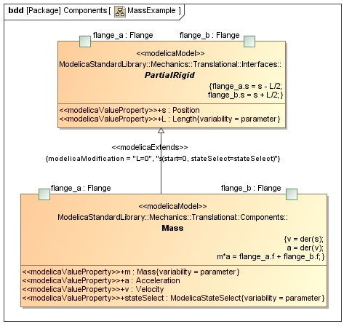
- : SysML4Modelica model for translational mass
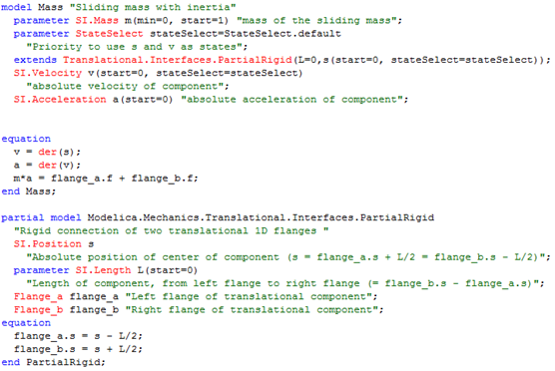
The corresponding Modelica models (with annotations omitted):
- : Modelica Model for a Mass from the Modelica Standard Library
Remarks:
- The name of each model (Mass and PartialRigid) appear as the Name attribute of the corresponding «modelicaModel»
- The parameters of each model (m and stateSelect) appear as «modelicaValueProperty» in «modelicaModel»
- The connectors flange_a and flange_b appear as ports stereotyped to «modelicaPort»
- The equation sections are each mapped to a «modelicaEquation», which are shown as any other constraint in the concrete graphical syntax

«modelicaRecord»

Generalizations
- «modelicaClass» (from SysML4Modelica)
- «block» (from SysML)
Abstract Syntax
- See Figure 1.
Description
The Modelica specialized class record is restricted to contain only public declarations of components that in turn also contain only public declarations. A complete description of record is available in Section 4.6 of the Modelica Specification:
Only public sections are allowed in the definition or in any of its components (i.e., equation, algorithm, initial equation, initial algorithm and protected sections are not allowed). May not be used in connections. The elements of a record may not have prefixes input, output, inner, outer, or flow. Enhanced with implicitly available record constructor function. Additionally, record components can be used as component references in expressions and in the left hand side of assignments, subject to normal type compatibility rules.

Attributes
No additional attributes.

Associations
No additional associations.

Constraints
- An instance of a «modelicaRecord» must have a Name.
- An instance of a «modelicaRecord» can only have Properties that are stereotyped to «modelicaValueProperty».
- Any «modelicaValueProperty» owned by an instance of «modelicaRecord» must have visibility=public, flowFlag=non-flow, causality=null, scope=null.
- An instance of a «modelicaRecord» can only specialize other classifiers derived from «modelicaRecord». The stereotype «modelicaExtends» must be applied to the generalization relationship.
- All other attributes or associations inherited from «block» or Classifier may not be used. This includes the attributes: isActive, isEncapsulated; and the ownedElements: Behavior, Constraint.

Example
[To be added]

«modelicaBlock»

Generalizations
- «modelicaClassDefinition» (from SysML4Modelica)
- «block» (from SysML)

Abstract Syntax
- See Figure 1.

Description
The Modelica specialized class block is very similar to a model except that all its connectors must be either an input or output making it similar to a Simulink block. A complete description of block is available in Section 4.6 of the Modelica Specification:
Same as model with the restriction that each connector component of a block must have prefixes input and/or output for all connector variables. [The purpose is to model input/output blocks of block diagrams. Due to the restrictions on input and output prefixes, connections between blocks are only possible according to block diagram semantic]

Attributes
No additional attributes.

Associations
No additional associations.

Constraints
- An instance of a «modelicaBlock» must have a Name.
- An instance of a «modelicaBlock» can only have Properties that are stereotyped to «modelicaPart», «modelicaPort», or «modelicaValueProperty».
- Any «modelicaValueProperty» owned by an instance of «modelicaBlock» must have causality=input or output.
- An instance of a «modelicaBlock» can only contain Behaviors that are stereotyped to «modelicaFunction», «modelicaAlgorithm», or «modelicaInitialAlgorithm».
- An instance of a «modelicaBlock» can only contain Constraints that are stereotyped to «modelicaEquation» or «modelicaInitialEquation».
- An instance of a «modelicaBlock» can only specialize other classifiers derived from «modelicaBlock» or «modelicaRecord». The stereotype «modelicaExtends» must be applied to the generalization relationship.
- All other attributes or associations inherited from «block» or Classifier may not be used. This includes the attributes: isActive, isEncapsulated.

Example
[To be added]

«modelicaConnector»

Generalizations
- «modelicaClass» (from SysML4Modelica)
- «block» (from SysML)
Abstract Syntax
- See Figure 1.
Description
The Modelica specialized class connector is a model that cannot contain equations or algorithms in any of its components. A complete description of block is available in Section 4.6 and Chapter 9 of the Modelica Specification:
No equations or algorithms are allowed in the definition or in any of its components. Enhanced to allow connect(..) to components of connector classes.

Attributes
- isExpandable : Boolean
As explained in Modelica Specification 9.1.3, the Modelica expandable prefix can be applied to a connector. The primary purpose of expandable connectors is to allow for the convenient modeling of bus interfaces. The default value is false.

Associations
No additional associations.

Constraints
- An instance of a «modelicaConnector» must have a Name.
- An instance of a «modelicaConnector» can only have Properties that are stereotyped to «modelicaPart», «modelicaPort», or «modelicaValueProperty».
- None of the Properties owned by an instance of «modelicaConnector» can contain Behaviors or Constraints (at any level of containment).
- An instance of a «modelicaConnector» can only specialize other classifiers derived from «modelicaConnector», «modelicaType», or «modelicaRecord». The stereotype «modelicaExtends» must be applied to the generalization relationship.
- All other attributes or associations inherited from «block» or Classifier may not be used. This includes the attributes: isActive, isEncapsulated; and the ownedElements: Behavior, Constraint.

Example
[To be added]

«modelicaType»

Extensions
- Enumeration (from UML4SysML)

Generalizations
- «modelicaClassDefinition» (from SysML4Modelica)
- «modelicaValueType» (from SysML4Modelica)
- «block» (from SysML)

Abstract Syntax
- See Figure 1.

Description
The Modelica specialized class type is restricted to predefined types, enumerations, arrays of type or classes extending from type. It is enhanced to allow extension of predefined types. In the SysML4Modelica profile, the extension from predefined types is handled by making the predefined types instances of «modelicaType» (See Chapter 6).
The only additional distinct type for which a corresponding representation needs to be defined in SysML4Modelica is an enumeration. Enumerations are handled separately through the stereotype «modelicaEnumeration»

Attributes
No additional attributes.

Associations
No additional associations.
Constraints
- An instance of a «modelicaType» must have a Name.
- An instance of a «modelicaType» can only specialize other classifiers derived from «modelicaType». The stereotype «modelicaExtends» must be applied to the generalization relationship.
- All other attributes or associations inherited from «block» or Classifier may not be used. This includes the attributes: isActive, isEncapsulated; and the ownedElements: Property (including part, port and value properties), Behavior, Constraint.

Example
[To be added]

«modelicaPackage»

Generalizations
- «modelicaClass» (from SysML4Modelica)
- «block» (from SysML)

Abstract Syntax
- See Figure 1.

Description
May only contain declarations of classes and constants. Enhanced to allow import of elements of packages. (See also Chapter 13 on packages.)

Attributes
No additional attributes.
Associations
No additional associations.

Constraints
- An instance of a «modelicaPackage» must have a Name.
- An instance of a «modelicaPackage» can only have Properties that are stereotyped to «modelicaValueProperty».
- Any «modelicaValueProperty» owned by an instance of «modelicaPackage» must have variability=constant. (ref. Modelica Specification 4.6, package)
- An instance of a «modelicaPackage» can only specialize other classifiers derived from «modelicaPackage». The stereotype «modelicaExtends» must be applied to the generalization relationship.
- All other attributes or associations inherited from «block» or Classifier may not be used. This includes the attributes: isActive, isEncapsulated; and the ownedElements: Behavior, Constraint.

Example
[To be added]

«modelicaFunction»

Extensions
- FunctionBehavior (from UML4SysML)

Generalizations
- «modelicaClass» (from SysML4Modelica)

Abstract Syntax
- See Figure 1.

Description
The Modelica specialized class function represents a callable section of procedural algorithmic code. It is similar to a SysML FunctionBehavior. Compared to a general Modelica class, quite a few restrictions and enhancements apply; refer to the Modelica Specification sections 12.2 for details. Instead of including the procedural algorithmic code in an algorithm section, a Modelica function may refer to an external function specifier (e.g., an external C or Fortran function).
At this point, SysML4Modelica only allows for function definitions; functions cannot be “called” explicitly – they can only be referred to in concrete Modelica syntax portions of the model.

Attributes
- isExternal: Boolean [1]
Default value is false.

- externalLanguage: String [0..1]
The language in which the external function specifier is defined. It should only be defined when isExternal = true. Default value is “C”.

- externalFunctionSpecification: String [0..1]
The complete specification of the externally defined function (see Modelica Specification 12.8 for details). If is not defined, then the name of the «modelicaFunction» is used. It should only be defined when isExternal = true. Default value is null.

- externalAnnotation: String [0..1]
String containing a Modelica annotation associated with the external function call. It should only be defined when isExternal = true. Default value is null.

Associations
No additional associations.

Constraints
- An instance of a «modelicaFunction» must have a Name.
- An instance of a «modelicaFunction» can only have Parameters that are stereotyped to «modelicaFunctionParameter».
- Any «modelicaFunctionParameter» (owned by an instance of «modelicaPackage») for which causality=input may not be assigned values in the body of the function (i.e., it is read-only).
- An instance of a «modelicaFunction» can only have zero or one body attribute.
- If isExternal=false then externalLanguage, externalFunctionSpecification, and externalAnnotation must not be defined.
- If isExternal=true then body and language must not be defined.
- An instance of a «modelicaFunction» must have language=“Modelica” if the body attribute is defined.
- The body of the function must be represented in the Modelica syntax and must constitute a valid Modelica algorithm section.
- An instance of a «modelicaFunction» can only specialize other classifiers derived from «modelicaFunction». The stereotype «modelicaExtends» must be applied to the generalization relationship.
- All other attributes or associations inherited from FunctionBehavior or Classifier may not be used.

Example

function functionname
input TypeI1 in1;
input TypeI2 in2;
input TypeI3 in3 := default_expr1 "Comment" annotation(...);
...
output TypeO1 out1;
output TypeO2 out2 := default_expr2;
...
protected
<local variables>
...
algorithm
...
<statements>
...
end functionname;

A more specific example illustrating the different types of variables:
function testFunction
parameter Real x = 5;
constant Real y=1;
input Real z;
output Real k;
// Real invalid; --> if public, must be input or output
protected
Real valid = z*x; // this is ok, because it is protected
algorithm
k := valid + y;
end testFunction;

Discussion and Comments:
Must accommodate short definitions specifically with “der”

«modelicaExtends»

Extensions
- Generalization (from UML4SysML)

Abstract Syntax
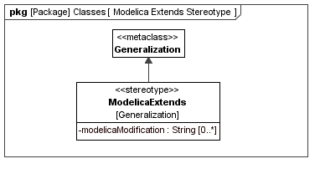
- : «modelicaExtends» stereotype definition

Description
The extends clause of Modelica is equivalent to a SysML Generalization. The only difference is that in Modelica the type being extended can be locally modified (Modelica Specification 7.1):
extends_clause :
extends name [ class_modification ] [annotation]

constraining_clause :
extends name [ class_modification ]
Similar local type modifications can be used when defining usages (i.e., Modelica components – see Chapter 7). In both cases the SysML4Modelica mapping currently captures the local modifications only as a text string in Modelica syntax. A separate modification can be defined for every component of a «modelicaClass»; in Modelica these modifications are grouped separated by commas in parentheses. Each such modification is represented in SysML4Modelica as a separate string. It corresponds thus to an argument as defined in the following extract of the Modelica EBNF (Modelica Specification 3.1, section 7.2):
class_modification :
"(" [ argument_list ] ")"
argument_list :
argument { "," argument }
argument :
element_modification_or_replaceable
| element_redeclaration
element_modification_or_replaceable:
[ each ] [ final ] ( element_modification | element_replaceable)
element_modification :
component_reference [ modification ] string_comment
element_redeclaration :
redeclare [ each ] [ final ]
( ( class_definition | component_clause1) | element_replaceable )
element_replaceable:
replaceable ( class_definition | component_clause1)
[constraining_clause]
component_clause1 :
type_prefix type_specifier component_declaration1
component_declaration1 :
declaration comment
Muliple inheritance is supported in Modelica. Therefore, more than one «modelicaExtends» relationship is allowed for a single «modelicaClass». The extends clause can be applied to any of the restricted classes (including packages).
If the extends clause appears in a protected section of the Modelica model, then all the elements of the base class become protected elements of the specialized class. It is therefore important to specify whether the «modelicaExtends» relation is public or protected.

Attributes
- modelicaModification: String [0..*]
An inherited Modelica class can be locally modified. The modifications are defined by this attribute in Modelica syntax. Each modification (as specified in the Modelica concrete syntax as a comma-separated expression) is specified as a separate instance of this attribute. Default value is null.

Associations
No additional associations.

Constraints
- Both the source and target of a «modelicaExtends» relation must be typed to instances of «modelicaClass».
- The visibility attribute of «modelicaExtends» can only take on values of public or protected.

Example
[To be added]

Short Class Definitions
Modelica provides a short-hand notation for definition of classes. It is equivalent to an inheritance construct, and is therefore redundant and not supported separately in the SysML4Modelica profile.

Predefined Types

Overview
The following predefined types are available in the Modelica language: Real Type, Integer Type, Boolean Type, String Type, Enumeration Types, StateSelect, ExternalObject, and Graphical Annotation Type (Modelica 3.1, section 4.8). These primitive types are defined as predefined types in SysML4Modelica::Types::ModelicaPrimitiveTypes. Although these types have direct counterparts in SysML, they are redefined to account for the additional attributes associated with them in Modelica. Note that in Modelica, the properties such as “start”, “quantity”, etc., are not really equivalent to user-defined complex data-types. For instance, if one defines “Real x;” then one cannot refer to “x.min” in an equation. The only way one can specify a value for these special properties is as part of a type definition or local modification: e.g., “Real x(start=1, unit=”m”);
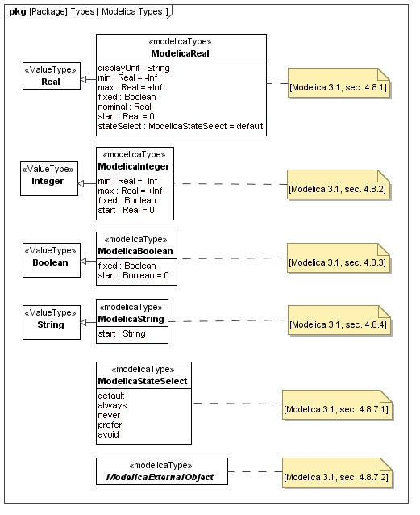
- : Package diagram with an overview of the stereotypes for Modelica Classes

ModelicaReal

Instantiation
- SysML4Modelica::ModelicaType

Generalizations
- SysML::Blocks::Real

Abstract Syntax
- See Figure 5.

Description
The predefined type Real in Modelica includes a variety of attributes besides its actual value (Modelica 3.1, section 4.8.1). In SysML4Modelica, these attributes are defined in ModelicaReal, a specialization of the primitive type SysML::Blocks::Real. As a result of this specialization, ModelicaReal, inherits the attributes: quantityKind and unit, which correspond to the Modelica attributes quantity and unit, respectively. Additional attributes are listed below.

Attributes
- displayUnit: String [0..1]
In addition to the actual units, a ModelicaReal can have a units used for display in a tool's graphical user interface or in plots. These units are defined in this attribute as a string. Default value is null.
- min: Real [1]
The minimum value the ModelicaReal variable can take on. Default value is -Inf.
- max: Real [1]
The maximum value the ModelicaReal variable can take on. Default value is +Inf.
- start: Real [1]
The value of the ModelicaReal variable at the beginning of a simulation. The meaning of this variable depends on the value of the attribute fixed. If fixed=false, then it is to be interpreted as an initial guess from which may be deviated in order to satisfy all the algebraic constraints. If fixed=true, then the variable is required to equal its start value. Default value is 0.
- fixed: Boolean [1]
This attribute qualifies the meaning of the attribute start. If fixed=false, then start is to be interpreted as an initial guess from which may be deviated in order to satisfy all the algebraic constraints. If fixed=true, then the variable is required to equal its start value. Default value is true for parameters and constants, and false for all other variables.
- nominal: Real [0..1]
The value of this attribute may be used by the solver for scaling purposes. Default value is null.
- stateSelect: StateSelect [1]
The value of this attribute determines how a Modelica solver should select state variables for the system of Differential Algebraic Equations (Modelica Spec 3.1, section 4.8.7.1). Default value is StateSelect.default.

Associations
No additional associations.

Constraints
No additional associations.

ModelicaInteger

Instantiation
- SysML4Modelica::ModelicaType

Generalizations
- SysML::Blocks::Integer

Abstract Syntax
- See Figure 5.

Description
The predefined type Integer in Modelica includes a variety of attributes besides its actual value (Modelica 3.1, section 4.8.2). In SysML4Modelica, these attributes are defined in ModelicaInteger, a specialization of the primitive type SysML::Blocks::Integer. As a result of this specialization, ModelicaInteger, inherits the attribute: quantityKind, which correspond to the Modelica attribute quantity. Additional attributes are listed below.

Attributes
- min: Integer [1]
The minimum value the ModelicaInteger variable can take on. Default value is -Inf.
- max: Integer [1]
The maximum value the ModelicaInteger variable can take on. Default value is +Inf.
- start: Integer [1]
The value of the ModelicaInteger variable at the beginning of a simulation. The meaning of this variable depends on the value of the attribute fixed. If fixed=false, then it is to be interpreted as an initial guess from which may be deviated in order to satisfy all the algebraic constraints. If fixed=true, then the variable is required to equal its start value. Default value is 0.
- fixed: Boolean [1]
This attribute qualifies the meaning of the attribute start. If fixed=false, then start is to be interpreted as an initial guess from which may be deviated in order to satisfy all the algebraic constraints. If fixed=true, then the variable is required to equal its start value. Default value is true for parameters and constants, and false for all other variables.

Associations
No additional associations.

Constraints
No additional associations.

ModelicaBoolean

Instantiation
- SysML4Modelica::ModelicaType

Generalizations
- SysML::Blocks::Boolean

Abstract Syntax
- See Figure 5.

Description
The predefined type Boolean in Modelica includes a variety of attributes besides its actual value (Modelica 3.1, section 4.8.3). In SysML4Modelica, these attributes are defined in ModelicaBoolean, a specialization of the primitive type SysML::Blocks::Boolean. As a result of this specialization, ModelicaBoolean, inherits the attribute, quantityKind, which correspond to the Modelica attribute quantity. Additional attributes are listed below.

Attributes
- start: Real [1]
The value of the ModelicaReal variable at the beginning of a simulation. The meaning of this variable depends on the value of the attribute fixed. If fixed=false, then it is to be interpreted as an initial guess from which may be deviated in order to satisfy all the algebraic constraints. If fixed=true, then the variable is required to equal its start value. Default value is 0.
- fixed: Boolean [1]
This attribute qualifies the meaning of the attribute start. If fixed=false, then start is to be interpreted as an initial guess from which may be deviated in order to satisfy all the algebraic constraints. If fixed=true, then the variable is required to equal its start value. Default value is true for parameters and constants, and false for all other variables.

Associations
No additional associations.

Constraints
No additional associations.

ModelicaString

Instantiation
- SysML4Modelica::ModelicaType

Generalizations
- SysML::Blocks::String

Abstract Syntax
- See Figure 5.

Description
The predefined type String in Modelica includes a variety of attributes besides its actual value (Modelica 3.1, section 4.8.4). In SysML4Modelica, these attributes are defined in ModelicaString, a specialization of the primitive type SysML::Blocks::String. As a result of this specialization, ModelicaString inherits the attribute, quantityKind, which correspond to the Modelica attributes quantity. Additional attributes are listed below.

Attributes
- start: Real [1]
The value of the ModelicaReal variable at the beginning of a simulation. The meaning of this variable depends on the value of the attribute fixed. If fixed=false, then it is to be interpreted as an initial guess from which may be deviated in order to satisfy all the algebraic constraints. If fixed=true, then the variable is required to equal its start value. Default value is 0.

Associations
No additional associations.

Constraints
No additional associations.

ModelicaStateSelect

Instantiation
- SysML4Modelica::ModelicaType

Generalizations
No generalizations.

Abstract Syntax
- See Figure 5.

Description
The predefined type ModelicaStateSelect is the type of the attribute stateSelect of ModelicaReal. It is an enumeration used to provide guidance to the Modelica solver tool for selecting appropriate state variables (See Modelica Spec 3.1, section 4.8.7.1).

Associations
No additional associations.

Constraints
No additional associations.

ModelicaExternalObject

Instantiation
- SysML4Modelica::ModelicaType

Generalizations
No generalizations.

Abstract Syntax
- See Figure 5.

Description
The predefined type ModelicaExternalObject is an abstract type used to indicate that a ModelicaType that specializes it refers to an object defined in an external language such as C or Fortran (See Modelica Spec 3.1, section 12.9.7 for details).

Associations
No additional associations.

Constraints
- The value of the attribute isAbstract (and hence isPartial) must be true.

Component Declarations

Overview
In the Modelica language, instances (or usages) of a class are referred to as “components”. In SysML these can be mapped to Block Properties, such as Value Property, Part Property, or Port. Note that Modelica does not have the equivalent of a reference property — properties are never shared (SysML Spec. 1.1, pg. 34). Modelica does also not distinguish explicitly between Value Properties, Parts, or Ports. Whether a component should be interpreted as a Value Property, Part or Port depends on the restricted type the usage has been typed to. If the usage is of restricted type class, model, or block then it is mapped to a «modelicaPart»; if it is of restricted type connector then it is mapped to a «modelicaPort»; and if it is of restricted type record or type then it is mapped to «modelicaValueProperty». In addition, the stereotype «modelicaFunctionParameter» is introduced to represent components of restricted type record or type that are used in a function (this is necessary because a Modelica function is mapped to a SysML FunctionBehavior which has parameters rather than properties). The restricted types package and function are not considered here because they cannot be instantiated.
Depending on the restricted type, a Modelica component declaration allows for a variety of modifications or additional specifications. This additional information is captured as attributes of the corresponding SysML4Modelica stereotypes, as show in Figure 6. The following production rules define Modelica components declarations:

component_clause:
type_prefix type_specifier [ array_subscripts ] component_list

type_prefix :
[ flow ]
[ discrete | parameter | constant ] [ input | output ]

type_specifier :
name

component_list :
component_declaration { "," component_declaration }

component_declaration :
declaration [ conditional_attribute ] comment

conditional_attribute:
if expression

declaration :
IDENT [ array_subscripts ] [ modification ]

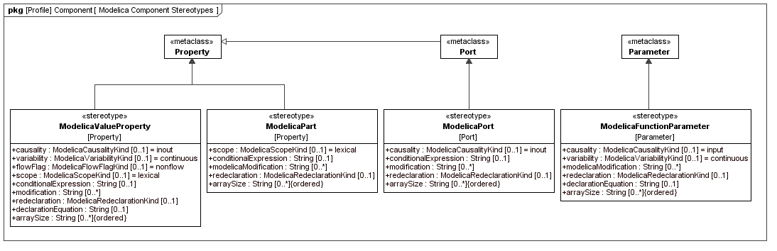
- : Package diagram with an overview of the stereotypes for Modelica Components

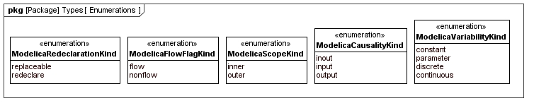
- : Package diagram with enumerations used in Modelica Component definitions

- : The applicable attributes for Modelica Components.
Attribute Name | «modelicaValueProperty» | «modelicaPart» | «modelicaPort»
visibility | • | •
causality | • |  | •
variability | •
flowFlag | •
scope | • | •
conditionalExpression | • | • | •
IsFinal | • | • | •
modification | • | • | •
redeclaration | • | • | •
declarationEquation | •
arraySize | • | • | •

«modelicaValueProperty»

Extensions
- Property (from UML4SysML)
Abstract Syntax
- See Figure 6.

Description
The Modelica specialized class model is the most general specialized class. All the Modelica class elements are allowed in models: variables, connectors, sub-models, equations and algorithm sections. A model can include state variables.

Attributes
- visibility: VisibilityKind [1]
This attribute is inherited from the meta-class Property. In the context of the SysML4Modelica profile, it is limited to the values public or protected. Default value is public.

- causality: ModelicaCausalityKind [0..1]
Default value is

- variability: ModelicaVariabilityKind [0..1]
Default value is null.

- flowFlag: ModelicaFlowFlagKind [0..1]
This attribute can only be applied to variables that are a subtype of ModelicaReal. It can only be used inside «modelicaConnector» or to define a Type. Input/output cannot be combined with flow. Default value is null.

- scope: ModelicaScopeKind [0..1]
Default value is null.

- conditionalExpression: String [0..1]

- isFinal: Boolean

- modification: String [0..*]

- redeclaration: ModelicaRedeclarationKind [0..1]

- arraySize: String [0..*] {ordered}
This attribute is an ordered list of strings, each of which must be a Modelica expressions that evaluates to an integer. The i^{th} element in the ordered list corresponds to size of the the multi-dimensional array in the i^{th} dimension. The default value is null.

- declarationEquation: String [0..1]
The result must be of the same type as the «modelicaPart» itself. Declaration Equation refers to the shorthand notation in Modelica. In this case the value of the tag is the right-hand-expression of the equations. The “=” sign is omitted, i.e., it is implicit. Default value is null.

Associations
No additional associations.

Constraints

Example

«modelicaPart»

Generalizations
- «modelicaComponent»

Abstract Syntax

Description
The Modelica specialized class model is the most general specialized class. All the Modelica class elements are allowed in models: variables, connectors, sub-models, equations and algorithm sections. A model can include state variables.

Attributes

Associations

Constraints

Example

Additional Notes
The following table lists all associated tags of the «modelicaPart» stereotype. Multiplicity [1] indicates a mandatory value and [0..1] indicates optional values. Empty “Initial Value” field implies an empty string (null).

SysML4Modelica Stereotype «modelicaPart»
Tag Name | Tag Value Type | Multiplicity, Default Value | Comment
Visibility | ModelicaVisibility = enumeration(public, protected) | [1], public | The default value can be omitted in Modelica. Although SysML does not explicitly define visibility, most implementation do have a visibility tag for properties because they are built on top of UML.
scope | ModelicaScope = enumeration(inner, outer) | [0..1], null | “lexical” is not a keyword in Modelica; “lexical” is the default when neither “inner” nor “outer” are specified. Note that the resolution of the scope is performed by the Modelica compiler in the instance hierarchy

«modelicaPort»
Generalizations
- «modelicaComponent»

Abstract Syntax

Description
The Modelica specialized class model is the most general specialized class. All the Modelica class elements are allowed in models: variables, connectors, sub-models, equations and algorithm sections. A model can include state variables.

Attributes
SysML4Modelica Stereotype «modelicaPort»
Tag Name | Tag Value Type | Multiplicity, Default Value | Comment
Causality | ModelicaCausality = enumeration(input, output) | [0..1], null | “none” is not a keyword in Modelica; “none” is the default when neither “input” nor “output” are specified.  Can only be applied to primitive types, records, or arrays; not to models, blocks, functions.

Associations

Constraints

Example

Additional Notes

«modelicaFunctionParameter»
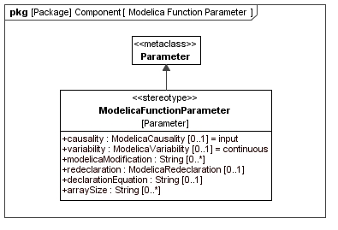
- : Definition of the «modelicaFunctionParameter» stereotype

Equation and Algorithm Sections

Overview
Equations and Algorithm are the main Modelica constructs for defining behavior of Modelica classes (Modelica Spec
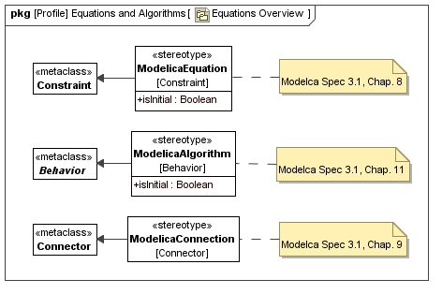
- : Package diagram with Equation and Algorithm definitions
Each of the stereotypes includes the tag “specification” which contains the actual equation or algorithm section. The equation itself is captured in the Constraint Specification field.

«modelicaEquation»

Generalizations
- Constraint (from UML4SysML)

Abstract Syntax

Description

Attributes
No additional attributes

Associations
No additional associations

Constraints

Example

Additional Notes

«modelicaAlgorithm»

Generalizations
- Behavior (from UML4SysML)

Abstract Syntax

Description

Attributes

Attributes
No additional attributes
Associations

No additional associations

Example

Additional Notes

«modelicaConnection»

Generalizations
- Connector (from UML4SysML)

Abstract Syntax

Description
The Modelica specialized class model is the most general specialized class. All the Modelica class elements are allowed in models: variables, connectors, sub-models, equations and algorithm sections. A model can include state variables.

Attributes

Associations

Constraints

Example

Additional Notes

In Modelica the causality of the connector is defined in the type while the flow direction of a FlowPort is associated with a usage. Thus Modelica connector cannot be mapped to FlowPort.
Alternatives:
  - (preferred solution) discard the direction attribute of an atomic FlowPorts, and FlowPort to an instance of a Modelica Connector in a Modelica Model/Block.
  - Connector Modelica is conceptually an interaction point, same is a Port in UML -> Define a new SysML construct form UML Ports, call it ???

Based on alternative 1: «modelicaConnector» is a type for an atomic FlowPort. FlowPort name is the name of the instance of a connector in a «modelicaModel» or «modelicaBlock».
Modelica connection is mapped to SysML connector. No new stereotype provided the FlowPorts are typed by FlowSpecification having «modelicaConnector» applied to it.

UML4SysML:: Connector | Connection clause

Related non-Modelica Constructs

«modelicaSimulation»

Generalizations
- Block

Abstract Syntax

Description

Attributes

Associations

Constraints

Example

Additional Notes
«modelicaSimulation» (mapped to SysML Block) is not a Modelica language construct. However, it is introduced in order to distinguish between the model and its simulation. The following tags are associated with this stereotype:

SysML  Abstract Syntax Reference | SysML4Modelica
SysML  Abstract Syntax Reference | New Stereotypes | Constraints
SysML::Blocks::Block | «modelicaSimulation»

SysML4Modelica Stereotype «modelicaSimulation»
Tag Name | Tag Value Type | Default Value | Comment
startTime | Real | 0.0 | Simulation start time
stopTime | Real | 1.0 | Simulation stop time
Model | «modelicaModel», «modelicaBlock» |  | Reference to the model to be simulated

We need to come up with a way to get to the results…

