Date: October 2009

SysML-Modelica
Transformation Specification

Version Alpha 1

____________________________________________________
OMG Document Number: dtc or ptc/200x-xx-xx
Standard document URL: http://www.omg.org/spec/acronym/1.0/PDF
Associated File(s)*: http://www.omg.org/spec/acronym/200xxxxx
http://www.omg.org/spec/acronym/200xxxxx
_________________________________________________

Source document: Title (document number)
* Original file(s): Title (document number)

Part III ̶̵̶ Modelica Meta-Model
The rest of this document still needs to be filled in – this is just as an example for the styles that should be used.

Class Definition

Overview
Some test here.

A code example… stored_definition:
[ within [ name ] ";" ] (Error: Reference source not found)
{ [ final ] class_definition ";" } (Error: Reference source not found)

the details of each stereotype are described.

- : Mapping for the Modelica specialized classes.
Modelica Construct | SysML Base Class | SysML4Modelica
Modelica Construct | SysML Base Class | New Stereotype | Comments
Class | UML4SysML::Classifier | «modelicaClass» | See Section Error: Reference source not found
Model | SysML::Blocks::Block | «modelicaModel» | See Section Error: Reference source not found
Record | SysML::Blocks::ValueType | «modelicaRecord» | See Section Error: Reference source not found
Block | SysML::Blocks::Block | «modelicaBlock» | See Section Error: Reference source not found
Connector | SysML::Blocks::ValueType | «modelicaConnector» | See Section Error: Reference source not found
Type | SysML::Blocks::ValueType | «modelicaType» | See Section Error: Reference source not found
Package | SysML::Blocks::Block | «modelicaPackage» | See Section Error: Reference source not found
Function | UML4SysML::Behavior | «modelicaFunction» | See Section Error: Reference source not found

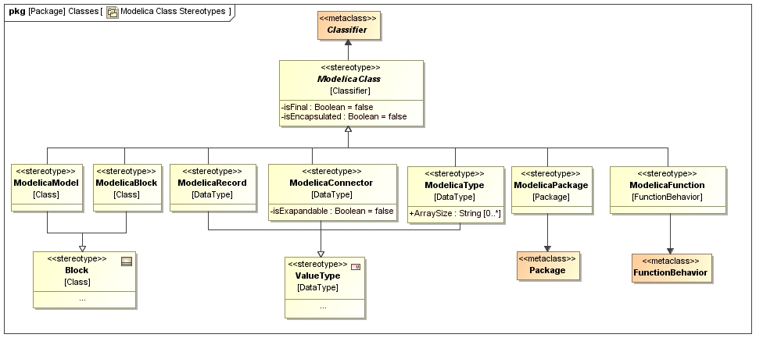
- : Package diagram with an overview of the stereotypes for Modelica classes

