Systems Modeling & Assessment Working Group Session Summary
Initial SysML v2 RFP Planning Meeting
December 09, 2014 reva

The following is a summary from the System Modeling and Assessment WG session held at the OMG meeting in Long Beach on December 09, 2014. The goal of the meeting was to discuss initial plans and driving requirements for a potential SysML v2 RFP. We received substantial inputs from this session to help formulate a plan forward. Please join the next WG telecon on January 6, 2014 at 10:00 AM ET to review the summary and next steps. The agenda, attendees, summary, and next steps are included below.

Note: Refer to System Modeling Assessment and Roadmap WG Site for this summary and related WG information.

Attendees:
Shaukat Ali  JD Baker  Yves Bernard  Roger Burkhart (remote)  Michael Chonoles  Arnaud Cuccuru  Chris Delp  Sanford Friedenthal  Laura Hart  Nerijus Jankevicius  Robert Karban | Uwe Kaufmann  Eldad Palachi  Russell Peak  Michael Pfenning  Nicolas Rouquette  Chris Schreiber  Rick Steiner  John Watson  Bernd Wenzel  Tao Yue
Agenda:
- Introduction
- Review of UML for SE RFP process
- Review of System Modeling Assessment & Roadmap WG results
- Open Discussion to address RFP questions regarding driving requirements and plan forward

Next Steps:
- Develop approach and begin to define the MBSE Use Cases – John Watson
- Capture Systems Engineering Conceptual Model (draft 12) in a modeling tool, including the semantic dictionary (this was a primary input to the requirements for the original UML for SE RFP) – Rick Steiner
- Develop approach, plan, and begin to develop a conceptual model for SysML v1.4 and SysML v2 – Robert Karban
- Review and elaborate the Systems Modeling Language driving requirements and conceptual approaches (refer to below)
- Develop a starting approach to manage the model-based artifacts for this effort – John Watson
- Continue to address and refine the responses to the RFP questions below (refer to initial responses at bottom of this document)

RFP Questions:
1. What are the goals/vision for SysML v2?
2. What is the scope of this RFP?
3. What are some of the key pain points that should be addressed by the RFP?
4. What are the evaluation criteria for the language?
5. What is the scope for the conceptual data model?
7. What are some of missing concepts the language should address?
8. How do the SME capabilities impact the requirements in this RFP?
9. How constrained should we be by the current UML infrastructure?
10. What sample model(s) should we develop as a basis for specifying the requirements and demonstrating the solutions?
11. How can we leverage the MBSE use cases to help drive out the requirements?
12. Should we include test cases in the RFP to verify the requirements are satisfied?
13. What tools/infrastructure should we use for developing the RFP?
14. How should we organize to prepare the RFP?
15. What are the critical skills needed to support this RFP?
16. What is the expected timeframe and major milestones for this RFP?
17. Do we need to issue an RFI? If so, how should it compare to the previous SysML v2 RFI?
18. What are related activities we could potentially leverage or integrate with?
Sanford Friedenthal
SE DSIG Chair
Summary:
This working session was held as a follow-up to an action from the System Modeling Assessment & Roadmap Working Group, co-chaired by Eldad Palachi and Sandy Friedenthal. The session is in response to a request from Yves Bernard, co-chair of the SysML RTF. This WG was established in March 2014 to assess how SysML is supporting MBSE, and to develop a roadmap.

Sandy introduced the session with a review of the original UML for Systems Engineering RFP process, artifacts, and timeline. The information can be found at the bottom of the OMG SE DSIG site. He reviewed some examples of the original requirements, and then highlighted the Systems Engineering Conceptual Model, which was a primary input to the requirements for the UML for SE RFP. All agreed that the conceptual model is an important input to be considered for a future RFP, since it provides systems engineering domain concepts and terminology that the modeling language should support. Rick agreed to capture the model and semantic dictionary (currently in PPT/Excel) in a modeling tool.

Sandy briefly reviewed the MBSE portion of the INCOSE SE Vision 2025 to emphasize a major message regarding the future state of MBSE. In particular, MBSE is put in the context of Virtual Engineering and the Digital Revolution. The opening summary on the future state of MBSE (pg 38) is:

“Formal systems modeling is standard practice for specifying, analyzing, designing, and verifying systems,
and is fully integrated with other engineering models. System models are adapted to the application domain,
and include a broad spectrum of models for representing all aspects of systems. The use of internet driven
knowledge representation and immersive technologies enable highly efficient and shared human
understanding of systems in a virtual environment that span the full life cycle from concept through
development, manufacturing, operations, and support.”

We reviewed results to date from the System Modeling Assessment and Roadmap WG. The WG overview and status presentation from the Austin OMG meeting in September 2014 can be found on the WG site. The WG progress includes:
- Identification of key inputs to system modeling assessment (e.g., traceability gaps from original RFP, SysML v2 RFI issued in 2009, RTF priorities, Adoption issues, and other SE DSIG inputs from several previous discussions)
- A preliminary conceptual framework that includes the scope, key capabilities, effectiveness measures, and conceptual architecture for a System Modeling Environment (SME)
- A high level set of roadmap activities to evolve the MBSE use cases, conceptual data model, and key capabilities to help specify the next generation System Modeling Environment

The following artifacts from the overview presentation are included below for reference:

- SE DSIG Input to Assessment of SysML
Source: System Modeling Direction & Needs from December 2011 and refined December 2012
- Rich diagrammatic syntax with standard symbol libraries for domain specific applications (e.g. Visio libraries)
- Extensive viewing capability to query the model and present the results. (e.g., similar to building architecture layers)
- Extensive modeling checking and analysis capability to reason about the system model and confirm its integrity
- Extensive reuse libraries
- Cross domain model integration through transformation technology and interchange standards
- Scalable model management part of PLM to include configuration control , change management & workflow
- Built in modeling metrics to effectively estimate productivity, quality, and risk

- Primary Stakeholders (users of the language)
- Model builders (systems modelers, etc.)
- Model interpreters (multi-disciplinary members of development team)
- Individuals who adapt/customize environment
- Tool developers

- Effectiveness Measures (reflect value to stakeholders and success criteria)
Expressive
- Coverage of system concepts
Adaptable/Customizable
- Extensible to other domain concepts and terminology
- User interface flexibility
Precise
- Unambiguous
- Concise/Minimal/Parsimony
Model construction
- Efficient and intuitive model construction (create, update)
Presentation/communication
- Ability to effectively communicate with diverse stakeholders
Interoperable
- Data exchange and transformation with other models and structured data
Manageable
- Can be efficiently managed (e.g., change mgmt/version mgmt/config mgmt)
Usable (applies to all aspects of user experience)
- Efficient, Intuitive, engaging
  - Efficient and intuitive model construction (create, update)
  - Effectively communicates with diverse stakeholders
  - …

Note: Each measure above, such as ‘Expressive’, reflects a stakeholder concern, such as ability for a systems engineer to express something about the system. These should drive the requirements, such as the ability for the language to coverage level of the domain concepts. In this particular example, we may use the concepts in the original systems engineering conceptual model used to drive the UML for SE Requirements as a measure/indicator of the coverage level.
- System Modeling Environment Capabilities
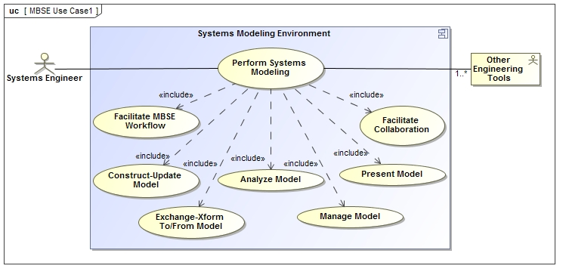

- System Modeling Environment Context/Information Exchange
Source: A Practical Guide to SysML, 3rd Edition (Figure 18.5)
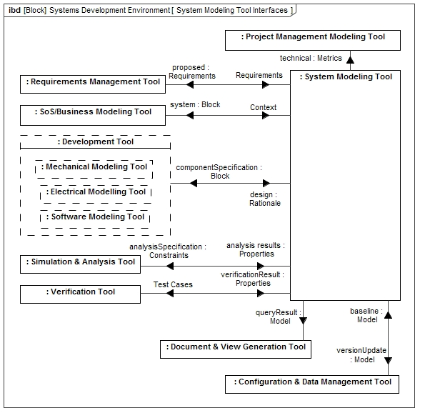

- System Modeling Environment Conceptual Architecture
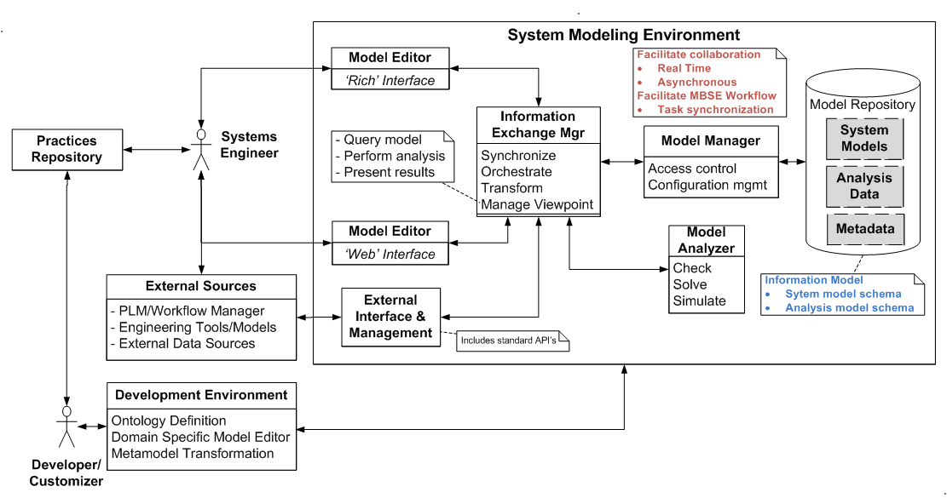

The following is a summary from the discussion.
System Modeling Language Driving Requirements
Provide a robust and adaptable system modeling language that supports multi-disciplinary systems engineering throughout the system lifecycle to specify, design, analyze, verify, and validate systems by providing the following:
- Data model that expresses the core domain concepts needed to model systems
- A logical formalism to provide unambiguous and concise expression
- Basic capability to solve and evaluate
- Mechanisms that enable modeling flexibility to defer commitment to a modeling approach and maintain continuity from conceptual modeling to specification and detailed design modeling (e.g., relax constraints to support early ‘sketch’ and then add constraints as design matures)
- Diagram definition with a default symbol set and capability to specify domain specific symbology
- View and viewpoint mechanisms that enable flexible presentation and reporting capability and flexible model input
- Dynamic zoom (semantic zoom), pan, filter, traversal, and analysis of complex graph
- Textual representation
- Flexible input (rules/pattern based, tabular, textual)
- Viewpoint method libraries
- Standard API with language bindings, file exchange, and web-based interchange formats to enable data access & exchange
- Defined metadata to support model management across the system lifecycle (e.g. versioning, change control, variant modeling, …), and ability to maintain change histories to record and access trace of incremental model changes (supports differencing models, etc.)
- Mechanisms that enable adaptation to domain specific applications:
- capability to express domain concepts and terminology including patterns and libraries
- extension mechanisms that support flexible model construction and presentation
- mechanisms that support data integration with other models, data sources, and tools, mechanisms to easily create and promulgate domain specific model patterns and libraries including QUDV, electrical, mechanical, sw interfaces, components, analysis, …
- Ability to migrate SysML models that were developed using SysML v1.x to SysML v2 with high confidence that minimum information is lost

Language Design Principles (TBD)
“Principles define the underlying general rules and guidelines for the design of the language” (refer to http://pubs.opengroup.org/architecture/togaf8-doc/arch/chap29.html

Plan Forward
The inputs from this working session provide a valuable starting point to help us to begin to formulate what is expected from a SysML v2 RFP. The initial driving requirements serve as a starting point for our future activities. Some key next steps include:
- Leverage the MBSE use cases to help refine the requirements for the modeling language
- Evolve a concept model for SysML that reflects the core domain concepts needed to model systems.
  - Capture the original Systems Engineering Conceptual Model that was used to drive the requirements for UML for SE RFP to serve as a minimum set of coverage requirements
  - Capture the conceptual model for SysML v1.4 to reflect the current concepts that are captured in the language
  - Capture a conceptual model for SysML v2 and associated model libraries to reflect the core concepts (e.g., block), and domain specific libraries (e.g., system, component) that drive requirements for the next generation language. This concept model serves as areference that other domain models can be mapped to, such as the Systems Engineering Conceptual Model used and the SysML v1.4 conceptual model referred to above
- Develop sample models that can serve as examples of the kind of models we expect to be able to produce, and continue to refine these models based on inputs from the other activities. These models can help to specify the requirements and test cases for the proposed solutions.
- Derive requirements, solution concepts, and prototypes that support the driving requirements such as visualization concepts
- Identify other relevant activities that can be leveraged and synergized with going forward (e.g., web standards)
- Develop a white paper that reflects the concept and requirements for the modeling language as part of a System Modeling Environment in support of MBSE

The following are other inputs in response to the RFP questions:

RFP Questions:
1. What are the goals/vision for SysML v2?
- Provide a general purpose system modeling language used by SE’s and other disciplines to support MBSE throughout the system lifecycle
  - Highly configurable/extensible to support diverse user/project/organization needs
- Embraced broadly across industries as an enabler of effective systems engineering
- Fundamental part of SE curriculum
2. What is the scope of this RFP?
- Modeling language (e.g., abstract syntax, concrete syntax, semantics)
- Model integration (e.g., standard API’s, file exchange)
- Model management (e.g. metadata to enable versioning, change mgmt)
- Model libraries (e.g., QUDV, interfaces, components, analysis, .)
- What are some of the key pain points that should be addressed by the RFP?
- Need for more precise semantics to avoid ambiguities
- Integration between structure and behavior
- Model maintenance and effective change management
- Continuous behavior
- Over complicated nested ports, parts and inconsistency with UML
- Support for variant modeling
- Lack of textual syntax
- Too many concepts in metamodel
- Too many ways to model the same thing
- Too limited in some areas and too flexible in others
- Lack of the general ability to evaluate the models
- Disproportionate dependency on UML tooling
- Lack of flexibility
- Support for web-based tools
- Inconsistency between specification and tool implementation
- Ability to differentiate prescriptive versus descriptive modeling (aka specification vs realization)
- Ability to integrate conflicting modeling needs (e.g. executable model requires you to model a specific way that precludes other uses of the model)
- Reuse of partial models including encapsulating file for exchange
- Ownership imposes constraints that limit reuse
- Need to assign intent to model elements
- Unattractive for mechanical engineers (want to see geometry), and other engineering disciplines
- Ability to represent property values over time
- Consistency between SysML and UPDM (but also, UTP, the upcoming security profile and others)
- Profile concept overlap - OMG needs to solve this universal problem of concepts that span across multiple profiles. As the Domain Specific Profiles become more prevalent we will see this problem become a serious issue. Today, domains define concepts almost independent of each other.

4. What are the evaluation criteria for the language?
- Refer to SME measures (e.g., expressive, extensible, precise, interoperable, manageable, usable)
- Granularity of modeling concept (e.g., brick vs. wall)
- Modeling flexibility and ability to defer commitment to a particular model element, while maintaining continuity from concept through detailed definition
- Automated construction
- Delete platform under interoperability (done)
- Add share/access along with information exchange to interoperable (done)
- Time to exchange
5. What is the scope for the conceptual data model ?
- behavior, structure, parametrics, requirements
7. What are some of missing concepts the language should address?
- fault/failure
- explicit time for both behavior response and lifetime of object
- event/milestone
- communication protocols
- directed relationship that is not a dependency
- collections (bag, list, set)
- basic logic library (and, or, xor, not) that can be applied to all relationships
- clearer distinction between specification and realization
- robust quantitative data representation (e.g. state variables, vectors, matrixes, time, probability)
- actual/measured data vs estimated data
- support for geometric/spatial view (e.g., mapping of parts to simple geometric/spatial representations)
- stub to project management concepts
- table, matrix, list, plot
8. How do the SME capabilities impact the requirements in this RFP (refer to driving req’ts above)?
- Model visualization/presentation
- Model construction
- Model analysis
  - Evaluability
  - Ability to plug in simulation
  - Refer to axioms such as those used in PSCS
  - Standard validation error codes/messages
- Model exchange
- Model management
  - Define metadata requirements (intent, maturity, version, config, ..)
  - Integrate with metadata management environment such as PDM/CM
  - Ability to create model fragments as reusable modules
  - Ability to create dependency maps
  - Ability to store and maintain links between external model elements
  - Leverage CAD/PLM concepts
- MBSE workflow
- MBSE collaboration
- How constrained should we be by the current UML infrastructure (MOF/UML metamodel, profiles)
- Consider not requiring a UML-based solution
- Vendors varied from it must be a UML profile to being open to a complete new tool
- Defer this question
10. What sample model(s) should we develop as a basis for specifying the requirements and demonstrating the solutions?
- Note: the sample models can be widely leveraged by vendors, educators, evaluation, etc.
- Use Hybrid SUV and use as a basis for comparison with current SysML
- Include Karban cruise control model and integrated with Hybrid SUV
- Include other simpler models as needed to demonstrate specific capabilities
- Integrate with other models to support SoS, hardware and software design, analysis, testing
- Integrate with UPDM
- How can we leverage the MBSE use cases to help drive out the requirements?
- Maintain close coordination between the activities to develop the modeling language requirements and the MBSE use cases.
- Update the sample models to support the use cases
- Should we include test cases in the RFP to verify the requirements are satisfied?
- Verify solution/specification conforms to the RFP (traceability, sample problem)
- Verify tool conforms to specification (refer to MIWG test cases, W3C, PSCS)
- What tools/infrastructure should we use for developing the RFP?
- Develop SysML model of RFP
  - Text requirements
  - Use cases/scenarios
  - Concept model
  - Sample model
  - Test cases
- Common format of artifacts
- Refer to UPDM approach for auto generating the specification
- Refer to Tool Infrastructure WG approach including Papyrus open source tool
- Use of OMG SVN, MBSE Wiki/Portal
- How should we organize to prepare the RFP?
- This was not addressed due to time limitations
- Key is to set up a collaborative process and CM environment
- What are the critical skills needed to support this RFP?
- This was not addressed due to time limitations
16. What is the expected timeframe and major milestones for this RFP?
- Consider multiple RFP’s
- Consider RFC for model libraries
- This was not addressed due to time limitations
- Do we need to issue an RFI? If so, how should it compare to the previous SysML v2 RFI?
- This was not addressed due to time limitations
- What are related activities we could potentially leverage or integrate with?
- UPDM – referred to by Laura
- Framework for usability (fueml) – referred to by Arnaud
- CAD/PLM concepts for model management – referred by Uwe K, Michael P
- This was not addressed due to time limitations

