OSLC4MBSE MoM 2013-07-22

- OMG/OSLC SE (MBSE) Work Group:
- Define scenario
- What concepts and services are specific to the SE (MBSE i.e. SysML)
- What concepts needs to be covered by other domains (i.e. other specifications)
- What concepts needs to be covered by the core as we believe all domains will benefit from their existence

- We may create a OSLC WG for SE (i.e. MBSE) or a User Group (define the challenges around SE from a user point of view).
- Positioning SE with others (i.e. STEP)
  - AP233, Action: Meeting with OSLC-AM and STEP/AP233 (Nigel) [Parham]
  - Relative to the SysML Concepts [Axel]

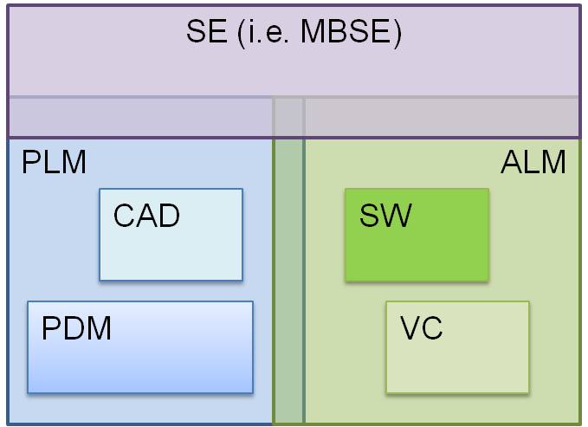

- Demonstration System: HSUV Automotive Example (defined in SysML, in v1.3 publicly available)
  - http://www.omg.org/ocsmp/HSUV.pdf

- Example: Requirements Change Request : Fuel Economy (reduce by x%) – System affected
  - Power System, Fuel System
  - Implementation in tools
    - PLM (Windchill, Share-A-Space, Team Center)
    - ALM (Jazz, Integrity)
    - Modeling (Rhapsody, MATLAB, MagicDraw, Enterprise Architect, Artisan Studio)

- Scenario about maintenance and operation (Integration scenario for PLM) [Sylvere K.]

