 | Artificial  Intelligence  Platform  Task  Force

Welcome to the AI Platform Task Force Wiki
This wiki complements the AI PTF marketing page on the main OMG website. It is intended as a place to keep the community (OMG members and non-members alike) informed of the activities derived from OMG's 2019 initiative on Artificial Intelligence, and consolidated into a new Platform Task Force chartered in September of that year. It is focused on how we operate as a Task Force.
The vision behind the AI PTF is to create and “animate” an OMG-based AI center, coordinating and complementing AI-related efforts in other groups (such as Ontology, Retail, Healthcare. and more) and especially considering aspects that can benefit from standardization -- making OMG the place to come for AI technology standardization.

Go to the Private Area

Charter and History of the AI PTF
Charter (adopted on 27 Sep 2019, revised on 13 Dec 2019)
OMG’s Artificial Intelligence Platform Task Force (AIPTF) will promote the adoption of specifications that standardize foundational capabilities of artificial intelligence.
Among the goals of the AIPTF is freeing AI technology suppliers as well as end users from interoperability and interchange limitations with respect to models, languages and data, and to enable them to focus instead on development of advanced AI applications.
In the context of this charter, Artificial Intelligence is defined broadly and includes, but is not limited to:
* Modeling of AI artifacts
* Machine learning, deep learning and neural networks
* Image understanding, speech recognition, and computer vision
* Robotic systems
* Virtual and augmented reality
* Autonomous and autonomic systems and agents
* Knowledge representations
* Natural language processing (NLP)
* Security, privacy, social and other ethical aspects of AI
The purpose of the AIPTF includes development of foundational specifications that support AI in the above broad sense.
The AIPTF may, when appropriate, generate discussion papers, RFIs or RFPs or recommend technologies for adoption. It will also collaborate with other OMG subgroups to identify and document use cases and interoperability requirements for AI, and identify the need for AI-related additions or revisions to those groups’ existing and emerging specifications. It will seek to identify external stakeholders, including other standards development organizations, and partner with them as needed.

History
The history of OMG's efforts related to AI can be summarized as follows:
The Agent Platform SIG was created in (date).OMG's Board of Directors requested the development of an OMG AI standards strategy in March 2019.The development of that strategy was interrupted in May 2019 by NIST's issuance of a Request for Information on AI standards; the focus shifted to responding to the RFI, which was achieved in early June.At the June 2019 meeting, the Agent PSIG was expanded and transformed into an AI PSIG.The development of the AI strategy resumed and completed during the summer, leading to a paper adopted by the Board at the end of September 2019.Consistent with the strategy paper recommendations, the AI PTF held a formation meeting in September 2019 and was formally chartered.Considering that there were specific technologies in the agent domain that some members would like to work on without addressing the broader scope of AI, the Platform Technical Committee voted at the same meeting to re-charter the Agent PSIG.The charter was updated in December 2019 to clarify two of the scoping bullets, and to correct the omission of robotic systems.The AI PTF started meeting quarterly, with occasional interim conference calls, and those meetings have been (for the most part) documented as shown below.

Co-Chairs
Bobbin Teegarden (OntoAge)Claude Baudoin (cébé IT & Knowledge ManagementThe co-chairs are collectively reachable at the address ai-chair@omg.org.

Interested Organizations
The purpose of this section is to keep track of organizations that have contacted us, or participated in meetings. This is obviously a list under construction. If needed, we'll make it into a separate page later. We're not showing people's e-mail addresses to avoid getting them spammed. If you wish to contact someone on this list, email the co-chairs.
Augmented Reality Enterprise Alliance (AREA) (Christine Perey)Torch.AI (Artem Beer, Jae Cha)The Linux Foundation's Trusted AI Committee. It covers AI fairness, explainability, and robustness to adversarial attacks. IBM plays an active role in it, and IBM Research created three open source Python libraries for those topics (information received from Svetlana Levitan on 20 Jan 2020).The U.S. Department of (Defense Joint AI Center (Col. Doug Drakeley).prostep ivip (Rachel Bauer), which reports having the following focus areas related to AI:Standardization of ETL-processes -- the Data Preparation for Data Analytics (DPDA) projectParticipation in the AI Marketplace consortium, aimed at creating a marketplace for industrial users and AI-VendorsIdentification of most important use cases Identification of relevant tools, interfaces a.nd standards in product development and production, to ensure data provision for AI applications.Firepoint, an R&D consulting organization with a two-year contract to help the U.S. Army's Aviation and Missile Center (AvMC) examine the landscape of AI capabilities that could be leveraged (contacts: Logan Schraeder and Timothy Johnson).Lockheed Martin. Ademola Adejokun has participated in some meetings and intends to collaborate on the AI taxonomy effort. * NIST. As of January 2023, NIST is engaged in exploratory discussions with OMG's AI PTF because ov th overlap with an ontology effort related to the Industrial Ontology Foundry (IOF).

Mailing list
OMG maintains a mailing list, ai@omg.org. To be added (or removed, or to change your address) please click here.
We welcome great ideas, emerging AI technology, and new AI standards, bring your digital twin and join us!

Scope of AI Technologies
Work has started on an AI taxonomy. You can explore it visually here.
An “AI metamodel” (this term has been critiqued, since it seems to be more of a taxonomy than a metamodel) of the range of technologies that are “in scope” for the AI PTF was proposed during the Agent PSIG meeting in June 2019 and is shown below (click on the figure to enlarge it). The left hand side of the diagram is more about knowledge representations, the right-hand side about AI capabilities or applications based on those representations.
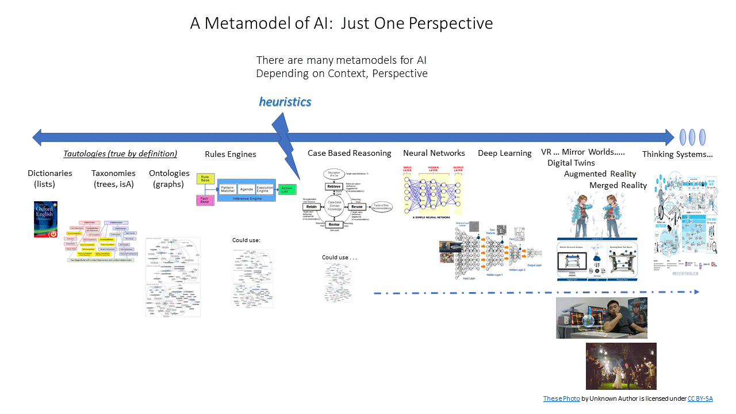

Meetings
Links below appear in three different colors automatically generated by Dokuwiki. They are:
green for links to other pages of this wikiblue for links to other websites, including the OMG document repository (which may require you to log in with your OMG credentials)red for pages that are planned but do not exist yet.
Date | Link | Remarks
Sep 2019 | AI Platform Task Force Sep. 2019 Meeting Summary
Dec 2019 | Notes from AI Meet-and-Greet and AI PTF Meeting, December 2019, Long Beach
Mar 2020 | March 2020 AI PTF virtual meeting notes | (Google Doc draft, to be finalized)
May 2020 | AI PTF Interim Virtual Meeting on 4 May 2020
Jun 2020 | June 2020 AI PTF regular quarterly meeting notes
Jul 2020 | July 29, 2020 AI PTF interim virtual meeting
Aug 2020 | August 25, 2020 AI PTF interim virtual meeting
Sep 2020 | September 2020 AI PTF regular quarterly meeting | (Google Doc draft, to be finalized)
Dec 2020 | December 2020 meeting notes
Mar 2021 | March 2021 meeting notes | Draft only
Jun 2021 | June 2021 meeting notes
29 Sep 2021 | Sep. 2021 meeting notes | Draft only
8 Dec 2021 | Agenda
22 Mar 2022 | Agenda
21 Jun 2022 | June 2022 meeting notes
23 Aug 2022 | Interim Virtual AI Taxonomy Meeting, 23 Aug 2022 | Pending participant review
20 Sep 2022 | Agenda | (notes expected in Oct.)
6 Dec 2022 | Planned date for the next meeting
Future meeting agenda ideas:
A full-day “forum” including representatives from NIST, and other organizations that responded to the NIST RFI on AI Standards. A “call for papers” was issued in mid-January 2020 to solicit additional presentations.Potential Speakers at AI PTF Meetings

Non-OMG Events
Unite.AI maintains a list of conferences and exhibits of potential interest to members. The scope of their calendar entries extends to robotics and data science
Note that any indications of a physical location in the coming months is highly subject to change until the COVID-19 pandemic is under control. Moreover, when an on-site conference is changed to a virtual one, the dates may also change.
Those who attend any external AI-related event are strongly encouraged to share their notes through our mailing list of for posting on this wiki.

References
OMG AI Bibliography
AI Landscape Report by the European Union Observatory on Standards (EUOS)
Standard for Artificial Intelligence and Machine Learning (AI/ML) Terminology and Data Formats (IEEE-SA Project P3123)
What's Next for AI Systems & Language Models -- a discussion with Ilya Sutskever of OpenAI on ML and explainability

