4.2 Currency Models
Return to Common Elements | <b> <a href="mailto:cbdc-feedback@omg.org?Subject=OMG's CBDC WG Response: 4.2 Currency Models ">Provide Feedback</a></b>

Overview
Return to Top
The Bank For International Settlements provides a good explanation of the problems confronting the U.S. Federal Reserve's CBDC effort.1)
CBDC is not a well-defined term. It is used to refer to a number of concepts. However, it is envisioned by most to be a new form of central bank money. That is, a central bank liability, denominated in an existing unit of account, which serves both as a medium of exchange and a store of value. This would be an innovation for general-purpose users, but not for wholesale entities. Central banks already provide digital money in the form of reserves or settlement account balances held by commercial banks and certain other financial institutions at the central bank. This mix of new and already existing forms of central bank money makes it challenging to precisely define what a CBDC is. In fact, for purposes of analyzing what may change, it is easier to define a CBDC by highlighting what it is NOT:
a CBDC is a digital form of central bank money that is different from balances in traditional reserve or settlement accounts.2)A key distinction between token [Digital Cash] and account-based [Digital Account] money is the form of verification needed when it is exchanged (Kahn and Roberds (2009)). Token-based money (or payment systems) relies critically on the ability of the payee to verify the validity of the payment object. With cash the worry is counterfeiting, while in the digital world the worry is whether the token or “coin” is genuine or not (electronic counterfeiting) and whether it has already been spent. By contrast, systems based on account money depend fundamentally on the ability to verify the identity of the account holder. A key concern is identity theft, which allows perpetrators to transfer or withdraw money from accounts without permission Identification is needed to correctly link payers and payees and to ascertain their respective account histories.

Taxonomy
Return to Top
CBDC is not a well-defined term. It is used to refer to a number of concepts. However, it is envisioned by most to be a new form of central bank money. That is, a central bank liability, denominated in an existing unit of account, which serves both as a medium of exchange and a store of value. This would be an innovation for general-purpose users but not for wholesale entities. Central banks already provide digital money in the form of reserves or settlement account balances held by commercial banks and certain other financial institutions at the central bank. This mix of new and already existing forms of central bank money makes it challenging to precisely define what a CBDC is. In fact, for purposes of analyzing what may change, it is easier to define a CBDC by highlighting what it is not: a CBDC is a digital form of central bank money that is different from balances in traditional reserve or settlement accounts. 3)Figure presents a Venn diagram of two different taxonomies that can be used to classify Cryptocurrencies.
The diagram on the left side of the figure represents the forms of money. Cash, for example, is Peer-to-Peer (P2P) but is not electronic. Cash is a Central Bank liability.
While bank deposits (i.e., Digital Accounts) are electronic but are not P2P. Bank Deposits are the liability of the bank that holds the accounts. The money is exchanged using a centralized system such as the Automated Clearing House (ACH) Network.
Cryptocurrencies attempt to bridge both the P2P and the electronic categories. There really isn't much liability for Cryptocurrencies other than the promises made in the governing White Papers and the value of the cryptocurrency itself.
The diagram on the right side uses a Venn Diagram to illustrate CBDC as the intersection of Central Bank Issued, Universally Accessible, and Electronic. At the intersection of the three Venn circles are: CBDC and Bank Account Money.
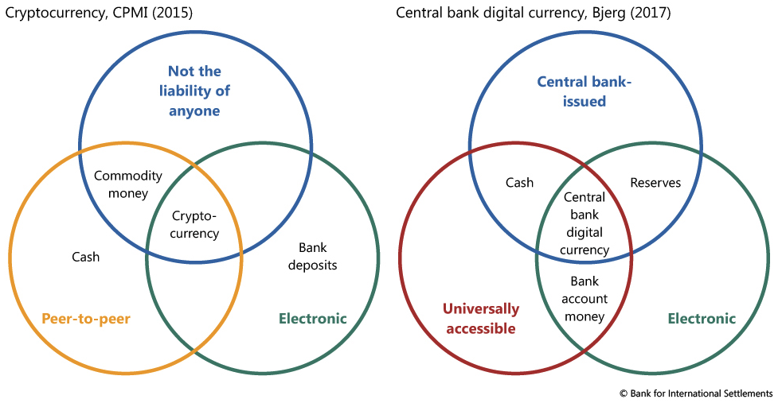
Venn Diagrams of Two Taxonomies of New Forms of Money4)
Figure is often referred to as the Money Flower. The Venn diagram has 4 circles:
Universally Accessible (red)Electronic (green)Central Bank Issued (blue)Peer-to-Pee (P2P) (gold)It then labels the intersection of the circles with various “concepts”. For example, one kind of CBDC is accessible to the general public(i.e., retail CBCC) and the other is available only to financial institutions (i.e., wholesale CBCC).
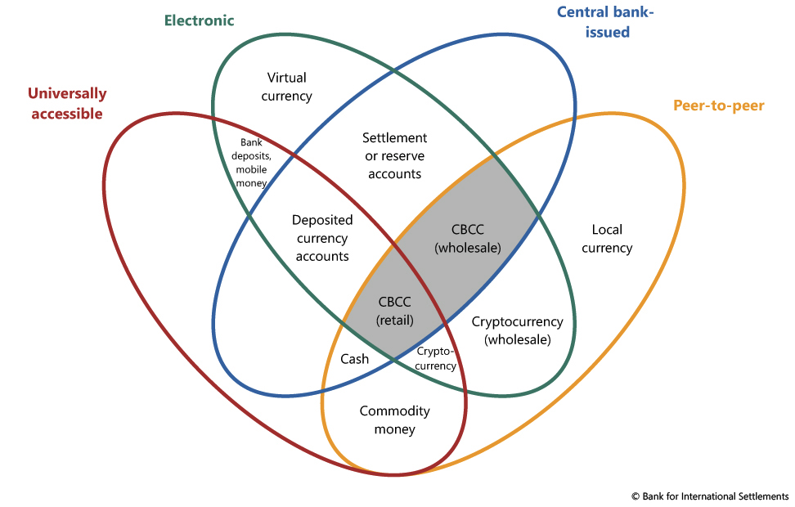
The Money Flower: A Venn Diagram of the Taxonomy of Money.5)
For this discussion on CBDC, two different models are used:
- Tokens 4.2.2 Digital Account Model - Accounts

1) Bank For International Settlements, Committee on Payments and Market Infrastructures, Markets Committee, March 2028, Accessed: 3 April 2022, https://www.bis.org/cpmi/publ/d174.pdf
2) Reserves and settlement accounts are available in most jurisdictions to “monetary policy counterparties”, i.e. financial institutions that are directly relevant for monetary policy implementation, such as deposit-taking entities, which are generally already granted access to the central bank deposit and lending facilities. In some jurisdictions, account holders may comprise a broader group and include non-monetary counterparties such as treasury, foreign central banks, or certain Financial Markets Infrastructures (FMIs). Some central banks are considering widening access. CBDC would further expand access to digital central bank money, but not to central bank lending facilities.
3) Benoît Cœuré, Jacqueline Loh, Klaus Löber, Aerdt Houben, Central Bank Digital Currencies, Bank of International Settlements, Committee on Payments and Market Infrastructures - Markets Committee, March 2018, Accessed: 16 May 2022, https://www.bis.org/cpmi/publ/d174.pdf
4) Morten Linnemann Bech, Rodney Garratt, Central Bank Cryptocurrencies, BIS Quarterly Review, 17 September 2017, Accessed: 16 May 2022, https://www.bis.org/publ/qtrpdf/r_qt1709f.htm
5) Morten Linnemann Bech, Rodney Garratt, __Central Bank Cryptocurrencies_, BIS Quarterly Review, 17 September 2017, Accessed: 16 May 2022, https://www.bis.org/publ/qtrpdf/r_qt1709f.htm

