4.5.2 Drug Trafficking
Return to National Security Considerations | <b> <a href="mailto:cbdc-feedback@omg.org?Subject=OMG's CBDC WG Response: 4.5.2 Drug Trafficking ">Provide Feedback</a></b>

Overview
Return to Top
Drug Trafficking is a big and difficult problem to address, especially since the laws have not been updated to reflect the use of Cryptocurrencies and especially a CBDC.
Drug Trafficking, also known as Drug Distribution, is the crime of selling, transporting, or illegally importing unlawful controlled substances, such as heroin, cocaine, marijuana, or other illegal drugs.Drug trafficking also applies to the illegal selling or transportation of prescription drugs, which has become an increasing problem in recent years.According to the Department of Justice, the sale and manufacture of drugs accounts for almost one-fifth of all drug-related arrests. 1)Drugs continue to come into the U.S. from many sources despite the efforts of numerous U.S. agencies (i.e., Drug Enforcement Administration (DEA)), law enforcement agencies, and border patrols. etc. This trafficking occurs regardless of U.S. and International laws trying to prevent it. Figure shows a map of the world's drug trafficking lanes.
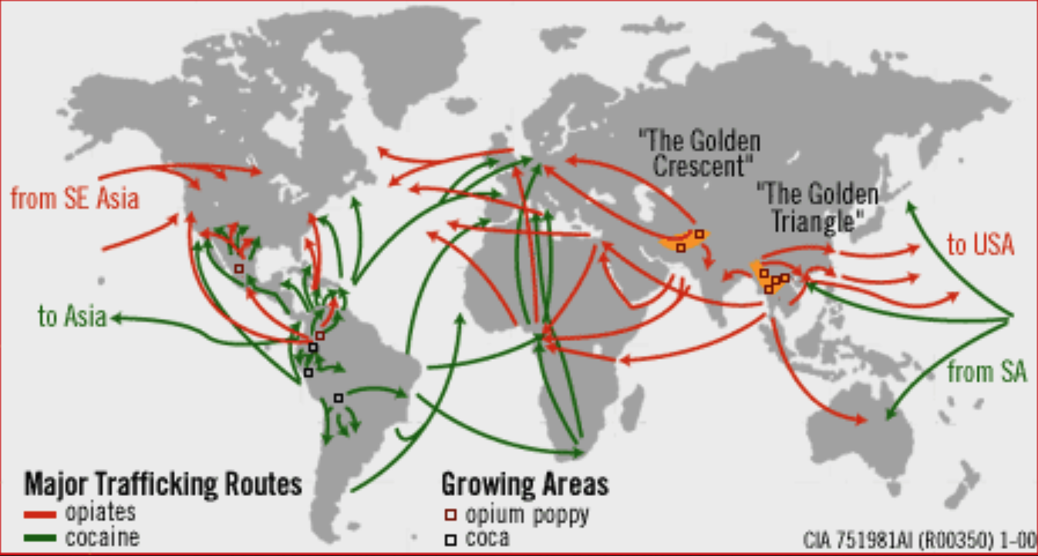  Major Drug Trafficking Routes throughout the world2). | 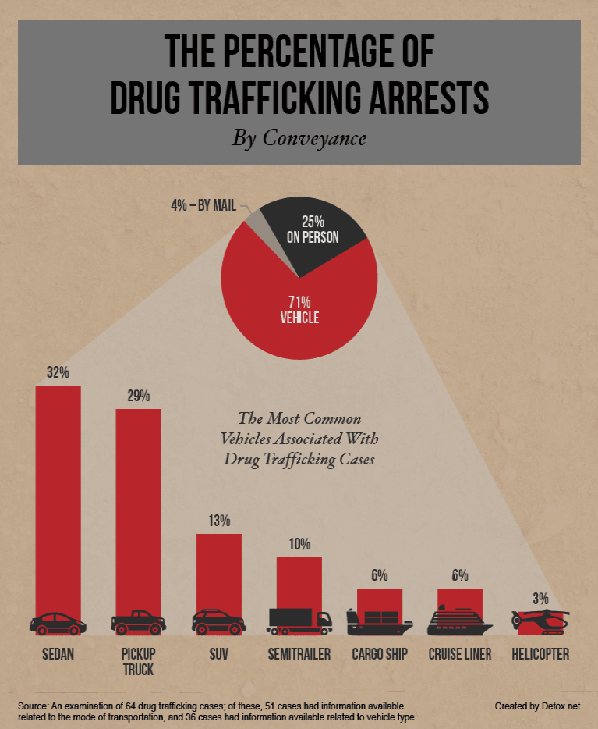  The Percentage of Drug Trafficking Arrests by Conveyance3)
Drug offenses of all types were the second most common federal crime in the fiscal year 2020. The 16,829 total drug cases reported to the Commission accounted for 26.1 percent of all cases, a decrease of 3,564 cases (17.5%) from the year before.4) | 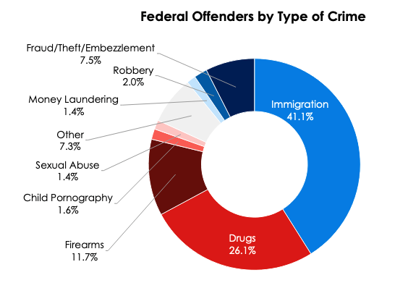  Federal Offenders by Type of Crime

U.S. Laws and Regulations
Return to Top
There is no single law or regulation within the U.S. that covers Drug Trafficking, but a whole set of laws. Table outlines most of the laws as determined by United States Attorney's Offices and by the Seattle Pacific University (SPU) .
There are roughly 9 Laws and Regulations in the U.S. covering Drug Trafficking.
List of U.S. Laws and Regulations covering Drug Trafficking.
Law or Regulation | Description
21 U.S. Code § 844 - Penalties for simple possession | Persons convicted of illegally possessing any controlled substance face penalties of up to 1 year in prison and a minimum fine of \$1,000, or both. Second convictions are punishable by not less than 15 days, but not more than 2 years in prison and a minimum fine of $2,500. Subsequent convictions are punishable by not less than 90 days but not more than 3 years in prison and a minimum fine of \$5,000.  Special sentencing provisions for possession of Flunitrazepam (Rohypnol, “roofies” or “roaches”) impose a prison term of up to 3 years, a fine, or both.  Civil penalties of up to \$10,000 may also be imposed for possession of controlled substances, whether or not criminal prosecution is pursued. Persons convicted of possession may also be fined for the reasonable costs of the investigation and prosecution of the offense. Penalties for possession with intent to distribute are potentially even more severe.
21 U.S. Code § 863 - Drug paraphernalia | Persons convicted on federal charges of the sale, import, export, or shipping of drug paraphernalia face penalties of up to 3 years in prison and a monetary fine
21 U.S. Code § 853 - Criminal forfeitures | Any person convicted of a federal drug offense punishable by more than one year in prison shall forfeit to the United States any personal or real property related to the violation, including houses, cars, and other personal belongings. Property may be seized upon arrest on charges that may result in forfeiture.
21 U.S. Code § 862 - Denial of Federal benefits to drug traffickers and possessors | A federal drug conviction may result in the loss of federal benefits, including school loans, grants, contracts, and licenses. Federal drug trafficking convictions may result in denial of federal benefits for up to 5 years for a first conviction, 10 years for a second conviction, and permanent denial of federal benefits for a third conviction. Federal drug convictions for possession may result in denial of federal benefits for up to 1 year for a first conviction and up to 5 years for subsequent convictions.
21 U.S. Code § 841 - Prohibited acts A | Penalties for federal drug trafficking convictions vary according to the number of controlled substances involved in the transaction. The tables below summarize penalty information for several types of controlled substances. Persons who violate federal drug trafficking laws within 1,000 feet of a university may face penalties or prison terms and fines up to twice as high as the regular penalties for the offense, with a mandatory prison sentence of at least one year (21 USC §860).
21 U.S. Code § 846 - Attempt and conspiracy | Prohibits conspiracies and attempts to violate any substantive offense established by Subchapter I of Title 21 (“Control and Enforcement”)—in other words, Section 846 makes it a crime to conspire to violate or attempt to violate any substantive offense set forth in 21 U.S.C. §§ 801-904.
21 U.S. Code § 843 - Prohibited acts C | 1. It shall be unlawful for any person to place in any newspaper, magazine, handbill, or other publications, any written advertisement knowing that it has the purpose of seeking or offering illegally to receive, buy, or distribute a Schedule [1] I controlled substance.2. It shall be unlawful for any person to knowingly or intentionally use the Internet, or cause the Internet to be used, to advertise the sale of, or to offer to sell, distribute, or dispense, a controlled substance where such sale, distribution, or dispensing is not authorized by this subchapter or by the Controlled Substances Import and Export Act [21 U.S.C. 951 et seq.].
21 U.S. Code § 848 - Continuing criminal enterprise - "Drug Kingpin Statute | A mandatory minimum of 20 years and a maximum of life can be imposed on a leader of an organization of five or more individuals who engage in a continuing series of drug violations from which the person derived substantial income. Mandatory life and death penalty available under certain circumstances.
18 U.S. Code § 1952 - Interstate and foreign travel or transportation in aid of racketeering enterprises | Five-year maximum for traveling or using the mail or instruments of interstate commerce (telephone/internet) with intent to facilitate drug trafficking.

1) Justia, Accessed: 5 April 2022, https://www.justia.com/criminal/offenses/drug-crimes/drug-trafficking/
2) Wikipedia - Public Commons
3) American Addiction Centers, Editorial Staff, 14 December 2021, Accessed: 7 April 2022, https://detox.net/uncover/drug-mules-trafficking-by-the-numbers/
4) United States Sentencing Commission, the Fiscal Year 2020 - Overview of Federal Criminal Cases, April 2021, Accessed: 7 April 2022, https://www.ussc.gov/sites/default/files/pdf/research-and-publications/research-publications/2021/FY20_Overview_Federal_Criminal_Cases.pdf

