Question: 06. Could a CBDC adversely affect the financial sector? How might a CBDC affect the financial sector differently from stablecoins or other nonbank money?
Return to CBDC Benefits, Risks, and Policy Considerations \ | <b> <a href="mailto:cbdc-feedback@omg.org?Subject=OMG's CBDC WG Response: Question: 06. Could a CBDC adversely affect the financial sector? How might a CBDC affect the financial sector differently from stablecoins or other nonbank money? ">Provide Feedback</a></b>

Question
Return to Top
Could a CBDC adversely affect the financial sector?How might a CBDC affect the financial sector differently from Stablecoins or other nonbank money?

Answer
Return to Top

Overview
Return to Top
To answer the question it is important to first define what is meant by Financial Sector, Financial Market and Clearinghouse
The Financial Sector refers to businesses, firms, banks, and institutions providing financial services and supporting the economy and encompasses several industries such as banking and investment, consumer finance, mortgage, money markets, real estate, insurance, retail, etc. The adoption of a U.S. CBDC will not affect all of the Financial Service industries and it will not affect each one in the same way. In general terms, the Financial Sector is used as an indicator of the health of the economy because it generates revenue through interest rates, mortgages, loans, debt finance, and capital funds, consequently spurring economic growth meaning the weaker the Financial Sector, the weaker the economy. This is why the question is so important.
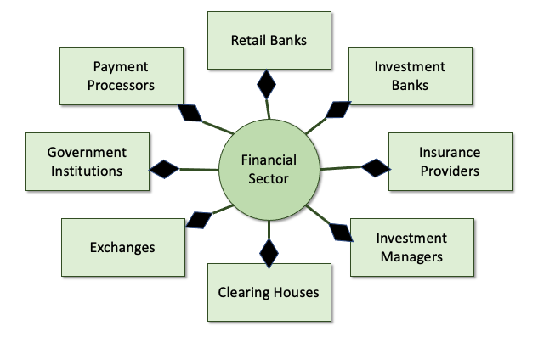
The Composition of the Financial Services
Sometimes, the Financial Sector is falsely equated to Financial Markets which is a broad term and includes various types of markets where companies requiring investment can borrow money at a low cost.
These financial markets are regulated by independent regulatory bodies with strict rules and regulations. They have stringent and mandatory reporting and compliance standards. Any violation by companies, investors, brokers, banks, financial institutions, or any other authorized bodies can lead to heavy penalties and, in extreme cases, cancellation of license. 1)Figure provides a graphical representation of the composition of the Financial Markets.
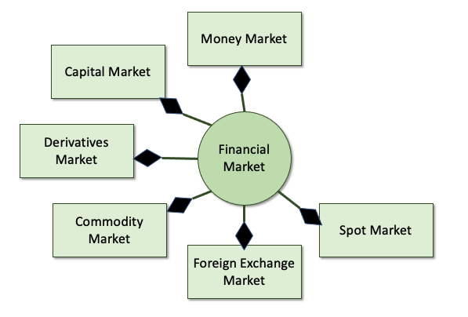
The Composition of the Financial Maket
At the heart of the U.S. CBDC (Stablecoin) will be a DIDO Platform (i.e.Ethereum, Hyperledger, Iota, Hedera, etc.). Each DIDO Platform has its own Consensus Mechanism (i.e., Proof-of-Work (PoW), Proof-of-Stake (PoS), etc.). Within the U.S. CBDC, the DIDO Platform Consensus will act as a Clearinghouse for Transactions within the DIDO Platform (see Figure .
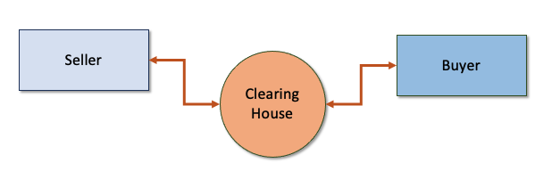
The relationship between a buyer, a seller and a Clearinghouse.

1. Could a CBDC adversely affect the financial sector?
Return to Top

Technically
Return to Top
Each of the Financial Sector components will respond differently to the use of a U.S. CBDC depending on how much they want to support the use of CBDC as an alternative to the approved Clearinghouse. The Financial Sectors normally using U.S. Dollars on both sides of a transaction could use something like the ACH/CBDC network proposal ( see Figure . This should require a minimum of change in their current processes and require them to be able to hold U.S. Dollars and U.S. CBDC in the pertinent accounts. The main benefit of using a CBDC Network should be the increase in speed (almost real-time) for settlements since the U.S. CBDC will use an automated Consensus Mechanism. However, in order to check for Privacy and Criminal Activity by enforcing the National Privacy Concerns and National Security Conncerns as well as respecting International Concerns, the Consensus process most likely needs to be extended to help enforce the existing laws and regulations. This extension could rely heavily on the use of Artificial Intelligence (AI) and Intelligent Agents.
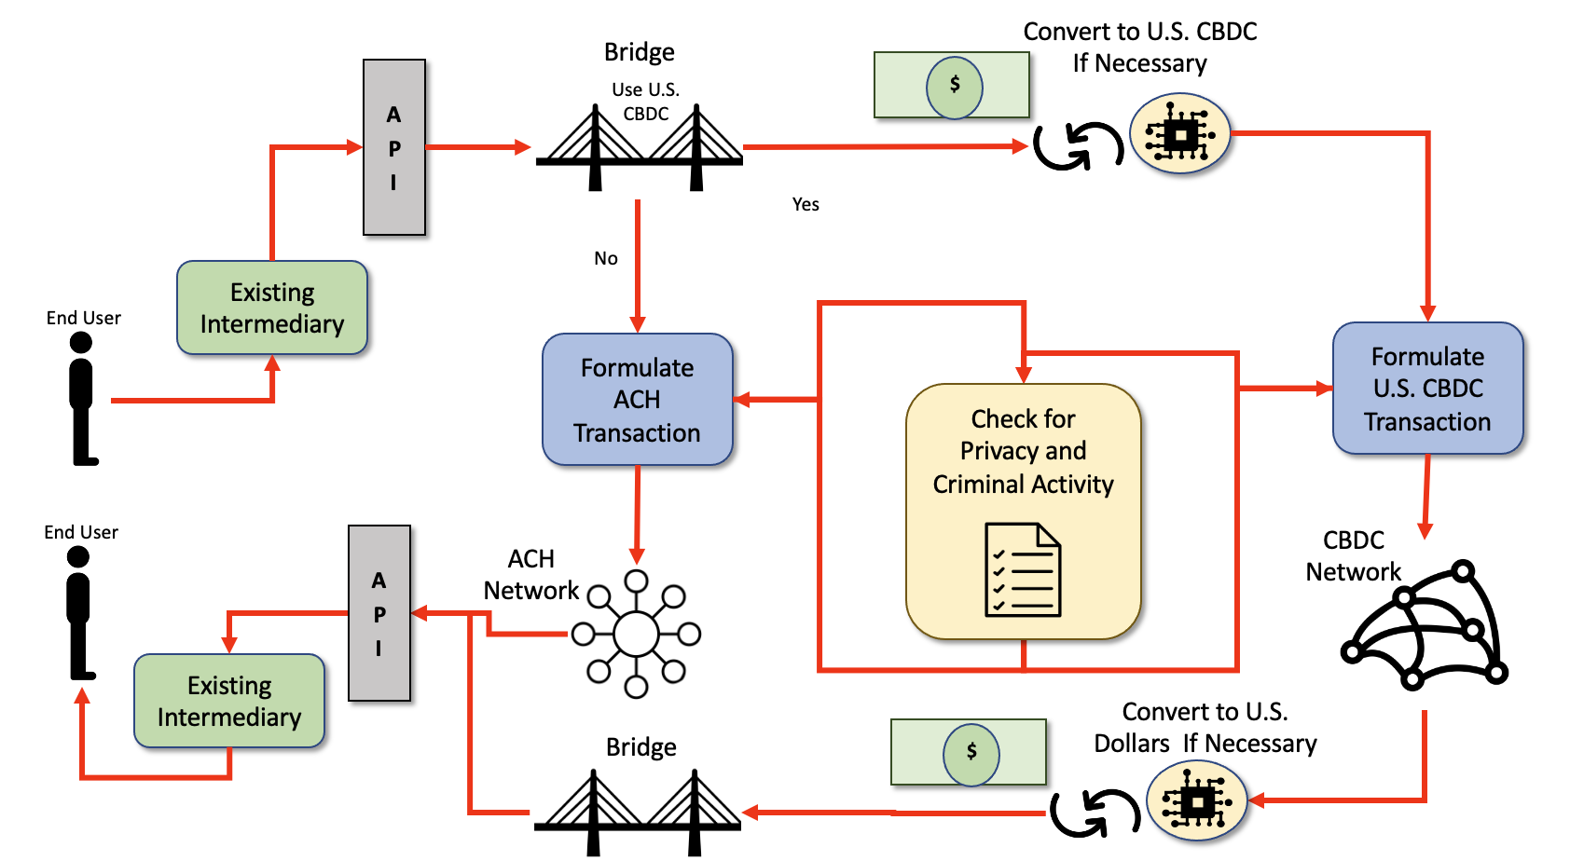
Theoretical Very Simplified Dual ACH-CBDC Network Concept.
For those Financial Sector components that use U.S. Dollar-to-Asset transactions, the appropriate Clearinghouses could also support U.S. CBDC-to-Asset the speed of the clearing may be faster since securing the U.S. CBDC would be near real-time.
For those Financial Sector components that do not use U.S. Dollar to Dollar transactions, the individual Clearinghouses need to address the problem individually

Reputation
Return to Top
Obviously, if there is a breach or hack in the U.S. CBDC, all the Financial Sector components would be affected. See the existing Risks identified in the White Paper and the response to Question: 11. Are there additional ways to manage potential risks associated with CBDC that were not raised in this paper?.

2. How might a CBDC affect the financial sector differently from Stablecoins or other nonbank money?
Return to Top
There is an entire section on Stablecoin. See section 4.3 Stablecoins.
Currently, Stablecoins and nonbank money need to be converted to U.S. Dollars in order for the money to be used within the financial sector.

1) Madhuri Thakur and Dheeraj Vaidya, What is the Financial Market?, Wall Street Mojo, Accessed: 25 April 2022, https://www.wallstreetmojo.com/financial-market/

