Question: 09. How might domestic and cross-border digital payments evolve in the absence of a U.S. CBDC?
Return to CBDC Benefits, Risks, and Policy Considerations | <b> <a href="mailto:cbdc-feedback@omg.org?Subject=OMG's CBDC WG Response: Question: 09. How might domestic and cross-border digital payments evolve in the absence of a U.S. CBDC? ">Provide Feedback</a></b>

Question
Return to Top
How might domestic and cross-border digital payments evolve in the absence of a U.S. CBDC?

Answer
Return to Top
Without the advent of a U.S. CBDC, there are a few possible scenarios that will evolve. Some existing areas will be the use of:
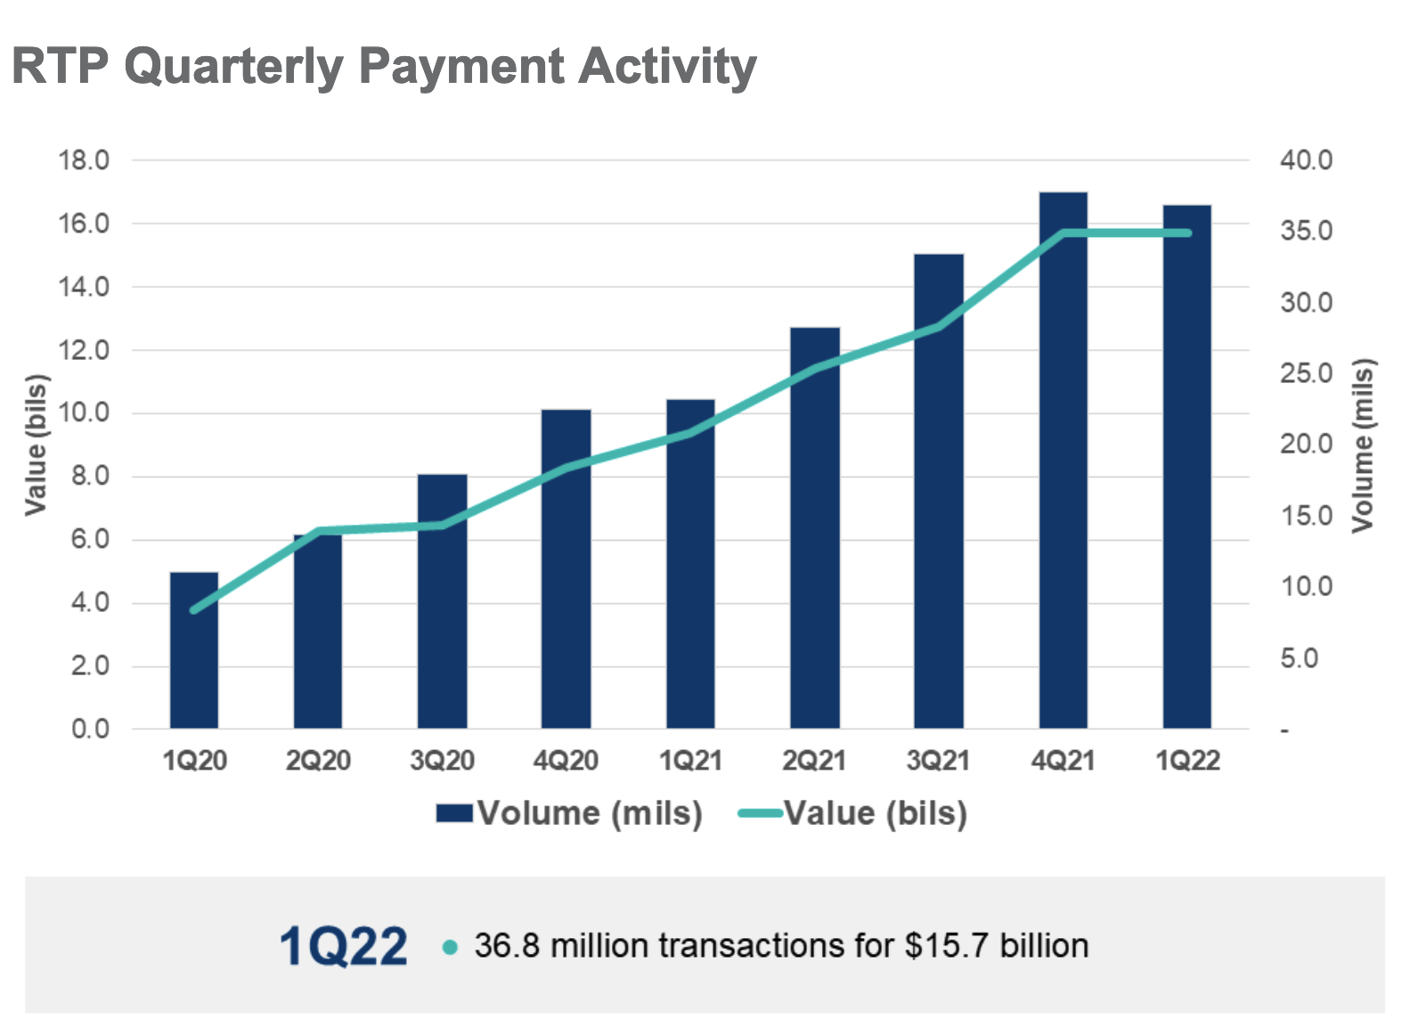
Cryptocurrencies (i.e., Bitcoin, Ethereum, etc.) to transfer money across borders Europay MasterCard®, and Visa (EMV) Mobile Payment systems such as PayPal, Venmo, Zelle, CashApp, Apple Pay, and Google Pay Payment Cards such as Credit Cards, Debit Cards, Charge Cards, Prepaid Cards or Electronic Benefits Transfer (EBT) Prepaid Cards issued by banks and branded by major credit card companies such as Visa, Mastercard, Discover, and American Express Gift Card issued by international stores and merchants such as Amazon, airlines, and hotels Real-Time Payments (RTP) NetworkThe RTP® network from The Clearing House is a real-time payments platform that all federally insured U.S. depository institutions are eligible to use for payments innovation. With mobile technology and digital commerce driving the need for safer and faster payments in the U.S., financial institutions of all sizes are taking advantage of the RTP network’s capabilities to create or enhance digital services for their corporate and retail customers.1)
Real-time Payment Activity by Quarter.1)

1) The Clearing House, Real-TIme Payments for All Financial Institutions, First Quarter 2022, Accessed: 5 May 2022, https://www.theclearinghouse.org/payment-systems/rtp

