Question: 17. What types of firms should serve as intermediaries for CBDC? What should be the role and regulatory structure for these intermediaries?
Return to Design Considerations | <b> <a href="mailto:cbdc-feedback@omg.org?Subject=OMG's CBDC WG Response: Question: 17. What types of firms should serve as intermediaries for CBDC? What should be the role and regulatory structure for these intermediaries? ">Provide Feedback</a></b>

Question
Return to Top
What types of firms should serve as intermediaries for CBDC?What should be the role and regulatory structure for these intermediaries?

Answer
Return to Top
The answer depends on:
Currency Model(s) are adopted, see section 4.2 Currency Models)Architectural choices, see section 4.7 Dual Payment NetworksDesign considerations, see section 4.3 Stablecoins

Currency Model Considerations

Digital Cash Model
Return to Top
Using a Digital Cash Model it would be expected that all the existing Intermeidaires types continue to serve in their existing roles, however, these would have to be extended to support the new form of cash. There may need to be new intermediaries that exclusively use the new Digital Cash in ways yet to be determined but mostly like online services.
What should be the role and regulatory structure for these intermediaries?
The regulatory structure should be the same as the current system for both the current Intermediaries types as well as any new Intermediaries types unless new laws and regulations are enacted to specifically exempt the CBDC from existing 60+ laws and regulations governing:
1. National Privacy Considerations 2. National Security Considerations Human Trafficking Drug Trafficking Corruption Money Laundering 3. International Considerations Data Residency Data Sovereignty Data Localization

Digital Acount Model
Return to Top
Using a Digital Account Model it would be expected that all the existing Intermeidaires types continue to serve in their existing roles, however, these would have to be extended to support the new form of cash most likely offering the ability to keeps account balances denominated in either U.S. Dollars or in U.S. CBDC. The main benefit of using U.S. CBDC would be to use the CBDC Network to transfer money in near real-time versus using the traditional Automated Clearing House (ACH) Network .
What should be the role and regulatory structure for these intermediaries?
The regulatory structure should be the same as the current system for both the current Intermediaries types as well as any new Intermediaries types unless new laws and regulations are enacted to specifically exempt the CBDC from existing 60+ laws and regulations governing:
1. National Privacy Considerations 2. National Security Considerations Human Trafficking Drug Trafficking Corruption Money Laundering 3. International Considerations Data Residency Data Sovereignty Data Localization

Dual Payment Model
Return to Top
Using a Dual Payment Network Model of Automated Clearing House (ACH) Network and a U.S. CBDC Network as described in Figure , the existing Intermediaries would continue to play a role, however, they would have to adapt their existing policies and procedures to allow for the use of both the U.S. Dollar based ACH and to support the use of the near real-time U.S. CBDC network while using CBDC.
What should be the role and regulatory structure for these intermediaries? The role and regulatory structure for these intermediaries would remain largely unchanged except for having to account for U.S. CBDC as part of the Banking Reserves.
The regulatory structure should be the same as the current system for both the current Intermediaries types as well as any new Intermediaries types unless new laws and regulations are enacted to specifically exempt the CBDC from existing 60+ laws and regulations governing:
1. National Privacy Considerations 2. National Security Considerations Human Trafficking Drug Trafficking Corruption Money Laundering 3. International Considerations Data Residency Data Sovereignty Data LocalizationThere would also be a need for Intermediaries that exclusively use a new U.S. CBDC. These intermediaries would need to also participate in having Banking Reserves, be subject to auditing and follow al the existing Laws and Regulations such as, Privacy, Security, and Internationa Agreements
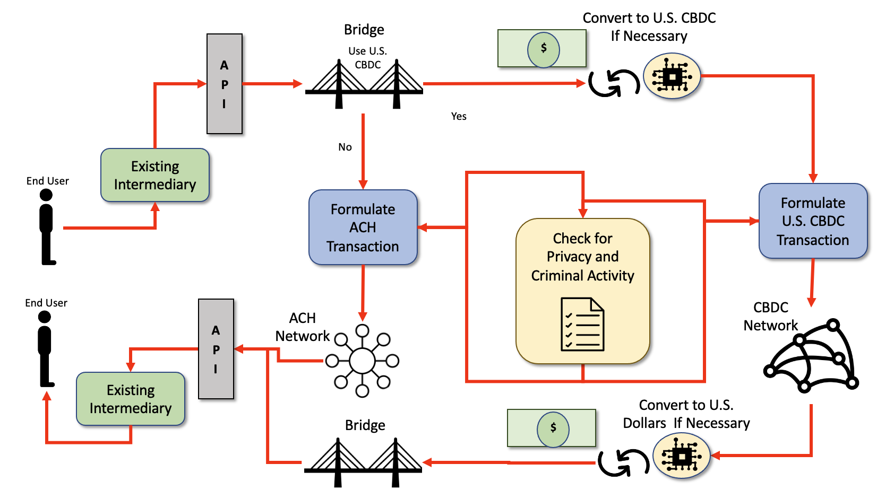
Theoretical Very Simplified Dual ACH-CBDC Network Concept.

Design Considerations
Return to Top
A Stablecoin is a class of cryptocurrencies attempting to offer price stability by backing the Coins with a reserve asset, such as U.S. Dollars. Stablecoins have gained traction as they attempt to offer the best of both worlds—the instant processing and security or privacy of payments of cryptocurrencies, and the volatility-free stable valuations of fiat currencies.
The only Design Consideration presented in the White Paper are described in the Sections on Stablecoin Examples and in Stablecoin Discussion of Examples .
Section 4.3 Stablecoins describes four types of Stablecoins with the Fiat-Collateralized Stablecoins as the most likely relevant to a U.S. CBDC. These are collateralized, or backed, by a Fiat Currency and are generally backed at a 1:1 ratio, meaning 1 Stablecoin is equal to 1 unit of currency. So for each Stablecoin that exists, there is (theoretically) one real Fiat Currency being held in a bank account to back it up.
Stablecoins could work with either Digital Currency Model (i.e., Digital Cash Model or the Digital Account Model). Regardless of which Digital Currency Model used, a Stablecoin Design will probably support all the existing Intermediaries as well as any new CBDC-only Intermediaries, especially if a [[cbdc:public:cbdc_omg:04_doc:15_common:70_dualnets:start | Dual Payment Network is adopted.
What should be the role and regulatory structure for these intermediaries?
The regulatory structure should be the same as the current system for both the current Intermediaries types as well as any new Intermediaries types unless new laws and regulations are enacted to specifically exempt the CBDC from existing 60+ laws and regulations governing:
1. National Privacy Considerations 2. National Security Considerations Human Trafficking Drug Trafficking Corruption Money Laundering 3. International Considerations Data Residency Data Sovereignty Data Localization

