Question: 19. Should a CBDC be designed to maximize ease of use and acceptance at the point of sale? If so, how?
Return to Design Considerations | <b> <a href="mailto:cbdc-feedback@omg.org?Subject=OMG's CBDC WG Response: Question: 19. Should a CBDC be designed to maximize ease of use and acceptance at the point of sale? If so, how? ">Provide Feedback</a></b>

Question
Return to Top
Should a CBDC be designed to maximize ease of use and acceptance at the point of sale?If so, how?

Answer
Return to Top
By using a system designed roughly as outlined in section 4.7 Dual Payment Networks, much of the current infrastructure would remain in place and the ease of use and acceptance at the point of sale would be very little different than the current system since the End User Front End would be done by existing Intermediaries or newly specialized U.S. CBDC Intermediaries.
Table provides the system components of a very simplified, theoretic ACH / CBDC network. Figure graphically shows a theoretical, very simplified, dual ACH-CBDC Network Concept.
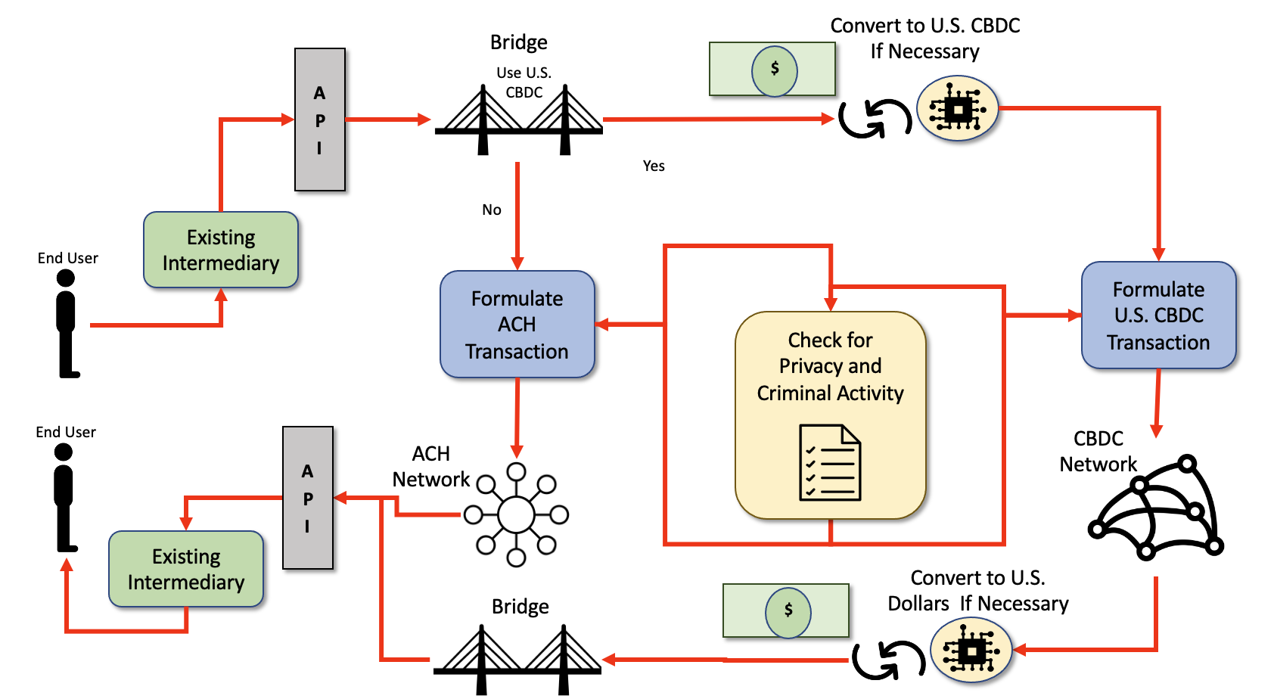
Theoretical components of a Dual ACH / CBDC System Development of a U.S. CBDC is probably based on Stablecoin Model.Use of an energy-efficient Consensus AlgorithmDevelopment of a bridge between the existing Automated Clearing House (ACH) Network and the new U.S. CBDC NetworkDevelopment of a new standardized Application Programming Interface (API) to connect the outside world to the newly enhanced combined ACH Network and CBDC Network for the existing intermediaries to use for transfersNote: The API could be in the form of Web Services, Remote Procedure Calls (RPC), Common Object Request Broker Architecture (CORBA), Data Distribution Service (DDS) or other interprocess communication mechanisms defined using ISO/OMG Interface Definition Language (IDL), standardized Web Services Interface Language (WSDL), etc.
Theoretical Very Simplified Dual ACH-CBDC Network Concept.

Examples
Return to Top
The “desirements” specified in White Paper and identified by the OMG's CBDC WG White Paper Analysis as ease of use and acceptance at the point of sale are listed in Table .
Examples of ease of use and acceptance at the point of sale identified during the White Paper Analysis conducted by the OMG's CBDC WG.
Category | Desirements
Benefits | B0003, B0007, B0009, B0011, B0012, B0013
Policies and Considerations
Risks | R0007
Design
Note: B = Benefit, P = Policy, R = Requirement, D = Design.

Discussion of Examples
Return to Top
Table provides discussion points for each of the “desirements” identified by the OMG's CBDC WG White Paper Analysis which apply to ease of use and acceptance at the point of sale.
Desirement No. | Desirement Text | Comment
B0003 | Complement, rather than replace, current forms of money and methods for providing financial services | The proposed Dual ACH/CBDC networks would do exactly that. The existing Intermediaries would be allowed to expand their services to include U.S. CBDC by basically making it a consumer choice.
B0007 | Provide households and businesses a convenient and electronic form of central bank money with: 1. safety2. liquidity | In all accounts, U.S. money could be kept as U.S. Dollars or as U.S. CBDC. Since the U.S. CBDC would probably be backed by a U.S. Dollar Stablecoin, there should be no advantage or disadvantage to either. The main difference is the End User's choice to use the real-time CBDC or the existing ACH Network. Note: There may be a cost associated with converting between the two currencies.
B0009 | Provide faster and cheaper payments (including cross-border payments) | If the U.S. CBDC network is selected by the End User, the transactions will most likely be faster but not necessarily cheaper. There is a cost associated with using the Consensus facilities of the U.S. CBDC as well as the possibility of costs associated with converting U.S. Dollars to U.S. CBDC.
B0011 | Make payments: 1. faster2. cheaper3. more convenient4. more accessible | Using the Dual Network, the End User can decide how fast they want the payments to be made. The cost of using a U.S. CBDC is still unknown. There is a cost associated with using the Consensus facilities of the U.S. CBDC as well as the possibility of costs associated with converting U.S. Dollars to U.S. CBDC.  It is up to the free market and the entrepreneurs to make it more convenient and accessible.
B0013 | Provide immediate access to transferred funds | If an End User chooses to use the U.S. CBDC network, the funds will be available as fast as the U.S. CBDC infrastructure permits. Usually within minutes. See Consensus Algorithms for more information.
R0007 | Risk CBDC is difficult to use without service providers | At a minimum, the existing Intermediaries would be able to use most of their existing infrastructure to use the U.S. CBDC. In the Workflow for creating a payment transaction:  1. Need to ask if it is going to use a CBDC transfer. a. If yes, they need to make sure the End Users account has the correct about of CBDC Stablecoinsi. If not, they need to convert U.S. Dollars to U.S. CBDC Stablecoinsii. formulate a standardized U.S. CBDC transaction and all the required datab. If not, do ACH Network business as usual
B = Benefit Considerations
P = Policy Considerations
R = Risk Considerations
D = Design Considerations

