6.03 Establish a Consortium
Return to Recommendations | <b> <a href="mailto:cbdc-feedback@omg.org?Subject=OMG's CBDC WG Response: 6.03 Establish a Consortium ">Provide Feedback</a></b>
The OMG's CBDC WG members recommend the Federal Reserve define a task for establishing a Stakeholders Consortium which would be a fulfillment of P0011 and P0030 Desirements1). These are provided in Table for convenience.
The Policy Considerations identified in the White Paper
Statement No. | Page No. | Desirement
P0011 | 3 | The Federal Reserve does not intend to proceed with the issuance of a CBDC without clear support from:Executive BranchLegislative BranchIdeally in the form of a specific authorizing law
P0030 | 21 | The Federal Reserve will only take further steps toward developing a CBDC if: Research points to benefits for households, businesses, and the economy overall that exceed the downside risksIndicates that CBDC is superior to alternative methods
Each of the two Desirements needs to be pursued separately. The Federal Reserve should continue to pursue garnering support from the Executive and Legislative Branches of Government for a CBDC as stated in P0011 and also pursue obtaining an authorizing law. However, while pursuing these avenues, it is important to present Data, Information, Knowledge, Understanding, and Wisdom based on the findings from Research Development Test & Evaluation (RDT&E).
The purpose of a Consortium would be to help initiate, guide, oversee, and coordinate RDT&E efforts. These efforts would be used to help formulate an authorizing law and provide evidence to the Executive and Legislative branches of government.
The CBDC is a large problem with many moving parts, all of which require a lot of systems analysis, engineering, testing, and simulation in order to ensure public confidence:
For a nation’s economy to function effectively, its citizens must have confidence in its money and payment services. The Federal Reserve, as the nation’s central bank, works to maintain the public’s confidence by fostering monetary stability, financial stability, and a safe and efficient payment system. from the Executive Summary provided in the Money, and Payments: The U.S. Dollar in the Age of Digital Transformation White PaperPursuing a CBDC that is flawed or not having stakeholder buy-in could ultimately inflict more damage than it is worth.
The OMG's CBDC WG further recommends that an Other Transaction (OT) Consortium be considered and the stakeholders are invited to join. An OT Consortium is a formal relationship between a government sponsor (i.e., Federal Reserve), an OT Administrator, and a collection of traditional and non-traditional vendors, non-profit organizations, and academia aligned to a technology domain area (i.e., cyber, space, undersea, propulsion) that are managed by a single entity, and focused on innovative solutions to government technology challenges that meet the intended scope and purpose of other transactions.
OT Consortium is based on the following OT Consortium Model:
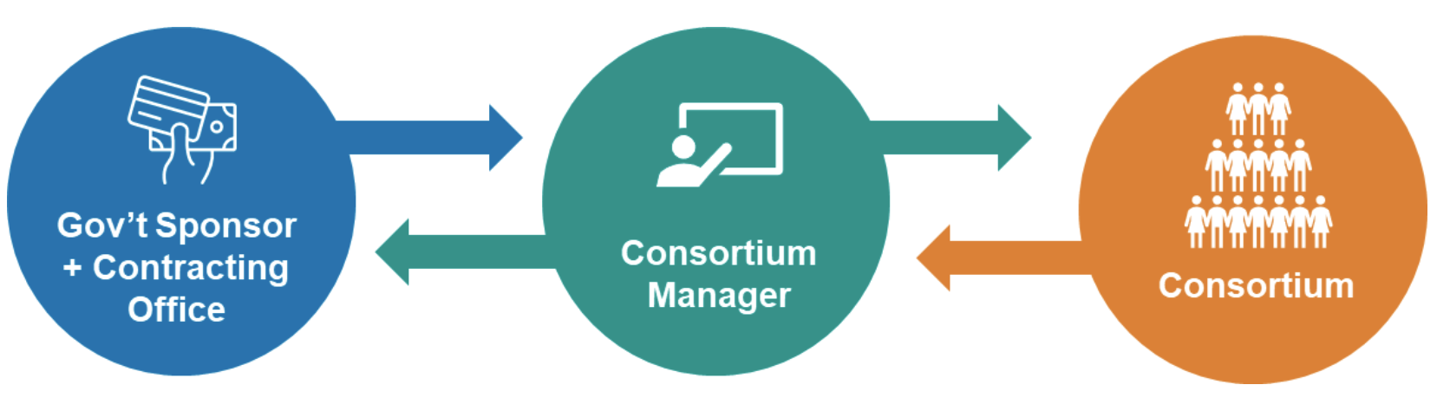
The Existing OT Constoria Model
Generally, an OT Consortium has three components:
Government SponsorGovernment Contracting OfficeConsortium ManagerConsortium (i.e., Stakeholders)Note: Sometimes the government sponsors prefer to manage a consortium in-house rather than hire an industry Consortium Manager or Consortium Management Firm.The Consortium Manager is awarded an OT agreement by the government (base OT agreement) and manages OTs awarded to its consortium member organizations (project OT agreements) under the base agreement. In the OMG Distributed Immutable Data Object Reference Architecture (DIDO-RA), this highest level (i.e., OT Consortium) is referred to as the Ecosphere which would roughly follow the steps outlined in Steps for Establishing an Ecosphere. The OT Consortia (ie., Ecosphere) can create any number of Ecosystems and Domains as is needed. It is recommended that the Ecosystems create and are responsible for Domains that fall under their auspices, however, the Policy and Procedures (P&P) may require the Ecosphere's approval for creation.

1) A Desirement is a blended word combining the word Desire and Requirement. Desirement is something that is desired, but not absolutely required and is often used to caption the capabilities of a product or system before it has reached the formal requirements phase. Source: Desirement

