6.04 Formally Define Stakeholders
Return to Recommendations | <b> <a href="mailto:cbdc-feedback@omg.org?Subject=OMG's CBDC WG Response: 6.04 Formally Define Stakeholders ">Provide Feedback</a></b>
The OMG's CBDC WG members recommend the Federal Reserve define a task for establishing a U.S. CBDC Consortium that has well defined Charter, ByLaws, Policy and Procedures (P&P), and Guidance allowing all stakeholders to participate and have a voice in the final U.S. CBDC.
The OMG's CBDC WG members recommend the Federal Reserve establish a formal list of Stakeholders in the U.S. CBDC. Obviously, when it comes to determining the Stakeholders it might be fair to include every U.S. Resident, or at least those having banking or credit union accounts. Obviously, this would be unwieldy. All these individuals are supposedly represented in government through elected officials in Congress and the President. These elected officials have taken the problem and made various departments or agencies that should be representing these people. Based on a cursory review, it appears that there are at least 33 different Oversight authorities in the U.S., see Table .
Summary of the estimated number of Government Stakeholders for the CBDC.
Potential Oversight Authorities | No. of Stakeholders
U.S. Federal Government Oversight Authorities | 14
non-U.S. Federal Government Oversight Authorities | 19
Total | 33
However, this does not include the roughly 4,200 Commercial Banks insured by the FDIC, see Figure or the largest Banking Association in the U.S., The American Banking Association (ABA), or its competitors, nor the roughly 5,300 Credit Unions.
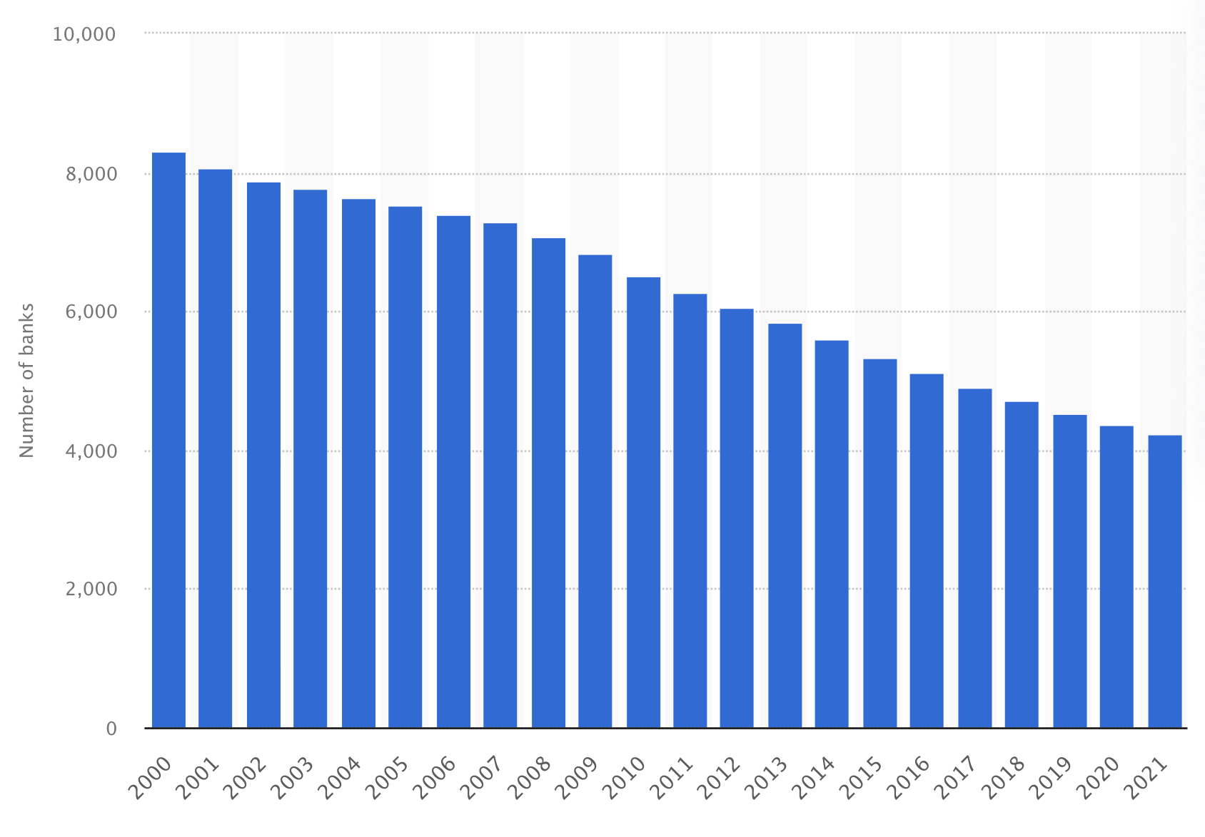
Number of FDIC-insured commercial banks in the United States from 2000 to 2021.1)Note: In 2021, there were 4,236 FDIC-insured commercial banks in the United States.
It does not represent all the retail outlets, service providers, landlords, etc that all have a “stake” in the U.S> Dollar and consequently a U.S. CBDC. For more on the Stakeholders identified in the OMG's CBDC WG analysis, please refer to section 4.1 Stakeholders.

1) Statistica, Number of FDIC-insured commercial banks in the United States from 2000 to 2021, Accessed: 8 May 2022, https://www.statista.com/statistics/184536/number-of-fdic-insured-us-commercial-bank-institutions/

