6.11.4 Smart Contracts
Return to RDT&E | <b> <a href="mailto:cbdc-feedback@omg.org?Subject=OMG CBDC Response: 6.11.4 Smart Contracts ">Provide Feedback</a></b>
The OMG members recommend the Federal Reserve use Research Development Test & Evaluation (RDT&E) Funding in developing and perfecting Smart Contracts. Currently, the de facto standard for Smart Contracts is the Ethereum language called Solidity. See the Ethereum Solidity Language Specification. However, there are shortcomings in the language which could either be updated or replaced with a more comprehensive language and may not even be procedural in nature. For example, the graphically based Business Process Model And Notation (BPMN). Another possibility would be to develop a standardized, Platform-Independent Model for a Smart Contract Application Programming Interface (API) which could have multiple Platform Specific Models developed from the PIM.
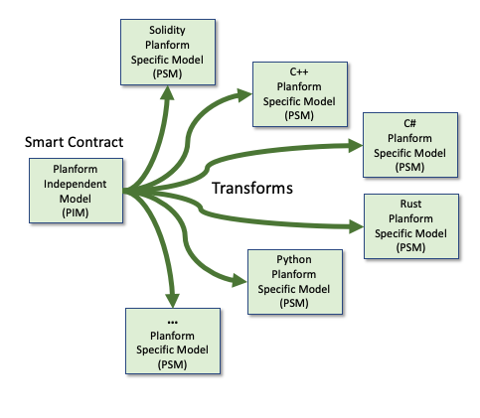
Creating a Platform Indepenent Model (PIM) and transforming it into various Platform Specific Models (PSMs)

