OMG Responses to Federal Reserve Discussion Paper
View this document in the WIKI OR Download the OMG CBDC Response.pdf
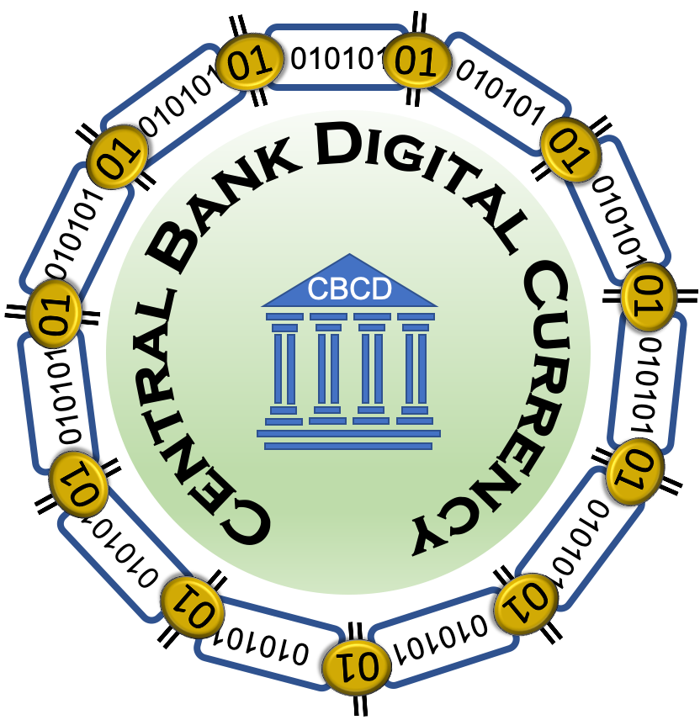
<center style="font-size:35px"> <b>Object Management Group® (OMG®) Response to The US Federal Reserve's</b> </center> <br> <center style="font-size:25px"> <i>Money and Payments: The U.S. Dollar in the Age of Digital Transformation</i> </center> <br> <center> <i>Version 1.0</i> </center> <center> <i>20th May 2022</i> </center> <center style="font-size:12px"> R. W. “Nick” Stavros<br/> Ian T. Stavros<br/> Char Wales </center> <center style="font-size:10px"> <b><i>Jackrabbit Consulting</i></b> </center> <center style="font-size:12px"> Steven MacLaird <br/> Terrance Milligan </center> <center style="font-size:10px"> <b><i>Object Management Group (OMG)</i></b> </center>

Abstract
The members of the Object Management Group (OMG) have produced a single response to the Federal Reserves White Paper “ Money, and Payments: The U.S. Dollar in the Age of Digital Transformation”. The White Paper was divided into two main sections: Discussion of a Central Bank Digital Currency (CBDC), and specific questions about the potential of a U.S. CBDC. The questions were further categorized into two main areas: CBDC Benefits, Risks, and Policy Considerations; and CBDC Design Considerations. The OMG response was written as a series of small sections using a WIKI and then printed as a PDF for submission back to the Federal Reserve. After the submission to the Federal Reserve, the contents of the WIKI are publicly available on the Internet. In order to relate the two sections, the OMG first analyzed the Discussion portion of the White Paper for "Desirements" (the white paper was not written as a requirements document, therefore the use of the term “Desirements”1)). Each of the “Desirements” was classified as being a Benefit , Policy , Risk , Design Considerations, numbered, referenced to the original page number in the White Paper, and listed in appropriate tables as a quick reference. Finally, each of the 22 questions was answered using the “Desirements” as context back to the discussion portion of the White Paper. As the answers to the questions were formulated, some Common Elements were identified and made into independent subsections for reuse in the formulation of the answers to multiple questions.

Book Contents
Return to Top
- Cover Letter
- I. Front Matter
  - a. Cover Page
  - b. Legal Responsibility
  - c. Summary of Changes
  - d. Abstract
  - e. Copyright Notice
  - f. Contents
  - g. About Content Providers
  - h. Preface
- II. Main Document
  - 1.0 Introduction
  - 2.0 Methodology
  - 3.0 White Paper Analysis
  - 4.0 Common Elements
  - 5.0 Questions and Responses
  - 6.0 Recommendations
- III. Appendices
  - Appendix A: Acronyms
  - Appendix B: Glossary
  - Appendix C: Other Transaction Authority (OTA)
  - Appendix D: Model-Based Systems Engineering (MBSE)
- V. Administrivia
  - Change Log
  - Parking Lot

1) Desirement is a blended word combining the word Desire and Requirement. Desirement is something that is desired, but not absolutely required and is often used to caption the capabilities of a product or system before it has reached the formal requirements phase. Source: Desirement

