Welcome to the OMG Central Bank Digital Currency (OMG-CBDC) Working Group (WG) Wiki
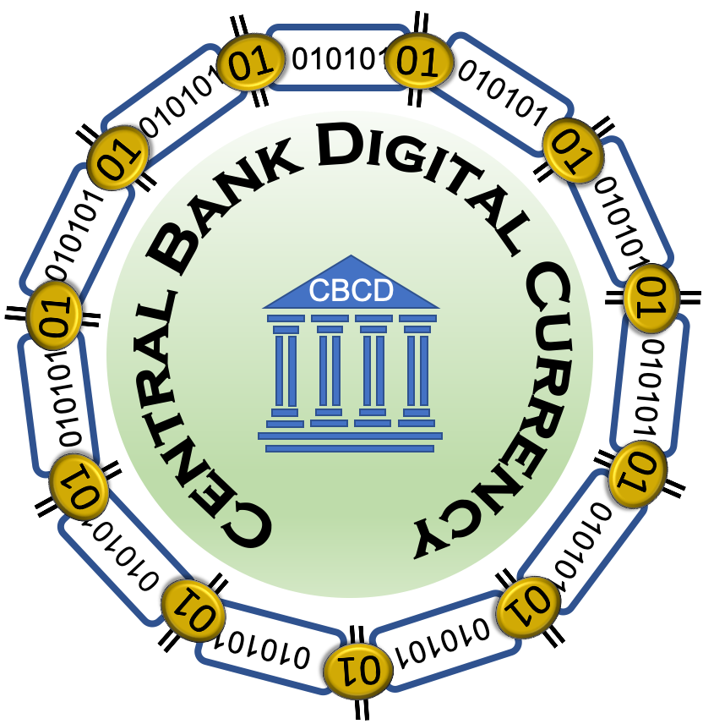

Contact Us:
Email : Contact OMG

Purpose of Wiki
The Object Management Group (OMG) wiki for Central Bank Digital Currency (CBDC) is managed by the OMG-CBDC Working Group (WG) within the OMG. It provides a place where interested parties can share publicly and among themselves information about the establishment of CBDCs. This includes capturing a Glossary of Terms, Bibliography, Acronyms, User Experiences, and content that helps explain idea and concepts important to the community such as Requirements, Overview Explanations and any applicable technical standards from community such as Requirements, Overview Explanations and any applicable technical standards from Standards Developing Organizations (SDOs) or de facto standards developed as Open Source Software or by corporations that are applicable to the CBDC.

About Object Management Group (OMG)
The Object Management Group® (OMG) is a Standards Developing Organization (SDO) that is international, open membership, not-for-profit technology standards consortium.
Founded in 1989, OMG standards are driven by vendors, end-users, academic institutions and government agencies. OMG Task Forces develop enterprise integration standards for a wide range of technologies and an even wider range of industries.

About Central Bank Digital Currency (CDBC)
Central Bank Digital Currency (CBDC) represents the digital form a Fiat Currency issued for a particular Fiat Money from nation (or region), and is issued and regulated by the competent monetary authority of the country.1)

WIKI Organization
The OMG-CBDC WKI site is organized into a private and a public area.
Private Area - this is for internal use. The information could be for private use only such as information about topics that are considered Internet Protocol (IP) or it may be content that is “Under Construction” and is not ready for release to the public.Public Area - this is for content that has been approved for public release and requires no approval to access and can be indexed y search engines. Note: Each page has its own clean Uniform Resource Identifier (URI) allowing it to be referenced easily by outside documents, web pages, or applications.

1) Central Bank Digital Currency (CBDC), Shobhit Seth, Investopedia, 6 September 2018, Accessed 24 July 2020, https://www.investopedia.com/terms/c/central-bank-digital-currency-cbdc.asp

