Parking Lot
Return to Administrivia

Instructions
Return to Top
List of actions requiring attention in the Wiki, in other words, this section is a parking lot for sections waiting to be worked on some way -- completed, moved, edited, reviews, etc.'
Example
To assign a task to an individual, use the following syntax inside of the page:
<todo @user>TBD</todo>
or
<color blue><todo @user>This is a demonstration todo</todo></color>

Where
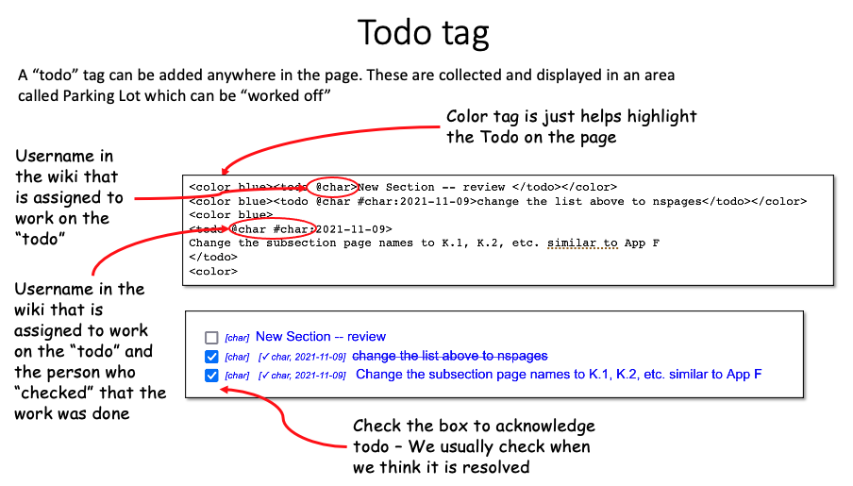
@user is the name of the OMG-CBDC WG Wiki user, such as nick
How to use the “todo” tag
For more information, see the “todo” Plugin Document: https://www.dokuwiki.org/plugin:todo

List of things "todo"
Return to Top

