DEIXWG Meeting – INCOSE IS 2022 Monday 6/27/22 10am
Celia presents Sean’s introduction Slides
Tamara, Ken, Terri: DVM
Frank: OSD representation
Chris: NDIA representation
Slides and notes will be put onto DEIX Wiki Page

Name | Email
Frank Salvatore | Frank.salvatore@saic.com
Hyman Duan | Hyman.duan@peraglobal.com
Richard Martin | tinwisle@bloomington.in.us
Garrett Thurston | Garrett.thurston@3ds.com
Tamara Hambrick | Tamara.hambrick@boeing.com
Matthew Owen | Matthew.m.owen@boeing.com
Bill Hubbard | William.e.hubbard@boeing.com
Chris Schreiber | Chris.schreiber@lmco.com
Angela Robinson (SBSE WG) | Sbse.incose@gmail.com
Bob Dillow | Bob.a.dillow@aero.org
Yasushi Matsunaga | Yasushi4536@ihi-g.com
Darryl Howell | Darryl.howell@pcgconsults.com
Greg Parnell | gparnell@uark.edu
Joe Marvin | Joe.marvin@incose.net
Arthur Brooks | Arthur.h.brooks.ctr@army.mil
Veejay Gorospe | Veejay.gorospe@3ds.com
Ryan Noguchi | Ryan.a.noguchi@aero.org
Eran Gery | Eran.gery@il.ibm.com
Eric Alexander | Eric.j.alexander13.civ@army.mil
Terri Chan | Terri.w.chan@boeing.com

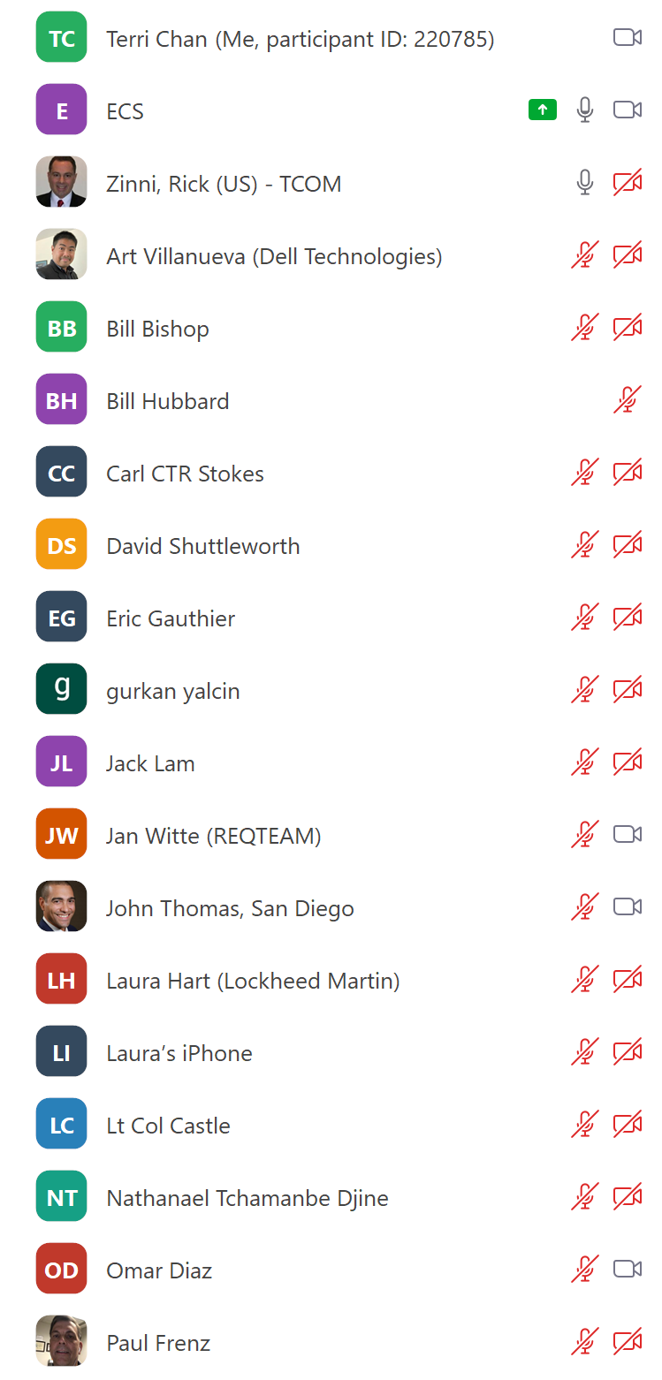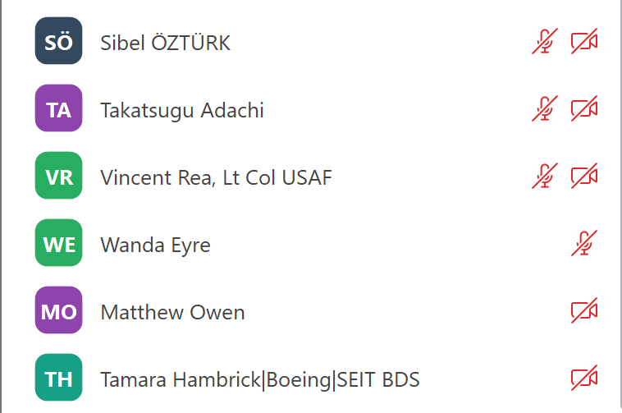

DEIX-SF (Lead: Celia Tseng)
2018 first draft of standards survey across industry to see where gaps are. Now working with ISO/IEC SC7/AG6 to product recommendation report.

DVM (Lead: Tamara Hambrick)
DVM is a concept model with four pillars. Currently building use cases in various domains to validate the concept model.
It will serve DE to connect with other industries and groups for the discussion of ontologies.
NDIA tutorial – live version of UC solicitation
Starter Model – available in Cameo 19.0
Comment: ISO/IEC 62559 Use Case Methodology
Action: DEIXWG needs a collaborative space for INCOSE, NDIA, etc. for engagement external to the group. Collaborator view of starter model and DVM concept model for those who do not have Cameo.
Action (Garrett): check with Gan for collaborative Cameo environment
--
Question re: goal of DEIXWG from a new member
Defining views and viewpoints with information exchange. Role based interactions. (e.g. CDRLs)
[technical break to move room setup – esp. the owl – closer to the center of the group]
--

DEIXWG SF Sub-Team
June 2 Plenary ISO/IEC/JTC SC 7 Kick-off. Celia has a detailed report and will be posting it onto the OMG Wiki page.
Comments from Zoom
Bill Bishop: Does the DEIXWG have a means to learn whether the participants present at IS 2022 include people from other groups who can speak to lessons learned from other approaches to digital engineering information exchange? Digital Engineering (US DoD), Digital Transformation (NASA), Industrie 4.0 (Germany), or Industry 5.0 (European Union)?
Omar Diaz: Hello Bill, there are lessons learned from some of the members of the community you asked. However, some of these groups, in specific those in the intelligence side might be hesitant to share. NATO should be an interesting community to explore on their lessons learned about digital engineering information exchange.
A lot of people think MBSE is DE, which isn’t true. How we holistically hold together information (no air gaps) is what is important.
Action (Richard Martin): Provide point of contact for IEC TC 1 JTP 3
DE is the discipline for the transformation. (will need to get the chat transcript)

--
Connect Art with DVM sub-team
Arthur.h.brooks.ctr@army.mil

