Workshop at OMG FDTF Chicago
We worked through the process elements of a Vanilla IR swap.
Attached are two deliverables from this: a hand drawn diagram on the fkip chart
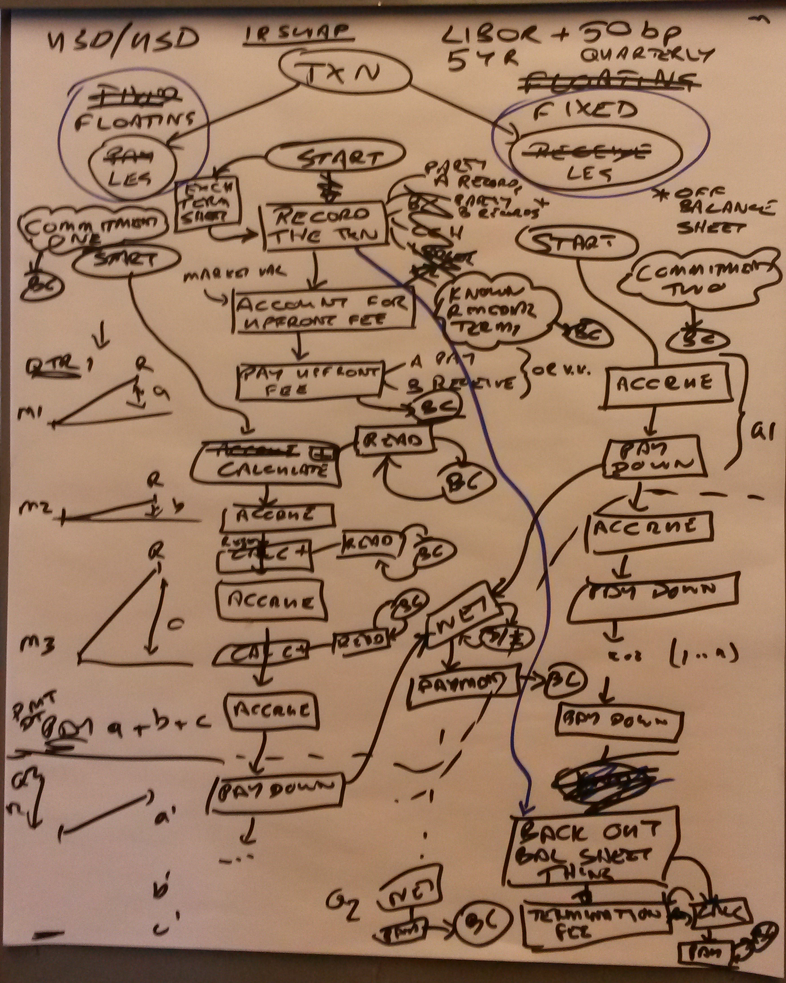flip chart
and an MqgicDraw UML Activity Diagram model - you will need to unzip the latter locally.
We discussed these on the most recent Blockchain WG call on 20 September (no separate notes). Agreed action was to complete the UML model in line with the flip chart details and then start adding links to the data elements.

