FDTF Distributed Ledger WG Call notes
10 April 2018

Attendees
Name | Affiliation
Dan Webb | Higher Upstream
Bobbin Teegarden | OntoAge / NoMagic
Pete Rivett | Adaptive
Mike Bennett | EDM Council
Rob Nehmer | Oakland University

Agenda
- Diagrammatic exploration of the FIBO IR Swaps model
- Use of Occurrence and OccurrenceKind as basis for process definition versus occurrence of variable data events during the life of the swap

Call Notes
Reference: IR Swaps Process Diagram unchanged since last week) – see Figure 1.
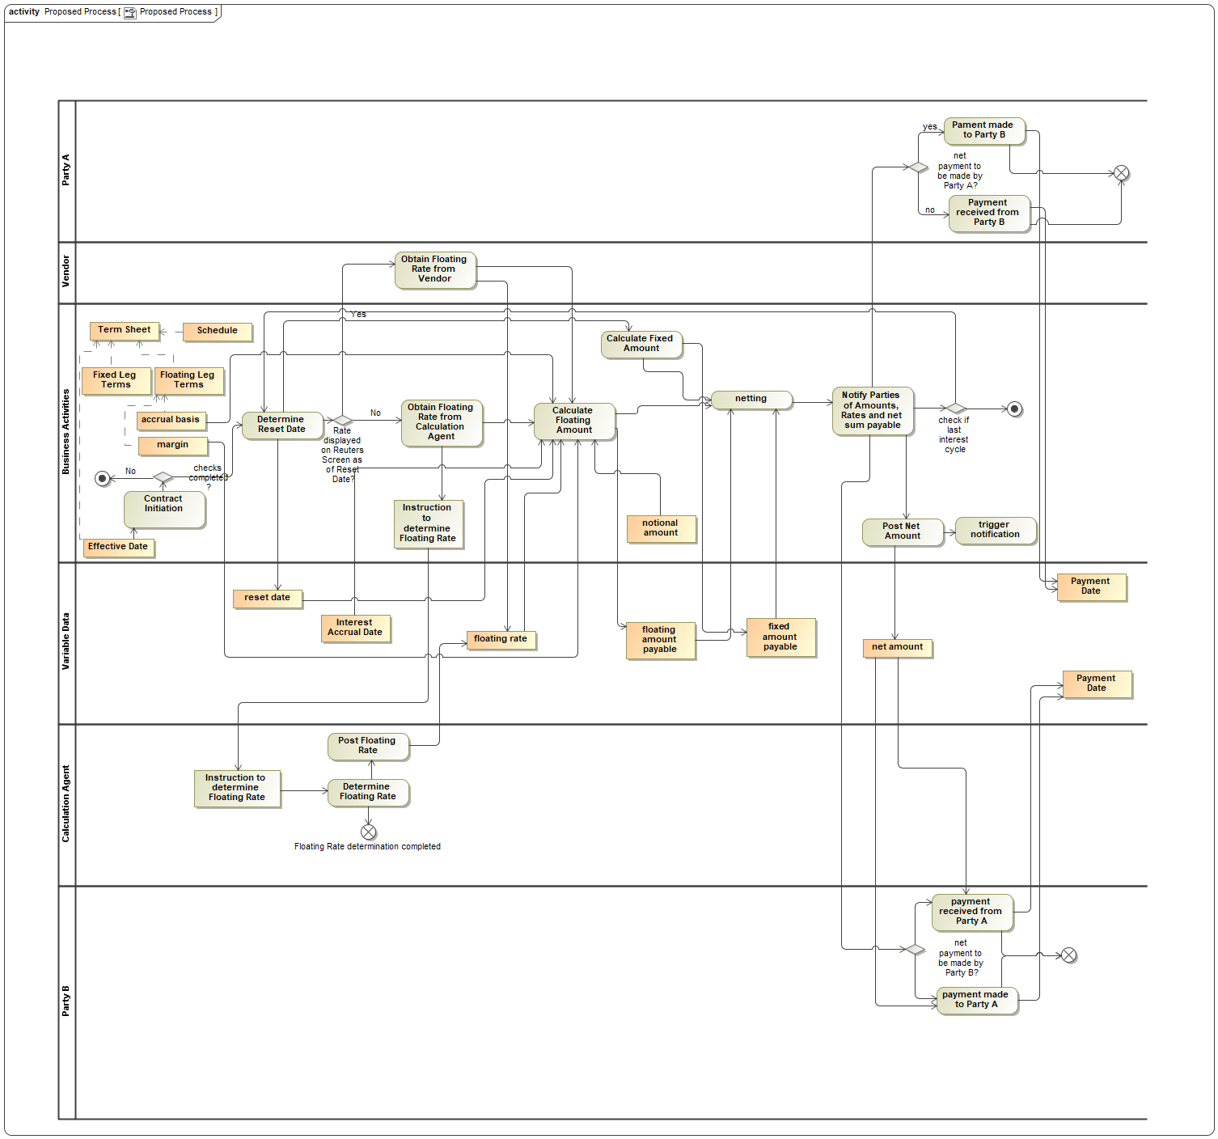
Figure 1: IR Swap Process working diagram

Current Model for IR Swaps
MB made slight adjustments to the IR Swaps FIBO ontology diagram since last time. This is in Figure 2. A zoomed-in close-up of the relevant (non-inherited) parts of this diagram are in Figure 3.
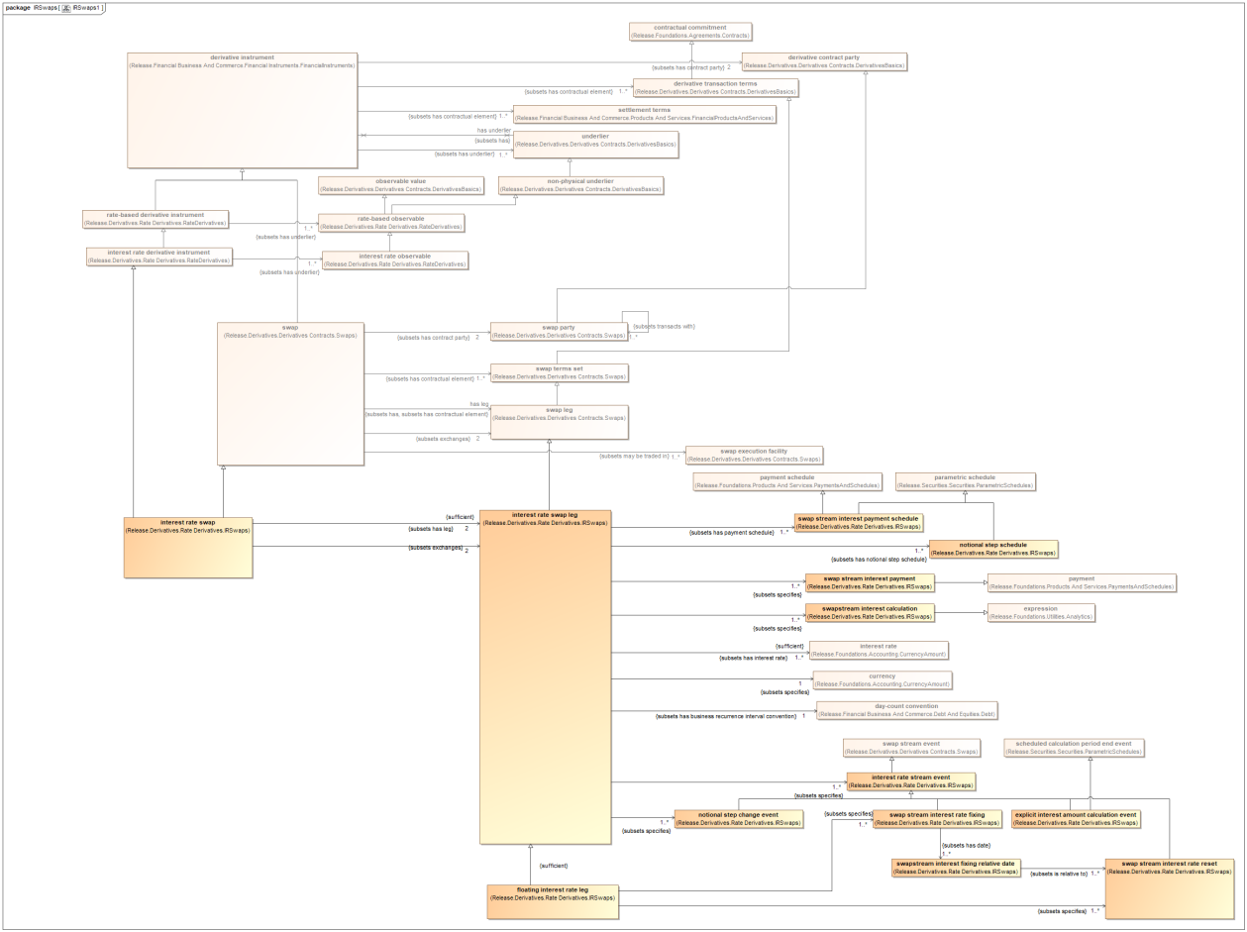
Figure 2: IR Swaps detailed exploration diagram
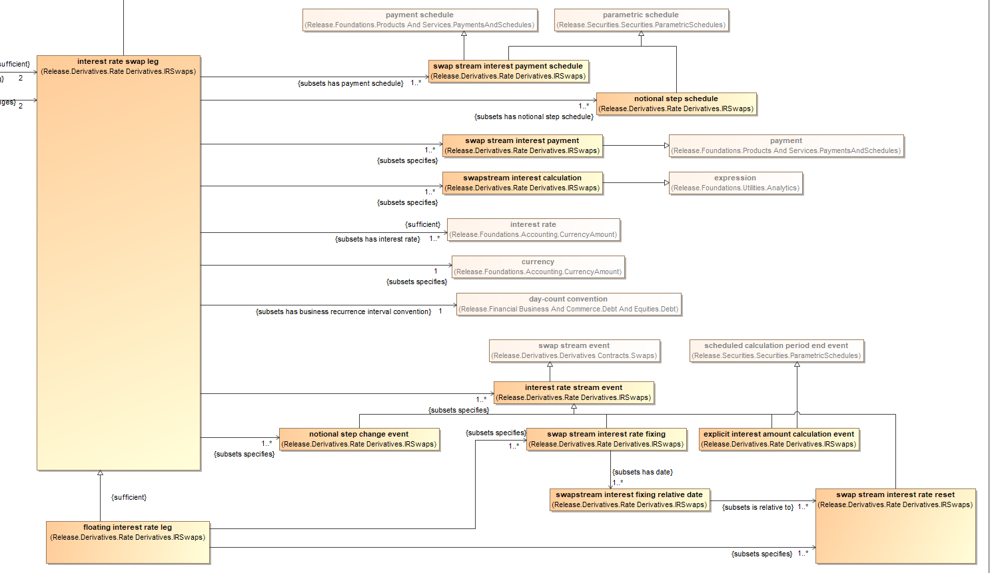
Figure 3: Detail of terms local to IR Swap in the above diagram

Discussion
The stated aim of today’s call was to figure out where the identified ‘Variable Data’ in the IR Swaps process diagram fit in.

FIBO Background
MB describes the original model. In this, variables that take different values over time (i.e. variables) have always been retained in a separate top level domain, called Market Data. The exception is for Indices and Indicators, where a similar distinction was made in the conceptual origins, between Variables and the Values that those variables might take i.e. past, present and future values.
The thinking was that these should be ring fenced from the static definition of the meanings of contracts themselves, and that we would seek out the most appropriate research on the ways to adequately represent past, present and future values and the temporal granularity of the values of variables themselves, i.e. overnight, real time, monthly and other types of temporal variation.

Review
MB is surprised to note that the Release model for Interest Rate Swaps in the Release DER domain, shown in Fig 2 and 3, includes what appear to be classes of ‘Event’.
We need to establish whether these classes represent categories of event (kinds of occurrent – see discussion below), or if they represent categories of the specification or definition of events, as seen in process definitions (kinds of OccurrentKind – see below).
First we looked at the Occurrence and OccurrenceKind classes in Release FIBO to see what these are intended to mean.

Occurrence / Occurrence Kind
Review of Occurrence and OccurrenceKind in FIBO as basis for process definition versus occurrence of variable data events during the life of the swap.

Seem to relate to definition and instance of something that occurs.

Definitions
OccurrenceKind
‘An OccurrenceKind is a type of event, which has a description. An OccurrenceKind may or may not ever happen, and thus does not have a Date. An OccurrenceKind happens as an Occurrence, which does have a Date.’
Occurrence
‘An Occurrence is a happening of an OccurrenceKind. Each Occurrence has a DateTimeStamp, which identifies when the Occurrence happened, and a Location (possibly virtual), that identifies where the Occurrence happened.’

FIBO History
We acquired these terms from FIBO OWL developers (Mark Linehan) in the Release version of time terms, called FinancialDates. This itself is based on 2 core concepts taken from SBVR, called Occurrence and OccurrenceKind. This introduces these as new upper ontology partitions for the occurrents space, following the removal of the original upper ontology partitions, which included Continuant versus Occurrent (i.e. a level above this).

Other sub partitions of Occurrent in the original Upper Ontology included intended versus non intended occurrent, cumulating versus non cumulating occurrent and several others. We used common sense labels where possible (resisting the label ‘telic’ for functional occurrents). The labels selected were self-explaining.

Original conceptual semantics in FIBO identifies one of these pairs of disjoint facets of Occurrent, as
Descriptive v Prescriptive Occurrent. Prescriptive Occurrent forms the basis for processes, plans and other prescriptions of things that should happen. Descriptive is things that did or will happen, having a date (in the past, present or future) and therefore correspond closely to the Release FIBO notion of Occurrence. By extension, all other kinds of Occurrent seem to correspond to what in Release FIBO is OccurrenceKind, including but not limited to Prescriptive Occurrent.

SMIF Models
More recently we also have the work introduced by Cory Casanave into FIBO Foundations, where we have the notion of Thing versus Kind, as a means to address among other things the treatment for PowerTypes. Cory also suggested that the same pattern could be parental to the existing pairing in Release FIBO of Occurrence and Occurrence Kind. This would bring much needed clarity to those existing models, where the existence of Occurrence and occurrence Kind have been an ongoing source of concern to many OWL modelers on different FIBO Content Teams, most notably Loans.
The proposal today is to use Kind from the SMIF work as a way to frame the distinction between Occurrence and Occurrence Kind in these existing FIBO Release terms.

Discussion
Terminology is a problem:
- Descriptive v Prescriptive Occurrent - is intimidating but unambiguous.
- Occurrence Kind is confusing and subject to multiple interpretations

Academic words are less subject to misinterpretation but intimidating.

What do these even mean?
- An instance of the Occurrent is an Occurrence
- An instance of the Occurrence Kind are any categories of occurrence including Prescriptive and others.

MB notes: this fits in with the PowerTypes usage suggested in SMIF, since it relates to cases where the end user might wish to stand up instance data where that instance data stands in relation to a category of individual things in the world (a category of actions or activities in this case).

Possible description:
[none suggested]

Possible Labels:
Occurrence v Occurrence Definition

Where Occurrence Definition can include process step / activity definitions.

Then:
- Process flow is all under Occurrence Definition
- Actual payment, calculated amounts etc. all under Occurrence

MB adds: it is unlikely that the already reviewed and agreed Occurrence and Occurrence Kind concepts are able to be changed at this stage. We may comment, correctly, that the labels render these concepts impossible to understand, but they have been part of Release FIBO for some time. Our remit in FIBO itself is to improve upon what is already there. This work would be carried out by the FIBO foundations Content Team and does not fall under the work of this Working Group.
We can suggest to the FIBO FND FCT that we add sensible synonyms to these concepts. Specifically, we would add the synonym ‘Occurrence Definition’ to the class ‘OccurrenceKind’

Completing the Review
With these findings in mind, we come back to the classes labeled as some kind of ‘Event’ in the FIBO models shown in Fig 2 and 3.
The question to address is, are these intended to be specifications of these events in a process model (classes of OccurrenceKind AKA Occurrence Definition), or are they intended to be actual occurrences i.e. actual payments of interest and the like, these being the terms we have in the ‘Variable Data’ column in Figure 1.

Results

Definitions
Most of these appear not to have definitions. The exception is the class ‘explicit interest amount calculation event’ whose definition is:
‘the explicit representation of the calculation event in a given period, in which an interest payment is calculated based on the rate (fixed or floating) and the notional amount (in the payment currency, and factored for Fx if necessary), on a given date’
This appears to suggest that this is of the kind of thing that is an actual occurrence rather than a definition or kind of occurrence.
The sibling term ‘notional step change event’, which is not directly relevant to this PoC but is a sub-class of the same common term for these events, has the following definition:
‘a step change in the notional amount of the swap stream’
Unlike the previous definition, this one does not make it clear whether it refers to the actual step change that occurs in each cycle, or the prescriptive definition of that kind of event in the schedule.

The parent of all these classes is SwapStreamEvent, which has the following definition:

‘a payment event (e.g., interest payment, coupon payment, etc.) against one leg of a swap stream’

Depending on the intended semantics of the word ‘event’ here, this would appear to refer to the occurrence of the event, i.e. the class of things of which each individual occurrence is an instance.

Class Hierarchy
An exploration of the class hierarchy for these terms yields Figure 4.
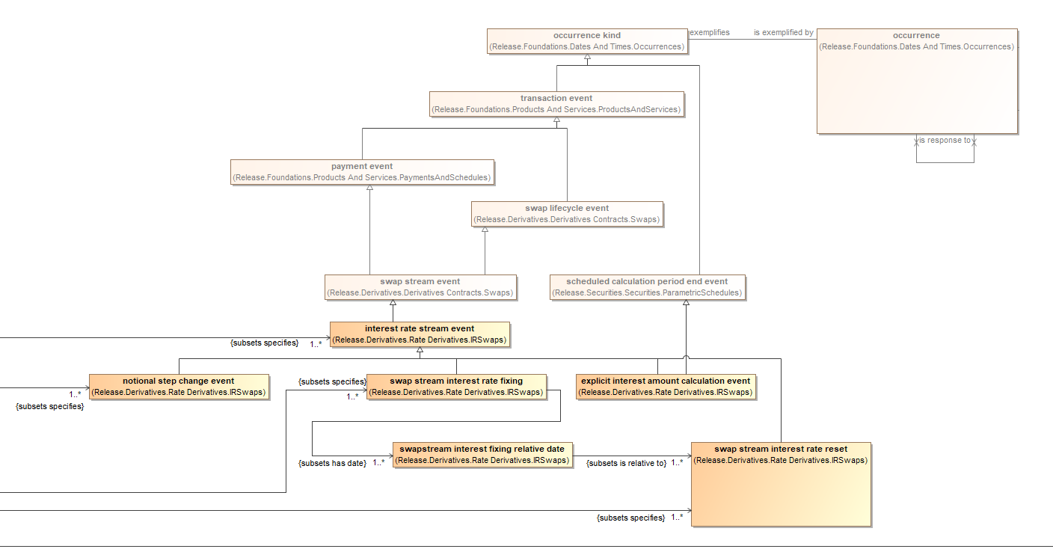
Figure 4: Exploration of IR Swaps Events Taxonomic Hierarchy

Occurrence
A further exploration of Occurrence in the above yields that this has the following 2 properties:
- exemplifies [1] Thing
- someValuesFrom restriction on property isLocatedAt Location

So Occurrence is the thing that happens (despite seemingly lacking a time, it has a place, which may be physical or virtual). Occurrence Kind is the thing that should exemplify this. However, since Occurrence itself is the domain of the property ‘exemplifies’ and has a cardinality restriction of 1 on this, even that is not so clear cut.

Moreover these are shown as all being kinds of ‘Transaction Event’ (including ‘Notional Step Change Event’), where the definition of Transaction Event frames it as being that event which is a transaction rather than some event that forms part of a transaction. This is incorrect.

Conclusions
It seems likely that the classes identified as Events in the IR Swaps model in FIBO are intended to describe the actual variable data event rather than an exemplification of these as prescriptive kinds of event in a process, though this is not completely clear.

It is also possible that these are intended to serve the purposes of both of these concepts, though that would raise the question of why the Occurrence / Occurrence Kind distinction is used in this part of the model at all.

The written definitions where available appear to identify these concepts as representations of actual events that occur in the world, which would make them the events that correspond to the data represented in the classes in the ‘Variable Data’ swimlane of our IR Swaps PoC process diagram.

These are also shown as kinds of Transaction Event, which is incorrect since the definition and usage of Transaction Event describes actual transactions not events within a transaction, which these are.

Note that some of the concepts and relationships we have identified in this PoC are not present in this FIBO model.

Next Steps
We should proceed on the basis that some classes like this are representations of the actual events that occur in each quarterly cycle, but re-create these as an extension of the FIBO IR Swaps ontology, with no generalization links to OccurrenceKind or to TransactionEvent.
To this extension ontology we should add the remaining events corresponding to the Variable Data in our IR Swaps process model.
As kinds of actual event these should have a simple common ancestor that has a date property, with the granularity appropriate to how and when they occur. Specifically, they have the granularity of a date not a date/time stamp. Since having a datatype property of Date is not possible in OWL we should use the Values arrangement given elsewhere in FIBO to refer to the date as an actual calendar date as a string, if this is available, and create it if it is not.
Meanwhile a JIRA issue has been raised against DER for the missing definitions and the ambiguous semantics of these classes in FIBO itself.

