Workstream 1 (Content/Planning) Session Notes
Thursday 12 July 2012

Agenda
  - Identify what work needs to be done to achieve the refocused objectives
  - Plan the calls and activities for this, going forward

Headline Points
- Will do a convenience document for September, addressing all the comments to date
  - This will not be put to a vote in OMG but is to be presented to previous reviewers
  - This will have updated content which removes the things we won’t include in the formal FIBO release (use our own judgment)
- Formal scoping of content for FIBO-BE to meet business requirements for LEI etc. will need further business SME input, and take longer (not in August / September time frame).
  - We will need to identify and recruit suitable business experts.
  - Calls will be in Wednesday 10am SME Review time slot (or as convenient for participants) and will start after Labor Day with the September convenience document as a starting point.
- Work is ongoing on the Adaptive migration in parallel with this (graphics, UI features) – end of August completion
- Transaction semantics alignment to be completed by end of August (not a critical path item)
- No meeting next week (19 July); we meet again 26 July to identify what sessions are needed in August.

References
Finance Domain Task Force June 2012
Doc Number | Title | Filename
Finance/12-06-01 | FIBO Foundation (convenience doc) | Finance-12-06-01.doc
Finance/12-06-02 | FIBO Business Entities (convenience doc) | Finance-12-06-02.doc
Finance/12-06-03 | Value Delivery Modeling Language (VDML) Overview for the Finance Task Force | 12-06-20 VDML for Finance - 2.pptx
Finance/12-06-06 | FIBO Usage Scenarios | FIBO Usage Scenarios.pptx
Finance/12-06-07 | FIBO Release Planning | FIBO Release Planning.pptx

Contents
Agenda 1
Headline Points 1
References 1
Introduction 3
Activity Planning 4
Discussion 4
Business Use Cases 5
LEI / Regulatory Requirements 5
Counterparty Credit Risk 6
Operational Ontologies 6
Planning: FIBO RFCs 7
Recap: Comments Received to Date 7
RFC Actions Summary 7
Decisions 8
Convenience Document (September) 8
Material and Scope 8
Calls and Planning 8
Informal Discussion: Shared Semantics / Namespace Alignment 9
Transactions and REA 9
Other OMG REA Initiatives 9
Ongoing Work 9
Date Time Vocabulary 10
Shared Semantics Summary 10

Introduction
Based on yesterday’s monthly update, we need to refocus the work so that when we release something to the world, we have something which delivers demonstrable value. The following slide summarizes the objectives:
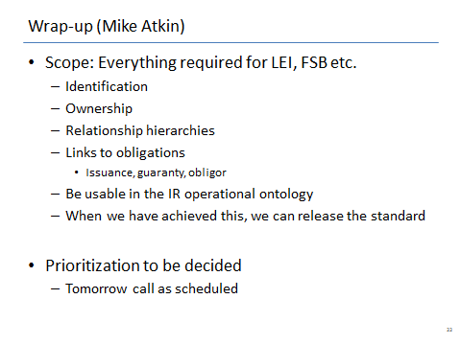
Figure 1: Conclusions at Monthly Update Call
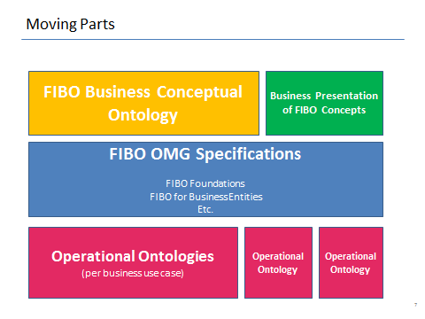
Figure 2: Summary of FIBO Moving Parts

Activity Planning
The main part of today’s session was looking at the activities needed to bring all of FIBO to a point where we can bring something to the marketplace.
Based on the overall “moving parts” map above, the things we need to deliver or maintain are:
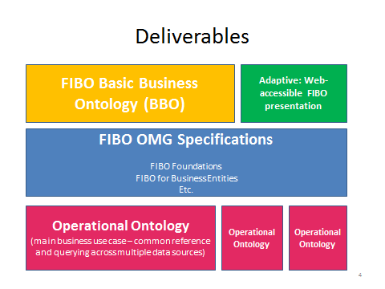
Figure 3: FIBO Deliverables per the Moving Parts

Discussion
We will not submit FIBO-Foundations and FIBO-BE for a vote in September. Rather, we shall wait until the remaining parts are in place, such that we can deliver something which is worth announcing to the world, which has a clear and demonstrable business application (operational ontology), which can be accessed by people (via Adaptive) and which is well explained.
Separately, a decision has been made that the FIBO RFC specifications to be taken to the OMG for a vote are not to include some of the “extraneous” terms which exist to formalize the meanings of concepts, but which do not have an immediate business application. That is, the OMG releases need to be more pragmatic than the current submissions. This will entail the removal of some terms from what has currently been included in the May submissions and June convenience documents.
At present, there is no material which clearly communicates to a business audience what FIBO is to be used for, and no material which clearly communicates to a data modeling audience how to use FIBO or how it relates to what would be found in a typical data model. This needs to be addressed, alongside the actions to progress the deliverables above.
What we need to work on in order to deliver the above is:
- FIBO Business Conceptual Ontology / Basic Business Ontology:
  - focus only on what is immediately needed (transactions, DTV)
- Presentation:
  - Get the material into Adaptive corresponding to each FIBO RFC
  - Design the splash screen and introductory diagrams so that people coming to this can understand it
  - Design the small icons which will be used to identify “item types” in Adaptive (archetypes in FIBO)
- FIBO Specifications for OMG
  - Identify what to take out from the content
  - Re-write the Conformance section
  - Address remaining comments from AB members
  - Add business-facing spreadsheet as an appendix
- Operational Ontologies
  - Operational Ontology Task Force
  - Believe this is being progressed through David Newman’s POC calls
  - Questions remain over whether this will result in OMG standards which are operational ontologies, or one OMG standard for the production of operational ontologies from the FIBO business material

Business Use Cases
The final FIBO deliverables in November must meet realistic business requirements, specifically:
- LEI – cover the terms and relationships which have been identified alongside Legal Entity Identifier, as being needed for regulatory purposes (minimal set of parent, ultimate parent relations)
- Counterparty Credit Exposure (FSB list) – set of Business Entity terms required to support this
  - A similar scoping exercise against FIBO-Securities and FIBO-Derivatives will be needed to complete the scope of these
The practical applications of these can be manifested in one of two ways (and deliverables are to be provided which demonstrate both)
- Operational ontology – showing automatic classification, reasoning etc. in RDF/OWL
- Business Model – showing mapping to data models, message models etc.

LEI / Regulatory Requirements
Need a minimal set of terms for business entities and legal entities, including the basic relationships of ownership and control.
We created a great deal of material in the SME reviews for relationships, including several kinds of control, and a separation of beneficial ownership from controlling ownership. This may be overkill.
A minimal ontology can be delivered which segregates and (at least for now) removes the relationships based on for example managerial control, board composition and the like. Business-facing SME Review will determine which of these terms are of interest to the current use cases.
At the same time, terms in the more abstract layers of the model (showing a more complete range of kinds of autonomous entity) may also be segregated into a non-issued section as not being relevant to this use case.

Counterparty Credit Risk
MB had a meeting the other day with Lisa Taikitsadaporn and Tom Brown of FIX, to identify what we should be working on together. Agreed that the modeling of transactions semantics was a way off (and would be easier once the Transaction Shared Semantics work is completed at the end of August). We agreed that instead we want to focus on the FSB Counterparty Credit Reporting requirements.
The plan is to produce some material from FIBO with the terms that correspond to those identifiable on the draft spreadsheets of FSB Counterparty Credit Report requirements. This is to be represented, as a minimum, in the established spreadsheet format. Diagrams may also be produced.
This will be used to map to FIX terms, and to identify any gaps in FIX coverage, specify possible new FIX messaging terms, and also identify any gaps or ambiguities in the FSB spreadsheet itself (for example, instrument types are given only as column headings, with insufficient information to determine the precise scope required or implied for these instruments).
This is an implementation of the primary use case of FIBO: define business terms and definitions in such a way that they may be mapped to logical or physical models.
Note also that mapping is unlikely to be one to one in many cases. We expect to explore ways of representing and mapping many-to-many or many-to-graph relationships. Adaptive is one tool that may be used for this.

Operational Ontologies
Question: If we are to put forward a proposed OMG specification RFC, what form will this take? Will it describe a single operational ontology (or several operational ontologies), or will it describe a forma method for deriving operational ontologies from the FIBO conceptual material?
Both of these options are on the table. MB preference is the latter – come up with a formal set of methods and techniques for deriving operational OWL ontologies, and include in this how the extraction may be tailored for specific use cases. Others may have different views. We should note that the current Proof of Concept ontologies for IR Swaps represents a small part of a small part of what is already in FIBO.

Planning: FIBO RFCs
See “Convenience Documents” released in June:
Finance/12-06-01 | FIBO Foundation (convenience doc)
Finance/12-06-02 | FIBO Business Entities (convenience doc)

Recap: Comments Received to Date
Comments received from members of the Architecture Board (AB) on the May 2012 submitted documents. The bulk of these comments related to two problem areas:
- The format in which the model content was presented
- The Conformance sections
The comments were received from Steve Cook (Microsoft), Elisa Kendall (Thematix) and Andrew Watson (OMG). Additional comments were received from Sridhar Iyengar and a colleague (IBM) along with a reminder to revisit earlier IBM comments on a previous informal draft.
The convenience documents above have addressed the first points, since they contain material generated from Adaptive and in a format agreed by the FDTF at the Cambridge meetings. Previously we had generated these content sections from the EA tool, and the format and implied metamodel of these was impossible for reviewers to understand and review.
In fairness, we should allow that reviewers found the material difficult to read and disorienting for two reasons not one: as well as the format of the EA reports, it is likely that the content itself is disorienting and difficult to follow. This is to be addressed partly by better descriptive material and diagrams, and partly by removing those items which do not have an obvious business application in an OMG standard.
The second point, on Conformance sections, requires a re-write. At the Cambridge meeting we identified a way of addressing conformance which would satisfy the bulk of the comments (i.e. reducing the number and nature of available conformance points) while still satisfying the basic requirement for people to be able to assert conformance to FIBO for a range of types of application. That is, the combinational explosion of conformance points has been addressed in the new suggestions.
This just needs implementing in the written specification.

RFC Actions Summary
The following is a description of what needs to be done to complete the RFC specification documents for FIBO-Foundations and FIBO-BE:
- Content: Remove the content which is not suitable for an OMG specification
- Presentation: Generate the same Adaptive output for the model content, as we did in the June convenience documents
- Conformance: re-write the conformance section
- Other comments / readability: revise, apply errata, check for “audience” notes in each section etc.
All of this can be done between now and September without risk of slippage. However the precise scope of the completed FIBO-BE content will require the involvement of business subject matter experts. This cannot realistically be done by the mid August 4-week submission deadline for the September meetings.

Decisions
- Provide a convenience document to show to the reviewers
- Come up with a minimum scope for the OMG FIBO-BE release

Convenience Document (September)
It will be good to show the AB reviewers a clean, convenience document for FIBO, which aims to address their concerns. This will let us see if those concerns have been addressed, and will show everyone that the momentum of this work is continuing.
Action: Implement the FDTF decisions on Conformance points
Action: Fix the remaining comments (including earlier IBM comments)
Action: Produce a convenience document for FIBO-BE and for FIBO-Foundations.
The convenience document can be produced at the end of August.

Material and Scope
We may not be able to determine the exact scope of the FIBO-BE material from a business perspective, but we can still make a judgment on a minimal set of terms to remove.
Action: Remove (or mark for non-inclusion) those items which we know we will not be including in the formal OMG RFC submissions
Then a separate series of business subject matter expert calls (provisionally, the Wednesday 10 – 11 SME Review call slot) can work through the business content requirements, and arrive at a final scope for the November / December time frame. To be started after the beginning of September.

Calls and Planning
Given the above, we can now figure out about the calls.
- Next week there are no calls for this group (MB is at a conference)
- Next call is 26 July
- Pete is on vacations from the last week in July, to 8 August
Decision: We will meet in 2 weeks from now, review progress, and identify whether to have scheduled calls or ad hoc calls between now and the end of August.
There are a number of activities to be completed by the end of August, as follows:
- Identify what content we think should be taken out of FIBO for the OMG releases
- Rewrite the Conformance sections in both documents according to the decisions made by FDTF
- Re-run the Adaptive import process on the new material
- Produce an updated document for each FIBO RFC by the beginning of September
- Circulate this as a Convenience Document
Most of this work involves MB and PR and can be done off line.
The Adaptive presentation work is also ongoing during this time (MB to draft icons, introductory diagrams)
Meanwhile, the longer term work on what to include or exclude for the main business use cases, will likely be done as Wednesday 10 – 11 SME Reviews, and can start in September. This will use the above convenience document and content as a starting point.

Informal Discussion: Shared Semantics / Namespace Alignment
The following initiatives are ongoing in the “Shared Semantics” work:
- Transactions – alignment of REA, XBRL terms for transactions, double entry book-keeping/reports, rights and obligations or commitments
- Date and Time – alignment with the OMG’s Date Time Vocabulary (DTV)

Transactions and REA

Other OMG REA Initiatives
Pete Rivett has connected up the work we are doing, with separate work in the OMG on the REA ontology, in which Pavel Hruby (one of the leading lights in the REA community) is involved. This latter work is on the application of REA principles internally to an organization, and feeds in to the OMG standard for Value Delivery Modeling Language (VDML).
Reference:
“Value Delivery Modeling Language (VDML) Overview for the Finance Task Force” by Fred Cummins. Presentation at the Cambridge June Quarterly meeting, to the FDTF.
OMG document number Finance/12-06-03.

Ongoing Work
Mike Bennett recounted a recent session with Bill McCarthy of Michigan State University, the originator of the REA ontology. Bill was able to address many of the open questions by the Transaction Shared Semantics working group, having missed several sessions. A follow-up call is scheduled for next week.
The group have agreed to continue the work through August, on a more frequent basis than the current monthly calls (i.e. weekly or bi-weekly). We anticipate having the work in a publishable state by the end of August. This is also the time that this work can be brought into the main FIBO repository (it is currently ongoing in a separate instance of the repository).

Date Time Vocabulary
This is still in the early stages. Mike is on the Finalization Task Force (FTF) for the DTV standard, and has also been invited onto the Revision Task Force (RTF) for the latest revision of the SBVR standard, in view of the connection between ongoing questions around “State of Affairs” including questions that need to be addressed for FIBO securities and derivatives schedules and for the future work on date and time-sensitive terms (market data etc.).
In fact some quite fundamental questions are being considered in this work, and the work is a long way from being in a state where we can use it.

Shared Semantics Summary
The “Shared Semantics” work is to take something of a back seat in the months up to our full formal release of FIBO materials. However, the transaction related work will continue and should come to a conclusion by the end of August when it can be incorporated into the main ontology.
See also notes in the technical modeling session: we want to consider alignment of other upper ontology terms, principally GIST and DOLCE, as part of our cleaning up of the overall modeling framework.
There is also a long-term vision for the architecture to support shared semantics, under the heading of the “Basic Business Ontology” (BBO). This name was suggested by Benjamin Grosof and reflects the accepted usage of the term “Basic Ontology” for this combination of upper ontology and abstract business terms.
This work comes under the section identified as “FIBO Business Conceptual Ontology” in the main picture. It will not form part of the OMG FIBO releases for FIBO Foundations or FIBO for Business Entities, but forms the supporting semantic infrastructure which holds this together.
The aim is to be able to release something in November (for December votes) which not only embodies the FIBO OMG RFCs, but includes all of the supporting ecosystem (conceptual ontology; operational ontologies). This is a necessary part of that, and we should at least get it to the point where all the relevant abstractions are in place and are unlikely to change (other than by addition) going forward.

