System Modeling Assessment & Roadmap WG,
The following is a summary and follow-up actions from our two day face-to-face Working Group meeting at the La Jolla OMG meeting on December 8 and 10, 2015. Please review this summary and respond to the actions below. The presentation slides from the meeting are posted along with this meeting summary on the meeting page off our WG Wiki at:
http://www.omgwiki.org/OMGSysML/doku.php?id=sysml-roadmap:la_jolla_dec_2015_meeting_presentations .

Hedley will provide the web and dial up information for our next WG telecon on Wednesday, January 6, at 11:00 AM ET.

FOLLOW-UP ACTIONS
- Hedley to schedule next telecon for Wednesday, January 6, at 11:00 ET
- Sandy to post meeting summary and presentation slides to the WG Wiki.
- Concept leads to review and comment on summary of key features of their concepts below in the SME section following the figures and provide updates to Sandy by December 23
- Concept leads to continue to refine concepts based on feedback and include the following:
  - Driving Requirement (refer to SME Requirements)
  - Limitations of current SysML modeling capability
  - Proposed SME concept
    - Effectiveness measures
    - Service requirements (e.g. functions)
    - Illustration of concept for Hybrid SuV scenario
    - Prototype of concept to demonstrate feasibility
- Concept leads to create/update their Wiki page for their concept
- Hedley to draft an example of a service requirement for the RFP and service specification for the SysML v2 specification
- Sandy to draft agenda for 2 day WG meeting (Tuesday and Thursday) the week of March 14, 2016 at the OMG meeting in Reston

BACKGROUND
The following background is an extract from the September 2015 meeting in Cambridge for your convenience.

This WG was chartered to develop the requirements for the SysML v2 RFP, which is intended to be a next generation System Modeling Language. The WG is in the early stages of developing the requirements and concepts for a System Modeling Environment (SME) that encompasses the system modeling language and tools needed to support model-based systems engineering (MBSE). The SysML v2 requirements will be derived from these higher level requirements and concepts.

The initial high level requirements for the SME are documented in the August 2015 edition of the INCOSE Insight, which has MBSE as its theme. The article is entitled 'Evolving SysML and the System Modeling Environment to Support MBSE' and defines 7 capabilities, 8 measures of effectiveness (moe), and 11 driving requirements for the SME (Note: these are included in the extract from the article below). The publishing of this article serves as an initial baseline and is an important milestone for SysML v2 development.

MEETING SUMMARY
The objectives for our face to face meeting were to begin to refine, integrate, and illustrate the System Modeling Environment (SME) concepts to support requirements development for SysML v2 RFP. The agenda included the following:

MEETING AGENDA
Tuesday, December 8, 2015
09:00 - 09:30 Introduction - Sandy Friedenthal
09:30 - 10:30 Change scenario use case review - John Watson/Sandy
10:30 - 11:00 Break
Concept reviews
11:00 - 12:00 Modeling Formalism [R2] - Yves Bernard
12:00 - 13:00 Lunch
13:00 - 14:00 Analysis Concept [R2] - Manas Bajaj
14:00 - 14:30 Analysis Profile RFC - Conrad Bock
14:30 - 15:00 Break
15:00 - 16:00 Model Construction [R4] - Ron Williamson
16:00 - 17:00 Model Visualization [R3] - Chris Schreiber, Josh Feingold
17:00 - 17:15 Summary and Updated Agenda for Thursday

Thursday, December 10, 2015
09:00 - 09:15 Introduction & Recap
09:15 - 10:30 Systems Engineering Concept Model (SECM) [R1] - John Watson
10:30 - 11:00 Break
11:00 - 12:00 Systems Engineering Concepts - H Eisenmann/HP de Koning
12:00 - 13:00 Lunch
13:00 - 13:45 Model Management [R7] - Laura Hart
13:45 - 14:30 Integration with PLM [R7] – U Kaufmann/M Pfenning/C Muggeo
14:30 - 15:00 Break
15:00 - 16:00 Model Interoperability [R5] and Standard API [R6] - Axel Reichwein
16:00 - 16:15 Usability layering of the SME - Bertil Muth
16:15 - 17:15 Planning and Next Steps - All
Each of the concept leads presented their concepts and progress. The presentations are included on the La Jolla meeting page off the WG Wiki.

The concept leads should address the feedback from the meeting, and continue to refine their concepts. This includes defining the required functionality by updating the service requirements and the corresponding key effectiveness measures. They should show how their concept supports the Hybrid SUV change scenario, and where practical, provide actual prototypes of potential solutions to demonstrate feasibility of their concept. Also, Concept leads should capture their progress on their Wiki page to provide visibility and a running history.

Sandy will draft a proposed agenda for the next meeting in Reston the week of March 14, 2016. Our current intent is to schedule a two day meeting on Tuesday and Thursday of that week, which will focus on reviewing the baseline SME Concept and begin discussions on the SysML v2 RFP as summarized below:

- SME Concept baseline
  - Systems Engineering Concept Model (SECM) - (initial draft)
  - Service requirements (Initial draft)
  - Illustration of concept support for Hybrid SUV scenario
  - Prototypes of concept (where practical) to demonstrate feasibility
  - SME Model
  - SME Concept white paper
  - Concept leads wiki updates
- SysML v2 RFP approach
  - Scope (supported processes, data, and services)
  - Key questions, issues
  - Constraints
  - Related standards
  - Test cases and validation
  - Timeline

As noted above, the SME Concept provides the modeling capabilities to enable model-based systems engineering (MBSE), and will be used to help derive requirements for the SysML v2 RFP. The following figure highlights the approach to develop SysML solutions that support MBSE. In particular, the RFP requirements to support MBSE and the SysML v2 specification that are implemented by vendor solutions.
Figure 1. SysML v2 Specification Development Approach
SME Concept
The following figures represent a starting point for an integrated SME Concept.

The System Modeling Environment is used to perform MBSE in the broader context of Model-Based Engineering (MBE). It provides a systems view of an overall MBE Environment as indicated below.

Figure 2. The System Modeling Environment provides a systems perspective of the broader Model-Based Engineering (MBE) environment that enables systems engineers to perform MBSE

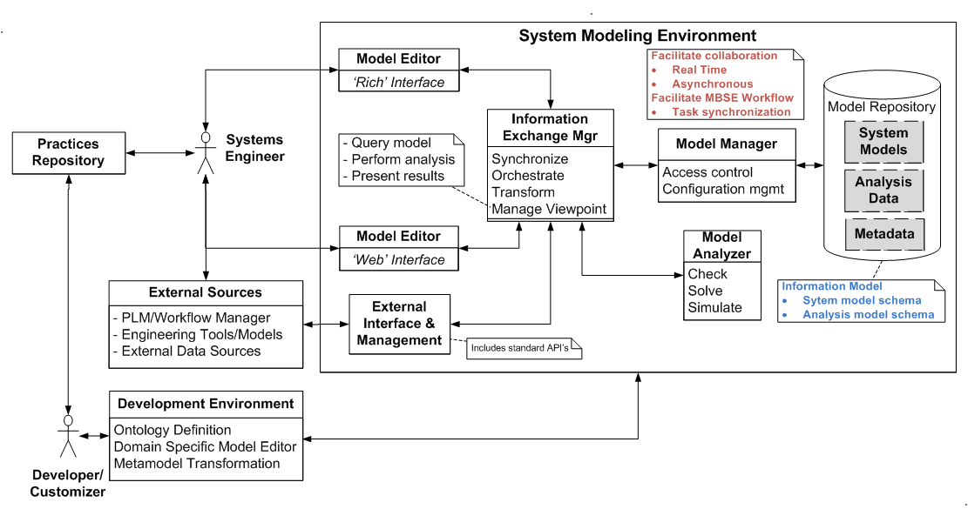

Figure 3. System Modeling Environment-Logical Architecture

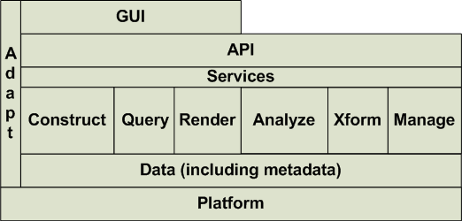
Figure 4. System Modeling Environment Layered Architecture
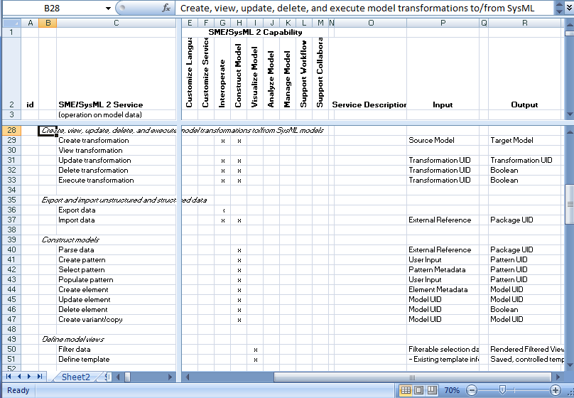
Figure 5. Service Requirements (Extract from initial draft)

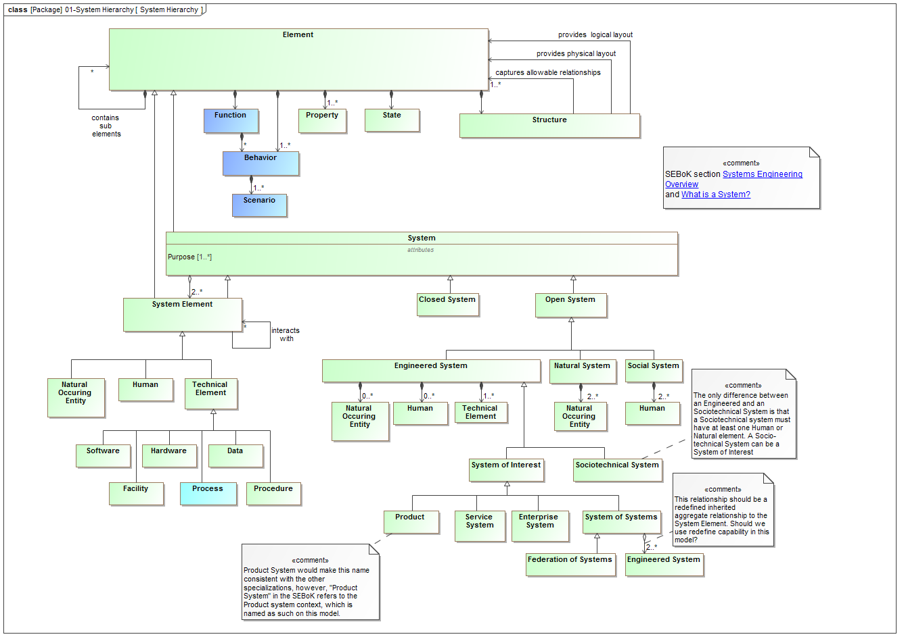
Figure 6. Systems Engineering Concept Model (SECM-2015 Industry Reference) (Extract from recent draft)

The following is a rough draft of some of the key features of the System Modeling Environment (SME) Concept presented to date. Concept leads are requested to review and update this list to highlight the more important features to emphasize as part of our concept.

General capability. The SME includes a federated data repository and applications to enable systems engineering concepts to be expressed, visualized, analyzed, managed, exchanged, and documented in support of MBSE collaboration and workflows. The environment is highly extensible to enable domain specific applications, including extensions to the language concepts, services, and user interface.

SME capabilities. The SME provides the following capabilities:
- model construction
- model visualization
- model analysis
- model management
- model exchange and integration
- support for MBSE collaboration and workflow

SME scope. The SME scope includes the following elements:
- SysML modeling language and tools
- Reuse libraries (e.g., models, practices, ..)
- Integrations with other engineering models and tools
- Extension and customization facilities

SME open environment. The SME will leverage standards from the OMG and other standards bodies where practical to provide an open environment. Possible standards include:
- OMG standards - MOF, MOF Versioning, Diagram Definition, Diagram Interchange
- Web standards (RDF, REST, SPARQL, OSLC,..)
- Other standards (FMI, ...)

SME functionality. The SME functionality supports the SME capabilities noted above.
- This functionality will be implemented as services that are exposed by a standard API
- Each unit of SME functionality supports the create, read, update, delete, execute, and change notification of the model

SME usability. The SME will provide a user interface that is intuitive and efficient.
- The SME will adapt its user interface to accommodate the needs of different classes of users including different levels of modeling expertise, different domains, and different levels of rigor.
- Continuous feedback will be provided to the user on their model development, along with on line help guidance
- Includes simplified web-based interface and rich modeling interface
- The SysML v2 specification should include guidelines to ensure the user experience is both efficient and intuitive

Systems Engineering Concept Model (SECM). The SECM will capture the key concepts needed to support systems engineering
- Capture concepts in an industry reference model based on SEBok, ISO 15288, and INCOSE SE Handbook
- Develop RFP model with inputs from industry reference model, other industry ontologies, and related OMG specifications
- SysML v2 specification includes a metamodel, profile, and model libraries that provide a precise, unambiguous, and highly usable expression of the SECM concepts
- The specification will include requirements to validate the model with defined data sets

Language formalism. The language formalism provides the foundations needed to support both quantitative and logical analysis.
- The language will be computer interpretable enabling each update of the model to be interpreted.
- The language will support complex queries that include time
- The language will include extensive validation checking to evaluate the model
- The language will provide variable enforcement that includes warnings, errors, and responses
- The language will support model to text and model to model transformation

Model analysis. SysML v2 models will seamlessly integrate with diverse engineering analysis models.
- Support for robust analysis specification
- Ability to represent robust quantitative properties to enable quantitative analysis
- Ability to support simple geometric shapes and geometric analysis
- Enhanced quantity and units libraries
- Intuitive equation generation and solving including basic math opeators
- Support for standardized expression languages
- Support for static analysis and simulation via built in solvers
- Visualization of quantitative analysis (e.g., plots, tables, ..)
- Model transformations
- Management of analysis results

Model construction. The SME will enable intuitive and efficient model construction.
- Model inputs
  - User input
  - External data sources and tools (structured and unstructured)
  - Linked data
- Text and graphical representations
- Support for model patterns
- Extensive reuse libraries
- Support for process implementation/wizard

Model visualization. The SME must provide flexible and rich visualization and reporting capabilities to support a broad range of model users.
- Highly flexible viewpoint specification and view generation through model-view-controller mechanism
- Graph visualization
- Filter, zoom, and pan capability
- Dynamic view generation
- Document generation
- Diagram definition standard with extensions to be considered

Model and data exchange. The SME will integrate with discipline-specific engineering tools, including hardware and software design, analysis and simulation, and verification.
- Standardized API and file exchange, and file storage format
- Compatible with web based standards to represent, access, and query data
  - URI, RDF, REST, SPARQL
- Support for linked data concepts
- Other standards to support model execution and analysis such as FMI
- Standardized formats for persistent data storage

Model management. The SME will be capable of managing system models as part of a heterogeneous and distributed modeling environment.
- Standardized metadata for capturing change, variant, and configuration information
- Integrate with PLM environment
- Manage SysML and its dependencies as a graph
- Unique id for all model elements
- Model configuration item is the level the model is versioned
- Model diff at element level
- Model branch and merge capabilities
- Capture incremental changes efficiently
- Ensure automated transformation between SysML v1 and SysML v2 and later versions
- Broad support for model transformation

Workflow and collaboration.
- Notification of change
- Executable worklfows

Extensibility facilities. The SME enable extension points to the Meta-model, Services, and User Interface

EXTRACT FROM AUGUST 2015 INCOSE INSIGHT
Evolving SysML and the System Modeling Environment to Support MBSE
Future Directions for SysML
The OMG Systems Engineering Domain Special Interest Group (SEDSIG) chartered the System Modeling Assessment and Roadmap WG to assess how well SysML is supporting MBSE, and to develop a roadmap for SysML as part of a System Modeling Environment. The WG is beginning to identify driving requirements for the next generation of SysML and the tools that implement the language. Some of the initial capabilities and requirements are below. These are subject to further analysis, inputs, and review with the broader community.
System modelers who perform MBSE in the broader context of Model-Based Engineering (MBE) use a System Modeling Environment (SME). This environment must provide basic capabilities that impose requirements on both the modeling language and the tools.

Some of the key capabilities for the SME include:
- Language/environment extension (added after the article)
- Model construction
- Model visualization
- Model analysis
- Model management
- Model exchange and integration
- Support for MBSE collaboration and workflow
Some of the key effectiveness measures include:
- Expressive: Ability to express the system concepts
- Precise: Representation is unambiguous and concise
- Presentation/communication: Ability to effectively communicate with diverse stakeholders
- Model construction: Ability to efficiently and intuitively construct models
- Interoperable: Ability to exchange and transform data with other models and structured data
- Manageable: Ability to efficiently manage change to models
- Usable: Ability for stakeholders to efficiently and intuitively create, maintain, and use the model
- Adaptable/Customizable: Ability to extend models to support domain-specific concepts and terminology.
Based on the above capabilities and effectiveness measures, some of the preliminary driving requirements for the next-generation system modeling language and tools are as follows:
1. The next-generation modeling language must express the core systems engineering concepts. This requires definition of a robust data model that reflects these concepts. The requirements that drove SysML derive from the original Systems Engineering Conceptual Model, jointly developed by the INCOSE/OMG/AP233 WG requirements team. Modifications and refinements to this model will occur in light of lessons learned over the last several years, and as necessary to express the core systems engineering concepts.
2. The next-generation modeling language must include precise semantics that avoid ambiguity and enable a concise representation of the concepts. SysML currently leverages the UML metamodel for much of its semantic foundations. The language must derive from a well-specified logical formalism that can leverage the model for a broad range of analysis and model checking. This includes the ability to validate that the model is logically consistent, and the ability to answer questions such as the impact of a requirement or design change, or assess how a failure could propagate through a system. The language and tools must also integrate with a diverse range of equation solvers and execution environments that enable the capture of quantitative data.
3. The next-generation modeling language and tools must provide flexible and rich visualization and reporting capabilities to support a broad range of model users. SysML currently includes concepts for view and viewpoint. Tool vendors and end users have been able to apply this capability to query the model and provide flexible reporting capability. The next generation must extend this capability with advanced visualization techniques that include dynamic zoom, filtering, traversal of model relationships, and visualization of the dynamic behavior of a system, such as those provided by simulations. The modeling language must also support symbol libraries that extend well beyond the current SysML notations. In addition, the modeling environment must provide a simplified web interface to dynamically view the model from a diverse set of viewpoints.
4. The next-generation modeling language and tools must enable much more intuitive and efficient model construction. It often requires several clicks to capture a core concept in a model. More streamlined and efficient user interfaces could reduce the time and effort to build and maintain a model. The ability to repeat common modeling patterns with reduced user input (e.g., table-based entry) is another capability to increase modeling productivity and understanding.
5. The next-generation modeling language and tools must support MBSE in the broader context of Model-Based Engineering (MBE), where the models and tools fully integrate across discipline-specific engineering tools, including hardware and software design, analysis and simulation, and verification. All these model-based tools working together establish an environment for engineering the total system.
6. The next-generation modeling language must provide a standard application programming interface (API) to provide dynamic access to the model, while providing appropriate access controls. It should also integrate with emerging platforms for managing and integrating model-based content, such as Open Services for Lifecycle Collaboration (OSLC), which is based on linked data and semantic web technology, and the Functional Mockup Interface (FMI), which provides model exchange and co-simulation capability for executable behavior models. Model transformation is another core capability of the SME that provides the ability to translate from one modeling language to another.
7. The next-generation modeling language must be capable of management in a heterogeneous and distributed modeling environment. The ability to manage change to the model, where multiple users are collaborating on a single model, is challenging enough. This basic capability requires extensive branch and merge capability that includes effective means for evaluating and integrating changes from multiple users, while maintaining a history of all changes. These challenges increase when multiple models and tools are all part of the collaboration. The ability to integrate with Product Lifecycle Management (PLM) environments, which enable versioning, configuration, and variant management, is a fundamental SME requirement.
8. Usability must be a primary consideration for the next-generation modeling language and tools. As noted previously, the learning curve for the SysML language and tools is quite steep The next-generation modeling language and tools must enable efficient and intuitive use by a broad range of users with diverse skills. This imposes requirements on model precision, model construction, model visualization, model management, and several other aspects of the language and tools.
9. The next-generation modeling language and tools must be highly adaptable and customizable to multiple application domains. This implies that the modeling language must be extensible to address domain-specific concepts, and that the modeling tools provide flexible means for the user to enter, analyze, and visualize model data in ways that are meaningful to each domain. In addition, the SME must accommodate customization performed in a standard and rigorous way.
10. To protect investments made by organizations, the next-generation modeling languages must support the migration of existing models with minimum information loss. Models must also be capable of being stored in neutral formats, retained for future access.
11. The next-generation modeling language and tools must be modular and extensible to enable evolution of the above capabilities to take advantage of on-going advances in technologies, concepts, methods, and theories.

