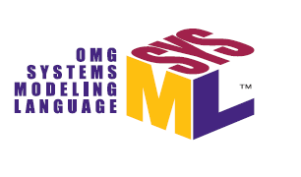

OMG Systems Modeling Language Version 2
(OMG SysML® v2)
Requirements Review Document

INITIAL DRAFT

4 June 2017
Table of Contents
1 Introduction 7
1.1 Document Purpose 7
1.2 Background 7
1.3 Organization of this Document 10
2 System Modeling Environment (SME) Overview 12
2.1 Role of System Modeling Environment in a Model-Based Engineering Environment 12
2.2 SME Capabilities and Effectiveness Measures in Support of MBSE 13
2.3 SME Architecture 14
3 Mandatory Requirements 17
3.1 Formalism 17
3.1.1 Formalism Introduction 17
3.1.2 Formalism Requirements 19
3.2 Data Model 23
3.2.1 Common Core 25
3.2.2 Properties, Values & Expressions 32
3.2.3 Structure 36
3.2.4 Interfaces 42
3.2.5 Behavior 46
3.2.6 Requirements 51
3.2.7 Verification 58
3.2.8 Analysis 60
3.3 Concrete Syntax 64
3.3.1 Concrete Syntax Introduction 64
3.3.2 Concrete Syntax Requirements 65
3.4 API 65
3.4.1 API Introduction 65
3.4.2 API Requirements 66
3.5 Services 68
3.5.1 Model Construction Services Introduction 68
3.5.2 Model Visualization Services Introduction 69
3.5.3 Model Analysis Services Introduction 70
3.5.4 Model Management Services Introduction 71
3.5.5 Workflow & Collaboration Services Introduction 72
3.5.6 Services Requirements 73
3.6 Other 82
3.6.1 Interoperability Introduction 82
3.6.2 Execution Languages Introduction 84
3.6.3 Usability Introduction 84
3.6.4 Reference Model Introduction 84
3.6.5 Other Requirements 85
3.7 Conformance 86
3.7.1 Conformance Introduction 86
3.7.2 Conformance Requirements 87
4 References & Glossary Specific to this Document 88
4.1 References Specific to this Document 88
4.1.1 Bibliographic Citation List for this Document 88
4.1.2 OMG Standards Relevant to this Document 90
4.1.3 Other Standards Relevant to this Document 92
4.2 Glossary Specific to this Document 92
5 General Reference and Glossary 121
5.1 General References 121
5.2 General Glossary 123

Table of Figures
Figure 1.1. SysML v2 Approach Diagram 7
Figure 2.1. The SME is part of the broader MBE environment that enables systems engineers to perform MBSE 10
Figure 2.2. The System Model (Source: A Practical Guide to SysML, 3rd Edition (Friedenthal, Moore, and Steiner 2014)) 11
Figure 2.3. System Modeling Environment-Logical Architecture 13
Figure 2.4. System Modeling Environment Layered Architecture 14
Figure 3.1. Uniform Interpretation (Source: SysML v2 RFP Formalism WG) 15
Figure 3.2. Core SEBoK Concepts (Extract from draft SECM-2015 Industry Reference. Used with permission) 22
Figure 3.3. Organization of SysML v2 Modeling Concepts 23
Figure 3.4. Common Core Model Element Concepts 24
Figure 3.5. Common Core Relationship Concepts 25
Figure 3.6. Common Core Model Concepts 25
Figure 3.7. Variability Concepts 26
Figure 3.8. Specifying an unambiguous system design configuration 35
Figure 3.9. Sample of Structure Modeling Concepts 36
Figure 3.10. SysML v2 Interface Concept 40
Figure 3.11. Interface Concepts 41
Figure 3.12. Top Level Behavior - Take Picture 45
Figure 3.13. Camera Context with Take Picture Functions 46
Figure 3.14. Camera Context with State Machine 47
Figure 3.15. Requirement Groups 50
Figure 3.16. Requirement Concepts 51
Figure 3.17. Example Weight Requirement 52
Figure 3.18. Verification Concepts 57
Figure 3.19. SysML v2 Analysis Concepts 59
Figure 3.20. Vehicle Weight & Acceleration Analysis 60
Figure 3.21. SysML v2 API Specification Approach 64
Figure 3.22. Model Visualization Concepts (Source: SysML v2 RFP Visualization WG) 68
Figure 3.23. Integrated System Model (ISM) Lifecycle Management Concepts (Source: SysML v2 RFP Model Management WG) 69
Figure 3.24. Workflow & Collaboration Concepts 70
Figure 3.25. System Model Interoperability Concepts 81

Introduction

Document Purpose
The content of this document was developed by the Object Management Group (OMG) SysML v2 RFP Working Group. This document provides the initial draft requirements and supporting information for the SysML v2 Request for Proposal (RFP) that will be issued by the OMG. The RFP defines the requirements that the specification for the next generation System Modeling Language (OMG SysML®) called SysML v2 must satisfy. The SysML v2 specification, in turn, will be implemented by tool vendors in their modeling tools to enable practitioners to perform their model-based systems engineering (MBSE) activities. The initial requirements in this document are expected to be updated based on inputs from review and additional requirements analysis. The requirements for SysML v2 are included in tables at the end of the subsections of Section 3 of this document.
Reviewers of the SysML v2 requirements in this document are also encouraged to read Sections 1, 2, and 3 and refer to the Glossary of Terms in Section 4 to understand the context for these requirements.

Background
The following extract is from the two previous INCOSE INSIGHT articles that provide background on this effort.
- Evolving SysML and the System Modeling Environment to Support MBSE (Friedenthal and Burkhart 2015)"
- INCOSE INSIGHT article in December 2016 entitled "Evolving SysML and the System Modeling Environment to Support MBSE-Part 2 (Friedenthal 2016)"
The need for a standard systems modeling language. The transition to a MBSE approach is essential for systems engineering to meet the demands of increasing system complexity, productivity and quality, and shorter design cycles. Many other engineering disciplines, such as mechanical, electrical, and controls engineering, utilize models as integral parts of their practice. Such models have long been important for systems engineering as well to support systems analysis and design, but MBSE emphasizes the need to create a coherent model of the system that helps integrate other aspects of the design, including electrical, mechanical, and software.
The system model provides a shared view of the system that can enhance communication and coordination across the system development lifecycle. This model represents an authoritative source of information that is maintained to ensure consistency and traceability between requirements, design, analysis, and verification. The model-based approach contrasts with the traditional document-based approach in which information spans many different documents created in common applications such as Word, Visio, Excel, and PowerPoint. To take full advantage of a model-based approach, the system model must be maintained as part of the technical baseline, and integrated with other engineering models and tools.
The capability to express system concepts in the form of models can result in quality improvements by reducing downstream design errors, and in productivity improvements through reuse of models throughout the lifecycle and across projects. Systems engineers realize other benefits, such as the ability to automate tasks such as change impact analysis, and auto-generation of reports and documentation with increased confidence that the information is valid, complete, and consistent.
A systems modeling language enables systems engineers to express fundamental systems engineering concepts about the system such as system composition, interconnection and interfaces, functional and state-based behavior, parametric aspects, and traceability relationships between requirements, design, analysis, and verification. The modeling language is an essential capability to specify and architect increasingly complex systems. A standard systems modeling language can help overcome the informational "Tower of Babel" by providing a means to express these concepts in a standard and precise way that enables communications between engineers and tools.
SysML background. The Object Management Group (OMG) adopted the OMG Systems Modeling Language (www.omgsysml.org) in 2006 and Version 1 was available in 2007. The SysML specification resulted from a collaborative effort between INCOSE, the OMG, and the ISO STEP AP-233 Working Group (WG) to develop the requirements for the language, and then develop the system modeling language solution in response to the requirements.
SysML is a general-purpose graphical modeling language for specifying, analyzing, designing, and verifying complex systems that may include hardware, software, information, personnel, procedures, and facilities. The language provides graphical representations with a semantic foundation for modeling system requirements, behavior, structure, and constraints.
Since its adoption, SysML enabled broad recognition and increased adoption of model-based systems engineering practices across industry. Systems engineers, tool vendors, and academia have learned much from this experience, in both the strengths and weaknesses of SysML as a language, and the benefits and challenges in adopting and applying MBSE with SysML.
Based on these experiences, the OMG SysML v2 RFP Working Group was initiated on July 23, 2016 in Orlando, Florida to begin work on the requirements for SysML v2. This concluded an approximate year-long effort to establish a baseline concept for a System Modeling Environment (SME). The SME is the environment that systems engineers interact with to perform model-based systems engineering activities, and the SME concept is used to help derive requirements for SysML v2 as shown in the figure below.
Figure 1.1. SysML v2 Approach Diagram
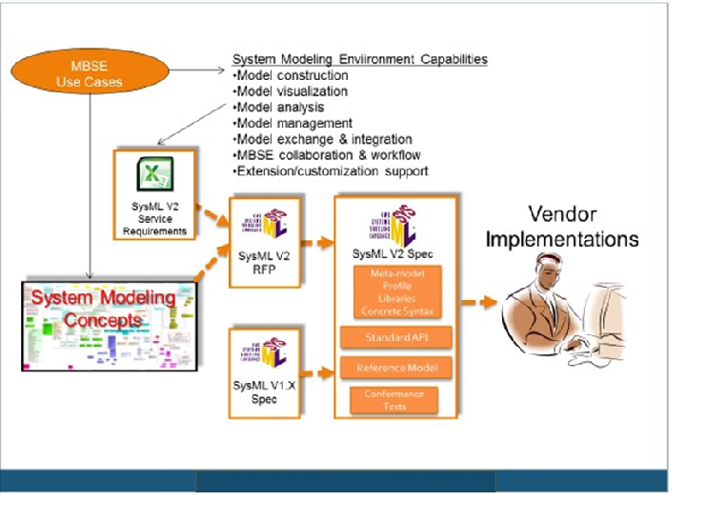

The initial high-level requirements for the SME are documented in the August 2015 edition of the INCOSE INSIGHT. The article is entitled 'Evolving SysML and the System Modeling Environment to Support MBSE' and defines 7 capabilities, 8 measures of effectiveness (moe's), and 11 driving requirements for the SME to support the specification, design, analysis, and verification of systems. A second article was published in the December, 2016 edition of the INCOSE INSIGHT entitled 'Evolving SysML and the System Modeling Environment to Support MBSE - Part 2'. This article summarizes the baseline SME Concept in response to the requirements in the earlier article. Both articles are available in final draft form under the Articles section of the SysML v2 RFP Working Group Wiki at:
http://www.omgwiki.org/OMGSysML/doku.php?id=sysml-roadmap:sysml_assessment_and_roadmap_working_group
The SysML v2 RFP defines the requirements for the SysML v2 specification, which is then implemented by tool vendors. The overarching objectives for SysML v2 are to enhance support for MBSE by improving the precision and expressiveness, interoperability, and usability of SysML v2 over SysML v1. The SysML v2 RFP includes requirements to represent system behavior, structure, parametrics, and requirements similar to the requirements for SysML v1, along with requirements that support additional system modeling concepts not explicitly included in SysML v1. The SysML v2 RFP also includes service requirements to support model construction, model visualization, model analysis, model management, and workflow and collaboration. Service requirements were not included in the SysML v1 RFP.
Submission teams will develop the SysML v2 specification in response to the SysML v2 RFP requirements. The modeling concepts and associated requirements will be satisfied in the SysML specification by both a SysML metamodel and a profile of UML. A vendor can choose to implement the metamodel or profile or both. The combination of a metamodel and a profile enable a broader range of vendor implementations. The metamodel supports implementation of the system concepts without some of the constraints imposed by UML, while the profile supports implementation of the system concepts that is more closely aligned with SysML v1 implementations.
The service requirements in the RFP will be satisfied by a standard API specification that is part of the SysML v2 specification. The standard API specification facilitates interoperability by enabling external tools, plugins, and user interfaces to access the system model using standard service requests. Tool vendors will then implement the SysML v2 metamodel and/or profile, and the standard API specification.

Organization of this Document
This document is organized into the following sections.
1. Introduction. This section includes the purpose, background, and organization of this document
2. System Modeling Environment (SME) Overview. This section provides an overview of the System Modeling Environment.
3. Mandatory Requirements. This section is organized into the following subsections for each logical grouping of requirements. Each subsection includes relevant concepts that reflect systems modeling needs to motivate the requirements, and a summary of key issues with SysML v1 in terms of its support for these concepts. The requirements are then included in tables at the end of each subsection. In some cases, motivating examples are provided to further illustrate the concept and/or highlight SysML v1 issues.
3.1 Formalism
3.2 Data Model
3.2.1 Common Core
3.2.1 Properties, Values, and Expressions
3.2.2 Structure
3.2.3 Interfaces
3.2.4 Behavior
3.2.5 Requirements
3.2.6 Verification
3.2.7 Analysis
3.3 Concrete Syntax
3.4 API
3.5 Services
3.5.1 Model Construction Services Introduction
3.5.2 Model Visualization Services Introduction
3.5.3 Model Analysis Services Introduction
3.5.4 Model Management Services Introduction
3.5.5 Workflow and Collaboration Services Introduction
3.5.6 Services Requirements
3.6 Other
3.6.1 Interoperability Introduction
3.6.2 Execution Languages Introduction
3.6.3 Usability Introduction
3.6.4 Reference Model Introduction
3.6.5 Other Requirements
3.7 Conformance
4. References & Glossary Specific to Document. This section includes a glossary of terms that are used to represent the concepts and requirements in this document and a list of references used in this document.
5. General Reference and Glossary. This section identifies applicable references to a broader set of standards that may have been used or are intended to be used in support of these requirements.

System Modeling Environment (SME) Overview

Role of System Modeling Environment in a Model-Based Engineering Environment
In the figure below, each of the disciplines contributes to the development of the technical baseline of the system as part of a Model-Based Engineering (MBE) approach. Each of the disciplines use their discipline-specific models to capture and analyze different aspects of the design. The MBE environment is the overall set of tools that all disciplines use to implement a MBE approach. The System Modeling Environment (SME) is the part of the overall MBE environment that systems engineers use to perform MBSE and interact with other members of the development team. (Note: The scope of the SME is limited to SysML v2 modeling to support these requirements, but it is recognized that the SME can be extended to include many other kinds of system models and data.)
Figure 2.1. The SME is part of the broader MBE environment that enables systems engineers to perform MBSE
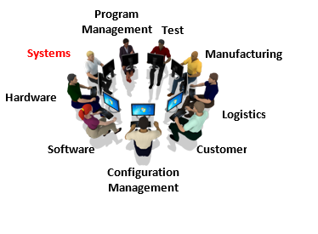

The system model provides an overall description of the system that facilitates integration with the other engineering models and tools as shown in the figure below.
Figure 2.2. The System Model (Source: A Practical Guide to SysML, 3rd Edition (Friedenthal, Moore, and Steiner 2014))
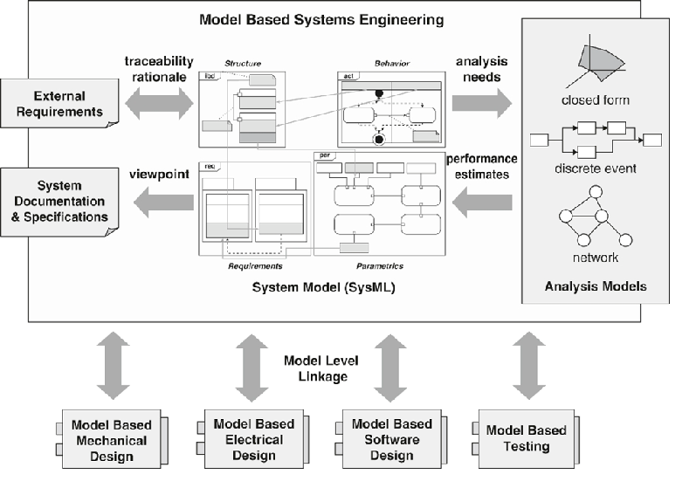

The systems engineer and others use the SME to perform MBSE as part of an overall development process to flow requirements from the mission/enterprise level to systems, subsystems, and components, and verify the components, subsystems, system, and mission requirements are satisfied. This process continues throughout the development lifecycle, with the aim of delivering systems and products that meet the stakeholder needs.

SME Capabilities and Effectiveness Measures in Support of MBSE
The definition of the initial SME capabilities and driving requirements are identified in the August 2015 INCOSE INSIGHT article (Friedenthal and Burkhart). This article defines 7 capabilities, 8 measures of effectiveness (moe's), and 11 driving requirements the SME should support. The capabilities enable the systems engineer to perform MBSE as part of a broader model-based engineering effort, and include:
- Model construction
- Model visualization
- Model analysis
- Model management
- Model exchange and integration
- MBSE workflow and collaboration
- Extension/customization support
The effectiveness measures for the SME are used to evaluate how effectively the SME supports the above capabilities. Some of these measures are difficult to quantify, and will require further refinement. The preliminary set of effectiveness measures include:
- Expressive: Ability to express the system concepts
- Precise: Representation is unambiguous and concise
- Presentation/communication: Ability to effectively communicate with diverse stakeholders
- Model construction: Ability to efficiently and intuitively construct models
- Interoperable: Ability to exchange and transform data with other models and structured data
- Manageable: Ability to efficiently manage change to models
- Secure: Ability to protect all relevant data from threats
- Usable: Ability for stakeholders to efficiently and intuitively create, maintain, interpret, and use the model
- Adaptable/Customizable: Ability to extend models to support domain-specific needs

SME Architecture
The SME must provide the functionality needed to enable systems engineers and others to evolve the system model throughout the life cycle. The diagram below is a view of the logical architecture of the SME. The model repository contains the data about the system, including the system model, analysis data, other metadata, and reuse libraries. This repository is shown as a single logical repository, but may be federated across multiple physical repositories.
The diagram shows the systems engineer using a rich model graphical user interface that provides the full functionality of the SME to create, maintain, and use the system model and other data in the model repository. The systems engineer and other disciplines can also interact with the SME using a web interface that provides the functionality needed to use and/or review the system model and other data. The user interface can present different views of the model to address different user needs. For example, a power subsystem engineer may view the power interfaces, and a mechanical engineer may view the system breakdown and mass allocation. The SME also enables other engineering tools and models and plug-ins to access the repository.
Figure 2.3. System Modeling Environment-Logical Architecture
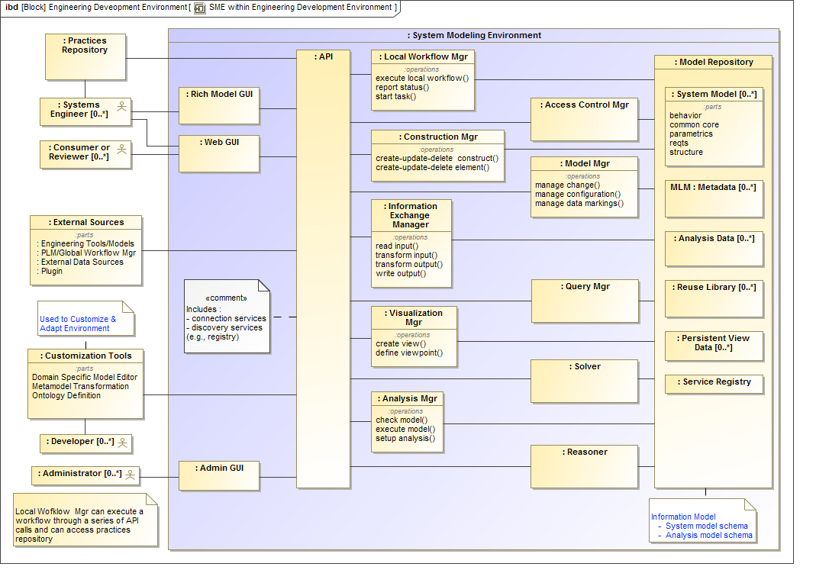

External tools also must interact with the model repository. The graphical user interfaces and the external tools access the model repository by requesting standard services through an application program interface (API). The API provides the interface to the model repository and support the SME modeling capabilities described above including model construction, model visualization, model analysis, model management, and workflow and collaboration services.
A product life cycle management (PLM) capability can interact with the SME and other discipline-specific environments to control the configuration and manage change across the overall MBE environment, and across the system life cycle. This includes synchronization tasks via notifications as the engineering work products change state. The combination of the PLM capability and the integrated system model facilitate a collaborative engineering environment.
In addition, the logical architecture includes Customization Tools to further extend and customize the SME to support different domain and program needs, and ensure the customized environment continues to be interoperable with the rest of the MBE environment.
Finally, there is a practices repository that stores the systems engineering and modeling practices that are implemented by the users of the SME. The local workflow manager is intended to facilitate the systems engineer and others to perform these practices.
The SME can be implemented by multiple vendors. A systems engineer should be able to request a service of the SME through the standard API to access the data repository without regard for where the data resides or what SME implementation provides access to this data.
The logical components from the SME Logical Architecture are allocated to different layers of the SME architecture as shown in the SME Layered Architecture in the diagram below. The platform layer provides the basic computing infrastructure. The data layer stores the model data in the repository. The services layer contains a set of applications that implement the services needed to support the SME capabilities (for example: model construction, visualization, analysis, management). An application program interface (API) requests these services. The graphical user interface (GUI) provides the interface for the users, and one or more adapters enable other tools to access the API to request these services. Finally, there is an extension layer that enables the Customization Tools to modify and extend the SME data model, services, and interfaces.
Figure 2.4. System Modeling Environment Layered Architecture
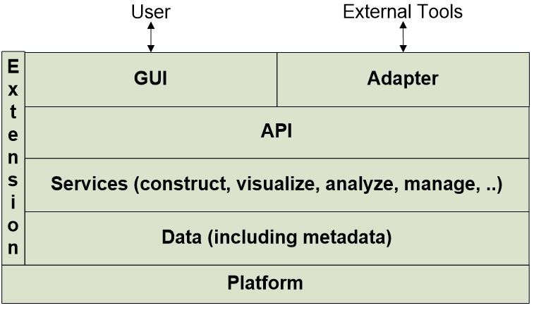

Mandatory Requirements
This section is organized into logical groupings of requirements. Each subsection contains key concepts that reflect the system modeling needs and issues with SysML v1, and some motivating examples to highlight the concepts and/or issues. The table of requirements applicable to each section is included at the end of each section.

Formalism

Formalism Introduction
The formalism defines how the language is specified in terms of its syntax, semantics, vocabulary, and interchange format. The abstract syntax specifies the grammar including the basic constructs of the language analogous to verbs and nouns, and the rules for constructing legal sentences (i.e., statements). The concrete syntax specifies the symbols for these constructs and how they can be presented. The semantics specify the meaning of the constructs so that they can be interpreted in the operational domain that the model represents. The formalism also includes how computers read and write the language to support model interchange. Figure 3.1 shows the relationship between the language formalism and the user model that is defined using the language formalism, and the things being modeled.
Figure 3.1. Uniform Interpretation (Source: SysML v2 RFP Formalism WG)
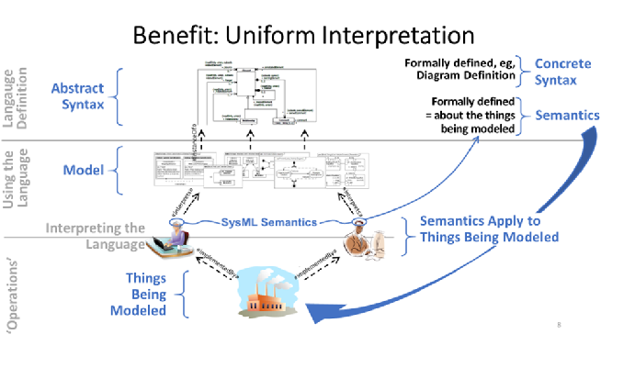

The formalism is intended to enable the language specification to express the domain concepts so they can be interpreted unambiguously by humans and computers. This requires consistent use of terminology and rules of grammar (well formedness), and consistent interpretation of meaning. The domain concepts and associated semantics specified in the language determine the analysis that can be performed to answer the fundamental questions related to the system specification, design, analysis, and verification. The language can also include model libraries that are analogous to a dictionary of terms that are derived from more fundamental language concepts.
SysML v1 includes a language formalism that is specified as a profile of UML in the SysML v1 specification, which includes abstract syntax, concrete syntax, semantics, model libraries, and a model interchange standard. The profile extends the UML metamodel. However, there are some significant limitations of the current formalism that result in ambiguities of interpretation. For example, SysML v1 does not include a complete formal mapping between the concrete syntax and the abstract syntax resulting in potential ambiguity of the symbols. In addition, the semantics of SysML v1 are often defined in English rather than a more precise formal representation resulting in some ambiguity of meaning.
The requirements for SysMLv2 are intended to more formally specify the language abstract syntax, concrete syntax, the mapping between them, and the semantics. An approach is to specify a small set of foundational terms and their base semantics, and include model libraries to further extend the terms and associated semantics to reflect the domain concepts. A control node used in activity diagram serves as an example to illustrate the approach. Currently, each type of control node such as a fork node, join node, decision node, and merge node is defined with their own unique semantics. In SysML v2, the general concept of a control node may be specified along with its semantics. The specific control nodes for a fork node, join node, decision node, and merge node could be specified in a model library, with semantics that are specialized from the control node semantics. The language formalism would include rules for specializing the semantics.
The formalism requirements are included in the table below. One requirement is that SysML v2 have a declarative semantics expressed in mathematical logic. A formal model with declarative semantics can be used to make deductions based on a set of assertions, and by analogy, prove things are true or not true about the system or domain that is being represented by the model (i.e., the interpretation). Declarative semantics contrast with the operational semantics that specify how a model executes, where the results of the execution must be evaluated to determine how the system will behave.
A simple example of declarative semantics may be to define a type, an instance, and the rules for an instance to conform to a type. One could then evaluate whether a set of instances conform to the type. In contrast with declarative semantics, the operational semantics define how to create an instance from a type, and then evaluate the execution trace.
The other formalism requirements define how to specify the abstract syntax, concrete syntax, semantics, and interchange to ensure consistent syntactic and semantic interpretation.

Formalism Requirements

Table 3.1.
ID | Name | Requirement Text | SysML v1.x Construct
FML 01 | Declarative Semantics | SysML v2 shall have a declarative semantics expressed in mathematical logic and/or other semantics with a translation to declarative semantics in mathematical logic.  Supporting Information: Rationale  - Reduced ambiguity: Semantics expressed in natural language causes miscommunication between users, and diverging implementations. This requirement (combined with S2) enables vendors to build tools for model checking, execution/simulation, and analysis that give the same results for the same models. Then users can learn a consistent SysML semantics by using these services on their models.  - More integrated language: Some engineering concepts are inherently different but must be integrated, such as structure and behavior. This requires abstractions that apply to both, but are not engineering-specific, i.e. mathematical, enabling SysML to integrate its concepts better.
FML 02 | Model Libraries | SysML v2 semantics shall be modeled in domain-independent SysML v2 model libraries that are automatically used when models are created.  Supporting Information: Rationale  - Makes the mathematical semantics of S1 accessible to non-mathematicians.  - Simplifies the language when model libraries can be used without additional abstract syntax (reduces the amount of abstract syntax).  - Enables SysML to be improved and extended more easily by changes and additions to model libraries, rather than always through abstract syntax.
FML 03 | Abstract Syntax | The SysML v2 abstract syntax shall be independent of notation.  Supporting Information: Rationale  - Support non-SysML visualizations: Engineers and project managers need a wide variety of visualizations for information captured in models, including non-SysML graphics, tables, and reports. SysML's abstract syntax should not inhibit creating these visualizations.  - Simpler model and tool construction: Sometimes the same notion has multiple standard notations in SysML, such as temporal precedence in interactions, state machines, and activities. The abstract syntax should represent these notions once. This makes is it easier for modelers to keep diagrams consistent and for vendors to construct tools that operate on models (model checking, execution/simulation, analysis).
FML 04 | Modeled Formally | The SysML v2 abstract syntax shall be modeled formally (including abstract syntactic constraints).  Supporting Information: Rationale  This is the requirement for a SysML v2 metamodel.  Reduced ambiguity: Syntax expressed in natural language, such as abstract syntax constraints, causes miscommunication between users, and diverging implementations. This requirement enables vendors to build tools for model construction and checking that give the same results. Then users can learn SysML consistently across tools.
FML 05 | Concrete Syntax | Any SysML v2 concrete syntax shall include a formal model and interchange format/API for diagram and text information that is not included in the abstract syntax, but is linked to the abstract syntax (e.g., DD's DI).  Supporting Information: Rationale  This is the requirement for a SysML v2 view metamodel and the mapping to the SysML metamodel.  Enables diagrams to look the same across tools, at least for those aspects that modelers control (e.g., node positioning and line routing).
FML 06 | Syntax Examples | All examples of notation in the SysML v2 specification shall be accompanied by instances of the syntax models.  Supporting Information: Rationale  The Model Interchange Working Group (MIWG) found that most tool interchange problems were due to differences in translating graphics to instances of abstract syntax. Providing models for all diagrams in the specification will help iron out these differences.
FML 07 | Extensibility | Where SysML v2 is extensible, the syntax, semantics, and model libraries shall both be extensible.  Supporting Information: Justification  Language specification includes syntax, semantics, and vocabulary, so extending a language requires all of these to be extensible.
FML 08 | Meta-Circular Language | SysML v2 syntax shall be specified in a subset of SysML v2.
FML 09 | Dynamic and Multiple Classification | SysML v2 shall support dynamic and multiple classification.
FML 10 | Derived Property Rules | SysML v2 shall support graphical and textual definition of derived properties and relationships.
FML 11 | Classification vs Capability Features | SysML v2 shall support features that provide capabilities and features that cannot be specialized to prevent reclassification, whereas those not providing capabilities can.
FML 12 | Extension Mechanism | SysML v2 shall provide mechanisms to extend the language.  Supporting Information: Note: this requirement may be moved to another section.
FML 13 | MOF | The SysML v2 specification shall provide or reference a mapping between the subset of SysML v2 used to define SysML v2 and SMOF.  Supporting Information: Note: this requirement may be moved to another section.
FML 14 | Tool Interchange Format | SysML v2 shall provide a tool neutral format that can be exported and imported by a SysML v2 conformant tool.  Supporting Information:  Note: this requirement may be moved to another section.  Note: The file should facilitate long term retention, file exchange, and version upgrades
FML 15 | SysML Profile | SysML v2 shall include a profile that can be mapped to SysML v1.X.  Supporting Information: Note: This corresponds to a subset of SysML v2.
FML 16 | Model Mapping | SysML v2 shall specify a formalism for model mappings which may refer to an existing standard.  Supporting Information: Note: this requirement is still under review by the formalism WG.
FML 17 | Model Transformations | SysML v2 shall specify a formalism for model transformations which may refer to an existing standard.  Supporting Information: Note: this requirement is still under review by the formalism WG.

Data Model
Systems Engineering Concept Model (SECM). SysML v2 is intended to provide the capability to model systems with a precisely defined systems engineering vocabulary. A Systems Engineering Concept Model (SECM) is used to capture the key concepts to represent systems, and is a primary input to help specify the requirements for the SysML v2 metamodel, profile, and model libraries. The SECM is used as part of the analysis to derive the SysML v2 requirements, but is not considered part of the mandatory requirements in the SysML v2 RFP.
The concepts in the SECM reflect industry standards for systems engineering that include the Systems Engineering Body of Knowledge (SEBoK), the ISO standard for Systems and Software Engineering -- System lifecycle processes (ISO/IEC/IEEE 15288:2015), and the INCOSE Systems Engineering Handbook v4. These sources and others provide the basis for defining the high-level concepts which can be further elaborated to support the requirements for SysML v2. The figure below is an extract from the SECM-2015 Industry Reference showing some of the core concepts. There are many other concepts in the industry reference model beyond what is shown in this Figure.
Figure 3.2. Core SEBoK Concepts (Extract from draft SECM-2015 Industry Reference. Used with permission)
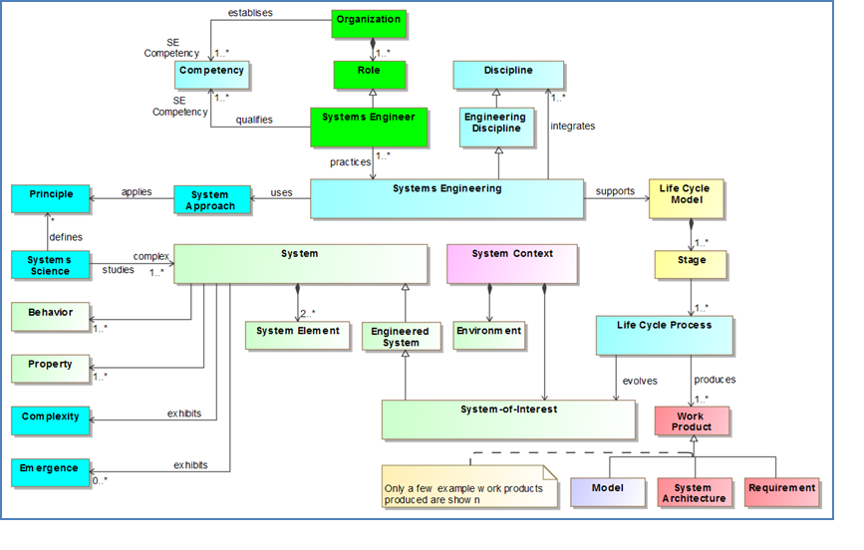

SysML v2 includes concepts directly related to the specification, design, analysis, and verification of systems. The SysML v2 concepts are intended to align with the industry standards, but the scope of SysML v2 is not intended to address the full scope of the industry reference model. At the same time, SysML v2 may include additional concepts that are not explicitly in the industry reference model.
Data model requirements. This set of system modeling concepts includes the scope of SysML v1, which includes support for modeling structure, behavior, parametric, and requirements, often referred to as the 4 pillars of SysML. The SysML v2 concepts also include additional concepts related to verification, analysis, and other concepts beyond what is in SysML v1 as indicated in the figure below.
Figure 3.3. Organization of SysML v2 Modeling Concepts
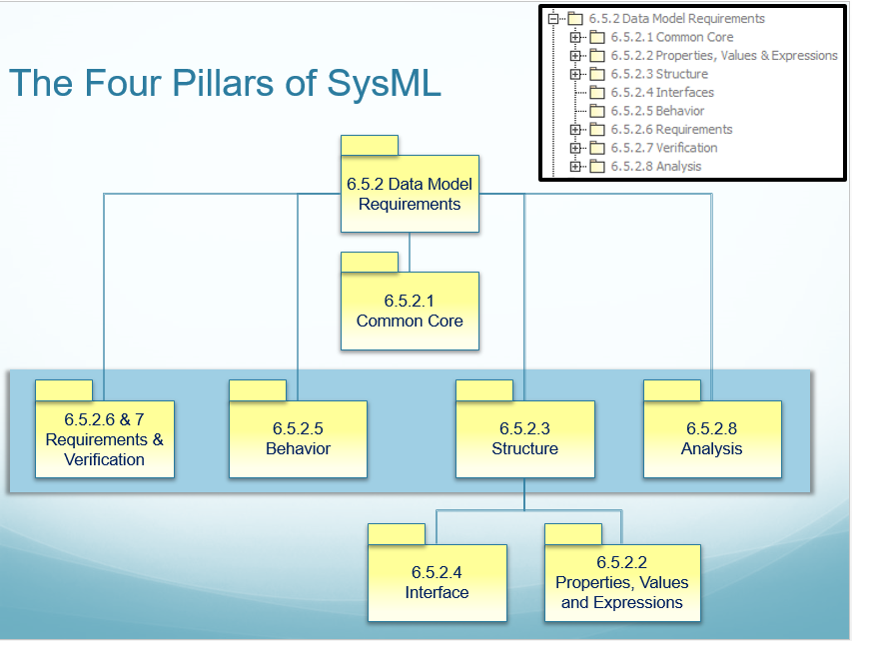

A major emphasis for SysML v2 is to ensure integration of the concepts. This is in part accomplished by defining a core set of concepts and patterns and then applying them consistently to define other concepts. For example, the concept of decomposition can be performed consistently for structure and behavior, and the concept of precedence can be applied consistently in different behavior representations such as activities and state machines. Logic expressions such as AND, OR, NOR, and NOT can also be applied consistently throughout the language.

Common Core

Common Core Introduction
The Common Core concepts and associated requirements are common to all kinds of model elements. A model element is a general class that includes features common to all other kinds of model elements that are specified in the language.
As shown in the figure below, a model element contains certain properties such as unique id, name, alias, and definition. An Annotation is a subclass of model element that can refer to other model elements.
Figure 3.4. Common Core Model Element Concepts
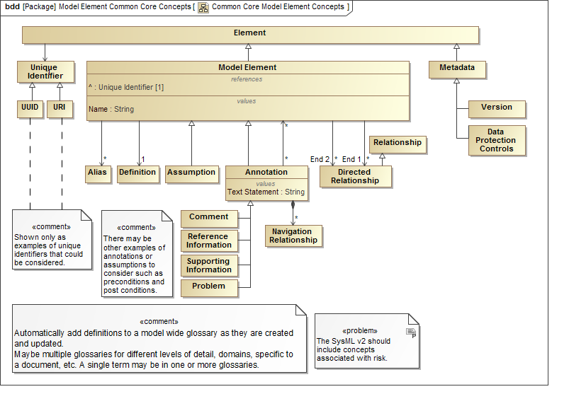

In addition, a model element can have a relationship with other model elements. There are several general relationships shown in the figure below such as a dependency, trace, and allocate that can have any model element on one end of the relationship.
Figure 3.5. Common Core Relationship Concepts
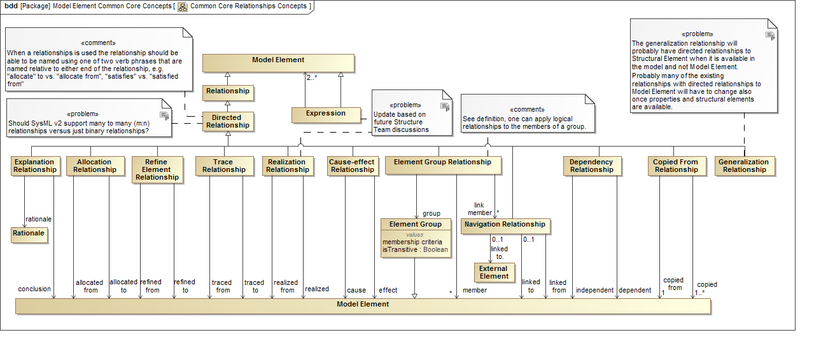

In the following figure, the model is a top-level model element that contains other model elements. There are various subclasses of models identified, and a model transformation is a concept that is used to transform one model to another model based on a set of mapping rules.
Figure 3.6. Common Core Model Concepts
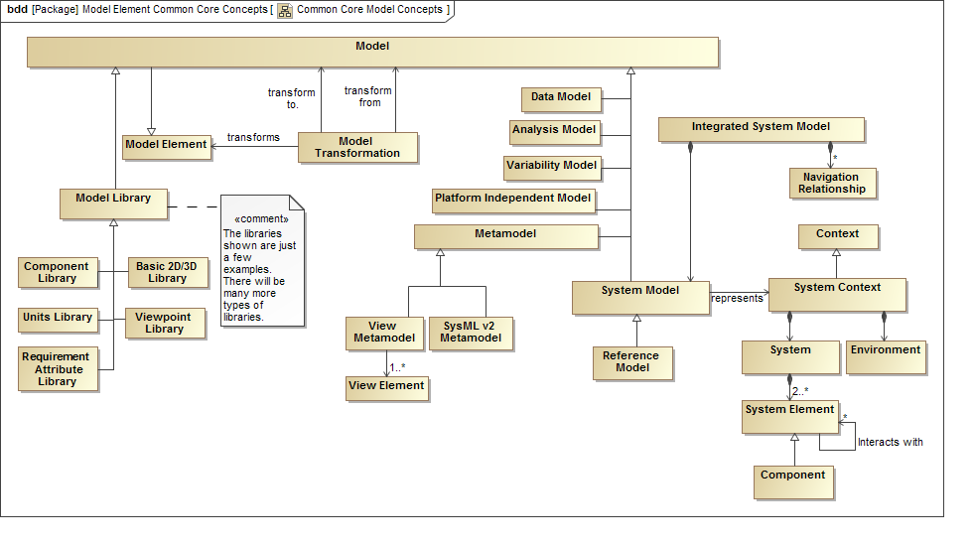

The following figure shows the concepts of variability included in the Common Core that can be applied to any model element. These include the concept of a variation point that identifies some part of the model that can vary, and a variant that identifies the specific choices. For example, wheel size can be a variation point, and narrow and wide are variants. Variability constraints can be defined to constrain the valid choices (i.e., variants) for one or more variation points. A variant binding concept is also included to enable a separate variant model to represent the variant concepts and refer to the base model elements in the SysML model.
Figure 3.7. Variability Concepts
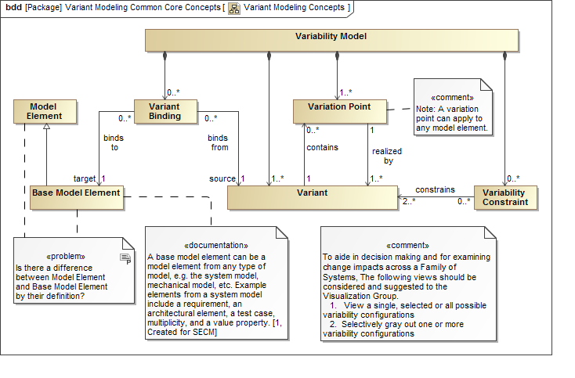

The concepts of View and Viewpoint are also included as Common Core Concepts since they can be applied to any model element. These concepts are used by the Visualization services that are defined in the Services section below.

Common Core Requirements

Table 3.2.
ID | Name | Requirement Text | SysML v1.x Construct
CMC 1 | Common Core Requirements Group | The following specify the requirements that apply to all model elements.
CMC 1.1 | Model Requirements Group
CMC 1.1.1 | Model Element | SysML v2 shall include a capability to represent a model (aka system model) that contains a set of uniquely identifiable model elements. | Model Element
CMC 1.1.2 | Model Library | SysML v2 shall include a capability to represent a Model Library that contains a set of model elements that are designated to be reused. | Model Library
CMC 1.1.3 | Model Transformation | SysML v2 shall provide the capability to represent a transformation between the system model and other data sources that maps the model elements from the system model to the data structure of the data source. | QVT
CMC 1.2 | Model Element Requirements Group
CMC 1.2.1 | Unique Identifier | SysML v2 shall include a capability to represent a single unique identifier for each model element that does not change over the model element's lifetime. (Note: clarify whether the unique id can be applied to another element after the model element is deleted.) | GUID
CMC 1.2.2 | Name and Aliases | SysML v2 shall include a capability to represent the name and one or more aliases for each model element. | Element Name
CMC 1.2.3 | Definition / Description | SysML v2 shall include a capability to represent a user defined definition and/or description for each model element. | Documentation field for annotation
CMC 1.2.4 | Annotation | SysML v2 shall include a capability to represent an annotation that includes a text string and/or navigation links which can be associated with one or more model elements. | Comment
CMC 1.2.5 | Element Group | SysML v2 shall include a capability to represent a group of model elements that includes criteria for membership in the group. (Note: A member of a group is not dependent on the Group) | Element Group
CMC 1.3 | Model Element Relationships Requirements Group
CMC 1.3.01 | Dependency Relationship | SysML v2 shall include a capability to represent a Dependency Relationship between any two model elements where one side of the relationship refers to the target (i.e., independent element) and the other side of the relationship refers to the source (i.e., dependent element). | Dependency
CMC 1.3.02 | Cause-Effect Relationship | SysML v2 shall include a capability to represent a Cause-Effect Relationship between any two model elements where one side of the relationship refers to the target (i.e., cause) and the other side of the relationship refers to source (i.e., effect).
CMC 1.3.03 | Explanation Relationship | SysML v2 shall include a capability to represent an Explanation Relationship between any two model elements where one side of the relationship refers to the target (i.e., rationale) and the other side of the relationship refers to the source (i.e. conclusion). | Anchor on a rationale
CMC 1.3.04 | Refine Relationship | SysML v2 shall include a capability to represent a Refine Relationship between any two model elements where one side of the relationship refers to the target (i.e., refined to) and the other side of the relationship refers to the source (i.e., refined from). | RefineReqt
CMC 1.3.05 | Trace Relationship | SysML v2 shall include a capability to represent a Trace Relationship between any two model elements where one side of the relationship refers to the target (i.e., traced to), and the other side of the relationship refers to the source (i.e., traced from). | Trace
CMC 1.3.06 | Realization Relationship | SysML v2 shall include a capability to represent a Realization Relationship between any two model elements where one side of the relationship refers to the target (i.e., realized to), and the other side of the relationship refers to the source (i.e. realized from). | Realization
CMC 1.3.07 | Allocation Relationship | SysML v2 shall include a capability to represent an Allocation Relationship between any two model elements where one side of the relationship refers to the target (i.e., allocated to), and the other side of the relationship refers to the source (i.e. allocated from). | Allocated
CMC 1.3.08 | Element Group Relationship | SysML v2 shall include a capability to represent an Element Group Relationship where one side of the relationship refers to the target (i.e., member) and the other side of the relationship refers to the source (i.e., group). | Anchor
CMC 1.3.09 | Navigation Relationship | SysML v2 shall include a capability to represent a Navigation Relationship between a model element and another model element or an external element where one side of the relationship refers to the target (i.e., linked to), and the other side of the relationship refers to the source (i.e. linked from). | Some tools support navigation links, but not standard.
CMC 1.3.10 | Copy From Relationship | SysML v2 shall include a capability to represent a Copy Relationship between a model element and another model element where one side of the relationship refers to the target (i.e., new copied element) and the other side of the relationship refers to the source (i.e., copied from element).
CMC 1.4 | Variability Modeling Requirements Group
CMC 1.4.1 | Variability Concepts | SysML v2 shall include a capability to model a set of entities (e.g., systems, components) sharing common and variable model elements, and which include the following concepts.  - Variation point  - Variant  - Variability constraint  - Variant binding
CMC 1.4.2 | Variability Notation | SysML v2 shall include a capability to provide modeling notation to represent the variability concepts.
CMC 1.5 | Visualization Common Core Requirements Group | The following specify the common core requirements associated with visualization.
CMC 1.5.1 | View | SysML v2 shall include a capability to represent views that conform to a viewpoint.
CMC 1.5.2 | Viewpoint | SysML v2 shall include a capability to represent viewpoints that include the stakeholder, their concerns, and a viewpoint method.

Properties, Values & Expressions

Properties, Values & Expressions Introduction
The foundation concepts in SysML v1 for specifying quantitative characteristics and supporting engineering analysis are value properties and value types, the usage of constraint blocks that capture reusable equations and parameters, and a rich non-normative model for representing quantities and units. SysML v2 will extend these concepts to include a more robust set of value types such as arrays and vectors, and a discretely sampled function which can capture discrete functions that are often specified as tabular data such as amplitude versus frequency. SysML v2 also includes concepts related to coordinate systems and geometric shape to enable representation of physical envelopes. SysML v2 also provides improved support for probability concepts, quantities and units, standard expression languages that can be applied to any feature or property.

Properties, Values & Expressions Requirements

Table 3.3.
ID | Name | Requirement Text | SysML v1.x Construct
PRP 1 | Properties, Values and Expressions Group | Unified representation of the type of properties, variables, constants, operation parameters and return types as well as literal values and value expressions. Both numerical and non-numerical. Including variable size collections, compound value types, measurement units and scales.
PRP 1.01 | Unified Representation of Values | SysML v2 shall include a capability to represent the common aspects of a value of any observable characteristic such as a property of a model element, a constant, a variable in an expression as well as a formal parameter and the return type of an operation in a unified way. The generic model concept for an observable characteristic with a value is called Value Element. | ValueType, QuantityKind, Unit, Annex E.5 QUDV
PRP 1.02 | Value Type | SysML v2 shall include a capability to represent a named definition of the essential semantics and structure of the set of possible values of an observable characteristic, without the value itself. Such a definition is called a Value Type.
PRP 1.03 | Value Expression | SysML v2 shall include a capability to represent a value expression that can be evaluated to yield a value, where the expression language is defined in a platform independent formalism, and one or more mappings to a platform specific concrete syntax and grammar.  Supporting Information: It is deemed practical to select an existing modeling language with strong expression capabilities like Modelica verbatim or as guidance, rather than to develop a full expression language from scratch. | Opaque and OCL value expressions
PRP 1.04 | Unification of Expression and Constraint Definition | SysML v2 shall include a capability to represent a constraint through definition of an equality or inequality where the left and right hand sides are expressed in the same expression language as the Value Expression language. | Opaque and OCL value expressions
PRP 1.05 | Intended Use of Value | SysML v2 shall include a capability to convey the intended use of a Value Element, and as a minimum the capability to distinguish between default (static, invariant) value, boundary condition value and initial value.
PRP 1.06 | System of Quantities | SysML v2 shall include a capability to represent a named system of quantities and physical dimensions that supports definition of numerical Value Types in accordance with formal or de facto standards. | SystemOfQuantities in Annex E.5 QUDV
PRP 1.07 | System of Units and Scales | SysML v2 shall include a capability to represent a named system of measurement units and scales to define the precise semantics of numerical Value Types. | SystemOfUnits in Annex E.5 QUDV
PRP 1.08 | Range Restriction for Numerical Values | SysML v2 shall include a capability to represent a value range restriction for any numerical Value Type.  Supporting Information: Such a capability could be naturally combined with the definition of optional lower and upper bounds on an associated measurement scale.
PRP 1.09 | Mapping to SysML v1 Value Types | SysML v2 shall include a capability to represent a mappable superset of all SysML v1 concepts concerning valueType, QuantityKind and Unit as well as the concepts defined in Annex E.5 QUDV.  Supporting Information: TBD: This requirement may be covered by the requirement to be able to migrate SysML v1.x to SysML v2.
PRP 1.10 | Automated Quantity Value Conversion | SysML v2 shall include a capability to represent all information necessary to perform automated conversion of the value of a quantity expressed on one measurement scale to the value expressed on another, compatible measurement scale in order to support model integration from multiple sources. | Most concepts are defined in Annex E.5 QUDV
PRP 1.11 | Computer Data Types | SysML v2 shall include a capability to represent the following computer data types as a minimum: signed and unsigned integer, signed and unsigned double precision real, string, boolean, enumeration type, ISO 8601 date and time, selected universally unique identifier (UUID). | ValueType
PRP 1.12 | Variable Length Collection Value Type | SysML v2 shall include a capability to represent variable length value collections where all items are typed by a particular Value Type, and where the collection may be one of the established collection types: sequence (ordered, non-unique), set (unordered, unique), ordered set (ordered, unique) or bag (unordered, non-unique).
PRP 1.13 | Compound Value Type | SysML v2 shall include a capability to represent both scalar and compound Value Types, where a scalar Value Type represents elements with a single value, and compound Value Type represents elements with a fixed number of component values, where each component value is typed in turn by a scalar Value Type or another compound Value Type.  Supporting Information: Such compound value types are needed to support the representation of vector, matrix, higher order tensor, computer data record, and other richer values. | ValueType
PRP 1.14 | Discretely Sampled Function Value Type | SysML v2 shall include a capability to represent variable length sets of values that constitute discrete time series data, frequency spectra, temperature dependent material properties, and any other datasets that can be represented through a discretely sampled mathematical function.  Supporting Information: Such a discretely sampled function can be defined by a tuple of one or more Value Types that prescribe the type of the domain (independent) variables, and a tuple of one or more Value Types that prescribe the range (dependent) variables, as well as a variable length sequence of tuples that represent the actual sampled values.
PRP 1.15 | Discretely Sampled Function Interpolation | SysML v2 shall include a capability to represent an option for the Discretely Sampled Function Value Type to define an interpolation scheme for derivation of the function's range values for domain values that are in between sampled values.
PRP 1.16 | Probabilistic Value Distributions | SysML v2 shall include a capability to represent the value of a Value Element with a probabilistic value distribution, including an extensible mechanism to detail the kind of distribution, i.e. the probability density function for continuous random variables, or the probability mass function for discrete random variables. | Annex E.7 Distribution Extensions

Structure

Structure Introduction
The structure modeling concepts are intended to facilitate modeling of the deeply nested structure and interconnection of a system design. A limitation of SysML v1 is highlighted in the figure below showing a nested structure of Lugbolts that are part of Wheels that are part of a Vehicle. The challenge in SysML v1 is the inability to easily represent the structures corresponding to a specific design configuration that have localized values. For example, in the IBD in the figure below, the 2nd lugbolt on the rear wheel with a specific torque value should be clearly distinguishable from the torque on the 1st lugbolt in the tool browser. This can be done in SysML v1 but requires considerable effort and knowledge that may require the use of property specific types, redefinition, subsetting, bound references, and other advanced features of SysML.
Figure 3.8. Specifying an unambiguous system design configuration
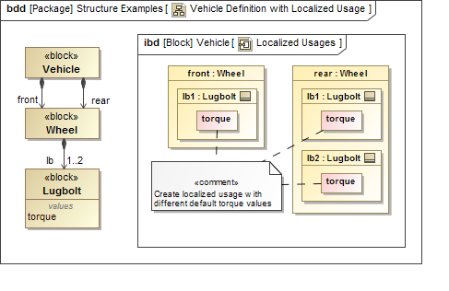

Modeling structure in SysML v2 builds on SysML v1 concepts of definition and usage (e.g., blocks and parts), but adds the concept of a deeply nested part as shown in the figure below.
Figure 3.9. Sample of Structure Modeling Concepts
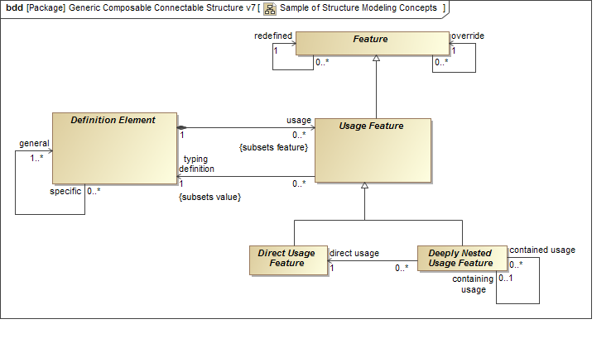

Like SysML v1, SysML v2 can model structure with variation points that may be represented with part multiplicity and component subclasses. In SysML v2, additional concepts are provided to model system design configurations with the variation removed. The system design configuration can include property values that over-ride the original values such as the torque values on the lugbolts in the example above.
Another limitation of SysML v1 is the ability to model an individual system with measured values that over-ride the as-designed values associated with the system design configuration. This can be done in SysML v1 by creating an instance. However, once this is done, there can be no further changes to the structure of the system, which limits the ability to model a system across its lifecycle. For example, a part cannot be replaced in an instance model.
SysML v2 includes the concept of a model of an individual system, such as an as-built system on the factory floor with a serial number. The individual system can include property values corresponding to its measured values that further over-ride the property values of the system design configuration. The individual model has its own lifetime where its structure can change over time, and its property values can change over time.

Structure Requirements

Table 3.4.
ID | Name | Requirement Text | SysML v1.x Construct
STC 1 | Structure Requirement Group | Generic composable, deeply nested, connectible structure with and without variants. Refer to Vehicle Definition Example for illustration of specific localized type.
STC 1.01 | Modular Unit of Structure | SysML v2 shall include a capability to represent a modular unit of structure - called a Definition Element - that defines its characteristics through value properties, interface ends (ports) and connectors, constraints, and behavioral features.  Support Information: Such modular units of structure can be regarded as the fundamental and uniquely identifiable, named building blocks from which system representations, i.e. architectures, can be constructed. | Block, Activity, ConstraintBlock,
STC 1.02 | Usage Feature | SysML v2 shall include a capability to represent inside the definition of a Definition Element a usage of another Definition Element - called a Usage Feature - in order to support modular, deeply nested hierarchical composition structures. | Part property, Port property, CallAction, ConstraintProperty, ElementPropertyPath, NestedConnectorEnd,
STC 1.03 | Generic Hierarchical Structure | SysML v2 shall include a capability to represent hierarchical composition structure in such a generic way, that it can be re-used (i.e. specialized) for any set of concepts that have hierarchical composition traits.
STC 1.04 | Usage Reference | SysML v2 shall include a capability to represent a reference from a Definition Element to any usage of another Definition Element in the subtree of the referencing element. | reference property
STC 1.05 | Multiplicity of Usage | SysML v2 shall include a capability to define the multiplicity of any particular Usage Feature or Usage Reference, either as a single value or a value range. | Multiplicity on properties.
STC 1.06 | Definition Element Specialization | SysML v2 shall include a capability to represent a specialization from a more general Definition Element into a more specific Definition Element, where the more specific element inherits all features of the more general element. | All classifiers: Block, Activity, ConstraintBlock, ...
STC 1.07 | Unambiguous Deeply Nested Structure | SysML v2 shall support a capability to represent and unambiguous identify deeply nested Usage Features in a way that is fully integrated with direct (one level deep) Usage Features.  Support Information: Deeply nested Usage Features may be lazily instantiated, i.e. only when needed for specific localized typing or interface representation. | ElementPropertyPath, NestedConnectorEnd
STC 1.08 | Structure With Variation | SysML v2 shall include a capability to represent multiple possible variants of a system-of-interest through a single collection of Definition Elements and Usage Features - called a Definition Model - where at each usage level in the (de)composition a variation - called a Variation Point - between different possible Usage Features can be defined. | Multiplicity of property, specialization of classifiers.
STC 1.09 | Structure Resolved to a Single Variant | SysML v2 shall include a capability to represent a single variant of a system-of-interest - called a Configuration Model composed of Configuration Elements - that establishes a fully expanded hierarchical (de)composition conforming to an associated Structure With Variation where for each Variation Point a single choice has been made.  Support Information: A SysML v2 implementation should support auto-generation of Configuration Models from a Definition Model. A SysML v2 implementation should ideally also provide a capability to semi-automatically generate a Definition Model from one or more Configuration Models.
STC 1.10 | Structure of an Individual | SysML v2 shall include a capability to represent a hierarchical structural (de)composition of usages that is a digital representation of an individual system or product - called an Individual Model composed of Individual Elements - that actually or potentially exists in the real world, and that conforms to an associated Structure Resolved to a Single Variant.  Support Information: Such a digital representation of a real world system is also sometimes called a 'digital twin'. The elements in a Structure of an Individual are typically designated by a unique serial number, a batch number or an effectivity code.
STC 1.11 | Usage Specific Localized Type | SysML v2 shall include a capability to represent local override, redefinition or addition of features with respect to the features defined by its more general type.  Support Information: The more-general to more-specific type chain is: Definition Element - direct Usage Feature - deeply nested Usage Feature - Configuration Element - Individual Element. | PropertySpecificType
STC 1.12 | Logical Expressions for Variation Points | SysML v2 shall include a capability to represent a Variation Point on a Usage Feature with a logical expression, that supports as a minimum the standard boolean operators AND, OR, NOT, XOR and conditional expressions like IF-THEN-ELSE and IF-AND-ONLY-IF, in which symbols bound to any features (e.g. value properties) may be used.  Support Information: The expression language should be unified with the general expression language to define values.

Interfaces

Interface Introduction
The goals for interface modeling include the ability to model a diverse range of interfaces (e.g., electrical, mechanical, software, user). The core concept of an interface includes 2 interface ends and an interface connection as shown below.
Figure 3.10. SysML v2 Interface Concept
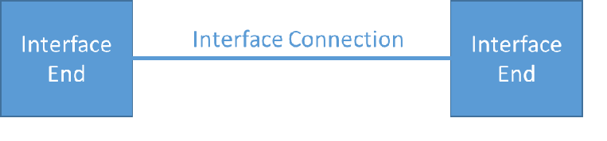

The concepts of definition and usage apply to the interface ends and interface connection consistent with SysML v1. These concepts are being aligned with the structure modeling concepts described above to allow multiple levels of nested interfaces. SysML v2 also requires support for layered interfaces such as when modeling an OSI stack with application layers and physical layers. Another important concept is an interface agreement, which can be used to specify and constrain the interface ends. The interface agreement can specify behavioral constraints on the exchange of messages within an application layer of a protocol stack, and can specify physical constraints within a physical layer, such as torque and angular rate constraints for a motor to gear interface. The interface concepts are highlighted in the figure below.
Figure 3.11. Interface Concepts
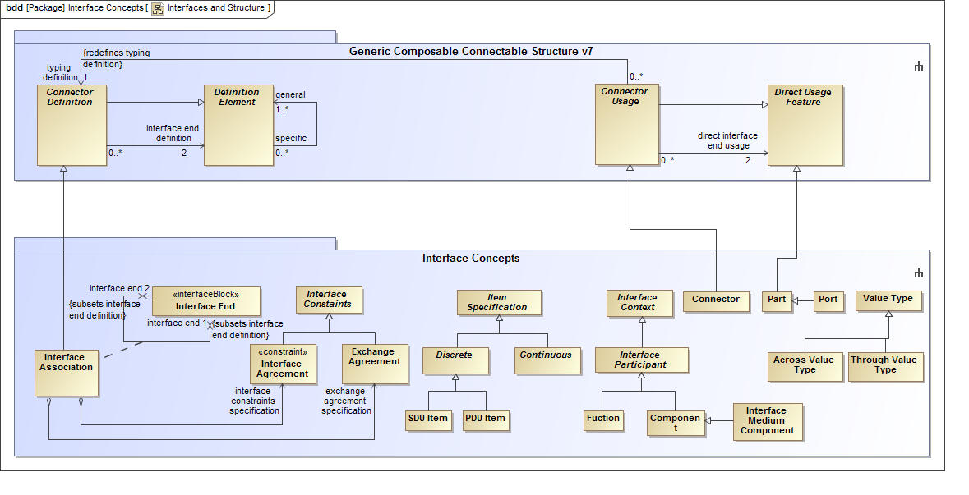

One of the key issues with SysML v1 is the inability to readily support views of different abstraction levels of complex interfaces. For example, a desired view of a detailed multi-layer interface may show one layer of a stack and hide others, or show highly detailed pinouts between physical connectors. This issue is being addressed by the visualization concepts and requirements to facilitate the generation of views in support of different stakeholder viewpoints (e.g., a software view of the application layer or a hardware view of the physical layer).

Interface Requirements

Table 3.5.
ID | Name | Requirement Text | SysML v1.x Construct
ITF 1 | Interface Requirements Group | SysML v2 is intended to provide a robust capability to model interfaces that constrain the interaction between structural elements. An interface in SysML v2 includes two (2) interface ends, the connection between them, and any constraints on the exchange between the ends. An interface should support the following: a) different levels of abstraction from logical to physical interfaces, nested interfaces, and interface layers; b) diverse domains that include a combination of electrical, mechanical, software, and user interfaces; c) reuse of interfaces in different contexts ; d) generation of interface control documents and interface specifications  Note: The ability to construct and visualize different views of interfaces including different abstraction levels are addressed by the visualization and construction services.
ITF 1.1 | Interface Usage | SysML v2 shall provide the capability to represent an interface that constrains the interaction between any two (2) structural elements. | Combined use of association blocks, blocks, sequence diagrams, activities, state machines and parametric diagrams
ITF 1.2 | Interface Definition and Reuse | SysML v2 shall provide the capability to define an interface that can be used in different contexts that includes the definition of the interface ends, the interface connections, the items that are exchanged, and the interface constraints.  Supporting Information: Note: Interfaces must conform to the structural concepts of definition and usage) | Current use of blocks, parts, ports, association blocks and connectors
ITF 1.3 | Interface Decomposition | SysML v2 shall provide the capability to represent nested interfaces, such as when modeling two electrical connector with pin to pin connections. (Note: Interfaces must conform to the structural concepts of definition and usage) | nested ports
ITF 1.4 | Interface End Definitions | SysML v2 shall provide the capability to represent an Interface End whose features constrain the interaction that it can participate in, including items that can be exchanged and their direction, behavioral features that are provided or requested, and constraints on properties. | Interface blocks with item flow properties
ITF 1.5 | Item Definitions | SysML v2 shall provide the capability to represent Item Specifications that define the kind of items that can be exchanged between Interface Ends.  Supporting Information: Item Specification may be marked as continuous or discrete time. | Blocks
ITF 1.6 | Interface Agreement
ITF 1.6.1 | Item Exchange Constraints | SysML v2 shall provide the capability to constrain the interaction between the interface ends that includes constraints on the items to be exchanged, the allowable sequences and directions of those items, timing of the exchange and other characteristics. The items exchanged shall be consistent with the type and direction of the items specified in the connected Interface Ends. | Activities, state machines and sequence diagrams in an association block with participant properties
ITF 1.6.2 | Property Constraints | SysML v2 shall provide the capability to constrain the interaction between the interface ends that include mathematical constraints on the properties exposed by the Interface Ends.  Supporting Information: The properties may further be marked as Across or Through variables consistent with standard usage of the terms, e.g. across and through variables, for specifying properties that are constrained by conservation laws). | Parametric diagrams in an association block with participant properties. Also needs value types exposed in interface definition blocks
ITF 1.6.3 | Geometric Constraints | SysML v2 shall provide the capability to constrain the interaction between the interface ends that include geometrical constraints on either Interface End (e.g., plug and socket).
ITF 1.7 | Interface Medium | SysML v2 shall include a capability to represent an Interface Medium that describes the communications channel between Interface Participants.  Supporting Information: The Interface Medium may represent either an abstract or physical channel, and may connect one to many participants to support peer-to-peer, multi-cast and broadcast communications. | Can define property typed by block with user-defined stereotype indicating its special function.
ITF 1.8 | Interface Layers | SysML v2 shall provide the capability to represent interfaces between structural elements that represent a specified layer of an interface stack, and connections between structural elements in adjacent layers of an interface stack.  Supporting Information: An exchange at an upper layer in a stack may be realized by transforming the data to match the next lower layer, performing the exchange at that lower layer, and then performing the inverse of the data transformation. In order for the layered interface as a whole to work together, each layer must meet its requirements separate. | By complex combination of all of the above.
ITF 1.9 | Allocating Functional Exchange to Interfaces | SysML v2 shall provide the capability to allocate functional exchanges to interfaces including the interface ends, item exchanges, and/or interface connections, and validate the consistency between the functional exchange and the interface. | By defining custom stereotypes to indicate whether blocks represent components or functions, and performing some sort of allocation between them.

Behavior

Behavior Introduction
Behavior modeling concepts are used to specify how structural elements and their inputs and outputs change over time.
Some of the SysML v1 issues that should be addressed by SysML v2 behavior models include:
- Lack of integration between structure and behavior (e.g., flows, triggers, input to do/behavior)
- Limitations of executing behavior that is integrated with structure/ports
- Lack of integration between different kinds of behavior (seq, act, stm, uc, timing)
- Lack of integration with analysis expressions so that it is simple to create an expression anywhere in the model
- Unification of expressions and constraints
- Inability to represent structure of I/O and how they are input to different functions
- Lack of representation of timelines
- Inability to easily create and destroy relationships such as connectors
- More flexible pre/post conditions using bdd/instance diagrams (refer to Keith Butler presentation)
- Support for software architecture concepts
As noted above, one of the critical issues in SysML v1 is the limitations associated with integrating behavior and structure with respect to input and outputs of activities, item flows on connectors, and flow properties on ports. The key requirement for SysML v2 is to seamlessly integrate behavior and structure by integrating the function inputs and outputs with the interfaces.
The Camera model example below illustrates the need for this integration. In the first figure, the Take Picture activity integrates structure and behavior by represents the actions the User, Camera, and Environment perform to take a picture. The Camera accepts Light as an input from the Environment and the User inputs, and executes the Perform Imaging action to produce an Image to present to the User and store in the Camera (not shown).
Figure 3.12. Top Level Behavior - Take Picture
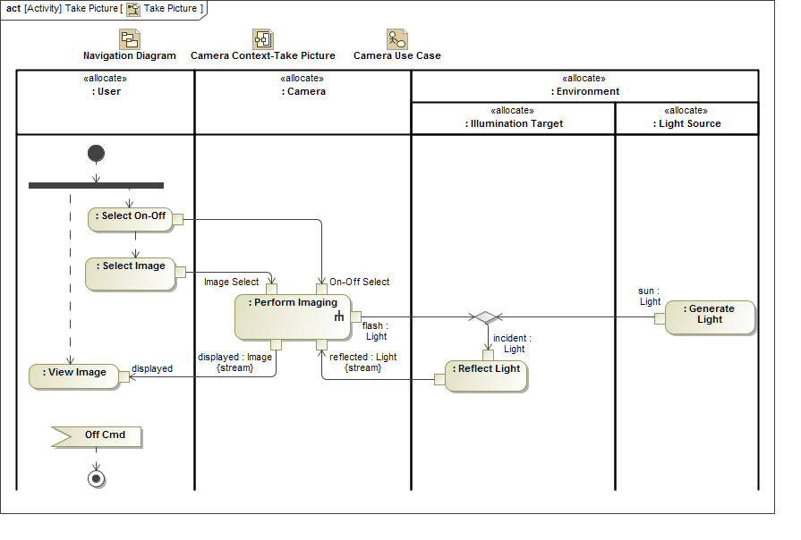

In the figure below, the internal block diagram highlights the interconnection of the parts of the camera with their allocated activities (i.e., functions). It is expected that SysML v2 enable the straightforward construction and presentation of different views of this model in a while maintaining consistency between the activities, their inputs and outputs, the flow properties on the ports (not shown), and the item flows on the connectors.
Figure 3.13. Camera Context with Take Picture Functions
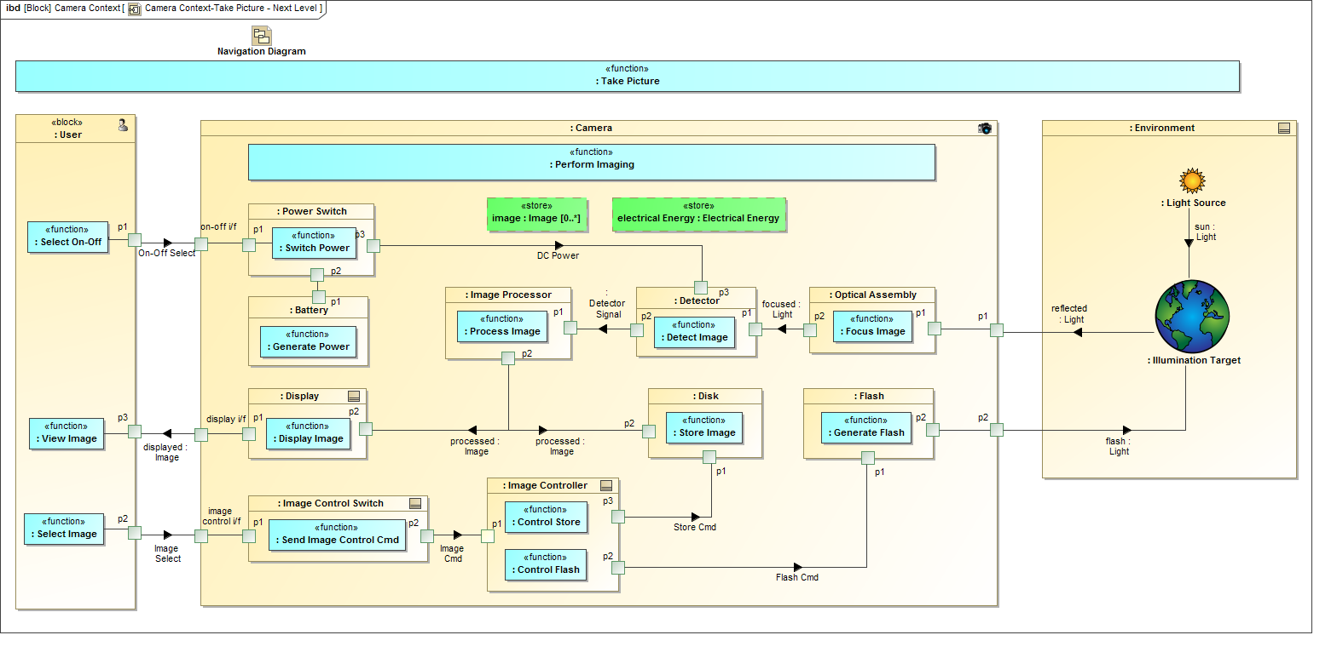

Another important view is the decomposition of the activities. SysML v1 support this capability, but does requires additional an additional concept called an adjunct property to establish correspondence between the activity decomposition and the actions in an activity diagram. In SysML v2, behavior decomposition should apply the same modeling concepts that apply to structure decomposition to simplify and integrate the language. Another limitation in SysML v1 is that is a do-behavior of a state machine, such as the Perform Imaging activity in the figure below, can only accept inputs and produce outputs by sending and receiving signals and read/write actions to an owning block. SysML v2 must ensure that activities used in state machines are not constrained as to how they accept inputs and produce outputs.
Figure 3.14. Camera Context with State Machine
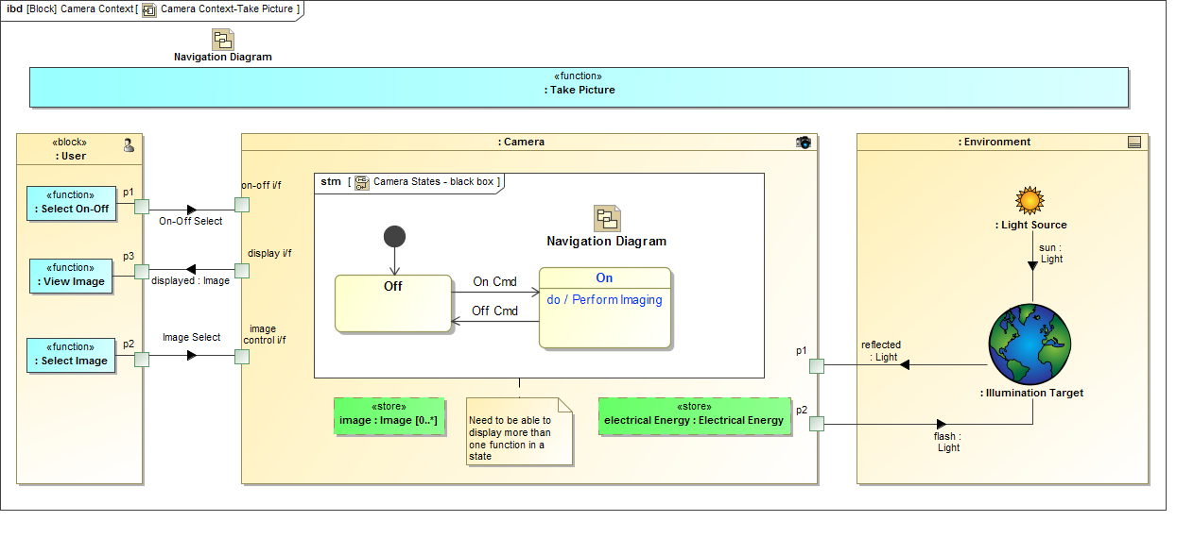

Behavior Requirements

Table 3.6.
ID | Name | Requirement Text | SysML v1.x Construct
BHV 1 | Behavior Requirements Group
BHV 1.01 | Behavior | SysML v2 shall include the capability to model a Behavior to represent how structural elements and their inputs and outputs change over time. | Activity, State Machine, Interaction
BHV 1.02 | Behavior Decomposition | SysML v2 shall include the capability to decompose a behavior to any level of decomposition using the SysML v2 structural decomposition patterns. | Behavior Classifier
BHV 1.03 | Function-based Behavior Group
BHV 1.03.1 | Function-based Behavior | SysML v2 shall include the capability to model a Behavior as a controlled sequence of actions that transform a set of inputs to a set of outputs. | Activity
BHV 1.03.2 | Function-library | SysML v2 shall include a model library of standard functions.
BHV 1.03.3 | Create/Destroy Relationships | SysML v2 shall include the capability to model functions which create and destroy structural relationships such as interconnections and composition. | Primitive Actions
BHV 1.04 | State-based Behavior Group
BHV 1.04.1 | Regions, States, and Transitions | SysML v2 shall include the capability to model a Behavior in terms of its concurrent regions with mutually exclusive states, and transition between states. | State Machine
BHV 1.04.2 | Integration of Function-based Behavior with State-based Behavior | SysML v2 shall include the capability to model Function-based Behavior both on transitions between states, and upon entry, exit, and while in a state. | Entry, Exit, Do Behavior and effect
BHV 1.05 | Deeply Nested Inputs and Outputs | SysML v2 shall include the capability to model deeply nested inputs and outputs.
BHV 1.06 | Discrete and Continuous Time Behavior | SysML v2 shall include the capability to model Behaviors whose inputs and outputs vary continuously as a function of time, or discretely as a function of time.
BHV 1.07 | Events | SysML v2 shall include the capability to model signal events, time events, and change events and their ordering.
BHV 1.08 | Control Nodes | SysML v2 shall include the capability to model control nodes that specify a logical expression of conditions for when inputs can flow.  Supporting Information: For Example: {Inputs A < a1 AND B>=b2 OR C AND NOT D} must be true).
BHV 1.09 | Behavior Constraints | SysML v2 shall include the capability to model constraints on a behavior that include a declarative specification in terms of its pre conditions and its post conditions and/or any invariants.
BHV 1.10 | Time Constraints | SysML v2 shall include the capability to specify the time associated with any event that includes start events, completion events, and duration constraints between events to represent the time-line of a behavior. | Simple Time
BHV 1.11 | Behavior Execution | SysML v2 shall include the capability to execute Behavior in a standard way that specifies the sequence of events, and flow of inputs and outputs, in accordance with the behavior and time constraints. | FUML
BHV 1.12 | Integration between Structure and Behavior
BHV 1.12.1 | Allocation of Behavior to Structure | SysML v2 shall include the capability to directly allocate behavior to structural elements | Allocate, Allocated Activity Partition
BHV 1.12.2 | Integration of Control Flow and Input/Output Flow | SysML v2 shall ensure the integration between inputs, outputs, and events from Behavior can seamlessly integrate with structural elements and interfaces

Requirements

Requirement Introduction
SysML v1 includes text-based requirements and requirements relationships to other requirements, design, analysis, and verification elements. It also provides a means to construct requirements hierarchies that correspond to the requirements in a specification. Some of the limitations associated with SysML v1 requirements include the inability to automatically verify a text requirement by analysis (although this is done in a non-standard way), the ability to group requirements and easily reuse a requirement. In addition, the standard attributes of requirements are limited to text and id, and do not include many commonly used requirements attributes.
SysML v2 will include a Requirement Group as a container for requirements that is not a shall statement, but can include additional context information for the requirements contained in the group. In the figure below, Group 1 contains requirements R1 and R2 and Group 1.1 contains requirements R3.1 and R3.2. A logical expression can be applied to the members of the Group such that Group 1 can contain R1 AND R2 AND (R3.1 OR R3.2). A requirement can also be contained in more than one Requirement Group to enable reuse of the requirement. The SysML v2 requirement will also include standard requirement attributes and requirement categories based on the INCOSE Handbook.
Figure 3.15. Requirement Groups
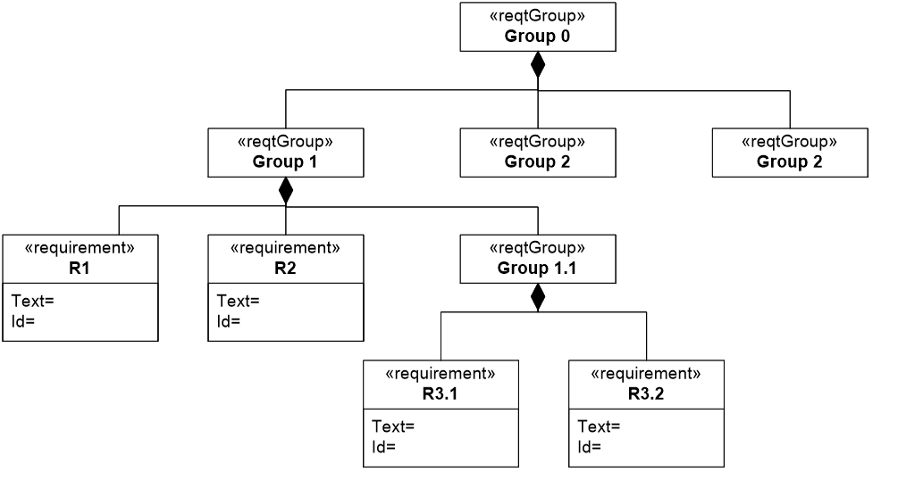

Text requirements can easily be misinterpreted. In SysML v1.5, the SysML requirement was refactored to enable both text based requirements and more precise statements of requirements, commonly referred to as property based requirements. SysML v2, is intended to represent property-based requirements by enabling requirements to contain formal expressions that constrain property values, such as weightActual<1000 kilograms. More complex expressions can also be specified to impose constraints on design solutions such as the required vehicle stopping distance as a function of speed and road conditions. The weight requirement in the figure below illustrates some of the requirements concepts including the requirement group, property based requirements, requirement attributes and categories. The SysML v2 requirement contains the formal expression that are specified as constraints, the properties that are being constrained, along with the id and text statement. The SysML v2 requirement also includes the ability to specify assumptions, such as whether the weight of oil, gas, and other fluids are included in the vehicle weight requirement. The assumptions are represented by context properties that can have values assigned or constrained.
Figure 3.16. Requirement Concepts
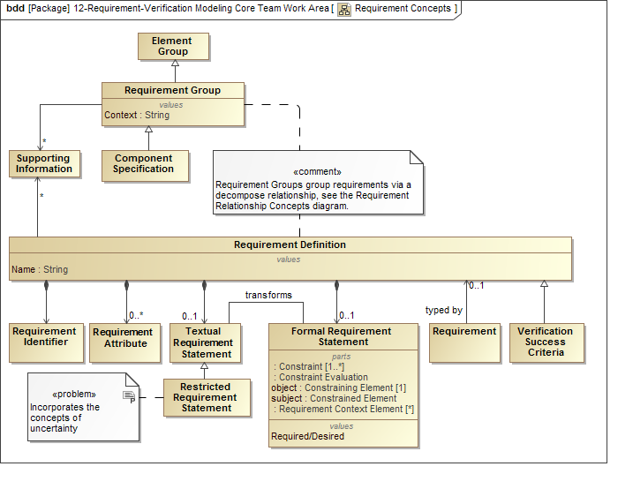

Figure 3.17. Example Weight Requirement
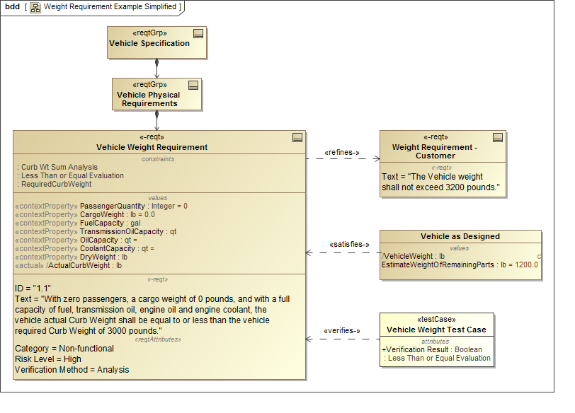

SysML v2 also supports the concept for restricted natural language text to specify requirements more precisely. In addition, SysML v2 supports the concepts of requirement definition and usage to facilitate reuse of requirements. A requirement can also be contained in more than one requirement group, and a generic requirement can be defined and specialized for specific usages. Some of the SysML v1.2 requirements concepts are highlighted in the figure below.

Requirements for Requirements

Table 3.7.
ID | Name | Requirement Text | SysML v1.x Construct
RQT 1 | Requirement Definition Group
RQT 1.1 | Requirement Definition Name | SysML v2 shall include a capability to represent a requirement definition that can be used to constrain a solution.
RQT 1.2 | Requirement Identifier | SysML v2 shall include a capability to represent a single identifier for each requirement that does not change over the requirement's lifetime and is adaptable to a predefined numbering scheme.
RQT 1.3 | Requirement Attributes | SysML v2 shall include a capability to represent the following optional requirement attributes for a requirement definition. (Note: this needs to be reconciled with other model element metadata and model element attributes that apply more generally)  - Requirement Identifier (conforms to a user specified naming and identifier production scheme)  - Requirement Status Attribute (baseline status)  - Priority Attribute  - Risk Attribute  - Originator/Author Attribute  - Owner Attribute  - User defined Requirement Attributes (e.g., confidence level, uncertainty status, etc.)
RQT 1.4 | Textual Requirement Statement | SysML v2 shall include a capability to represent a requirement definition that contains an optional textual requirement statement.
RQT 1.5 | Restricted Requirement Statement Group
RQT 1.5.1 | Restricted Requirement Statement | SysML v2 shall include a capability to represent a requirement definition that contains an optional restricted requirement statement which may include predefined sentence structures and key words.
RQT 1.5.2 | Restricted Requirement Statement Extensibility | SysML v2 shall include a capability to represent a restricted requirement statement that is extensible.
RQT 1.5.3 | Restricted Requirement Statement Transformation | SysML v2 shall include a capability to represent a transformation to maintain consistency between the restricted requirement statement and the textual requirement statement or the formal requirement statement.
RQT 1.6 | Formal Requirement Statement Group
RQT 1.6.1 | Formal Requirement Statement | SysML v2 shall include a capability to represent a requirement definition that contains an optional formal requirement statement.
RQT 1.6.2 | Constraint Expression | SysML v2 shall include a capability to represent a formal requirement statement that includes one or more expressions to specify the constraints on an acceptable solution. (Note: Consider combining this requirements with RQT1.6.1)
RQT 1.6.3 | Assumptions | SysML v2 shall include a capability to represent a formal requirement statement that includes one or more expressions to specify the assumptions including preconditions (precondition expression) for acceptable solutions (e.g., does the weight of a car include the fuel weight?)
RQT 2 | Groups of Requirements
RQT 2.1 | Requirement Group | SysML v2 shall provide the capability to model a group of requirements that are used to constrain a solution.
RQT 2.2 | Requirement Usage Identifier | SysML v2 shall include a capability to represent each requirement in a requirement group with a unique requirement identifier and a requirement definition.
RQT 2.3 | Requirement Ordering | SysML v2 shall include a capability to represent the order of each requirement in a requirement group shall have an order that is that is not constrained by its requirement identifier.
RQT 2.4 | Requirement Usage (localized) | SysML v2 shall include a capability to represent localized values of a requirement usage that can over-ride the values of its requirement definition.
RQT 2.5 | Group Logical Constraint | SysML v2 shall include a capability to represent a logical expression (e.g., And, Or, Exclusive Or, Not) that can be applied to each requirement in a requirement group with a default expression of "And".
RQT 3 | Requirement Definition Relationships Group
RQT 3.1 | Specialization | SysML v2 shall include a capability to represent a generalization relationship that relates a specific requirement definition to a more general requirement definition.
RQT 4 | Requirement Relationships Group | The requirements within this group relate a requirement or requirement group to other model elements. (Confirm these apply to usage and not definition).
RQT 4.1 | Requirement Group Membership | SysML v2 shall include a capability to represent a relationship between a requirement group and the members of the group that can be either a requirement or a requirement group.
RQT 4.2 | Requirement Satisfaction | SysML v2 shall include a capability to represent a satisfy relationship that relates a requirement to a model element that is asserted to satisfy it.
RQT 4.3 | Requirement Verification | SysML v2 shall include a capability to represent a verify relationship that relates a verification case to the requirement it is intended to verify.
RQT 4.4 | Requirement Derivation | SysML v2 shall include a capability to represent a derive relationship that relates a derived requirement to a source requirement.
RQT 4.5 | Requirement Allocation | SysML v2 shall include a capability to represent a requirement allocation relationship that relates a requirement to a model element that is intended to partially or fully satisfy it. (Note: Do we need this relationship to be differentiated from the more general allocate relationship. Also, the name allocation should be consistent with allocate)
RQT 4.6 | Requirement Refinement | SysML v2 shall include a capability to represent a requirement refine relationship that relates a more precise requirement to a less precise requirement.
RQT 4.7 | Requirement Trace | SysML v2 shall include a capability to represent a trace relationship with a requirement or requirement group on at least one end of the relationship.
RQT 4.8 | Relationships to a Requirement Group | SysML v2 shall include a capability to represent any relationship that is applied to a requirement group to each member of the requirement group.
RQT 5 | Relationship Logical Constraint | SysML v2 shall include a capability to represent a logical expression (e.g., And, Or, Exclusive Or, Not) to one or more requirement relationships of the same kind, with an associated completeness property (e.g., complete satisfaction or partial satisfaction) and with a default expression of "And" for the logical expression.
RQT 6 | Requirement Supporting Information | SysML v2 shall include a capability to represent supporting information for a requirement, requirement definition, and a requirement group.

Verification

Verification Introduction
The verification concepts shown in the figure below are intended to integrate with the requirements concepts in SysML v2 including concepts such as verification case, verification objectives, criteria, unit under verification, verification system, verification activity, verification evaluation activity, and verification results.
A Verification Case generalizes the Test Case from SysML v1, and is used to specify how a requirement is satisfied. This Verification Case includes the activity to perform the Verification Activity to obtain the verification data, and the activity to evaluate the data and determine how the Verification Success Criteria and associated requirements have been satisfied.
Figure 3.18. Verification Concepts
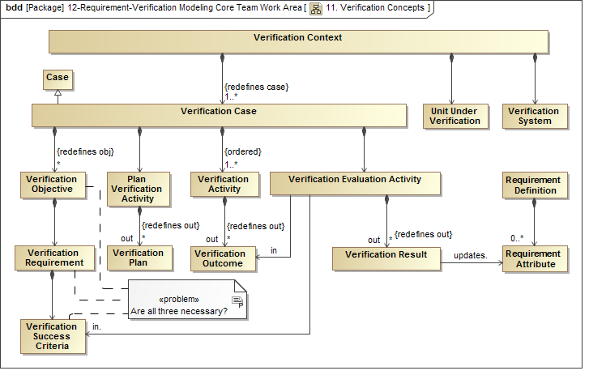

Verification Requirements

Table 3.8.
ID | Name | Requirement Text | SysML v1.x Construct
VRF 1 | Verification Context | SysML v2 shall include the capability to model a Verification Context that includes a Verification Case, a Verification System, and a Unit Under Verification.
VRF 2 | Verification Case Group
VRF 2.1 | Verification Case | SysML v2 shall include the capability to model a verification case to verify that one or more requirements are satisfied by a unit under verification.
VRF 2.2 | Verification Objectives | The verification case shall include verification objectives to be implemented by the verification activities.
VRF 2.3 | Verification Success Criteria | The verification case shall include the criteria used to evaluate whether the verification objectives are met and the requirements are satisfied.
VRF 2.4 | Verification Methods | The verification case shall define the methods used to verify the requirements, including inspection, analysis, demonstration, and test.
VRF 2.5 | Verification Activity | The verification case shall include the activities to collect and output the verification data that are output from the activities.
VRF 2.6 | Verification Evaluation Activity | The verification case shall include the activities to evaluate the verification data and the verification success criteria to generate a verification result of how well the requirements are satisfied (e.g., pass/fail/unverified).
VRF 3 | Verification System | SysML v2 shall include the capability to model the system and associated environment that is used to verify the unit under verification. (Note: the verification system may include verification elements that are combinations of operational and simulated hardware, software, people, and facilities.)
VRF 4 | Verification Relationships Group
VRF 4.1 | Requirement Verification | (Refer to above). (Note: Should there be a relationship between the verification case and the unit under verification?)
VRF 4.2 | Verification Objectives to Verification Cases | SysML v2 shall include the capability to model relationship between the verification cases and their verification objectives.

Analysis

Analysis Introduction
Although SysML v1 includes parametrics, it lacks some essential concepts to facilitate integration with analysis models. These concepts include concepts such as analysis, analysis case, analysis scenarios, analysis subject, analysis model, and analysis results. The analysis concepts for SysML v2 are shown in the figure below, and are similar to the verification concepts described in the previous section.
Figure 3.19. SysML v2 Analysis Concepts
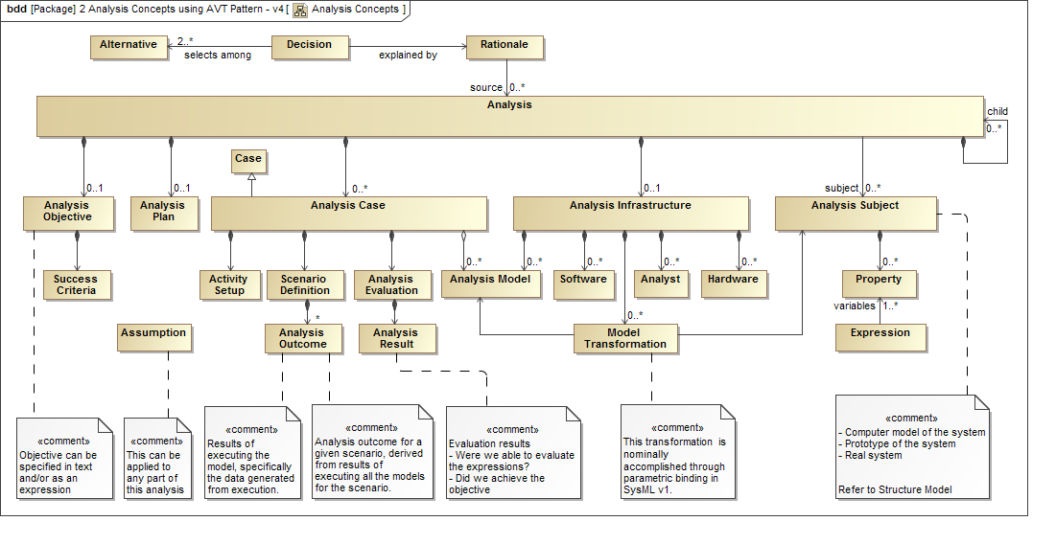

The example in the figure below illustrates how these concepts can be applied to specify the requirements for the Vehicle weight and acceleration analysis. The analysis block contains the analysis objectives to verify that the Vehicle weight and acceleration satisfy its requirements. The analysis case specifies the method to achieve the objectives in terms of the analysis scenario shown in the activity diagram. The scenario requires a weight analysis and an acceleration analysis to be performed. Each of these analyses is part of the Vehicle Weight & Acceleration Analysis block, which include their objectives, the key parameters of the analysis, and the subject of the analysis. The subject of the analysis is identified as the Vehicle for the Weight Analysis, and the Vehicle Context for the Acceleration Analysis. The constraints contain the key parameters, and also include a reference to the analysis models that execute the analysis. These concepts are used to specify the analysis and integrate with the appropriate analysis models and tools to perform the analysis.
Figure 3.20. Vehicle Weight & Acceleration Analysis
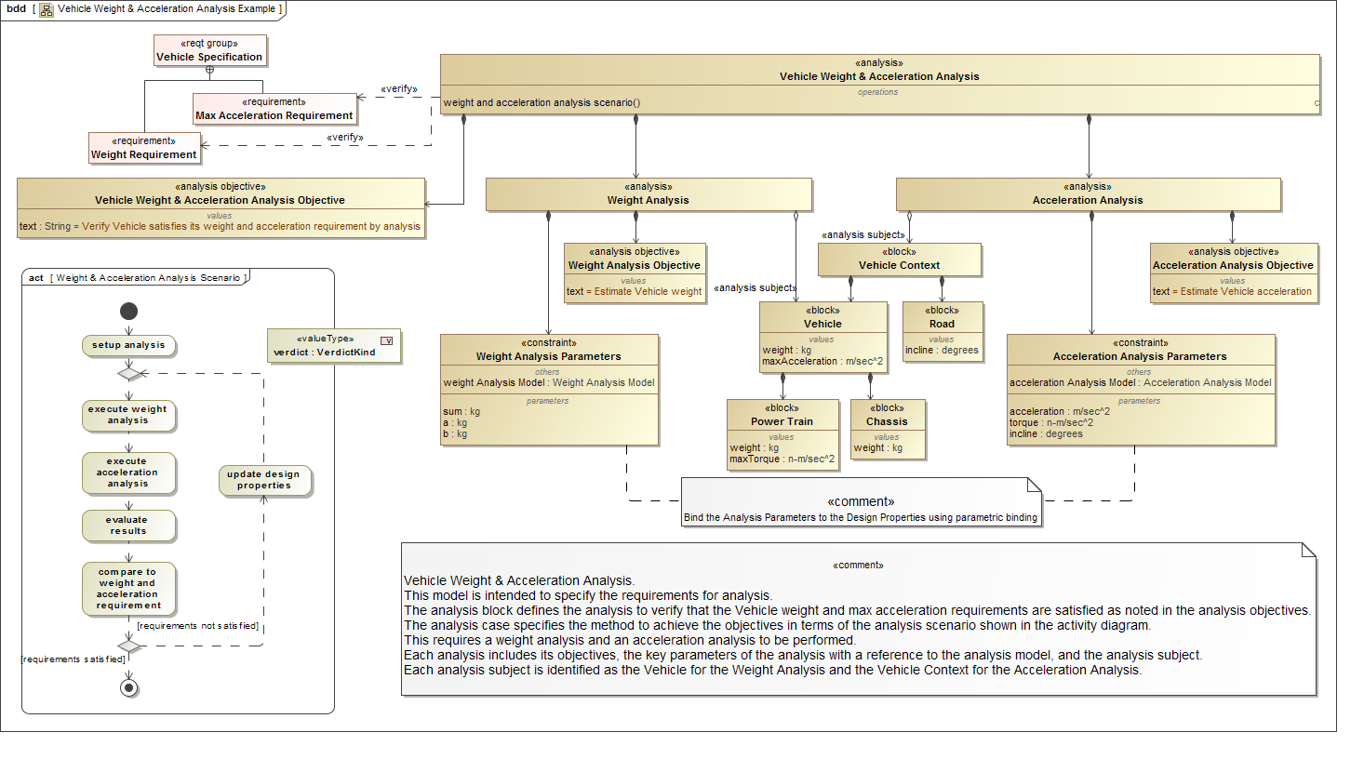

SysML v2 also includes a set of analysis services that leverage the analysis concepts described in this section to further support integrating SysML with analysis. The analysis service requirements are described in the Services section below.

Analysis Requirements

Table 3.9.
ID | Name | Requirement Text | SysML v1.x Construct
ANL 1 | Analysis Data Model Group
ANL 1.01 | Analysis | SysML v2 shall include the capability to model an Analysis, including subject of analysis (system), analysis objectives, plan, scenarios, and analysis models and related infrastructure to perform the analysis.
ANL 1.02 | System of Interest | SysML v2 shall include the capability to model the relationship between analysis and the subject of the analysis (system being analyzed).
ANL 1.03 | Parameters of Interest | SysML v2 shall include the capability to identify the key parameters of interest / measures-of-effectiveness / key performance parameters that are being computed in an analysis.
ANL 1.04 | Analysis Objectives | SysML v2 shall include the capability to model the objective of the analysis being performed in a mathematical formalism, e.g. math expression, so that it can be evaluated.
ANL 1.05 | Analysis Plan | SysML v2 shall include the capability to model the plan for performing an analysis, which will lay out how the analysis will be performed, the various scenarios that will be considered in analyzing the system-of-interest, the models for each scenario, and the infrastructure that will be needed for performing the analysis.
ANL 1.06 | Analysis Scenarios | SysML v2 shall include the capability to model the scenarios being investigated in a given analysis. Scenarios are the conditions, environment, or configurations in which the subject (system) is being investigated.
ANL 1.07 | Analysis Assumption | SysML v2 shall include the capability to model the assumptions of the analyses in a mathematical form, e.g. constraints and boundary conditions.
ANL 1.08 | Analysis Decomposition | SysML v2 shall include the capability to decompose an analysis into simpler analyses.
ANL 1.09 | Analysis Model | SysML v2 shall include the capability to relate analysis models to a given analysis or analysis scenarios.  Supporting Information: Analysis models can be defined natively in SysML (e.g. parametric model or behavior model) or externally (e.g. equation-based math models, finite element analysis models, or computational fluid dynamics models).
ANL 1.10 | Analysis Model - System Model Transformation | SysML v2 shall include the capability to represent the transformation and the mapping between the analysis model and the system model.  Supporting Information: This transformation will represent the algorithm or derivation process, if used, for generating analysis models from system model (or vice versa), and the mapping will provide a mechanism to verify and synchronize analysis models when system model changes (or vice versa).
ANL 1.11 | Analysis Result | SysML v2 shall include the capability to relate the results of executing analysis models to the analysis scenarios or the analysis.  Supporting Information: The results may be stored in the SysML v2 model itself or an in an external store (e.g. CSV file or database). The results will be queried for evaluating analysis objectives and for supporting the rationale for decisions taken based on the analysis.
ANL 1.12 | Analysis - Decision | SysML v2 shall include the capability to relate analyses to the rationale for decisions taken based on the analyses.
ANL 1.13 | Analysis Infrastructure | SysML v2 shall include the capability to represent the hardware, software, and the personnel (analysis experts) required for performing the analysis.
ANL 1.14 | Analysis Metadata | SysML v2 shall include the capability to represent the following metadata for analysis-related model elements (common to all SysML v2 model elements), such as unique id, element type, name, version, author, creation date, and last modified date.

Concrete Syntax

Concrete Syntax Introduction
The concrete syntax requirements are included as part of the formalism requirements and the visualization requirements. These include requirements to define a view metamodel to formally define the symbols used in the language, and to establish a formal mapping between the view metamodel and the SysML metamodel. In addition, there is a requirement to specify a standard symbol set to support the standard SysML views, and to be customizable to support domain specific extensions.

Concrete Syntax Requirements

Table 3.10.
ID | Name | Requirement Text | SysML v1.x Construct
CSN 1 | Concrete Syntax Requirements Group | Requirements in other topic areas that contain concrete syntax requirements include FML 05 (Concrete Syntax), FML 06 (Syntax Examples), SVC 06.1 (View Metamodel), SVC 06.2 (Metamodel & View Metamodel Transformation).
CSN 1.1 | SysML v2 Standard Notation | SysML v2 shall include a standard notation that maps SysML v2 model elements to standard SysML v2 view elements.  Supporting Information: The concrete syntax requirements are specified in the Formalism and visualization.

API

API Introduction
The SysML v2 RFP requires a standard way to request services through an API to support interoperability. SysML v2 should allow any client such as an external tool, plugin, or user interface to request services to access the system model repository in a standard way. As highlighted in the figure below, the API requirement is to produce a platform independent model (i.e., logical API model) with selected platform specific bindings that are then implemented by modeling tools to enable access to the system model repository. The platform independent model provides a service definition that is consistent with the information model. The platform specific binding defines the services using a particular technology (e.g., java, web services). A formal mapping is maintained between the platform independent model and platform specific bindings.
The API must also support various infrastructure services to support connection to the model repository, service registries, and capabilities that enable a client of the API to request services that are implemented by a federated multi-vendor implementation.
Figure 3.21. SysML v2 API Specification Approach
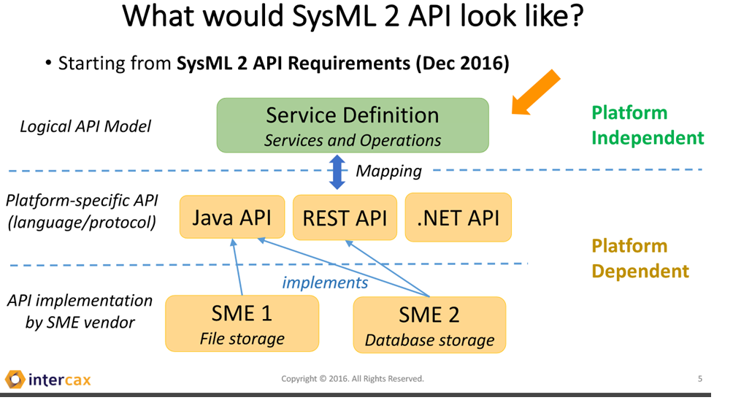

API Requirements

Table 3.11.
ID | Name | Requirement Text | SysML v1.x Construct
API 1 | API Requirement Group | Goal: SysML v2 will include an API specification that will be implemented by the System Modeling Environments (SMEs). Software application code written using this API specification will work with all SMEs that implement the API without requiring any change in the code.
API 1.1 | API Scope | SysML v2 API shall support the SME service requirements specified in the mandatory "Services" requirements.
API 1.2 | API Architecture | SysML v2 API shall provide:  - A platform-independent meta-model that defines the services and the operations provided by the API. Services are collections of operations. Inputs and outputs of each operation shall be defined. The meta-model shall be defined using SysML.  - Mapping approach to map platform-independent meta-model to platform-specific bindings. The mapping shall be formally represented using SysML.  - Platform-specific bindings to 2 or more commonly used programming languages, such as Java, .NET, and HTTP. The platform-specific bindings shall also include API documentation for each of the services and their operations.  Supporting Information: The platform-independent meta-model and the mapping approach should be complete and defined formally to allow for specifying other platform-specific bindings.  See the SysML 2 API Prototype presentation at OMG Technical Meeting, Reston VA, May 21, 2017 - SysML2_API_Prototype_OMG_Reston_2017-03-21.pdf for an example worked out for analysis services.
API 1.3 | API Conformance | SysML v2 API shall specify the conformance rules for a SME that implements the platform-specific binding(s) in the API. SysML v2 API shall also provide a formal mechanism to evaluate and score the conformance level of a SMEs implementation of the API specification.
API 1.4 | API Infrastructure Services | SysML v2 API shall provide the following infrastructure-level service specifications in addition to the systems engineering domain service specifications listed in API Scope requirement. SMEs that claim conformance to these services will provide an implementation.  - Connection to model repository - Connect to SysML v2 data model repository managed by the SME  - Service registry Check if a SME provides a service registry, i.e. a collection of all SysML v2 API services offered by the SME.  - Service discovery/lookup Query the service registry provided by the SME to lookup specific services.  - Federated implementations - support a federated multi-vendor SME implementation where a client of the API can request services that are implemented by multiple vendors with their own model repositories.
API 1.5 | Design Constraints | The SysML v2 API shall meet the following design constraints:  - Consume and publish data conforming to the SysML v2 data model specification  - Allow extensions of the platform-independent meta-model and platform-specific bindings

Services
This section contains the service requirements for the SysML v2 specification service definitions in the API model described in the previous section.

Model Construction Services Introduction
The background that led to the model construction concept and requirements are described on the Model Construction Wiki. The model construction concept is intended to provide a more efficient and intuitive means for model development by users with a diverse range of experience and needs. The requirements reflect the need to create, update, and delete any model element or group of model elements using graphical, tabular, or textual entry. In addition, these requirements are extended to apply to other model constructs beyond model elements that include metadata, modeling patterns, model queries, expressions, viewpoint methods, model transformations, and external links. Model construction is intended to be facilitated by mechanisms, such as patterns and wizards that enable a user to perform a specific systems engineering task or practice.

Model Visualization Services Introduction
The model visualization concept and requirements are captured on the Model Visualization Wiki at Model Visualization Working Group.
The visualization concept reflects a model view controller paradigm where the controller is the viewpoint method. A primary driving service requirement is to create, read, update, delete, and execute viewpoints. Executing the viewpoint method includes querying the model and rendering the query results in a view. This concept supports dynamic visualization, semantic zoom and pan, diagram differencing, and the ability to provide diverse renderings including graphical, tabular, text, and geometric views of the model. The visualization requirements also include the requirement to map the model elements to the view elements and provide support for domain specific symbol libraries.
SysML v2 is required to support the standard SysML v1 diagrams and a geometric view. In addition, the viewpoint method is required to be highly flexible to address a diverse range of systems engineering visualization needs. The views must also be capable of being stored in various formats, such as in standard document formats.
Figure 3.22. Model Visualization Concepts (Source: SysML v2 RFP Visualization WG)
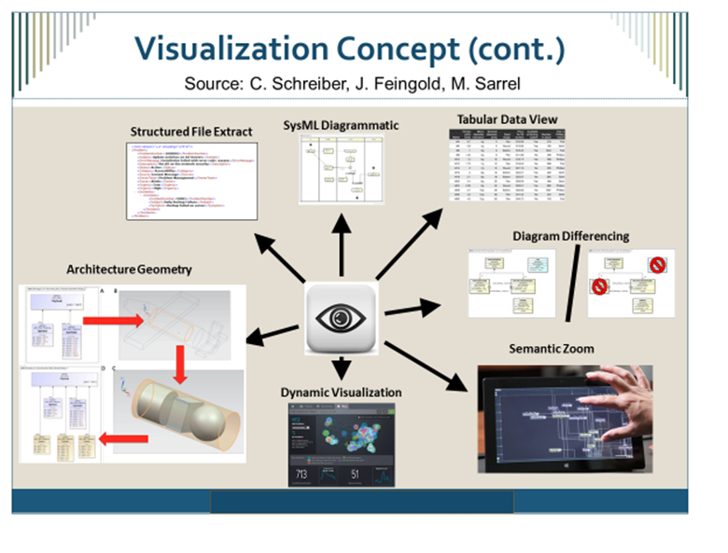

Model Analysis Services Introduction
The background that led to the model analysis concept and requirements are described on the Model Analysis Wiki. The goal is to facilitate multi-domain and multi-disciplinary analysis of the system model. The services are intended to support full lifecycle analysis that includes both quantitative and qualitative (logical) analysis.
The primary analysis service requirements are to Setup and Execute the analysis, Store the analysis results, and Query the analysis. The analysis services must integrate with the analysis concepts, and the concepts for properties, values, and expressions, as well as the other service requirements related to model construction, model visualization, and model management. This includes the need for representing a unique identifier, versioning, and model transformations to support analysis.

Model Management Services Introduction
The background that led to the model management concept and requirements are described on the Model Management Wiki. The goals of the model management services are to manage the configuration of the system model, and manage the change process for the system model. In addition to the system model, the scope of model management includes the links to other models and external data sources. This broader scope that includes the system model and the links is referred to as the integrated system model. Model management also encompasses management of other model constructs that are used to develop and maintain the system model such as validation scripts. The model management concept is highlighted in the figure below.
Figure 3.23. Integrated System Model (ISM) Lifecycle Management Concepts (Source: SysML v2 RFP Model Management WG)
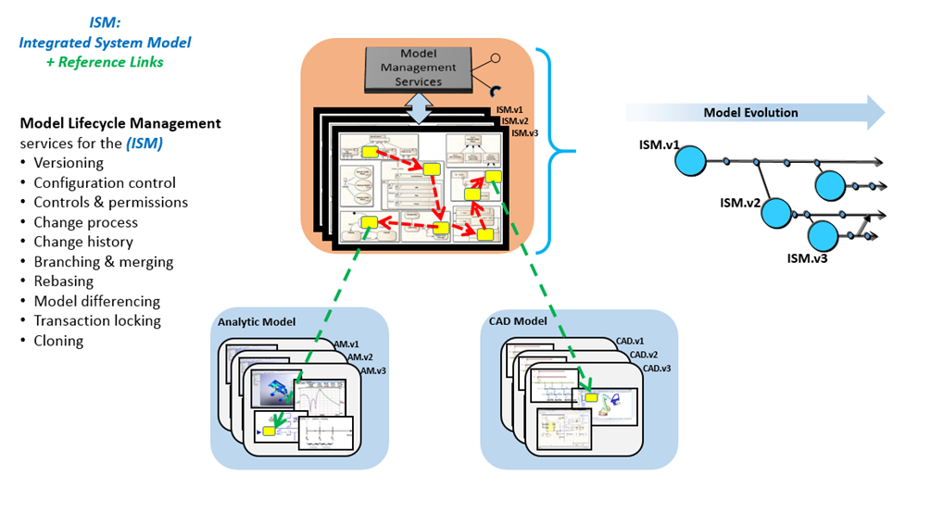

A key model management requirement is for each model element is to have a unique identifier, and for model elements to be capable of being versioned. The Universal Unique Identifier (UUID) was proposed as a potential standard for a globally unique id, along with the required metadata such as timestamp and its context (e.g., when created, changed, approved).
For SysML v2, there is a requirement for the metadata to be extensible. The intent is to identify what metadata is required to manage the system model, without over constraining where this metadata is stored, how it is stored, and whether the metadata is part the SysML model. There is also a requirement to interchange the metadata in a standard way.
The primary model management services are to create versions, create baseline configuration, log changes, compare differences, generate version histories, manage data protection controls such as data rights and markings, and manage user authorizations to the data. Services are also required to extend the metadata.

Workflow & Collaboration Services Introduction
The background that led to the workflow and collaboration concept and requirements are described on the MBSE Workflow and Collaboration Wiki. The Workflow and Collaboration concept is defined in the context of an of an external workflow management capability that manages the overall engineering workflow.
MBSE practices are captured in a master practices repository. The practices are tailored to a particular project, and used as an input for project planning, execution, and monitoring. As part of the planning process, the tasks are assigned to roles, and roles are assigned to individuals to perform the modeling tasks.
The minimum requirements for SysML v2 are to provide services that support integration of the modeling tasks with external process definition and workflow capabilities. In particular, SysML v2 should enable an external workflow environment to assign roles to specific users, accept notification to begin a task, and provide status/metrics on the performance and completion of the task.
The assignment of a user to a task should also include the scope of the model that the user has access to, which is indicated in the figure below by the relationship between the Task and User to the Model Configuration Item.
Figure 3.24. Workflow & Collaboration Concepts
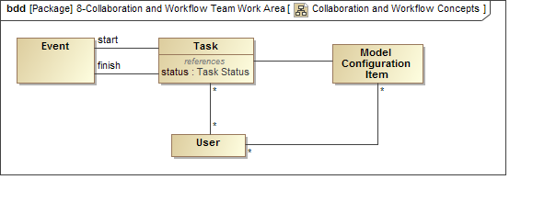

Services Requirements

Table 3.12.
ID | Name | Requirement Text | SysML v1.x Construct
SVC 01 | Structured Data Service | SysML v2 shall specify services to export and import structured data.
SVC 02 | Model Construction Services Group | Model construction is the ability to create, update, and delete individual model elements or sets of model elements or model constructs.  Model construction applies to model patterns, queries, rules and expressions, transformations, links to external data elements, metadata elements, and any other constructs that are used to support the construction of the system model.  The goal is for the SysML v2 specification is to enable adaptable, efficient and intuitive model construction for a broad range of users (novice to expert). SysML v2 should not limit the use of current and future technologies that support model construction.  Model construction can be performed in complementary ways that include  - Interactively, using the interface provided by the system modeling environment.  - In batch mode, by importing data/resources from an external file, database or software application, and transforming it to the corresponding SysML model constructs.  The model may be constructed using different forms that include textual, graphical, or tabular entry or a combination.  The requirements for model construction have interdependencies with other requirements related to model visualization, model management, workflow and collaboration, and model analysis.  - Model construction uses services provided by these other capability areas, and the other capability areas use the model construction services.  Model construction is supported by a transactional approach where the model updates can be completed successfully or rolled back to a prior consistent state.  The semantics associated with the deletion of model elements and constructs is assumed to be specified.
SVC 02.1 | Read and Transform Input Group
SVC 02.1.1 | Read Input Data | SysML v2 shall specify a service to read data from an external data source that is available in the following formats (TBD).
SVC 02.1.2 | Transform Input Data | SysML v2 shall specify a service to transform data from and an external data source to SysML v2 model elements in accordance with the mapping rules between the external data schema and the SysML v2 metamodel
SVC 02.1.3 | Maintain Source Identifier | SysML v2 shall maintain the element identifier of the source data if provided.
SVC 02.2 | Create Elements Group
SVC 02.2.1 | Create Model Elements and Model Constructs | SysML v2 shall specify a service to create model elements and other model constructs using textual, graphical, and/or tabular entry.
SVC 02.2.2 | Create Unique Identifier | SysML v2 shall create a unique identifier when creating a model element or other model construct.
SVC 02.3 | Update Elements Group
SVC 02.3.1 | Update Model Elements and Model Constructs | SysML v2 shall specify a service to update model elements and other model constructs using textual, graphical, and/or tabular entry.
SVC 02.4 | Delete Elements Group
SVC 02.4.1 | Delete Model Elements and Model Constructs | SysML v2 shall specify a service to delete model elements and other model constructs in accordance with the deletion semantics.
SVC 02.4.2 | Preserve Unique Identifier | SysML v2 shall retain the unique identifier when deleting a model element or other model construct.
SVC 02.5 | Patterns Group
SVC 02.5.1 | Create Pattern | SysML v2 shall specify a service to create a model pattern.
SVC 02.5.2 | Apply Pattern | SysML v2 shall specify a service to create, update, and delete model elements that conform to a defined model pattern.
SVC 02.6 | Model Metadata Services Group | The intent of this set of services is to support the use of model element metadata.  Scope: managing the metadata associated with model and model elements
SVC 02.6.1 | Create Metadata | SysML v2 shall specify a Create Metadata service to create model element metadata using textual, graphical, and/or tabular entry or by utilizing an API (e.g. algorithmic).
SVC 02.6.2 | Read Metadata | SysML v2 shall specify a Read Metadata service to read model element metadata using textual, graphical, and/or tabular entry or by utilizing an API (e.g. algorithmic).
SVC 02.6.3 | Update Metadata | SysML v2 shall specify an Update Metadata service to update model element metadata using textual, graphical, and/or tabular entry or by utilizing an API (e.g. algorithmic).
SVC 02.6.4 | Delete Metadata | SysML v2 shall specify a Delete Metadata service to delete model element metadata using textual, graphical, and/or tabular entry or by utilizing an API (e.g. algorithmic).
SVC 02.7 | Crosscutting Group
SVC 02.7.1 | Abstraction Level Construction | SysML v2 shall consider how to construct models through elaboration and refinement to transition from one level of abstraction to another, while preserving the earlier abstraction. (Note: this may be considered a transformation of one abstraction level to another that can be viewed in different viewpoints.)
SVC 02.7.2 | Model Construction Usability | SysML v2 shall demonstrate how the SysML v2 usability criteria are addressed by model construction
SVC 04 | Analysis Services Group | This set of services is used to setup, execute, store, and query analysis models and artifacts.
SVC 04.1 | Analysis Setup | SysML v2 shall specify services to setup analysis, such as identifying:  - Objectives, type, and fidelity of the analysis to be performed  - Key metrics (MoEs, KPPs, PoIs)  - The representation of the system which is being analyzed  - The plan for performing the analysis, and the scenarios being considered  - Analysis models for the analysis scenarios, including generation/derivation of analysis models from system model  - Software infrastructure required to formulate and execute analysis models
SVC 04.2 | Execute Analysis | SysML v2 shall specify services to execute analysis models for various analysis scenarios using the analysis infrastructure.
SVC 04.3 | Store Analysis | SysML v2 shall specify services to version and store all the information related to an analysis, including analysis models and their execution results that may be stored in the SysML v2 model repository or in an external repository.
SVC 04.4 | Query Analyses and Results | SysML v2 shall specify services to query all the information related to an analysis, including querying and filtering analysis models and execution results that may be stored in the SysML v2 model repository or in an external repository.
SVC 06 | Visualization Services Group | The following specify the requirements to enable visualization of the SysML v2 model.
SVC 06.1 | View Metamodel | SysML v2 shall specify a service to define view elements in a standard way.
SVC 06.2 | Metamodel & View Metamodel Transformation | SysML v2 shall specify a service to map SysML v2 model elements to SysML v2 view elements in a standard way.
SVC 06.3 | View Group | The following specify the requirements to render views that contain view elements.
SVC 06.3.1 | View Rendering Format | SysML v2 shall specify a service to render a view in diverse formats that include graphical, geometric, tabular, textual, and numerical formats.
SVC 06.3.2 | Manual and Automatic View Rendering | SysML v2 shall specify a service to render the layout of the view elements manually and automatically.
SVC 06.3.3 | View Filter, Zoom, and Layering | SysML v2 shall specify a service to filter, zoom, and layer the view elements.
SVC 06.3.4 | Standard Views | SysML v2 shall specify a service to render the predefined SysML standard views (refer to list).
SVC 06.3.5 | Persistent Views | SysML v2 shall specify a service to persist views in a standard format.
SVC 06.3.6 | View Interchange | SysML v2 shall specify a service to interchange view information so that the view can be generated by a SysML v2 conformant tool.
SVC 06.3.7 | View Management Service | SysML v2 shall specify a service to manage changes to persistent views.
SVC 06.4 | Viewpoint Group | The following specify the requirements to specify viewpoints.
SVC 06.4.1 | Viewpoint Method | SysML v2 shall specify a service to create, read, update, delete, and execute viewpoint methods that query the model, and render the query results in a view.
SVC 06.4.2 | Interactive Viewpoint Method | SysML v2 shall specify a service to create, read, update, delete, and execute viewpoint methods that support interactive behavior between the user and the view.
SVC 06.4.3 | Composite Viewpoints | SysML v2 shall specify a service to represent composite viewpoints and navigate between views.
SVC 06.4.4 | Viewpoint Library | SysML v2 shall specify a service to create, read, update, and delete viewpoint libraries that include predefined viewpoint methods (Note: this includes the methods to generate the SysML v2 standard views).
SVC 08 | Model Management Services Group | The intent of this set of services is to manage changes to model elements.  Scope: Configuration management control based on data privileges and change access.
SVC 08.01 | Identify Scope | SysML v2 shall specify services to identify the model scope to be reviewed and/or updated by a task (i.e., a task change set).  Supporting Information: This is not a minimum requirement for SysML v2 as not all tools are expected to provide fine grain groupings for 'scope'
SVC 08.02 | Provide Access | SysML v2 shall specify services to provide access permissions for identified users of a task to the model scope.  Supporting Information: This is not a minimum requirement for SysML v2 as not all tools are expected to provide fine grain access control
SVC 08.03 | Define MCI Definition Default Rules | SysML v2 shall specify services to define the default MCI content rules to determine what level of model element granularity will be versioned.  Supporting Information: Examples include Package, block, element
SVC 08.04 | Authorize Model Version Update | SysML v2 shall specify services to authorize model version update including individual permissions and working in conjunction with data protection services.
SVC 08.05 | Create or Update MCI versions | SysML v2 shall specify services to create or update MCI version on a commitment of an element or model.
SVC 08.06 | Log Change | SysML v2 shall specify services to log changes to model elements for a version.
SVC 08.07 | Compare and Identify Differences | SysML v2 shall specify services to identify differences between any two or more versions of the same MCI.
SVC 08.08 | Create Baseline Configuration | SysML v2 shall specify services to create a baseline configuration with MCIs.
SVC 08.09 | Create Branch Configuration | SysML v2 shall specify services to create a branch of a baseline configuration with MCIs.
SVC 08.10 | Update Branch with MCIs | SysML v2 shall specify services to update a branch of a baseline.
SVC 08.11 | Merge Branch to Trunk | SysML v2 shall specify services to merge a branch to a trunk of a baseline.
SVC 08.12 | Re-base Branch from Trunk | SysML v2 shall specify services to update a branch from a trunk baseline.
SVC 08.13 | Create Model Control | SysML v2 shall specify services to create the initial control of a model including the creation of a MCI and versioning.
SVC 08.14 | Add to Parent MCI | SysML v2 shall specify services to add additional model elements or MCIs to a parent MCI.
SVC 08.15 | Delete Model Control | SysML v2 shall specify services to delete or remove a model's model management metadata from the configuration management repository including all history.
SVC 08.16 | Provide History | SysML v2 shall specify services to provide log change history that was created by the log change service.
SVC 08.19 | Model Integrity | SysML v2 MLM services shall NOT modify any system model content.  Supporting Information: The intent of this requirement is to partition additional MLM metadata from the user model to allow the MLM metadata to be removed without impacting the model.
SVC 08.20 | Timestamp generation | SysML v2 shall specify a service to provide a standard formatted timestamp with a context.  Supporting Information: Example: timestamp= [time=2009-06-15T13:45:30; context=last-change]
SVC 10 | Manage Data Protection Control Services Group | The intent of this set of services is to create, read, update, and delete data protection controls based on data access rules such as activate directory, role based...  Scope: Control of data using access permissions, roles, data rights, markings
SVC 10.1 | Create Data Protection Controls | SysML v2 shall specify services to create data protection controls.
SVC 10.2 | Read Data Protection Controls | SysML v2 shall specify services to read data protection controls.
SVC 10.3 | Update Data Protection Controls | SysML v2 shall specify services to update data protection controls.
SVC 10.4 | Delete Data Protection Controls | SysML v2 shall specify services to delete data protection controls.
SVC 11 | Workflow and Collaboration Services Group | The minimum requirements for SysML v2 are to provide services via its API to support integration with an external process definition and workflow execution engine or process. In particular, the SysML v2 should enable a modeler to understand the task and role definition in the context of a workflow, accept notification to begin a task, gain some level of guidance on the execution of the task, and provide status/metrics on the performance of the task. It is assumed that some external workflow capability exists in some form.
SVC 11.1 | View Users | SysML v2 shall specify services to view available users.
SVC 11.2 | Start Task | SysML v2 shall specify services to create an SME specific task for a User.
SVC 11.3 | Task Status | SysML v2 shall specify services to provide user task state (e.g. completion) and metrics.
SVC 12 | Model Link Service | SysML v2 shall specify services to create, read, update, delete, and execute external links between SysML based system models and other structured data.
SVC 13 | Model Transformation Service | SysML v2 shall specify services to create, read, update, delete, and execute model transformations to/from SysML models.
SVC 14 | Metamodel Services Group | The intent of this set of services is to provide the capability to define new metadata terms that are needed by any of the SME service groups.  Scope: extending the core required metadata element that can be applied to model elements.
SVC 14.1 | Create Metamodel Element | SysML v2 shall specify services to create new metamodel elements to support capability extensions by any SME service group.  Supporting Information: This would be similar to extending a metaclass with additional properties.
SVC 14.2 | Read Metamodel Element | SysML v2 shall specify services to read metamodel elements.
SVC 14.3 | Update Metamodel Element | SysML v2 shall specify services to update metamodel elements.
SVC 14.4 | Delete Metamodel Element | SysML v2 shall specify services to delete metamodel elements.
SVC 14.5 | Exchange Metamodel Elements | SysML v2 shall specify services to exchange Metamodel elements.  Supporting Information: Model exchange should include mechanism for preserving user defined metadata within the context of model exchange.
SVC 14.6 | MLM Metadata Persistence | SysML v2 shall specify services to provide persistent model management metadata either in the data model of authoring tool or in a separate repository owned by the service provider (applies to services that authoring tool utilizes).
SVC 15 | Modify Services | SysML v2 shall specify services to create, read, update, and delete services
SVC 16 | SysML Version to Version Transformation | SysML v2 shall provide services to transform the previous version of SysML to the next version of SysML, beginning with the transformation of SysML v1 to SysML v2.
SVC 17 | Standard Read/Write Format | SysML v2 shall specify services to read and write a SysML model, its metadata, and its external links in a standard tool-independent format to support long term retention and model exchange.

Other

Interoperability Introduction
A major emphasis for SysML v2 is to improve interoperability with other engineering models and tools, and other external data sources. In the figure below, interoperability implies relationships between model elements that span different models. In many cases, an element in the SysML model has a direct correspondence to an element in another model, such as a component in the SysML model that had direct correspondence with a component in another model. However, the component in the SysML model is often an abstraction of the corresponding element in another model. The corresponding element in the other model may add further detail such as the case when a component in the SysML model is represented with detailed geometry by a component in a CAD model or an Electrical Model. In this way, the SysML model is more of a specification of the detailed design and analysis.
Figure 3.25. System Model Interoperability Concepts
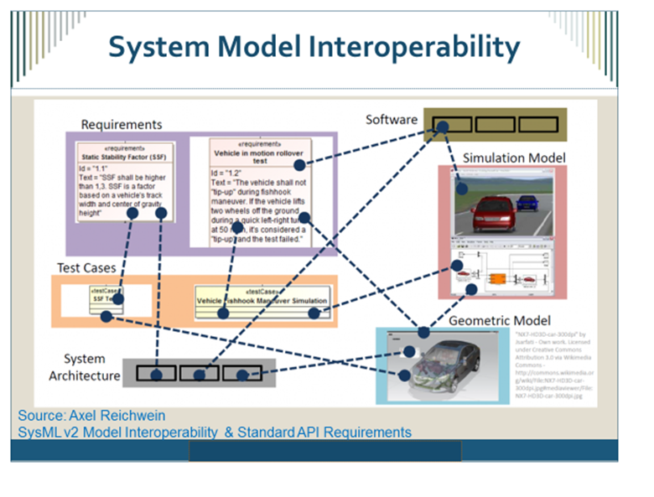

SysML v1 focused on interoperability between SysML models in different vendor tools. The primary mechanism for standard interoperability has been to leverage the XMI standard to support model interchange. SysML v2 is intended to provide much broader support for interoperability that include requirements for the following:
- A standard API to enhance integration with other SysML models and other models and tools
- A standard format to read and write SysML models
- Services to import and export structured data that is defined in standard formats, and enable transformations between the structured data and the model.
- A generalized capability to specify mapping rules and transform one model to another using the mapping rules.
- Migration of previous versions of SysML by specifying a transformation from each previous version of SysML to the next version of SysML, beginning with the migration from SysML v1 to SysML v2.
- A mapping between the shared concepts between SysML and UML to ensure a level of semantic interoperability between the system and software model.

Execution Languages Introduction
SysML v2 must support execution of queries, validation rules, expressions, viewpoint methods, and transformations. It is expected that SysML v2 will apply a common approach to specify execution languages that can provide maximum flexibility and growth, while maintaining a standard that can be executed and exchanged in a consistent manner. The approach is to apply the concepts of model driven architecture and specify a platform independent model with selected platform specific bindings.

Usability Introduction
Usability is a critical driver to the ultimate acceptance and use of SysML v2, and is fundamental to enabling more cost-effective application of MBSE. In particular, the usability goals are to reduce the learning curve for new users, improve productivity for constructing models for new and experienced users, and improve the visualization capability and interaction with the model for a diverse set of stakeholders that are primarily consumers of the model.
The SysML v2 RFP includes a minimal set of requirements to specifically address these usability concerns. This includes the requirement for the SysML v2 specification to establish usability criteria for different classes of users based on industry standards, and to identify methods and reports that demonstrate how an implementation satisfies the usability criteria. In addition, the SysML v2 specification will identify minimum levels of user documentation that must be maintained to aid in usability.
Some ways in which SysML v2 implementations are expected to address usability concerns include:
- Model construction services that include the use of patterns and workflow support
- Model visualization services that support a highly flexible view and viewpoint
- Customization and extensibility capabilities such as use of aliases, different native languages, domain specific symbol libraries concepts
- Consistency across language such as consistent terminology, symbols, shared concepts
- Consistent workflows, modeling patterns, and user interfaces
- Ability to quickly find relevant information within the current view
- Ability to quickly navigate to related information that is not in the current view
- Setting defaults to support common uses (e.g., default multiplicity of 1)
- Effective user documentation and support

Reference Model Introduction
The SysML v2 specification will include a reference model that provides a robust example of the application of SysML to a broadly relevant domain such as an automobile. The reference model can be used to support conformance evaluation of vendor implementations, and can also be used to demonstrate SysML concepts and support various training needs.

Other Requirements

Table 3.13.
ID | Name | Requirement Text | SysML v1.x Construct
OTR 1 | Interoperability Requirements Group | Other requirements from other topic areas that also relate to interoperability include API 01, FML 14, FML 16, FML 17, SVC 01, SVC 2.1, SVC 16 and SVC 17.
OTR 1.1 | UML Interoperability | SysML v2 shall provide the capability to model shared concepts between a system model and a software model, and a mapping of these shared concepts between SysML and UML.
OTR 2 | Model Libraries | SysML v2 shall include Model Libraries that contain reusable model elements such as:  - Primitive Data Types, Units, and Quantity Kinds  - Components  - Interfaces  - Environments  - Analyses
OTR 3 | Programming Language Specification Group
OTR 3.1 | Model Queries | SysML v2 shall provide a platform independent model and selected platform specific bindings to create, read, update, and delete model queries.
OTR 3.2 | Model Transformations | SysML v2 shall provide a platform independent model and selected platform specific bindings to create, read, update, and delete model transformations.
OTR 3.3 | Expressions | SysML v2 shall provide a platform independent model and selected platform specific bindings to create, read, update, and delete expressions.
OTR 3.4 | Viewpoint Methods | SysML v2 shall provide a platform independent model and selected platform specific bindings to create, read, update, and delete viewpoint methods
OTR 4 | Usability Group | An objective for SysML v2 is to address SysML v1 usability issues, and enable systems engineers and others to perform MBSE more effectively. The following high level usability goals apply to a diverse class of SysML v2 users:  a) User understandability when creating or interpreting models  b) User engagement when creating or interpreting models  c) User productivity when creating models
OTR 4.1 | Usability Criteria | SysML v2 shall define usability criteria based on industry standards* to achieve the usability goals, and map these criteria to the classes of SysML v2 users.
OTR 4.2 | Usability Demonstration | SysML v2 shall specify usability demonstration methods and reports based on industry standards* for vendors to demonstrate how their implementations achieve the usability criteria and goals.
OTR 4.3 | User Support Requirements Group
OTR 4.3.1 | User Documentation | The SysML v2 shall specify the level of user documentation that must be maintained to support the installation, use, and customization of the modeling tool.
OTR 5 | Reference Model | SysML v2 shall include a reference model that demonstrates the application of the SysML v2 language concepts to a commonly understood domain.

Conformance

Conformance Introduction
The SysML specification will include conformance tests to enable vendors and end users to specify and evaluate their level of conformance with the SysML v2 specification. This may include metamodel and profile conformance, concrete syntax conformance, API conformance, service conformance, and model interoperability conformance.

Conformance Requirements

Table 3.14.
ID | Name | Requirement Text | SysML v1.x Construct
CNF 1 | Conformance Requirements Group | The conformance approach defines a set of test cases that requires a SysML v2 implementation to import a reference model, and provide a response to standard service requests. The service response is evaluated for conformance to the specification based on the test cases.  Vendors may choose levels of conformance to support that may include specific services and language bindings, as well as other aspects of the SysML v2 specification such as data model conformance, and view and viewpoint conformance.
CNF 1.1 | Formalism Conformance | SysML v2 shall provide test cases to assess conformance of a SysML v2 implementation with the SysML v2 specification formalism requirements.
CNF 1.2 | API Conformance | SysML v2 shall provide test cases to assess conformance of a SysML v2 implementation with the SysML v2 specification API requirements.
CNF 1.3 | Metamodel & Profile Conformance | SysML v2 shall provide test cases to assess conformance of a SysML v2 implementation with the SysML v2 specification metamodel and profile requirements.
CNF 1.4 | Service Conformance | SysML v2 shall provide test cases to assess conformance of a SysML v2 implementation with the SysML v2 specification service requirements.
CNF 1.5 | Concrete Syntax Conformance | SysML v2 shall provide test cases to assess conformance of a SysML v2 implementation with the SysML v2 specification concrete syntax requirements.
CNF 1.6 | Model Interoperability Conformance | SysML v2 shall provide test cases to assess conformance of a SysML v2 implementation with the SysML v2 specification model interoperability requirements.
CNF 1.7 | Functional Thread Conformance | SysML v2 shall provide test cases to assess conformance of a SysML v2 implementation that support the following functional threads using a combination of services.  - Change impact thread (requirements to design to analysis to verification)  - Note: There may be additional threads to show how the SysML v2 specification supports various MBSE use cases

References & Glossary Specific to this Document

References Specific to this Document

Bibliographic Citation List for this Document
- Created for SECM - This citation indicates that this text was created specifically for the SECM and no other reference is known. Enter [1, created for SECM] at the end of the text field.
- INCOSE. 2011. INCOSE Systems Engineering Handbook, Version 3.2.2. San Diego, CA, USA: International Council on Systems Engineering (INCOSE), INCOSE-TP-2003-002-03.2.2.
- BKCASE Editorial Board. 2015. The Guide to the Systems Engineering Body of Knowledge (SEBoK), v. 1.5. R.D. Adcock (EIC). Hoboken, NJ: The Trustees of the Stevens Institute of Technology. Accessed DATE. www.sebokwiki.org. BKCASE is managed and maintained by the Stevens Institute of Technology Systems Engineering Research Center, the International Council on Systems Engineering, and the Institute of Electrical and Electronics Engineers Computer Society.
- ISO/IEC 2008. Systems and Software Engineering -- System Life Cycle Processes. Geneva, Switzerland: International Organization for Standardization / International Electromechanical Commissions. ISO/IEC/IEEE 15288:2008 (E).
- ISO/IEC 2015. Systems and Software Engineering -- System Life Cycle Processes. Geneva, Switzerland: International Organization for Standardization / International Electromechanical Commissions. ISO/IEC/IEEE 15288:2015 (E).
- Wikipedia: Safety: Mar 31, 2015: http://en.wikipedia.org/wiki/Safety#Safety_measures
- Douglas, Bruce: Safety Analysis of UML Models
- Wikipedia. Main Page. Mar 31, 2015. http://en.wikipedia.org
- Roedler, G.J. and Jones, C. December 27, 2005. Technical Measurement, Version 1.0, Practical Software and Systems Measurement (PSM) and International Council on Systems Engineering (INCOSE). INCOSE-TP-2003-020-01
- INCOSE (2015). Systems Engineering Handbook: A Guide for System Life Cycle Process and Activities (4th ed.) D. D. Walden, G. J. Roedler. K. J. Forsberg, R.D. Hamelin, and, T. M. Shortell (Eds.). San Diego, CA: International Council on Systems Engineering. Published by John Wiley & Sons, Inc.
- Merriam Webster on-line dictionary
- UML 4SE RFP. SE Definitions List, April 01 2003: http://syseng.omg.org/UML%20for%20SE%20Definitions%20030401.xls
- Business Dictionary.com - http://www.businessdictionary.com/
- INCOSE. 2015. Guide for Writing Requirements. Version 2, San Diego, CA, USA: International Council on Systems Engineering (INCOSE), INCOSE-TP-2010-006-02.
- OMG Unified Modeling Language (OMG UML), Version 2.5, March 2015, OMG Document Number - formal/2015-03-01
- OMG Systems Modeling Language (OMG SysML), Version 1.4, September 2014, OMG Document Number: formal/2015-06-03
- ISO Online Browsing Platform (OBP), Terms and Definitions, https://www.iso.org/obp/ui/#home
- Weilkiens, Tim: Variant Modeling with SysML, MBSE4U - Tim Weilkiens, Apr 12 2016, ISBN 978-3-9817875-4-2
- Hilbert, D., & Ackerman, W. (1950) Mathematical Logic (L. Hammond, G. Leckie, & F. Steinhardt, Trans.). New York, NY: Chelsea Publishing Company
- Friedenthal, Sanford, Moore, Alan, Steiner, Rick. A Practical Guide to SysML: the systems modeling language. New York, NY: Elsevier, 2015. Third Edition
- Friedenthal, S. 2016. "Evolving SysML and the System Modeling Environment to Support MBSE, Part 2" INSIGHT (December Volume 19 Issue 4, Pg 76-80)
- Torroni, P., Yolum, P., Singh, M., Alberti, M., Chesani, F., Gavanelli, M., Lamma, E., & Mello, P., (2009). Modeling Interactions via Commitments and Expectations. In Handbook of Research on Multi-Agent Systems: Semantics and Dynamics of Organizational Models (p. 263-284) Hershey, PA: IGI Global.
- Winskel, D., & Pitts, A. (2005) Lecture Notes on Denotational Semantics for Part II of the Computer Science Tripos. Retrieved at: http://www.cl.cam.ac.uk/~gw104/dens.pdf
- (2017) Oxford Living Dictionaries. Retrieved at https://en.oxforddictionaries.com
- ISO 9241-210:2010. Ergonomics of human-system interaction - Part 210: Human-centered design for interactive systems. Geneva, Switzerland: International Organization for Standardization.
- OMG Systems Modeling Language (OMG SysML), Version 1.5, May 2017, OMG Document Number: formal/2017-05-0
- Satellites to Supply Chains, Energy to Finance SLIM for Model-Based Systems Engineering, Part 1: Motivation and Concept of SLIM. Manas Bajaj, Dirk Zwemer, Russell Peak, Alex Phung, Andy Scott, Miyako Wilson (2011). Presented at the 21st Annual INCOSE International Symposium, Denver, CO, June 20-23, 2011. PDF available at http://www.omgsysml.org/SLIM_for_MBSE_Bajaj_Part1.pdf
- Satellites to Supply Chains, Energy to Finance SLIM for Model-Based Systems Engineering, Part 2: Applications of SLIM. Manas Bajaj, Dirk Zwemer, Russell Peak, Alex Phung, Andy Scott, Miyako Wilson (2011). Presented at the 21st Annual INCOSE International Symposium, Denver, CO, June 20-23, 2011. PDF available at http://www.omgsysml.org/SLIM_for_MBSE_Bajaj_Part2.pdf
- Introduction to SLIM www.intercax.com/slim
- MOF Support for Semantic Structures (SMOF), Version 1.0, April 2013, OMG Document Number - formal/2013-04-02
- Meta Object Facility (MOF), Version 2.5.1, November 2016, OMG Document Number - formal/2016-11-01
- Matthews, P.H. (2014) The Concise Oxford Dictionary of Linguistics: Oxford University Press. Retrieved at: http://www.oxfordreference.com/

OMG Standards Relevant to this Document
1. Business Motivation Metamodel (BMM)
http://www.omg.org/spec/BMM
2. Business Process Model and Notation (BPMN)
http://www.omg.org/spec/BPMN/index.htm
3. Decision Model and Notation (DMN)
http://www.omg.org/spec/DMN
4. Diagram Definition (DD)
http://www.omg.org/spec/DD
5. Meta Object Facility (MOF) Core
http://www.omg.org/spec/MOF/
6. MOF Support for Semantic Structures (SMOF)
http://www.omg.org/spec/SMOF/
7. MOF Versioning and Development Lifecycle (MOFVD)
http://www.omg.org/spec/MOFVD
8. Object Constraint Language (OCL)
http://www.omg.org/spec/OCL
9. Profile for Safety and Reliability
In process (POC Geoff Biggs)
10. Query View Transformation (QVT)
http://www.omg.org/spec/QVT
11. Requirements Interchange Format (ReqIF)
http://www.omg.org/spec/ReqIF
12. Reusable Asset Specification (RAS)
http://www.omg.org/spec/RAS
13. Semantics of Business Vocabulary and Business Rules (SBVR)
http://www.omg.org/spec/SBVR
14. Software and Systems Process Engineering Metamodel (SPEM)
http://www.omg.org/spec/SPEM
15. UML Testing Profile (UTP)
http://www.omg.org/spec/UTP
16. Unified Architecture Framework (UAF) previously UPDM
http://www.omg.org/spec/UAF
17. Unified Modeling Language (UML®)
http://www.omg.org/spec/UML
18. XML Metadata Interchange (XMI®)
http://www.omg.org/spec/XMI

Other Standards Relevant to this Document
1. FMI Functional Mock-Up Interface
http://fmi-standard.org/
2. ISO 10303-233:2012 (STEP)
https://www.iso.org/standard/55257.html
3. ISO 42010 - Systems and software engineering - Architecture description
http://cabibbo.dia.uniroma3.it/asw/altrui/iso-iec-ieee-42010-2011.pdf
4. ISO/IEC 25062:2006(en) - Software engineering Software product Quality Requirements and Evaluation (SQuaRE) Common Industry Format (CIF) for usability test reports
https://www.iso.org/obp/ui/#iso:std:iso-iec:25062:ed-1:v2:en
5. ISO/DIS 9241-220.2(en) Ergonomics of human-system interaction - Part 220: Processes for enabling, executing and assessing human-centered design within organizations
https://www.iso.org/obp/ui/#iso:std:iso:9241:-220:dis:ed-1:v2:en
6. ISO/IEC 15288:2015 - Systems and software engineering - System lifecycle processes
https://www.iso.org/obp/ui/#iso:std:iso-iec-ieee:15288:ed-1:v1:en
7. Open Services for Lifecycle Collaboration (OSLC)
http://open-services.net/

Glossary Specific to this Document

Table A.1.
Name | Definition
Abstract Syntax | Those aspects of the rules used in the formal specification of data which are independent of the encoding technique to represent the data (ISO 10161-1:2014(en), 3.3.1) [17, ISO OBP Definitions]
Activity Setup | The activity that takes place before an analysis can be executed. This includes:  - Model the types of analyses that need to be performed on the system representation  - Model the analysis objectives mathematically  - Define the key parameters (KPPs/MoEs) being computed or patterns/anti-patterns to be matched.  - Define mapping/transformation from system model to analysis model  - Execute the model transformation - Create or generate analysis model based on mapping/transformation (tool-neutral or tool-dependent)
Alias | An assumed or additional name. [11, Merriam Webster on-line dictionary]  An additional name could include, an acronym, an abbreviated name, a less formal name or a name used in a different domain. [1, created for SECM]
Allocation Relationship | Allocate relationship provides a mechanism for associating elements of different types, or in different hierarchies, at an abstract level. Allocate is used for assessing user model consistency and directing future design activity. It is expected that an allocate relationship between model elements is a precursor to a more concrete relationship between the elements, their properties, operations, attributes, or sub-classes. [16, derived from SysML spec]
Alternative | a : a proposition or situation offering a choice between two or more things only one of which may be chosen a government facing the alternative of high taxes or poor highways  b : an opportunity for deciding between two or more courses or propositions the alternative of going by train or by plane  [11, Merriam Webster on-line]
Analysis | The systematic investigation of a real or planned system to compare, evaluate, and select candidate system architectures, and/or determine causes & resolutions of failures and exceptions. [SEBoK, NASA SE Handbook 2007].  An analysis activity may include evaluation by means of modeling/simulation, inspection, demonstration, test, or a combination of these. ([1, created for SECM]  A systematic investigation of a real or planned system to determine the information requirements and processes of the system and how these relate to each other and to any other system. (ISO/IEC/IEEE 2009) [3, SEBoK Glossary]
Analysis Case | A situation requiring analysis investigation or action. [1, created for SECM]
Analysis Evaluation | The activity that occurs for an analysis case to evaluate the outcome data against the success criteria and determines an outcome. [1, created for SECM]
Analysis Infrastructure | All items needed to conduct the analysis effort, including tools, people, measurement devices, procedures, documentation and information. [1, created for SECM]
Analysis Model | The computation model used to calculate the system properties (relevant to the analysis) to meet the analysis objectives. An Analysis model could be computer-based executable model (e.g. Mathematica/MATLAB code or FEA/CFD model), or a model representing physical measurement on a prototype or actual system. For every analysis model, the following characteristics are modeled:  - Language in which the model is formulated  - Software used to formulate the model  - Type of model  - Result data from executing the model  - Relationship to the system representation, e.g. design model. This relationship embodies the model transformations required to generate or update the analysis model from the system representation  [1, created for SECM]
Analysis Objective | Represents the objective of the analysis. The objective can be specified in the form of textual description and/or as an expression. When the objective is modeled using a set of math expressions their formal evaluation can be automated. The objective of an analysis is met if the expressions can be successfully evaluated by the information generated during the analysis. [1, created for SECM]
Analysis Outcome | The output created from executing a scenario of an analysis case. [1. created for SECM]
Analysis Plan | Information item that presents a systematic course of action for achieving a declared purpose, including when, how, and by whom specific activities are to be performed. (ISO/IEC/IEEE 15289:2011) [3, SEBoK Glossary]
Analysis Result | This concept represents the result of the analysis in terms of the evaluations of all the expressions in the Analysis Objective. An analysis is successful if its objective has been met. [1, created for SECM]
Analysis Subject | Represents the subject of the analysis being performed. Since the scope of system analysis spans across the lifecycle, the subject of the analysis could be either of the following:  - Design representation of the system, such as a digital mock-up (computer model) of a spacecraft being developed  - Prototype of the system, such as a scaled or real prototype of the spacecraft  - Deployed system, such as the actual spacecraft deployed in orbit.  [1, created for SECM]
Analyst | 1. a member of the technical community (such as a systems engineer or business analyst, developing the system requirements) who is skilled and trained to define problems and to analyze, develop, and express algorithms. IEEE Std 1233-1998 (R2002) IEEE Guide for Developing System Requirements Specifications.3.1 (ISO/IEC/IEEE 24765:2010(en), 3.104) [17, ISO OBP Definitions]
Annotation | A note added by way of comment or explanation. [11, Merriam Webster on-line dictionary]  An annotation contains a text statement and can also contain one or more navigational links.
API | In computer programming, an application programming interface (API) is a set of subroutine definitions, protocols, and tools for building application software. A good API makes it easier to develop a computer program by providing all the building blocks, which are then put together by the programmer. [8, Wiki]
As-Built Realization | A description of how a specific Component Realization was actually built. [1, created for SECM]
As-Designed Realization | A description of the design of a Component Realization. [1, created for SECM]
Assumption | 3 a : an assuming that something is true <a mistaken assumption>b : a fact or statement (such as a proposition, axiom (see axiom 2), postulate, or notion) taken for granted [11, Merriam Webster on-line]
Axiomatic Semantics | Meanings for program phrases defined indirectly via the axioms and rules of some logic of program properties. [23, Denotational Semantics Lecture]
Base Model Element | A base model element can be a model element from any type of model, e.g. the system model, mechanical model, etc. Example elements from a system model include a requirement, an architectural element, a test case, multiplicity, and a value property. [1, Created for SECM]
Baseline | An immutable MCI Configuration. A Baseline uniquely defines an unchanged over time set of MCIs with its associated versions and variants. Model Baselines are often used to freeze MCIs at critical points in the model development lifecycle. [1, created for SECM]
Basic 2D/3D Library | A digital library containing a collection of predefined model elements representing a set of reusable basic two and three dimensional geometric shapes that can be copied or reference while constructing a model. [1, created for SECM]
Batch Mode | User initiated operations for creating model constructs using an external collection of model element properties, operations and/or relationships. [1, created for SECM]
Case | b (1) : a situation requiring investigation or action (as by the police) (2) : the object of investigation or consideration  [11, Merriam Webster on-line dictionary]
Cause-effect Relationship | Cause-effect relationship relates a cause to an effect. The cause and effect are the ends of the relationship. Those ends may be any model element including states. [1, Created for SECM]
Change Log | A chronological listing of changes to an MCI. Each change log is associated to a version. [1, created for the SECM]
Comment | a : an observation or remark expressing an opinion or attitude critical comments constructive comments  b : a judgment expressed indirectly sees the film as a comment on modern values  [11, Merriam Webster on-line dictionary]  A Comment is a textual annotation that can be attached to a set of (Model) Elements. [15, UML Spec]  A comment can also contain navigational links from this element or text within this element to other model elements or external elements. [1, created for SECM]
Component | (1) An entity with discrete structure, such as an assembly or software module, within a system considered at a particular level of analysis. (ISO/IEC 1998)  (2) One of the parts that make up a system. (IEEE 2008)  (3) A set of functional services in the software, which, when implemented, represents a well-defined set of functions and is distinguishable by a unique name. (ISO/IEC 2008)  [3, SEBoK Glossary]  In systems terms, we use component as the generic term for the level of decomposition at which system elements are no longer considered complex, and for which specialist design disciplines can be used. [3, SEBoK Glossary Discussion]
Component Library | A digital library containing a collection of predefined model elements representing a set of reusable components that can be copied or reference while constructing a model. [1, created for SECM]
Component Realization | A component that provides a solution that is intended to conform to the component specification. [1, created for SECM]
Component Specification | A specification is defined as:  a : a detailed precise presentation of something or of a plan or proposal for something, usually used in plural [11, Merriam-Webster on-line]  A Component Specification provides the physical, behavioral, and interface specification for a component to be designed and built. [1, created for SECM]
Concept | An abstraction; a general idea inferred or derived from specific instances. (Oxford Dictionaries Online 2012)  [3, SEBoK Glossary]
Concrete Syntax | Those aspects of the rules used in the formal specification of data that embody a specific representation of those data  ISO/IEC 2382:2015(en), 2123126 [17, ISO OBP Definitions ]
Configuration Element | Element of a Configuration Model  A Configuration Element may contain (or make use of) other Configuration Elements thereby constituting an explicit, fully expanded hierarchical composition structure.  [1, created for SECM]
Configuration Management | The process to manage and control system elements and configurations over the lifecycle as well as managing consistency between a product and its associated configuration definition. [5, ISO/IEC/IEEE 15288]
Configuration Model | A model that represents a fully expanded hierarchical composition structure for a particular configuration of a system and its interfaces.  The Configuration Model can be used in two ways:  - As an explicit representation that is generated from a Definition Model with a set of configuration parameters for any variation point, e.g. chosen multiplicity or usage expression, as well as possible filtering or pruning.  - Direct use of the Configuration Model as a simple 'loosely' typed hierarchical composition structure.  For the case (2) it is in principle possible to generate a (best effort) modular / typed Definition Model with some heuristic algorithm that detects elements of the same type.  Note: It is possible that a Configuration Model is over specified or out of sync w.r.t. to its associated Definition Model, and vice versa. Tool implementations will need to handle this situation with rules, refactoring and synchronization functionality.  [1, created for SECM]
Conform Relationship | The view conforms to the specified rules and conventions detailed in the viewpoint. When this is done, the view is said to conform to the viewpoint. [26, SysML 1.5]
Constrained Element | This element is bound to one or more elements in the realization that is constrained by the requirement. The constrained element is used by the Constraint Evaluation to determine is the system satisfied the requirement as stated in the constraining element. In a traditional textual requirement statement, this element is equivalent to the subject of the verb "shall" (or will, should, etc.). [1, created for SECM]
Constraining Element | The element that defines the requirement is constraining. This element can apply to any model element including properties, behaviors, etc. [1, created for SECM]
Constraint | A constraint establishes a limitation restriction. It is expressed in the form of a formal expression, e.g. a mathematical expression (including logical expressions), a behavior ( such as Activity diagrams, state diagrams, sequence diagrams), a table, text, etc.
Constraint Evaluation | Includes evaluation of satisfaction (assertion) and verification (evaluation):  1. Parent requirement is fully satisfied if logical combination of the following are satisfied:  - child requirements are satisfied  - derived requirements are satisfied  - design elements satisfy each requirement  2. Can include margin  [1, created for SECM]
Context | 1. Background, environment, framework, setting, or situation surrounding an event or occurrence. [13, BusinessDictionary.com]
Copied From Relationship | The intent of this relationship is to preserve the lineage to the source of the model element that it was copied from. To minimize the burden of the modeler this relationship could be automatically created by the modeling tool. [1, created for SECM]
Data Model | A Data Model is an abstract model that organizes elements of data and standardizes how they relate to one another and to properties of the real world entities.  A data model explicitly determines the structure of data. Data models are specified in a data modeling notation, which is often graphical in form.^{[2]}  [8, Wiki]
Data Protection Controls | Data Protection Controls are those metadata items associated with managing who can create, read, update and delete model elements. This includes managing access permissions, roles, data rights, and security markings. [1, created for SECM]
Decision | a : the act or process of deciding the moment of decision has come  b : a determination arrived at after consideration : conclusion made the decision to attend graduate school  [11, Merriam Webster on-line]
Declarative Semantics | Association of meaning that specifies what rather than how. Communication with declarative semantics specifies what actions should be brought out in an interaction, rather than how they are brought out. [22, Modeling Interactions via Commitments and Expectations]
Definition | a : a statement expressing the essential nature of something  b : a statement of the meaning of a word or word group or a sign or symbol dictionary definitions  c : a product of defining  [11, Merriam Webster on-line dictionary]
Definition Element | An element of a Definition Model  The set of Definition Element contained by a Definition Model can be regarded as the fundamental and uniquely identifiable, named building blocks from which system representations, i.e. architectures, can be constructed. Apart from a unique identifier and a human readable name a Definition Element defines the essence of what it represents through a set of named and typed features.  [1, created for SECM]
Definition Model | A model that captures a composite hierarchy of typed elements that represent the definition of a system and its interfaces A Definition Model represents a strongly typed, modular, hierarchical composite structure. It allows for inclusion of variation points so that it can represent a set of possible system variants. It also provides a generic structure to represent interfaces consisting of two Interface Ends and an Interface Connector. It is a generic pattern that can be specialized into concrete modular decomposition representations for e.g. a functional / behavior architecture and / or a physical architecture. System variation points can be included, e.g. for multiplicity ranges, inclusion or exclusion of subtrees, alternative composition with or without constraints, etc. The Definition Model contains a bag of building blocks represented by Definition Elements that may directly use (i.e. one level deep) zero or more Direct Usage Features of other Definition Elements. In many cases there is a need to unambiguously identify and reference more deeply nested usages, e.g. to introduce local override of feature values for a particular usage two or more levels down from a Definition Element or to define an interface connector between nested interface ends. For this purpose the Deeply Nested Usage Feature is made available. If no features need to be overridden, redefined nor added at a usage more than one level deep, then a Definition Model constitutes a complete implicit definition of the decomposition structure provided that a single top element is identified. With that, it is possible to automatically generate a corresponding Configuration Model that represents the full and explicit (deeply nested) expansion of the decomposition structure. It is important to note that Deeply Nested Usage Features need only be created (and persisted) if there is a need to override feature values, (re)define features or reference usages at a deeply nested level. Otherwise their representation can be automatically derived 'on the fly' as their existence is fully implied by Definition Elements and Direct Usage Features only. In case there are Variation Points present in the Definition Model, choices must be made within the range of possible variabilities in order to transform the Definition Model into a Configuration Model that represents a single actual variant that complies with the implicit definition represented by the Definition Model. Using some heuristics, and perhaps with some human assistance, it is in principle also possible to devise an algorithm that can automatically derive a Definition Model from a given Configuration Model. This is attractive since it would allow a beginning system modeler to start with the simpler, more easy to understand Configuration Model and transform it to the more powerful and generalized Definition Model. Such a capability would also support use cases for reverse engineering of existing system architectures. [1, created for SECM]
Denotational Semantics | Concerned with giving mathematical models of programming languages. Meanings for program phrases defined abstractly as elements of some suitable mathematical structure. [23, Denotational Semantics Lecture]
Dependency Relationship | A Dependency is a Relationship that signifies that a single model Element or a set of model Elements requires other model Elements for their specification or implementation. This means that the complete semantics of the client Element(s) are either semantically or structurally dependent on the definition of the supplier Element(s). [15, UML Spec]
Design Constraint | One of the potential category requirement selections available in the Requirement Type attribute. This selection identifies the requirement to be imposed during the design process. [1, created for SECM]
Directed Relationship | A Directed Relationship represents a relationship between a collection of source model Elements and a collection of target model Elements. [15, UML Spec]
Domain Specific View | A domain view is one or more views that are defined using presentations, shapes and icons that are specific for that domain, such as electrical views, software views, and mechanical views. [1, created for SECM]
Element | A entity with a unique identifier including Model Elements, Links, Scripts, Constructs, Files, Data, [1, created for SECM]
Element Group | A mechanism for grouping various and possibly heterogeneous model elements. For example, it can group elements that are associated with a particular release of the model, have a certain risk level, or are associated with a legacy design. The semantics of Element Group is modeler-defined. [16, SysML Spec]
Element Group Relationship | Element Group Relationship relates an element group to a member of the group. Logical expressions can be applied to membership of the group, such as AND, OR, NOR, NAND, etc. The default is AND. [1, created for SECM]
Environment | (1) Anything affecting a subject system or affected by a subject system through interactions with it, or anything sharing an interpretation of interactions with a subject system. (IEEE 1175.1-2002 (R2007), 3.6)  (2) The surroundings (natural or man-made) in which the system-of-interest is utilized and supported; or in which the system is being developed, produced or retired. (INCOSE 2010)  [3, SEBoK Glossary]
Event | 1. Occurrence of a particular set of circumstances. ISO/IEC 16085:2006 (IEEE Std 16085-2006), Systems and software engineering - Lifecycle processes - Risk management.3.2.  2. an external or internal stimulus used for synchronization purposes  [17, ISO OBP Definitions]
Explanation Relationship | This relationship is used between two elements to establish traceability between the element being rationalized, i.e. the conclusion, and the element justifying the conclusion, i.e. the rationale.  A conclusion element can be any type of element including elements such as blocks, requirements or relationships.  Typical rationale relationship elements include a derived or satisfy relationship.  Rationale elements can include a comment containing a text statement or an analysis.  [1, created for SECM]
Expression | In mathematics, an expression or mathematical expression is a finite combination of symbols that is well-formed according to rules that depend on the context. Mathematical symbols can designate numbers (constants), variables, operations, functions, brackets, punctuation, and grouping to help determine order of operations, and other aspects of logical syntax. [8, Wiki]
External (Resource) Collection | A file based or database or link based mechanism to persist descriptions of model elements. [1, created for SECM]
External Element | An entity external to the containing model or the SME. This external entity can include items such as a file, web page, or a model element in another model [1, created for SECM]
Formal Requirement Statement | A formal requirement captures all aspects of a requirement in a machine readable form, vs. text in a Textual requirement. This allows requirements to be used to automate tasks associated with validation of requirement information, verification of requirements and the use of the requirement parameters during system analysis.  Transformation of a textual requirement to a new formal requirement is one means of deriving a formal requirement. A textual view of a set of selected requirements is very useful to a user performing analysis or for a review.  [1, created for SECM]
Formalism | A description of something in formal mathematical or logical terms. [24, Oxford Living Dictionaries, "formal, n."
Function | (1) A system outcomes which contribute to goals or objectives. To have a function, a system must be able to provide the outcome through two or more different combinations of elemental behavior. (Ackoff 1971)  (2) An action, a task, or an activity performed to achieve a desired outcome. (Hitchins 2007)  (3) A broad work area encompassing multiple related disciplines (e.g., Engineering, Finance, Human Resources, etc.). (Created for SEBoK)  (4) A function is defined by the transformation of input flows to output flows, with defined performance. (Created for SEBoK)  [3, SEBoK Glossary]
Functional Requirement | One of the potential category of requirement selections available in the Requirement Type attribute. This selection identifies the requirement to be a functional requirement. [1, created for SECM]
Generalization Relationship | A Generalization is a taxonomic relationship between a more general Classifier and a more specific Classifier. Each instance of the specific Classifier is also an instance of the general Classifier. The specific Classifier inherits the features of the more general Classifier. A Generalization is owned by the specific Classifier.  [15, UML 2.5 Spec]
Geometric View | The geometric view is intended to specify geometric envelopes and requires concepts of shape and coordinate system. Refer to STEP standards. [1, created for SECM]
Hardware | 1. physical equipment used to process, store, or transmit computer programs or data. 2. all or part of the physical components of an information system. ISO/IEC 2382-1:1993, Information technology Vocabulary Part 1: Fundamental terms.01.010.07  cf. software  [17, ISO OBP Definitions]
Hyperlink | A hyperlink is a reference to data that the reader can directly follow either by clicking, tapping, or hovering. A hyperlink points to a whole document or to a specific element within a document. Hypertext is text with hyperlinks. [8, Wiki]  In a model links can also exist between model elements or information within in a model element such as values within an element, e.g. text within a definition. [1, created for SECM]
Individual Element | An element of an Individual Model An Individual Element typically has an identifier that uniquely identifies that element, e.g. a serial number, a batch number, or an effectivity. An Individual Element may be associated with a "slot" in the Configuration Model as represented by a Configuration Element or it may represent a spare part that is not (yet) integrated into a larger whole. [1, created for SECM]
Individual Model | A model that is a digital representation of an individual system or product that actually or potentially exists in the real world An Individual Model can be regarded as a "digital record" of the state of an individual system or product that was built according to a particular Configuration Model for e.g. development testing, verification, shipping, deployment or operation. Sometimes such a model is also known as a "digital twin". [1, created for SECM]
Integrated System Model | Contains the information about the system at any given stage during its lifecycle. It includes the system model and model-based connections between the system model and the various domain-specific models, such as CAD and CAE models that describe various aspects of the system and its sub-systems [27, SLIM Part 1][28, SLIM Part 2]. The connections between the System Model (or model elements) and domain-specific models (or model elements) may have different behaviors [4, Intro to SLIM], such as (1) reference connections for basic traceability, (2) data map connections for exchange for parameter values, (3) function wrap connections for wrapping executable code in system model elements, and (4) model transform connections for generating and synchronizing model structures bi-directionally.
Interactive Mode | User initiated operations using the graphical interface of the SysML user interface to interact with the modeling tool, for example to create, update, modify and delete model constructs and to maintain the model. [1, created for SECM]
Interactive Viewpoint | An interactive viewpoint provides visualization services that allows the user to adjust the view to meet the specific user's needs at the time. This interactive behavior can include services such as support for auto-layout, dynamic interactive visualization and manual diagram layout capability. The user will need to adjust the select scope of model being viewed, filters information content of the view, zoom in and out of specific areas of the view and the ability to specify which diagram layers are included. A diagram layers that consist of a group of diagram elements. Each layer can be included or removed, be assigned colors or offsets, etc.). [1, created for SECM]
Interface | 1. A shared boundary between two functional units, defined by various characteristics pertaining to the functions, physical signal exchanges, and other characteristics. (ISO/IEC 1993) 2. A hardware or software component that connects two or more other components for the purpose of passing information from one to the other. (ISO/IEC 1993) 3. To connect two or more components for the purpose of passing information from one to the other. (ISO/IEC/IEEE 200) [3, SEBoK Glossary]
Interface Requirement | One of the potential category requirement selections available in the Requirement Type attribute. This selection identifies the requirement to be associated with an interface. [1, created for SECM]
ISM | ISM is an acronym for Integrated System Model. See Integrated System Model for the definition. [1, created for SECM]
Language Binding | In computing, a binding from a programming language to a library or operating system service is an application programming interface (API) providing glue code to use that library or service in a particular programming language. [8, Wiki]
Layout Definition | A layout definition defines how the view will be organized and presented. It applies to graphical symbols, tables, serialized data, etc. It can include non-model info such as a backgrounds. [1, created for SECM]
Machine-readable Data | Machine-readable data is data (or metadata) which is in a format that can be understood by a computer. [8, Wiki]
Mathematical Logic | An extension of the formal method of mathematics to the field of logic. [19, Mathematical Logic, Hilbert & Ackerman]
MCI | MCI is an acronym for Model Configuration Item. See Model Configuration Item for the definition. [1, created for SECM]
MCI Configuration | A set of MCIs with their associated Versions and Variants. Within a specific Configuration, every MCI has a single and unique Version/Variant. A configuration is itself a MCI. [1, created for SECM]
Metadata | Metadata is "data that provides information about other data". Two types of metadata exist: structural metadata and descriptive metadata. Structural metadata is data about the containers of data. Descriptive metadata uses individual instances of application data or the data content.  Metadata is defined as the data providing information about one or more aspects of the data; it is used to summarize basic information about data which can make tracking and working with specific data easier. Some examples include:  - Means of creation of the data  - Purpose of the data  - Time and date of creation  - Creator or author of the data  - Location on a computer network where the data was created  - Standards used  - File size  [8, Wiki, Metadata]
Metamodel | A metamodel or surrogate model is a model of a model, and metamodeling is the process of generating such metamodels. [8, Wiki]
MLM | MLM is an acronym for Model Lifecycle Management. See Model Lifecycle Management for the definition. [1, created for SECM]
Model | A formal specification of the function, structure and/or behavior of an application or system.
Model Collection | A collection of model elements and/or modeling constructs used to construct the system model. [1, created for SECM]
Model Configuration Item | A specific portion of the system model (content and granularity) that is maintained in a controlled fashion, i.e. has a unique ID and version history. MCI can be defined in different granularities, from an individual fine grained Model Element, a set of Model Elements, a set of Elements, to the entire Model. Any MCI can contain another MCI. [1, created for SECM]
Model Construct | A model element or other entity used to construct a system model that includes model patterns, queries, rules and expressions, transformations, and links to external data elements. [1, created for SECM]
Model Element | A constituent of a model. [15, UML Spec] Model elements include things such as entities, relationships, properties, behaviors, multiplicities, comments, model organizational elements, etc. In the UML modeling language this is referred to as an "Element". [1, created for SECM] Because of the extensive use of the word "Element" in Systems Engineering the word "Model" was added to this term so as to express more specifically its intended use. [1, created for SECM]
Model Library | A library is a collection of sources of information and similar resources, made accessible to a defined community for reference or borrowing. [8, Wiki] A model library is a digital library containing a collection of predefined model elements representing a set of reusable components that can be copied or reference while constructing a model. [1, created for SECM]
Model Lifecycle Management | Manages the Engineering Change Process to provide Proposed Changes in response to Engineering Change Requests from the Formal Release Change Process. [1, created for SECM]
Model Pattern | (1) An expression of an observed regularity. (Alexander 1979) (2) A representation of similarities in a set or class of problems, solutions, or systems. (Alexander 1979) (3) Each pattern describes a problem which occurs over and over again in our environment, and then describes the core of the solution to that problem, in such a way that you can use this solution a million times over, without ever doing it the same way twice. (Alexander 1979) [3, SEBoK Glossary] A Model Pattern is expressed utilizing model elements. [1, created for SECM]
Model Repository | The model repository is located within the SME context and contains the data such as that associated with system models, analyses data, metadata, reuse libraries and persistent view data. [1, created for SECM]
Model Transformation | A mapping between two modeling languages that enables a model expressed in one modeling language to be expressed in whole or in part in the other modeling language. (Created for SEBoK) [3, SEBoK Glossary]
Model Validation | The process of ensuring the model correctly represents the domain or system-of-interest. (Friedenthal 2009) [3, SEBoK Glossary]
Model-Theoretic Semantics | An account of meaning in which sentences are interpreted in terms of a model of, or abstract formal structure representing, an actual or possible state of the world: compare possible world. Usually, at least, an account of truth conditions; i.e. sentences are interpreted as true or false in such a model. [
MOF | Meta-Object Facility - This International Standard provides the basis for metamodel definition in OMGs family of MDA languages and is based on a simplification of UML2s class modeling capabilities. In addition to providing the means for metamodel definition it adds core capabilities for model management in general, including Identifiers, a simple generic Tag capability and Reflective operations that are defined generically and can be applied regardless of metamodel. [31, MOF Spec]
Navigation Relationship | d: an identifier attached to an element (as an index term) in a system in order to indicate or permit connection with other similarly identified elements; especially: one (as a hyper link) in a computer file [11, Merriam-Webster]  A Navigational Link is one that establishes a navigable connection from a model element or text within a model element to an entity internal or external to the containing model. This could be a connection to an entity within the SME or external to the SME. [1, created for SECM]  The connections may have different behaviors, such as (1) reference connections for basic traceability, (2) data map connections for exchange for parameter values, (3) function wrap connections for wrapping executable code in system model elements, and (4) model transform connections for generating and synchronizing model structures bi-directionally. [29, Into to SLIM]
Operational Semantics | Meanings for program phrases defined in terms of the steps of computation they can take during program execution. [23, Denotational Semantics Lecture]
Originator/Author Attribute | The originator/author is the person responsible for entering the requirement. [14, Guide Writing Requirements, 5.3.3]
Owner Attribute | Identifies the person or element of the organization that maintains the requirement, who has the right to say something about this requirement, approves changes to the requirement, and reports the status of the requirement. [14, Guide Writing Requirements, 5.3.5]
Performance Requirement | One of the potential category requirement selections available in the Requirement Type attribute. This selection identifies the requirement to be a performance requirement. [1, created for SECM]
Physical Requirement | One of the potential category of requirement selections available in the Requirement Type attribute. This selection identifies the requirement to be a physical related requirement. [1, created for SECM]
Plan Verification Activity | An activity that creates a verification plan for the verification case. [1, created for SECM]
Platform Independent Model | A platform independent model (PIM) is a model of system or business system that is independent of the specific technological platform used to implement it. [8, Wiki]
Precondition Expression | Something that must exist or happen before something else can exist or happen [11, Merriam-Webster on-line definition] Types of preconditions can include: - Property values - Events - Textual Statements - provided in external referenced documents [1, created for SECM]
Priority Attribute | This is how important the requirement is to the stakeholders. It may not be a critical requirement (that is, one the system must possess or it won't work at all), but simply something that the stakeholder(s) hold very dear. Priority may be characterized in terms of a level (1, 2, 3 or high, medium, low). Priority may be inherited from a parent requirement. High priority requirements must always be met for the project to be successful; lower priority requirements may be traded off when conflicts occur or when there are budget or schedule issues. [14, Guide Writing Requirements, 5.3.20]
Problem | A Problem documents a deficiency, limitation, or failure of one or more model elements to satisfy a requirement or need or other undesired outcome. It may be used to capture problems identified during analysis, design, verification, or manufacture and associate the problem with the relevant model elements. [16, derived from SysML spec]
Process Requirement | One of the potential category requirement selections available in the Requirement Type attribute. This selection identifies the requirement to be imposed on a process that is to be used during a development, manufacturing, support or maintenance process. [1, created for SECM]
Property | Any named, measurable or observable attribute, quality or characteristic of a system or system element. (OMG 2003)  [3 SEBoK Glossary]  Note: SEBoK defined term was for System Property. It was changed to Property so it could be used at multiple levels, i.e. element, System Element and System.
Query | A precise request for information retrieval with database and information systems. [8, Wiki]
Query Language | Query languages are computer languages used to make queries in databases and information systems. [8, Wiki]
Query Method | A query method provides the functionality to query the models and associated metadata. [1, created for SECM]
Rationale | Argument that provides the justification for the selection of an engineering element. (Faisandier 2012) [3, SEBoK Glossary]
Realization Relationship | Realization is a specialized Abstraction relationship between two sets of model Elements, one representing a specification (the supplier) and the other represents an implementation of the latter (the client). Realization can be used to model stepwise refinement, optimizations, transformations, templates, model synthesis, framework composition, etc. [15, UML Spec]
Realized Element | An element within the realization component that is constrained by the constraining element. [1, created for SECM]
Reference Information | b: something (such as a sign or indication) that refers a reader or consulter to another source of information (such as a book or passage) [11, Merriam Webster on-line dictionary] This text can contain navigational links from this element or text within this element to the actual referenced material. [1, created for SECM]
Reference Model | A reference model in systems, enterprise, and software engineering is an abstract framework or domain-specific ontology consisting of an interlinked set of clearly defined concepts produced by an expert or body of experts in order to encourage clear communication. A reference model can represent the component parts of any consistent idea, from business functions to system components, as long as it represents a complete set. This frame of reference can then be used to communicate ideas clearly among members of the same community. [8, Wiki]
Refine Element Relationship | From UML 2.5, Refine Relationship Definition Specifies a refinement relationship between model elements at different semantic levels, such as analysis and design. The mapping specifies the relationship between the two elements or sets of elements. The mapping may or may not be computable, and it may be unidirectional or bidirectional. Refinement can be used to model transformations from analysis to design and other such changes. [15, UML]
Relationship | The way in which two or more things are connected. [11, Merriam-Webster on-line]
Reliability Requirement | One of the potential category of requirement selections available in the Requirement Type attribute. This selection identifies the requirement to be a reliability related requirement. [1, created for SECM]
Rendering Method | A rendering provides the functionality to generate a view this includes rendering in any combination of a tabular, serialized, graphical and document form. [1, created for SECM]
Required/Desired | This is a property of the formal requirement statement that defines if the requirement is a mandatory (required) requirement or a desired requirement from a customer perspective. In textual requirement statements the verb "shall" or "will" are typically used, respectively, to do this. When a textual form of the formal requirement statement is automatically generated then this verb will be used in the textual statement. [1, created for SECM]
Requirement | This concept represents a usage of a Requirement Definition and is therefore typed by a Requirement Definition. [1, created for SECM]
Requirement Attribute Library | A digital library containing a collection of predefined model elements representing a set of reusable requirement attributes that can be copied or reference while constructing a model. This collection should include all attributes and types defined in the INCOSE Requirements Writing Guide (see reference14). The intent is to make this library available to each organization and/or project to allow that organization or project to select which best fit their workflow needs. [1, created for SECM]
Requirement Allocation Relationship | A relationship from a higher architectural level (n) requirement to one or more requirements at a lower level (n-1) architectural component with the intent it will be satisfied. It is used to maintain traceability from the source requirement that was ultimately used to derive requirements for lower architectural components. During this allocation a value contained in the source requirement may be distributed to two or more components. See the Requirement Needs document for an explanation of where and how this relationship is used. [1, created for SECM]
Requirement Attribute | An attribute is additional information included with a requirement statement, which is used to aid in the management of that requirement. [14, Guide Writing Requirements, Definitions)
Requirement Context Element | An element that is referenced in the formal requirement statement that is contained within the context of the constraining element. [1, created for SECM]
Requirement Decompose Relationship | A decompose relationship is established from a requirement group to a requirement. The intent is to add constraints. There can be 1 or more decompose relationships from a requirement group. They are used to identify the set of requirements within a requirement group. [1, created for SECM]
Requirement Definition | Statement that identifies a product* or process operational, functional, or design characteristic or constraint, which is unambiguous, testable or measurable, and necessary for product or process acceptability. (ISO/IEC 2007) *includes product, service, or enterprise.[3, SEBoK Glossary]
Requirement Derive Relationship | A derived relationship imposes constraints to meet a higher level constraint. A derived relationship indicates a requirement has been added. It can be used in two ways; 1. A relationship between a higher architectural level requirement and one or more requirements derived in lower architectural components. 2. A relationship between 2 requirements on the same architectural level where one constraining element constrains another. [1, created for SECM]
Requirement Group | A grouping or organization of requirements. This can be an entity of a specification that contains a set of related requirements or it can any grouped set of requirements to facilitate any analysis task. In a black box specification a requirement context could be a functional items, external interfaces, or topic areas such as security, safety, design constraints, etc. In a white box requirement a context could also be a sub-components. The context can contain other related supporting information to help understand the requirements such as examples from other systems. [1, created for SECM]
Requirement Identifier | This is an identifier that uniquely identifies a requirement from other requirements, which can be either a number or mixture of characters and numbers used to refer to the specific requirement. This identifier is not a paragraph number. It can be a separate identifier or automatically assigned by whatever Requirement Management Tool (RMT) the organization is using. This identifier is used once and never reused. An identifier that is unique is also needed to link requirements in support of the flow down of requirements (allocation), traceability, and to establish peer-to-peer relationships. Some organizations include in the identifier codes that relate to the SOI to which the requirement applies: e.g., [SOI] 1234. [14, Guide Writing Requirements, 5.3.1] This is not the same as the Universally Unique Identifier (UUID) that every model element contains. This identifier should be unique across all requirements and can be tailored to meet a specific organization's needs. This identify typically includes some intelligence built into the number to help humans relate to its context (for example CR_100 for a customer requirement, where CR_ is a user-defined prefix unique to a requirement specification, and 100 is tool generated). [1, created for SECM]
Requirement Refine Relationship | A requirement refinement relationship is used between any two requirements or between a requirement group and one or more requirements, where one or more requirements are used to re-express the first element more precisely and with less ambiguity. Uses for between two requirements to include; 1. When a text requirement statement is refined with a formal requirement statement. 2. When a text requirement statement is initially defined and a later version contains improved text or transformed to a formal requirement statement. A refine relationship can also be used to refine a compound requirement to two or more singular requirements. A compound requirement is a concatenation of 2 or more requirements. This compound requirement should be decomposed into its constituent part requirements. This relationship established a connection between a compound requirement and its constituent requirements. A logical aggregation of the constituent requirements requirement is equivalent to the original compound parent requirement. (note that this could be defined as a kind of a Requirement Group) [1, created for SECM]
Requirement Status Attribute | This requirement attribute is intended to maintain the current status of the requirement. Typical values can include "draft", "ready for review", "accepted", "rejected", "implemented" and "verified". A requirement can continue to change after being accepted, implemented and/or verified. This change control management is typically managed via the same change control process as other model elements. [1, created for SECM]
Requirement Type/Category | Each organization will define types or categories to which a requirement fits, based on how they may wish to organize their requirements. The Type/Category field is most useful because it allows the requirements database to be viewed by a large number of designers and stakeholders for a wide range of uses. [14, Guide Writing Requirements, 5.3.25]
Restricted Requirement Statement | A specific type of Textual Requirement Statement, specified by using a restricted/controlled natural language that puts restrictions on grammar (which can be realized by templates and patterns) and vocabulary (by using e.g., pre-defined keywords). Restricted Requirement Statements (RRS) strikes a balance between practicality and level of automation, bridges the gap from informal requirements specifications in natural language to formal, precise, and analyzable specifications. [1, created for SECM]
Result Expression | This is the expression that determines the boundary used by the Constraint Evaluation. This boundary expression can be as simple as a text statement or define a volume in three dimensional space. It can presented in many forms including a table, equation, multidimensional graph or text. [1, created for SECM]
Revision | A state associated with the lifetime of a MCI at a given point in time, as designated by the formal release change process. [1, created for SECM]
Risk Attribute | A risk value assigned to each requirement based on risk factors. Requirements that are at risk include requirements that fail to have the set of characteristics that all well-formed requirements must have: necessary, singular, conforming, appropriate, correct, unambiguous, complete, feasible, and verifiable. Risk can also address feasibility/attainability in terms of technology, schedule, and cost. If the technology needed to meet the requirement is new with a low maturity, the risk is higher than if using a mature technology you have used in other similar projects. The requirement can be high risk if the cost and time to develop a technology is outside what has been planned for the project. Risk may be inherited from a parent requirement. [14, Guide Writing Requirements, 5.3.22]
Safety Requirement | One of the potential category of requirement selections available in the Requirement Type attribute. This selection identifies the requirement to be a safety related requirement. [1, created for SECM]
Satisfy Relationship | A relationship between a requirement and the constrained element (realized element) or its context (the container for the realized element), which asserts the constraint evaluation is true between the constraining element and the constrained element. There are other terms that are sometimes used for the term satisfy such as conforms, realize and specify. For this effort we have defined these terms as follows: - The terms realize and conforms are synonymous. Both of these terms are essentially defined as an abstraction of the set of satisfy relationships between the constrained elements and the requirements in a component spec. See the definition for conforms relationship for more information. We chose to use conforms vs. realize. - The term specify is the opposite of conforms and realize, i.e. converses of each other. Therefore if specify relationship did exist it would go from a Component Specification to the Component Realization. We chose to use one term not both and chose conforms vs specify. [1, created for SECM]
Scenario Definition | The definition of the procedural steps required to perform the analysis scenario. [1, created for SECM]
Security Requirement | One of the potential category of requirement selections available in the Requirement Type attribute. This selection identifies the requirement to be a security related requirement. [1, created for SECM]
Semantics | The rules by which syntactic expressions and model elements are assigned meaning. (ISO 13537:2010, 3.2.3.14) [17, ISO OBP Definitions]
Service | A service is a discrete unit of functionality that can be accessed remotely and acted upon and updated independently, such as retrieving a credit card statement on-line. A service has four properties according to one of many definitions of SOA: It logically represents a business activity with a specified outcome. It is self-contained. It is a black box for its consumers. It may consist of other underlying services. [8, Wiki, Service-oriented architecture]
SME | Acronym for System Modeling Environment. See System Modeling Environment for the definition.
SMOF | MOF Support for Semantic Structures. This extension to MOF modifies MOF 2 to support dynamically mutable multiple classifications of elements and to declare the circumstances under which such multiple classifications are allowed, required, and prohibited. [30, OMG SMOF]
Software | All or part of the programs, procedures, rules, and associated documentation of an information processing system. (ISO/IEC 2382-1:1993)  [3, SEBoK Glossary]
Specify Relationship | The Specify Relationship assumes that the realization has (or will) provided a satisfaction relationship from its constrained elements to each of the applicable requirements in the Component Specification. It can be thought of as a group of satisfied relationships. The "conforms to" connection will be able to specify what part, or subset of requirements, of the specification are applicable. This can be done by identifying each requirement ID or by identifying one or more requirement groups IDs. See the definition for the satisfy relationship to see the distinction in the terms satisfy, conforms, realize and specify, as defined for this effort. [1, created for SECM]
Stakeholder | (1) Individual or organization having a right, share, claim, or interest in a system or in its possession of characteristics that meet their needs and expectations (ISO/IEC/IEEE 2015) (2) Individual or organization having a right, share, claim, or interest in a system or in its possession of characteristics that meet their needs and expectations; N.B. Stakeholders include, but are not limited to end users, end user organizations, supporters, developers, producers, trainers, maintainers, disposers, acquires, customers, operators, supplier organizations and regulatory bodies. (ISO/IEC June 2010) (3) An individual, team, or organization (or classes thereof) with interests in, or concerns relative to, a system. (ISO/IEC 2007) (4) A stakeholder in an organization is (by definition) any group or individual who can affect or is affected by the achievement of the organization's objectives. (Freeman 1984)[3, SEBoK Glossary]
Standard View | A standard view is a SysML defined diagram type. They may or may not be the same set that were defined for SysML 1.x. [1, created for SECM]
Structured Data | Structured data refers to information that has a high level of organization such as in a pre-defined data model, images, lists, spreadsheets, relational databases, etc. Structured data is data that has been organized into a formatted repository so that its elements can be made addressable for more effective processing and analysis. [Derived from WhatIs.com, 29 Nov 2016, http://whatis.techtarget.com/definition/structured-data].
Supportability Requirement | One of the potential category of requirement selections available in the Requirement Type attribute. This selection identifies the requirement to be a supportability related requirement. [1, created for SECM]
Supporting Information | Supporting Information provides additional information to help better understand the intent of a model element and specifically for a requirement or requirement group. This information can include items such as an introduction to a set of requirements, one or more goals, a reference to further readings, justification, rationales, examples, diagrams, pictures, graphs, tables, etc. In addition it can include navigational links from this element or text within this element. [1, created for SECM]
Syntax | Structure of expressions in a language, and the rules governing the structure of a language; the relationships among characters or groups of characters, independent of their meanings or the manner of their interpretation and use. (ISO/PAS 16917:2002(en), 3.2.68) [17, ISO OBP Definitions]
SysML | The OMG Systems Modeling Language (OMG SysMLTM) is a general-purpose language for systems engineering applications.  SysML supports the specification, analysis, design, verification, and validation of a broad range of complex systems.  These systems may include hardware, software, information, processes, personnel, and facilities. [16, derived from SysML spec]
SysML v2 Metamodel | A model of a SysML model. [1. created for SECM]
System | (1) A set of elements in interaction. (von Bertalanffy 1968) (2) combination of interacting elements organized to achieve one or more stated purposes (ISO/IEC/IEEE 15288:2015) [3, SEBoK Glossary]
System Context | (1) Describes the system relationships and environment, resolved around a selected system-of-interest. (Flood and Carson 1993) (2) Diagram defining the highest level view of a system in its environment. (Flood and Carson 1993) [3, SEBoK Glossary]
System Element | A member of a set of elements that constitutes a system. A system element is a discrete part of a system that can be implemented to fulfill specified requirements. A system element can be hardware, software, data, humans, processes (e.g., processes for providing service to users), procedures (e.g., operator instructions), facilities, materials, and naturally occurring entities (e.g., water, organisms, minerals), or any combination. (ISO/IEC 15288:2015) [3, SEBoK Glossary]
System Model | (3) A simplified representation of a system at some particular point in time or space intended to promote understanding of the real system. (Bellinger 2004) (4) An abstraction of a system, aimed at understanding, communicating, explaining, or designing aspects of interest of that system (Dori 2002) (5) A selective representation of some system whose form and content are chosen based on a specific set of concerns. The model is related to the system by an explicit or implicit mapping. (Object Management Group 2010) [3, SEBoK Glossary]
System Model Management | Model Management Services for the Integrated System Model (ISM). It does not replace the linked models native configuration management tool. [1, created for SECM]
System Modeling Environment | The System Modeling Environment (SME) is the part of the overall Model-Based Engineering (MBE) environment that systems engineers use to perform model-based systems engineering (MBSE) and interact with other members of the development team. The SME must implement the SME services to provide the functionality needed to enable systems engineers and others to evolve the system model throughout the lifecycle. [21, Insight Article Part 2]
Task | A piece of work to be undertaken. [1, Created for SECM]
Task Status | The current situation (state) for a specific task (e.g. not started, stage of completeness, completed successfully, etc.) [1, Created for SECM]
Textual Requirement Statement | The traditional "shall" textual statement used to state a requirement. [1, created for SECM]
Timestamp | A sequence of characters or encoded information identifying when a certain event occurred, including the date and time of day. The timestamp refers to digital date and time information attached to digital data. For example, computer files contain timestamps that tell when the file was last modified.  [8, Wiki]  A timestamp should be represented using a common, time zone independent format that includes resolution and context such as UTC.  Format example: time=2009-06-15T13:45:30; context=last change  [1, created for SECM]
Trace Relationship | A generalized relationship between a requirement and one or more source elements. Since a requirement is an element the source can be a requirements. It has sometimes been used prior to making a clear distinction of which relationship to use. Is the trace relationship a real SE need assuming that all needs have been captured in the other listed relationships? If so we should state the need. [1, created for SECM] As defined from UML 2.5 Definition; Specifies a trace relationship between model elements or sets of model elements that represent the same concept in different models. Traces are mainly used for tracking requirements and changes across models. As model changes can occur in both directions, the directionality of the dependency can often be ignored. The mapping specifies the relationship between the two, but it is rarely computable and is usually informal. [15, UML Spec]
UML | The objective of the Unified Modeling Language (UML) is to provide system architects, software engineers, and software developers with tools for analysis, design, and implementation of software-based systems as well as for modeling business and similar processes. [15, UML Spec]
Uncategorized Requirement | One of the potential category of requirement selections available in the Requirement Type attribute. This selection identifies that categorizing requirements is part of the organization's process but the task has not been completed. [1, created for SECM]
Unique Identifier | This unique identifier is assigned to every element. This identifier must be unique universally, that is within the containing model, within the SME and external to the SME. [1, created for SECM]
Unit Under Verification
Units Library | A digital library containing a collection of predefined model elements representing a set of reusable units and quantity kinds that can be copied or reference while constructing a model. [1, created for SECM]
URI | In information technology, a Uniform Resource Identifier (URI) is a string of characters used to identify a resource. Such identification enables interaction with representations of the resource over a network, typically the World Wide Web, using specific protocols. [8, Wiki]
Usability | The extent to which a system, product or service can be used by specified users to achieve specified goals with effectiveness, efficiency and satisfaction in a specified context of use. [25, ISO 9241-210:2010]
Usability Requirement | One of the potential category of requirement selections available in the Requirement Type attribute. This selection identifies the requirement to be a user usability related requirement. [1, created for SECM]
Usage Feature | A named usage by a Definition Element of another Definition Element In other words through a Usage Feature a Definition Element establishes that containing or making use of another Definition Element is one of its essential characteristics. The Usage Feature permits to recursively construct modular, deeply nested hierarchical compositions. The usage relationships shall form an acyclic graph. [1, created for SECM]
User | A specific, defined end user of the System Modeling Environment (SME). [1, Created for SECM]
User Defined Requirement Attribute | This is a requirement attribute that is not available in the Requirement Attribute Library but can be can be created and defined by a specific organization or project to meet the needs of their workflow. See INCOSE Requirements Writing Guide [14] for additional attribute suggestions. [1, created for SECM]
User Defined View | This type of view is one or more views that are defined specifically for a meet a user's or organization's needs. The presentations, shapes and icons may be unique for this specific use. [1, created for SECM]
UUID | Universally Unique identifier (UUID) - A unique identifier assigned to every model element. This identifier must be unique both within the SME and external to the SME. This UUID conforms to IETF RFC 4122 http://datatracker.ietf.org/doc/rfc4122/. See also http://en.wikipedia.org/wiki/Universally_unique_identifier for a practical introduction on a UUID. [1, created for SECM]
Validation Rule | A Validation rule is a criterion or constraint used in the process of data validation, carried out after the data has been encoded onto an input medium and involves a data vet or validation program. [8, Wiki]
Variability Constraint | A variability constraint constrains the combination of variants. [1, Created for SECM]
Variability Model | A model that captures the desired variabilities and constraints for a set of system configurations. [1, Created for SECM]
Variant | A variant (or option) represents a choice that realizes a particular variation point (or feature). A variant can include additional variation points. [1, Created for SECM]
Variant Binding | A variant binding binds a base model element to a variant [1, Created for SECM]
Variation Point | A definition of more than one possible variant for some characteristic (feature) of a Definition Element The addition of one or more Variation Points in a Definition Element allows for a compact and inherently consistent representation of options or alternatives at any level in the hierarchical composition established by a Definition Model. Variation Points permit coherent modeling of e.g. design or configuration options as well as requirements specifications and architectures for product lines. See also Configuration Model for resolving all Variation Points into a single variant. [1, created for SECM]
Verification | (1a) Confirmation, through the provision of objective evidence, that specified (system) requirements have been fulfilled. (ISO/IEC 2008, section 4.38) (1b) Verification is a set of activities that compares a system or system element against the required characteristics. This includes, but is not limited to, specified requirements, design description and the system itself. The system was built right. (ISO/IEC/IEEE 2015, 1, Section 6.4.6) (2) The evaluation of whether or not a product, service, or system complies with a regulation, requirement, specification, or imposed condition. It is often an internal process. Contrast with validation. (PMI 2013) [3, SEBoK definition]
Verification Outcome | Describes the data and any other results from performing the Verification Activity. [1, created for SECM]
Verification Activity | An activity that accomplishes (i.e., realizes) one or more steps of the verification case. [1, created for SECM]
Verification Case | A structured scenario that describes a verification objective and individual steps representing the verification activities required. [1, created for SECM]
Verification Context | An environment context that supports the ability to ensure that requirements have been met. [1, created for SECM]
Verification Evaluation Activity | An activity that compares the verification outcome data produced by the verification activity with the verification success criteria. [1, created for SECM]
Verification Method | The verification method for each requirement simply states the planned method of verification (inspection, demonstration, test, analysis, simulation). [10, INCOSE Handbook] The Description property provides a textual description of the steps that will be taken in Verification Activity and Verification Evaluation Activity. [1, created for SECM] The type of method may also include sampling and analogy. [2, SEBoK Verification]
Verification Objective | An objective is the result to be achieved (ISO/IEC 27000:2016(en), 2.56) [17, ISO OBP Definitions] A verification object is the expected result to be achieved when executing a verification case. [1, created for SECM]
Verification Plan | This plan identifies and includes a verification strategy, selected verification actions, verification procedures, verification tools, the verified element or system, verification reports, issue/trouble reports, and change requests on design. [3, SEBoK, System Verification]
Verification Requirement | A requirement applied to the means of establishing compliance of an end item with its specification requirements. [1, created for SECM]
Verification Result | The result of the Verification Evaluation. [1, created for SECM]
Verification Success Criteria | The success criteria is a subset of the requirement being verified (e.g. selected points in a flight test envelope). [1, created for SECM]
Verification System | An aggregation of enabling elements needed to perform verification activities. This includes the equipment, users and facilities used to perform the activity. [1, created for SECM]
Verification System Element | A system element used to stimulate and interact with the unit under verification during the execution of the verification case. [1, created for SECM]
Verify Relationship | A relationship between a requirement and a verification case that can be elaborated to specify how verification of the requirement is accomplished and to produce a result from the constraint evaluation. [1, created for SECM]
Version | A state associated with the lifetime of a MCI at a given point in time, as designated by the engineering change process. [1, created for SECM]
View | A representation of a system from the perspective of a viewpoint. (OMG 2010) [3, SEBoK Glossary]
View Element | A constituent of a view Metamodel that defines how a model element is presented. [1, created for SECM]
View Instance | A view instance is view at a specific instance of time. [1, created for SECM]
View Metamodel | A model of a View model that references a set of domain specific View Elements. [1, created for SECM]
Viewpoint | A viewpoint is a specification of the conventions and rules for constructing and using a view for the purpose of addressing a set of stakeholder concerns (OMG 2010) [3, SEBoK Glossary]
Viewpoint Library | A digital library containing a collection of predefined model elements representing a set of reusable viewpoints that can be copied or reference while constructing a model. [1, created for SECM]

General Reference and Glossary

General References
The following documents are referenced in this document:
[BCQ] OMG Board of Directors Business Committee Questionnaire
http://doc.omg.org/bcq
[CCM] CORBA Core Components Specification
http://www.omg.org/spec/CCM/
[CORBA] Common Object Request Broker Architecture (CORBA)
http://www.omg.org/spec/CORBA/
[CORP] UML Profile for CORBA
http://www.omg.org/spec/CORP
[CWM] Common Warehouse Metamodel Specification
http://www.omg.org/spec/CWM
[EDOC] UML Profile for EDOC Specification
http://www.omg.org/spec/EDOC/
[Guide] The OMG Hitchhiker's Guide
http://doc.omg.org/hh
[IDL] Interface Definition Language Specification
http://www.omg.org/spec/IDL35
[INVENT] Inventory of Files for a Submission/Revision/Finalization
http://doc.omg.org/inventory
[IPR] IPR Policy
http://doc.omg.org/ipr
[ISO2] ISO/IEC Directives, Part 2 - Rules for the structure and drafting of International Standards
http://isotc.iso.org/livelink/livelink?func=ll&objId=4230456
[LOI] OMG RFP Letter of Intent template
http://doc.omg.org/loi
[MDAa] OMG Architecture Board, "Model Driven Architecture - A Technical Perspective"
http://www.omg.org/mda/papers.htm
[MDAb] Developing in OMG's Model Driven Architecture (MDA)
http://www.omg.org/mda/papers.htm
[MDAc] MDA Guide
http://www.omg.org/docs/omg/03-06-01.pdf
[MDAd] MDA "The Architecture of Choice for a Changing World
http://www.omg.org/mda
[MOF] Meta Object Facility Specification
http://www.omg.org/spec/MOF/
[NS] Naming Service
http://www.omg.org/spec/NAM
[OMA] Object Management Architecture
http://www.omg.org/oma/
[OTS] Transaction Service
http://www.omg.org/spec/OTS
[P&P] Policies and Procedures of the OMG Technical Process
http://doc.omg.org/pp
[RAD] Resource Access Decision Facility
http://www.omg.org/spec/RAD
[ISO2] ISO/IEC Directives, Part 2 Rules for the structure and drafting of International Standards
http://isotc.iso.org/livelink/livelink?func=ll&objId=4230456
RM-ODP]
ISO/IEC 10746
[SEC] CORBA Security Service
http://www.omg.org/spec/SEC
[TEMPL] Specification Template
http://doc.omg.org/submission-template
[TOS] Trading Object Service
http://www.omg.org/spec/TRADE
[UML] Unified Modeling Language Specification
http://www.omg.org/spec/UML
[XMI] XML Metadata Interchange Specification
http://www.omg.org/spec/XMI

General Glossary

Table B.1.
Name | Definition
Architecture Board (AB) | The OMG plenary that is responsible for ensuring the technical merit and MDA compliance of RFPs and their submissions.
Board of Directors (BoD) | The OMG body that is responsible for adopting technology.
Common Object Request Broker Architecture (CORBA) | An OMG distributed computing platform specification that is independent of implementation languages.
Common Warehouse Metamodel (CWM) | An OMG specification for data repository integration.
CORBA Component Model (CCM) | An OMG specification for an implementation language independent distributed component model.
Interface Definition Language (IDL) | An OMG and ISO standard language for specifying interfaces and associated data structures.
Letter of Intent (LOI) | A letter submitted to the OMG BoDs Business Committee signed by an officer of an organization signifying its intent to respond to the RFP and confirming the organizations willingness to comply with OMGs terms and conditions, and commercial availability requirements.
Mapping | Specification of a mechanism for transforming the elements of a model conforming to a particular metamodel into elements of another model that conforms to another (possibly the same) metamodel.
Meta Object Facility (MOF) | An OMG standard, closely related to UML, that enables metadata management and language definition.
Model Driven Architecture (MDA) | An approach to IT system specification that separates the specification of functionality from the specification of the implementation of that functionality on a specific technology platform.
Normative Provisions | To which an implementation shall conform to in order to claim compliance with the standard (as opposed to non-normative or informative material, included only to assist in understanding the standard).
Normative Reference References | To documents that contain provisions to which an implementation shall conform to in order to claim compliance with the standard.
Platform | A set of subsystems/technologies that provide a coherent set of functionality through interfaces and specified usage patterns that any subsystem that depends on the platform can use without concern for the details of how the functionality provided by the platform is implemented.
Platform Independent Model (PIM) | A model of a subsystem that contains no information specific to the platform, or the technology that is used to realize it.
Platform Specific Model (PSM) | A model of a subsystem that includes information about the specific technology that is used in the realization of it on a specific platform, and hence possibly contains elements that are specific to the platform.
Request for Information (RFI) | A general request to industry, academia, and any other interested parties to submit information about a particular technology area to one of the OMG's Technology Committee subgroups.
Request for Proposal (RFP) | A document requesting OMG members to submit proposals to an OMG Technology Committee.
Task Force (TF) | The OMG Technology Committee subgroup responsible for issuing a RFP and evaluating submission(s).
Technology Committee (TC) | The body responsible for recommending technologies for adoption to the BoD. There are two TCs in OMG the Platform TC (PTC) focuses on IT and modeling infrastructure related standards; while the Domain TC (DTC) focuses on domain specific standards.
UML Profile | A standardized set of extensions and constraints that tailors UML to particular use.
Unified Modeling Language (UML) | An OMG standard language for specifying the structure and behavior of systems. The standard defines an abstract syntax and a graphical concrete syntax.
XML Metadata Interchange (XMI) | An OMG standard that facilitates interchange of models via XML documents.

