 | Artificial  Intelligence  Platform  Task  Force

Welcome to the AI Platform Task Force Wiki
This wiki complements the AI PTF marketing page on the main OMG website. It is intended as a place to keep the community (OMG members and non-members alike) informed of the activities derived from OMG's 2019 initiative on Artificial Intelligence, and consolidated into a new Platform Task Force chartered in September of that year. It is focused on how we operate as a Task Force.
The vision behind the AI PTF is to create and “animate” an OMG-based AI center, coordinating and complementing AI-related efforts in other groups (such as Ontology, Retail, Healthcare. and more) and especially considering aspects that can benefit from standardization -- making OMG the place to come for AI technology standardization.

Go to the Private Area

Charter and History of the AI PTF
Charter (adopted on 27 Sep 2019, revised on 13 Dec 2019)
OMG’s Artificial Intelligence Platform Task Force (AIPTF) will promote the adoption of specifications that standardize foundational capabilities of artificial intelligence.
Among the goals of the AIPTF is freeing AI technology suppliers as well as end users from interoperability and interchange limitations with respect to models, languages and data, and to enable them to focus instead on development of advanced AI applications.
In the context of this charter, Artificial Intelligence is defined broadly and includes, but is not limited to:
* Modeling of AI artifacts
* Machine learning, deep learning and neural networks
* Image understanding, speech recognition, and computer vision
* Robotic systems
* Virtual and augmented reality
* Autonomous and autonomic systems and agents
* Knowledge representations
* Natural language processing (NLP)
* Security, privacy, social and other ethical aspects of AI
The purpose of the AIPTF includes development of foundational specifications that support AI in the above broad sense.
The AIPTF may, when appropriate, generate discussion papers, RFIs or RFPs or recommend technologies for adoption. It will also collaborate with other OMG subgroups to identify and document use cases and interoperability requirements for AI, and identify the need for AI-related additions or revisions to those groups’ existing and emerging specifications. It will seek to identify external stakeholders, including other standards development organizations, and partner with them as needed.

History
The history of OMG's efforts related to AI are summarized on the History of OMG's AI Initiative page.

Co-Chairs
Claude Baudoin (cébé IT & Knowledge Management)Isabell Kunst (Xephor Solutions)Bobbin Teegarden (OntoAge) is co-chair emerita (2019-2023) and her contributions are appreciated.
The co-chairs are collectively reachable at the address ai-chair@omg.org.

Interested Organizations
The purpose of this section is to keep track of organizations that have contacted us, or participated in meetings. This is obviously a list under construction. If needed, we'll make it into a separate page later. We're not showing people's e-mail addresses to avoid getting them spammed. If you wish to contact someone on this list, email the co-chairs.
Augmented Reality Enterprise Alliance (AREA) (Christine Perey)Torch.AI (Artem Beer, Jae Cha)The Linux Foundation's Trusted AI Committee. It covers AI fairness, explainability, and robustness to adversarial attacks. IBM plays an active role in it, and IBM Research created three open source Python libraries for those topics (information received from Svetlana Levitan on 20 Jan 2020).The U.S. Department of (Defense Joint AI Center (Col. Doug Drakeley).prostep ivip (Rachel Bauer), which reports having the following focus areas related to AI:Standardization of ETL-processes -- the Data Preparation for Data Analytics (DPDA) projectParticipation in the AI Marketplace consortium, aimed at creating a marketplace for industrial users and AI-VendorsIdentification of most important use cases Identification of relevant tools, interfaces a.nd standards in product development and production, to ensure data provision for AI applications.Firepoint, an R&D consulting organization with a two-year contract to help the U.S. Army's Aviation and Missile Center (AvMC) examine the landscape of AI capabilities that could be leveraged (contacts: Logan Schraeder and Timothy Johnson).Lockheed Martin. Ademola Adejokun has participated in some meetings and intends to collaborate on the AI taxonomy effort.NIST. As of January 2023, NIST is engaged in exploratory discussions with OMG's AI PTF because ov th overlap with an ontology effort related to the Industrial Ontology Foundry (IOF).Cloud Security Alliance. OMG maintains a liaison agreement with CSA due to our common interest in cloud guidance and standards, but CSA also has an AI working group.EDM Council. EDM Council is a member of OMG, and plays a leading role in information semantics and cloud management, but they also have some activities related to AI.

Mailing list
OMG maintains a mailing list, ai@omg.org. To be added (or removed, or to change your address) please click here.
We welcome great ideas, emerging AI technology, and new AI standards, bring your digital twin and join us!

Scope of AI Technologies
Work has started on an AI taxonomy. You can explore it visually here.
An “AI metamodel” (this term has been critiqued, since it seems to be more of a taxonomy than a metamodel) of the range of technologies that are “in scope” for the AI PTF was proposed during the Agent PSIG meeting in June 2019 and is shown below (click on the figure to enlarge it). The left hand side of the diagram is more about knowledge representations, the right-hand side about AI capabilities or applications based on those representations.
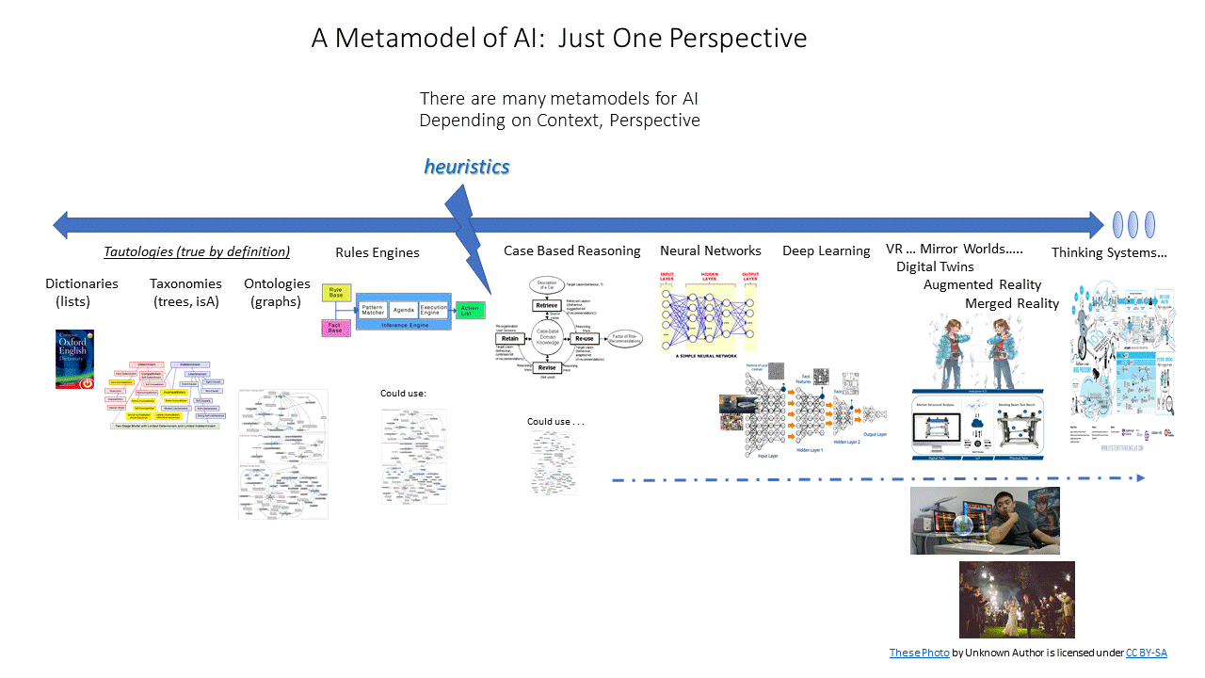
This model was further refined during interim conference calls, noting that it mixes concepts of information representation, “mechanisms” of AI, and applications of AI. This has led to the three-tier architecture shown below.
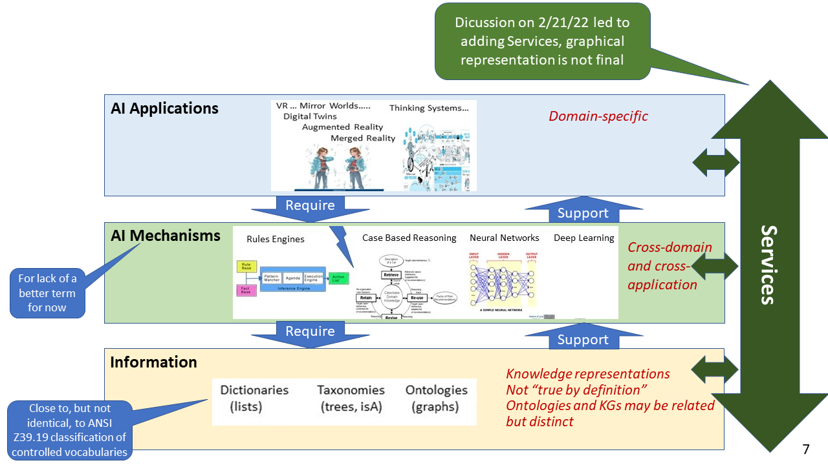

Meetings
See the Record of Past AI PTF Meetings.

Ideas for Future Meetings
A full-day “forum” including representatives from NIST, and other organizations that responded to the NIST RFI on AI Standards. A “call for papers” was issued in mid-January 2020 to solicit additional presentations.Write and issue an RFP on a UML model of neural networks (suggested by Xephor Solutions)Issue an RFI to “replace” the 2019 NIST RFI, due to (a) the evolution of the technology since then, (b) the fact that the NIST RFI was largely addressed to U.S. organizations, with several questions oriented to ensuring U.S. dominance of the marketTransform the AI vocabulary/taxonomy into an ontology or knowledge graph, perhaps using OMG's Multiple Vocabulary Facility (MVF)Potential Speakers at AI PTF Meetings

Non-OMG Events
Unite.AI maintains a list of conferences and exhibits of potential interest to members. The scope of their calendar entries extends to robotics and data science
Note that any indications of a physical location in the coming months is highly subject to change until the COVID-19 pandemic is under control. Moreover, when an on-site conference is changed to a virtual one, the dates may also change.
Those who attend any external AI-related event are strongly encouraged to share their notes through our mailing list of for posting on this wiki.

References
OMG AI Bibliography
AI Landscape Report by the European Union Observatory on Standards (EUOS)
Standard for Artificial Intelligence and Machine Learning (AI/ML) Terminology and Data Formats (IEEE-SA Project P3123)
What's Next for AI Systems & Language Models -- a discussion with Ilya Sutskever of OpenAI on ML and explainability

