Blockchain PSIG Call Notes
13 Feb 2020

Attendees
- Char
- Ian Stavros
- Mike Bennett
- Rencher, Robert J
- Robert Nehmer
- Bobbin Teegarden

Apologies
- Nick Stavros
- Nelson
- Lars Toomre

Agenda
- Updates on group membership and circulation
- Agenda planning for Reston
- Definitions for use in OMG and beyond
  - Blockchain
  - Distributed Ledger Technology (DLT)
  - Distributed Immutable Data Objects (DIDO)

Meeting Notes

Updates on group membership and circulation

General
Discussed the question of whether this Blockchain PSIG should or should not be open to non OMG members.

Background
Some questions have arisen for Domain and Platform Task Forces and for SIGs, about whether membership of these groups is open to non OMG members. The OMG has begun mailing each group. The overall picture is that D/PTFs have one year in which to finalize their membership arrangements, with the over-arching proviso that whenever a group has an RFC or RFP in play, it has to be limited to only OMG members, on account of IP considerations.
It was not clear prior to this call whether that also applied to the Blockchain PSIG, since any RFCs and RFPs are progressed via MARS or any other group with which we liaise to work on that RFP or RFC.
Meanwhile email invitations for meetings of this group have mostly only gone to the bc-psig with a small number of exceptions. These exceptions fall under 3 categories:
- Emails sent for convenience to people who are employees of an OMG member firm (e.g. IOTA) and are therefore eligible to get their own OMG number and subscribe directly
- People we invited to present to the group, in particular relating to the Interoperability RFI
- Emails sent to influential people who were once OMG members or employees and retain an interest in this group (but we have not heard from them in a while)

Individuals
Jens at IOTA – eligible to subscribe directly. MB to email him.
Char’s home gmail address was on this list – should it remain?
Char: retiring from MITRE this week. Will represent JackRabbit at OMG events going forward. The use of the personal email address was a convenience only. Will subscribe via JackRabbit and the additional home address can be removed now.

Discussion
Is everyone happy that this group be open to non OMG members?
- As long as there is no RFP/RFC being worked on

MB: Assumed this rule would not apply to PSIG since submissions are via other TFs e.g. MARS.
CW: OMG Policy – SIGs are incubators for RFC/RFPs that go to a TF but are still involved in working on submissions as they come in. So the rule about closing to members only would apply to such a SIG.
This applies once the RFP or RFC has been issued out of MARS or any other such group.
Does this also apply to RFIs? No. Because anyone can respond the above does not apply.
The people participating because of the RFI will have to come off once an RFC or RFP is issued, or become members – for instance there may be (will be) RFPs coming out of the RFI process and responses anyway. So this is an incentive for those firms to join.

Conclusion
This Blockchain PSIG will be closed to non-members as soon as we start to work formally on RFCs and RFPs. A lot of preliminary work already taking place with the LETS RFP, the IOTA Tangle RFC and (deferred for a quarter) the Event Scheduler RFP. We also expect one or likely more RFPs to come out of the RFI process. None of these is formally in process at present but they are all imminent, so this group will move to being closed as early as Q2 2020 (after the March meeting).
Actions are to mail the people who we copied in during the RFI process, with a view to dropping them off the list as soon as practicable. Times were not discussed but this would ideally be after the March meeting (and therefore well within the one year deadline for finalizing this). We anticipate a transition into membership for those of these firms that are interested in pursuing the Interoperability RFI further within OMG.

RFI Response Update(s)

Written Responses
We ae still expecting something from one member firm who wanted to see adjustments in the IP statements in the RFI itself before formally submitting their response. It is still not clear why they would want to include material that would be sensitive to IP requirements at this stage in the process (this would normally apply when they submit a response to an RFP), and MB has tried to head them off on this basis, but they are still pursuing their request for IP wording changes in the RFI itself, via OMG management and staff. This will delay their response but is in hand.

Jackrabbit
The Jackrabbit RFI response was the deck shared the other week on the DIDO Command Line Interface (CLI) concept. No further response is expected. The CLI material is not just about the command line interface but also reflects many of the DLT related concepts that the CLI would handle, and these are relevant to the questions of interoperability between Blockchain and DL ecosystems to the extent that they aim to standardize the concepts used across DLTs.
Note that the Jackrabbit CLI material contains a combination of two kinds of standardization:
- Standardizing the naming and definitions of concepts that exist in DLTs
- Proposing new concepts that do not exist in an or all DLTs at present but which are recommended, and which would promote further interoperability on the same basis as (1)

Other Information Relevant to RFI Responses
Relevant information not sent in but discovered on the net.

Tangle EE
MB presents a new community initiative TangleEE from IOTA of which the Software AG press release (one of the members of TangleEE) identifies an application in integration across disparate DLTs:
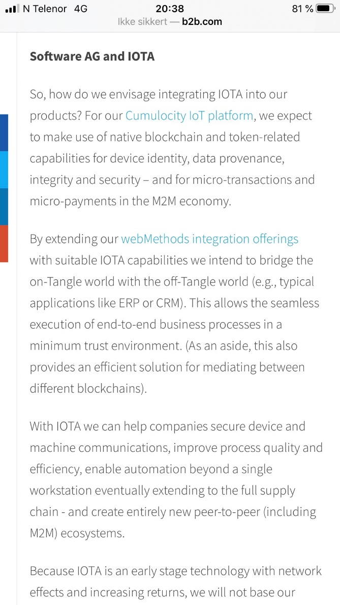
SoftwareAG press release regarding TangleEE

TangleEE Discussion
webMethods (mentioned in that press release):
BT: has detailed information on webMethods. This is a Pub-Sub-Hub – a post CORBA reaction for messaging. EAI as next generation beyond CORBA. For integration of enterprise processes and applications. Competes with TIBCO.
This covers the process side of things that Blockchain is missing.
Formerly known as ActiveSoftware – now webMethods. Founded by some CORBA people.
So this is indeed a viable reaction to the RFI and it falls back in to other OMG stuff.
(MB wonders if this might be part of the same stuff as the IOTA EEE stuff that also falls back into some of these existing OMG standards in the events / messaging / pub sub space)

Agenda planning for Reston
See slide deck: 20200206 bc-psig agenda planning.pptx (updated today).

Definitions for use in OMG and beyond

Needed for:
Use elsewhere in OMG, plus at MITIQ event (with Lars) in June. Publicity material for that event is due around now.
[MB adds: Last week we thought it was by last Friday that this was needed but in fact it is tomorrow, so we are still on time to deliver something for this]

Definitions
See separate ‘Definitions’ document: Definitions from Blockchain PSIG.docx

Notes and outcomes on Definitions
General: Recommendation of today’s meeting was to seek any definitions for these concepts that may already be defined in the DIDO RA paper or other DIDO reference materials.
Nick asserted that DLT and Blockchain are narrower terms of kinds of thing that are a kind of DIDO
MB: What are the differentiae?
Action: CW will look through that paper and extract the relevant terms.
MB: Please can Ian and Nick answer the question about what kind of thing can be a DIDO but is not a DLT and not a Blockchain? And what are the differentiae (distinguishing features) of a DLT, of a Blockchain as kinds of a DIDO.
Response:
e.g. a DDS would be considered a DIDO but is not a DLT or a Blockchain.
CW: So a DDS Topic is a piece of information passed around as an object, and is distributed and immutable.
In data centric pub/sub, you publish based on a data model. ‘Topics’ (a formal term in DDS) are bits of information passed around and are defined in a particular [something].
Next week – pick this up.

