Use Case 4: Digital Agriculture
Return to User Experiences

Details
Author | Jayachandran RameshBabu and Chidrupaya Samantaray
Title | IIoT Engineer and Director – Industrial Automation
Organization | Accessible Engineering Innovation
Date | September 20, 2020
Time | 33 Minutes
Presentation | https://www.brighttalk.com/webcast/12231/436130/dds-use-case-smart-agriculture
Document | http://public2.brighttalk.com/resource/core/299426/dds-agriculture-full-deck_666817.pdf

Executive Summary
Return to Top
This document provides an overview of a digital agriculture use case including the wide range of challenges and its solution architecture using the Data Distribution Service™ (DDS™) technology. The goal of digital agriculture and precision agriculture is to improve production while minimizing the cost and resource utilization.

Application
Return to Top
During the industrialization of agriculture, the mechanical machineries helped farmers reduce effort and time while increasing yield per acre. But the risks of rapid climate change plus growing demand for food products in market (such as food supply chain, food processing industries) for an increasing population, have increased dramatically. This demand has created pressure on the existing agriculture methods with a wide range of challenges. At the same time, it has created areas of opportunity for improvement.
Immediate Challenges in Industrial Agriculture
Imbalanced supply and demand“Restate” in supply chain? ()Inconstant yield rates.Mismatch between market demand and agriculture production.Rapid climate affect on production and yield rate.Over use of fertilizers, pesticides and water in cultivation. Causing soil degradation, ground water pollution, water shortage and highly resistant crop infestations.Industrial Agriculture still requires a high degree of manual physical labor.Digital Agriculture solutions
The integration of newer IoT technologies and devices into the agricultural practices is now pushing farmers to migrate to digital farming and precision agriculture. This advancement allows them to benefit from the current demand for agricultural products while resolving related challenges and risks. Digital farming and precision agriculture is reliant on a system of sensors and controllers along with robust communication technologies on every piece of equipment, throughout every stage of the farming process.
Makes the farming process more data driven. Using sensors, drones, and long term environmental data to address the current challenges in the current agricultural process.Brings all the stake holders in the agriculture value chain, including farmers, onto a single platform which bridges the gap between demand and production.Uses a long term weather pattern and climate data to design better farming practices which can sustainably improve the yield rate by adapting to the changing environment.It minimizes the utilization of resources, such as water, fertilizer, and pesticides by providing early and localized information about infected areas in the field.With the support of “autonomous pluckers?????”(),machineries, harvesters, feeders, and drones. Promises to reduce human involvement at every stage of the farming process.Growth Prospects of Digital Agriculture
The market size is expected to grow from 5.6 Billion USD in 2020, and projected to reach 6.2 Billion USD by 2021.

Use Cases within Digital Agriculture
These are the list of use cases within digital agriculture includes...
Crop ManagementGreen House automationCattle MonitoringIn this webinar we will focus mainly on the crop management segment.
Crop Management
Digital farming and precision agriculture is reliant on a system of sensors, controllers along with robust communication technologies throughout every stage of the farming process, and on every piece of equipment to perform the work more efficiently...
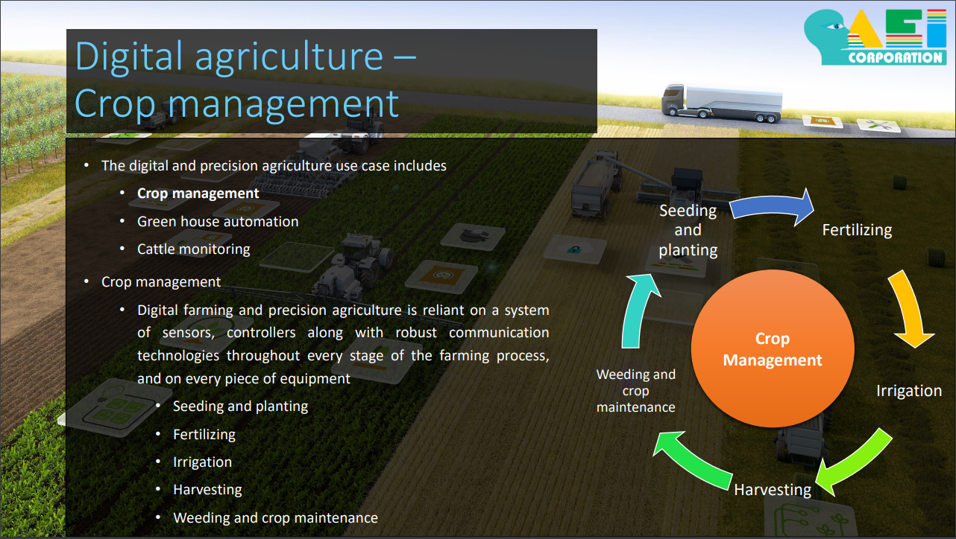
Seeding and plantingData from sensors are used to monitor the soil quality, density, moisture and healt (nutrient levels). This data is used to maintain the optimal conditions during seeding.Long-term weather, soil patterns, moisture and temperature monitoring help farmers to decide the optimal timeframe for crop cycle.FertilizingSoil health, quality, crop health and temperature are used to target areas in need for fertilizing.Drone are used to fertilize safely using data from real-time location, wind speed and object detection.IrrigationReal-time moisture level, plant health and irrigation motor device control help in optimal usage of water.HarvestingContinuous crop imaging data, real-time location and object detection data is gathered on farming machinery to help for efficient harvesting.Weeding and crop maintenanceReal-time imaging systems that are placed on GPS sensors and navigation systems help for automated crop maintenance.
Crop Management Cycle
The various types of sensors, drives and distributed control systems drive the need for a connected network which can facilitate the exchange of data in real-time/non real-time. This Data-Centric distributed system needs to be precise, highly complex, dynamic, secure and robust.

Deployment Architecture
This is a small representation of what a digital farm may look like...
Hyperspectral Sensor | That helps in detect, mapping minerals, and classifying agricultural crops.
Multispectral Sensor | capturing images, evaluate soil productivity, and analyzing plant health.
Fluorescence Sensor | For measuring macro nutrients in plants.
Thermal Sensor | For measuring the temperature of plants and soil.
Moisture Sensor | To evaluate the crop conditions.
Airborne Sensors | Airborne sensors in drones (UAV), are used for measuring the crop ??????()
Motion Detection Sensor | Helps to avoid collision between the vehicles.
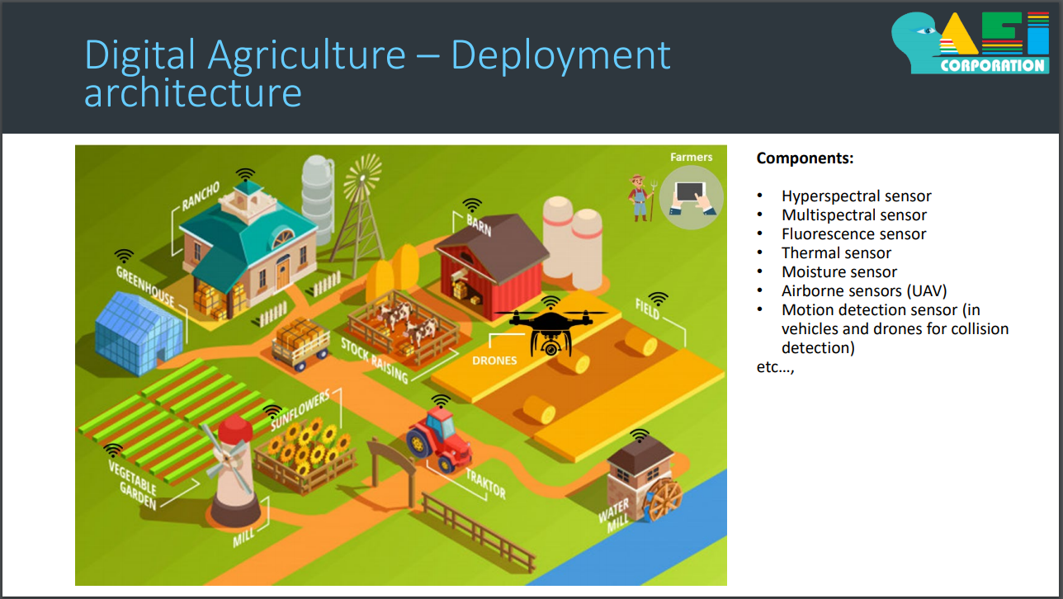
Small Representation of a Digital Farm.
Now you can imagine the number of sensors used for crop management and its not limited to this list. So here comes the complexity of configuring, controlling, and the maintenance of this bigger population of sensors in Digital Agriculture.

Challenges to Digital Agriculture
Return to Top
Interoperability | Huge integration and commissioning effort due to system complexity. | A typical digital platform can have 'n' number of sensors for drones, and autonomous machinery that also includes 'n' number of sensors within them. All of these working independently using a custom application platform and communication methods. So integration and commissioning of such a system becomes highly complex, time consuming, and costly.
Maintenance | Bottlenecks in scaling, reconfiguration, replacement due to the lack of transparency in individual closed systems. | The maintenance of such a complex system introduces high level of render dependency. This causes production delays, man-power loss, and possibly bottlenecks in achieving digitalization code. This also creates a challenge in any kind of customization, reconfiguration, and scaling or replacement of existing systems.
Security | The security of communication and information is ???????() to the end users.
Financial Resources | Maintenance CostDeployment Cost | Some of the financial challenges are linked to the high cost of hardware and maintenance.
These, listed above, are the major production challenges in Digital Agriculture.

How DDS addresses the need?
Return to Top
Data Distribution Service (DDS) simplifies the complex requirements listed above in a scalable way, making the digital agriculture process more effective.

Flexible model design
Return to Top
The DDS data-oriented design and decoupling feature provides flexibility and modular structure in the system. For example, in the irrigation stage, the digital agricultural appliances such as moisture sensors, irrigation motors and soil health sensors need to be associated in one-to-one, one-to-many and many-to-one secenarios for exchanging information, in order to decide the size of the watering distribution areas and their quantity/duration. Using DDS, the equipment can be grouped as participants of different functional domains. Only the equipment belonging to the same domain can communicate with each other. DDS also enables a dynamic re-configuration of this association mapping during runtime.

Compliance profiles and QoS
Return to Top
Data Availability – DDS provides a strong Quality of Service (QoS) policy to control the state of information throughout the system. For example, every piece of agriculture equipment/machinery offers unique services, yet the data availability requirement for precise agriculture is specific for each crop-cycle (i.e. each planting and seeding type) and the designated machinery.The QoS policy parameters in DDS, below, fulfill the data availability (i.e. state information of the equipment) requirement:History: The number of data samples to be stored can be configured.Minimum profile: The recent data sample or all data samples.Lifecycle: Removal of the data sample once the sensor is removed from the domain participant. This feature is helpful when the domain is re-configured and the existing samples are removed automatically from the system.Lifespan: The time period for which data samples to be kept on the system.For each crop cycle, the system can be re-configured by feeding the respective configuration during the time of seeding. The DDS Application running on the equipment allows for dynamic configuration. This guarantees the minimum resource utilization in the system.Data timeliness – In precision agriculture, the typical data exchange requirements are:Continuous low granularity, bulk historical data, e.g. for weather and soil character patterns.High-granularity non-real-time datasets in specific timeframes, e.g. for equipment health maintenance.Real-time datasets, e.g. for navigation systems, location and drive control, object collision detection, fire/hazard detection.Data Distribution Service (DDS) promises timely data delivery with minimal overhead. For example, the drones and ground vehicles (used for moisturizing, fertilizing and spraying the pesticide) exchange location/navigation data with the central control system in real-time for monitoring the crops in the field. The onboard sensors exchange environment data including object detection, drive speed, etc. for navigation control and collision safety. On the other hand, the onboard cameras on the drones capture and share crop-area images to the central control system, which coordinates the ground machines to carry-out pesticide spray and fertilization of the particular crop area, automatically and efficiently. This minimizes the time and manages the agriculture crop with minimal resource utilization.Using the following DDS QoS parameters, the drones and ground machines transfer the data in real-time:Latency Budget: Guarantee data delivery.Deadline: Maximum amount of time to send/receive the data samples collected in the sensor. Once the deadline is crossed, the data samples will be dropped.Liveliness: Ensures the entities’ live status periodically.

Event handling
Return to Top
Data Distribution Service (DDS) listeners in the entity provide a mechanism for the middleware to asynchronously alert the application of the occurrence of relevant status changes.
For example:
The sensors placed in field (temperature, moisture, humidity etc.) monitor standard attributes such as temperature, humidity and weather for every season. The pre-configured/predictedpattern of temperature and humidity threshold values, alert the framers and other equipment to any abrupt change in environment parameters to prevent natural disasters (e.g.: crop fire, sudden flooding and water stagnation).The sensors on the drones and self-driving ground vehicles monitor/exchange position parameters and objects insight, to prevent collisions with wild animals or nearby agriculture appliances.Using DDS, event handling of asynchronous events and conditional variables are shared on equipment including self-driving vehicles which alert among themselves to prevent damage and risks.

Live monitoring & control
Return to Top
Web-enabled DDS Services authenticate and control the DDS global data space (i.e. read/write topics) using standard web protocols such as RESTful, SOAP, HTTP etc, from the standard web client such as web browsers. For example, in farming, there are a number of digital agricultural appliances involved in the agriculture field where the farmers need access to each resources to use the digital agriculture methods and processes effectively. This needs a simplified UI dashboard for data visualization and control. By leveraging DDS web services, the parameters (i.e. topic of the agricultural appliances) can be read/write remotely.
The farmers can use the UI dashboard via the browsers in the handheld devices from any location to control the digital agricultural appliances.

Security
Return to Top
Data Distribution Service (DDS) security plugins and secure Real-time Publish-Subscribe (RTPS) messages protect against the unauthorized access and subscription of data throughout the digital agricultural ecosystem. For example, there are different vendor-devices involved in the digital agriculture appliances, operating in an open area along with equipment in nearby farms. In this situation, the appliances must have high Data Security in order to avoid threats and vulnerability and at the same time prevent unintentional information sharing and cross-talk. Using DDS-Security configurations and security policies defined for data distribution, the explicit policies created for protecting DDS domains based on the Data Models can ensure that the equipment information is not visible or discovered between different configured domains.

Conclusion - The Solution Architecture
Return to Top
So here is the solution architecture, as we can see here an on boarding of sensors to machineries, to integration into the cloud is seamless using unified DDS platform. Finally the concept of connected digital agriculture and sensors integrated onto the equipment makes the farming process more data driven and data enabled. Leveraging the intensive DDS integration capabilities and features that addresses the vertical and horizontal needs such as security, scalability, and robustness of data distribution. With DDS, real-time goals of digital agriculture can be realized cost effectively and without fragmentation to the system.
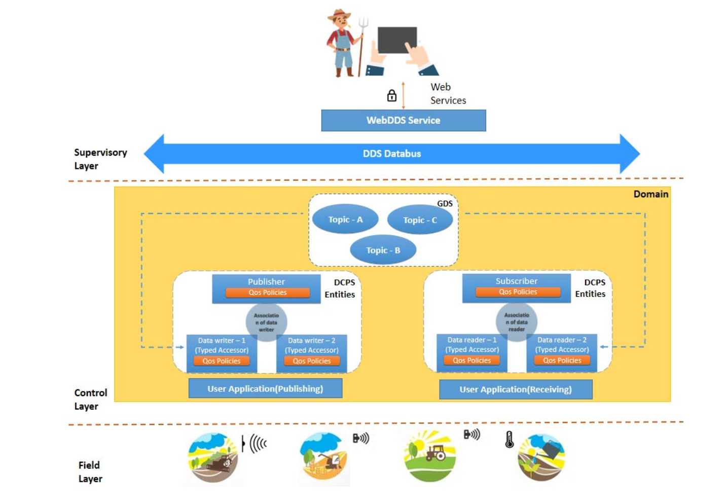
This is an overview of the entire DDS Digital Agriculture Architecture.
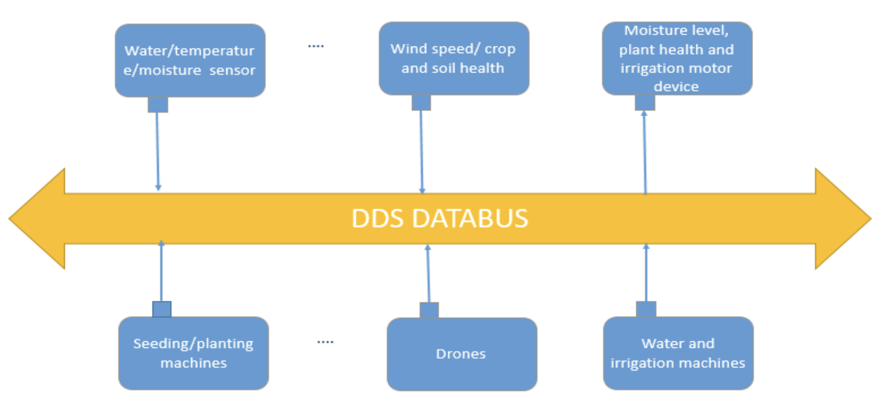
This is a closer look at the DDS DataBus.

