User Scenario 2: Data Acquisition and Instrumentation
Return to User Experiences

Overview
Instrumentation and data acquisition is focused on the collection of large volumes of Sensor data in a short amount of time. One example, is an aircraft engine test bed ( for example, MTU Aero Engines) where various sensors for things like temperature, pressure and vibration are place all around the inside and outside of an engine to collect data as the engine is running.
Data acquisition is not limited to jet engines, but found in a number of industries. On a small scale, there might be eight to sixteen sensors collecting information maybe at the 10 hertz rate. On a large scale , such as testing a jet engine, there might be hundreds to thousands of sensors collecting data anywhere from 1 hertz to 20 kilohertz.
Note: 1 hertz is roughly equivalent to 1000 milliseconds, 20 kilohertz is roughly equivalent to 0.05 milliseconds. See Unit Juggler.Many of these data streams must be processed in real-time, in order to detect issues requiring immediate engine shutdown.

DDS Benefits to Acquisition and Instrumentation
Return to top
A major benefit is to standardize an architecture around Data Distribution Service (DDS). These larger systems contain multiple data acquisition systems from multiple vendors developed at different times and locations. So, standardization on one Middleware and technology standard and interface allows for easy reconfiguration between different engine tests.
DDS is one of the few technologies to handle the amount of data and strict processing schedules for these distributed systems while providing multiple DDS vendor product interoperability.
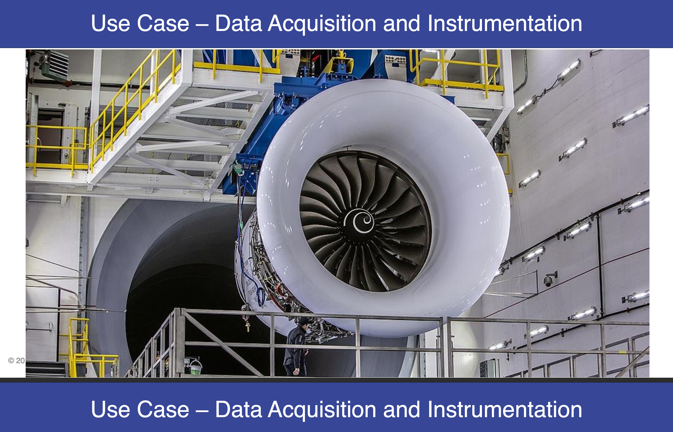
Low Overhead / High Throughput Data Delivery with low Latency.Scalability to 1000’s of devices making it a great solution for all data acquisition systems.On-the-wire Interoperability between DDS products allows for the fast binary transmission of data and ease of accessing the data on each end of the “wire”.

