Vendor: MILSOFT
return to DDS vendors
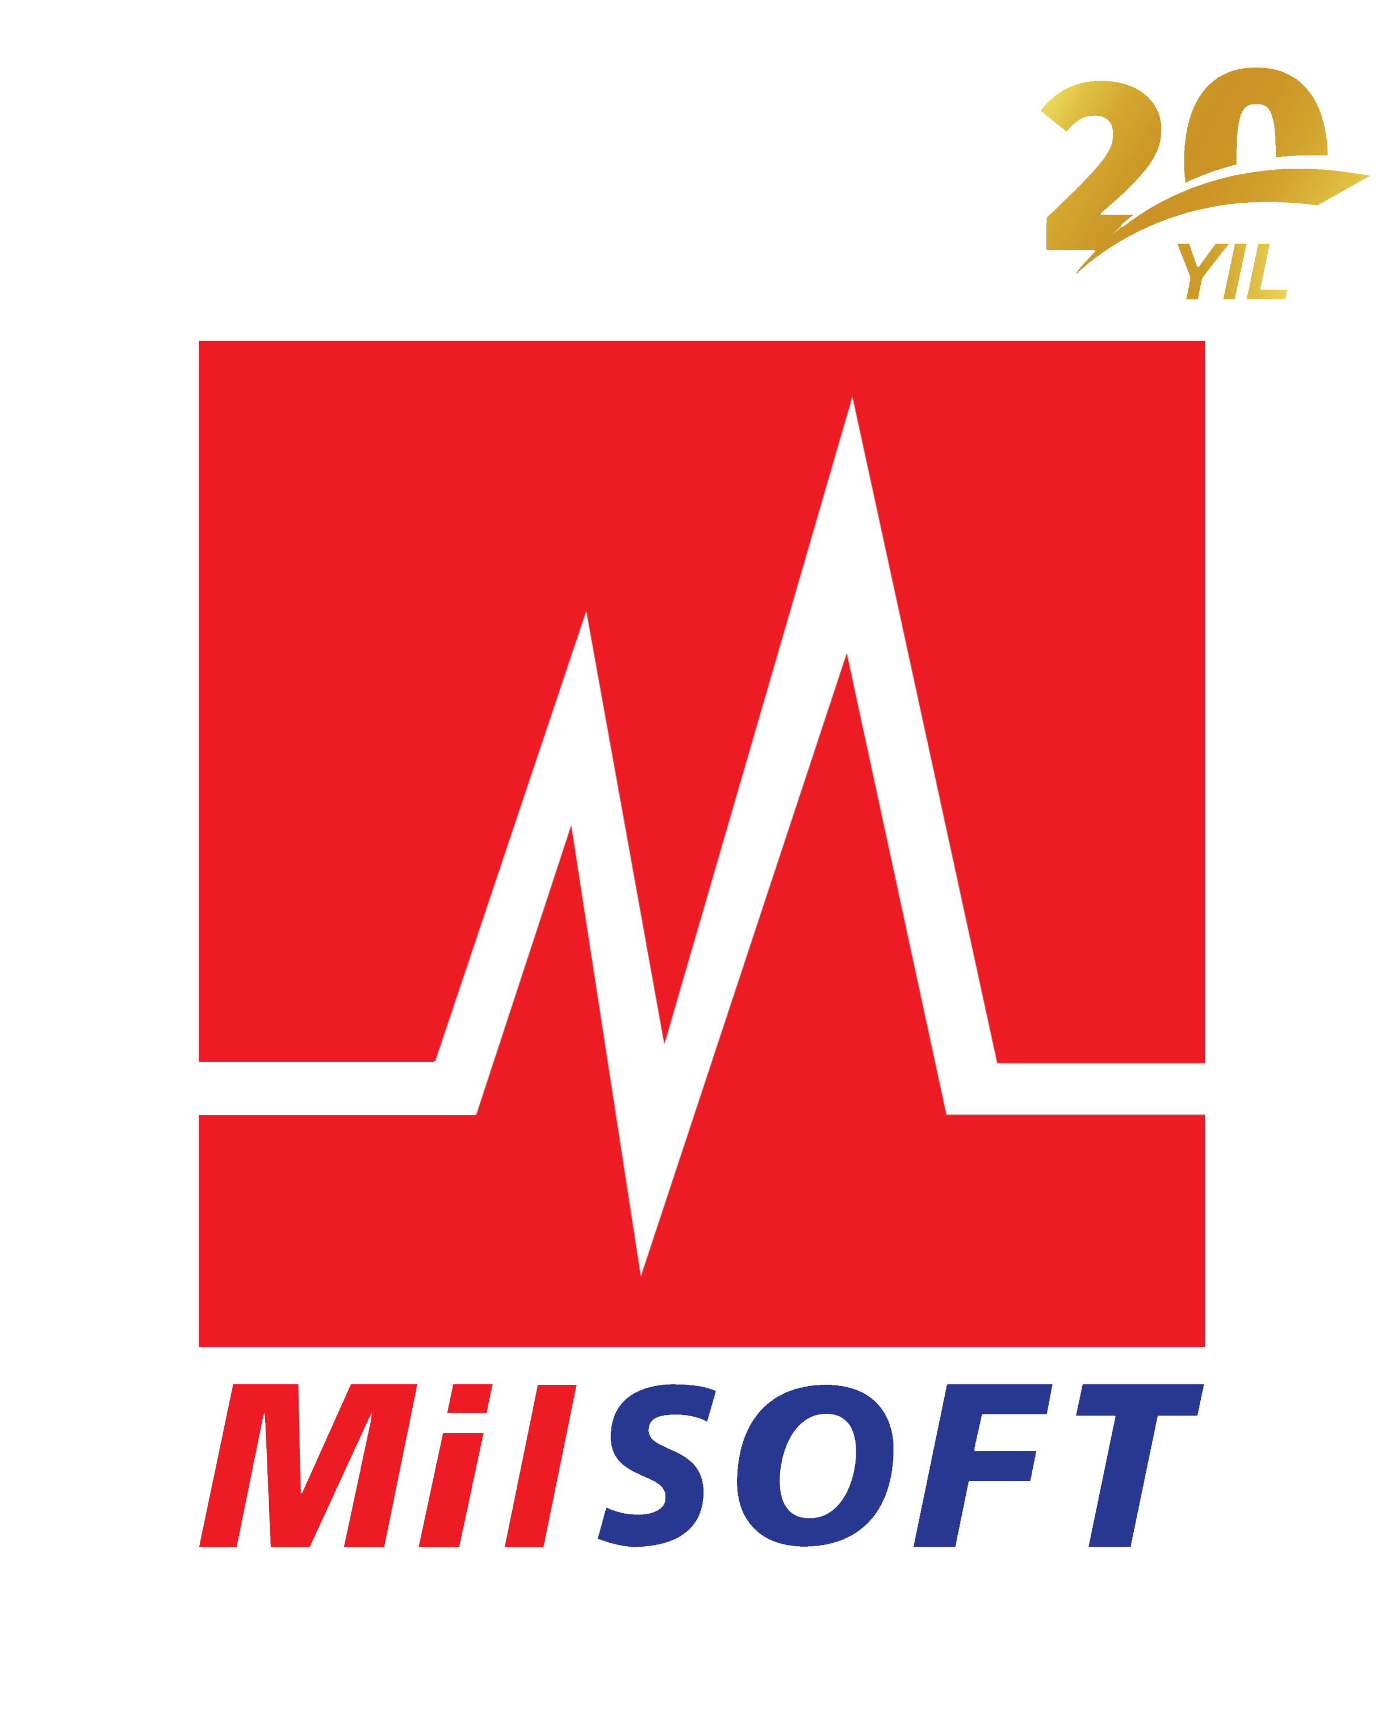

Company URL | http://www.milsoft.com.tr
Main Product URL | http://www.milsoft.com.tr/en/portfolio/mil-dds/
Company Overview | MilSOFT is a 100% Turkish national company specialized in system integration and software development offering cost-effective products to her customers in defense and civil industries. MilSOFT competes in both the Turkish national and the international markets by leveraging the cutting-edge technologies for her products via investing in research and development activities. MilSOFT is the first company in Europe to achieve Capability Maturity Model Integration (CMMI) Level-5. She has technical capabilities and expertise in Command, Control, Communication, Computer, and Intelligence (C4I), Tactical Data Links & Messaging, ISR and Image Exploitation Systems, Electronic Warfare, Training & Simulation, Embedded Systems, Cyber Security and Information Technologies.
Product Category | Distributed-Data
Product/Service Description | MilDDS is a product originating from MilSOFT's specialty in system integration and software development. MilSOFT has been a pioneer DDS vendor adopting the initial Data Distribution Service (DDS) standard in 2004. Today MilDDS is a proven technology and has been backbone to a wide variety of projects since then. MilDDS can be deployed on various platforms ranging from low-footprint devices to cloud systems and it is the key to the integration of complex distributed systems deployed on wide area. Some of the major projects integrated via MilDDS include, but are not limited to: Combat Management System, Tactical Data Link Processor, Simulation System, Coastal Surveillance and Image Exploitation projects. Major system integration companies including Aselsan, Roketsan and Havelsan rely on MilDDS as well. MilDDS reduces modeling, development, integration, testing and maintenance costs, it also ships a rich set of powerful tools boosting the users’ speed during these phases. With MilDDS, MilSOFT also offers to share her specialty both in DDS middleware and her know-how regarding large-scale distributed systems with her customers.
Sales Contact | Sinan Topuz
Sales Contact Email | mailto:milsoft@milsoft.com.tr
Sales Contact Phone | 903122923000
Downloads Page
Tutorial Page
Sample / Demo Code
DISCLAIMER: Listings are the sole responsibility of the posting company and are provided as a resource “as is” to anyone using the directory. Object Management Group® (OMG) in no way, explicitly or implicitly, warrants or endorses any of the claims, products, services or organizations listed. OMG does not accept any liability for the veracity of the postings, or for actions taken by users of the directory based on the information provided by the participating vendors/service providers. Please direct questions about the content of the listings to the vendor/service provider of that listing.

