Vendor: Remedy
return to DDS vendors
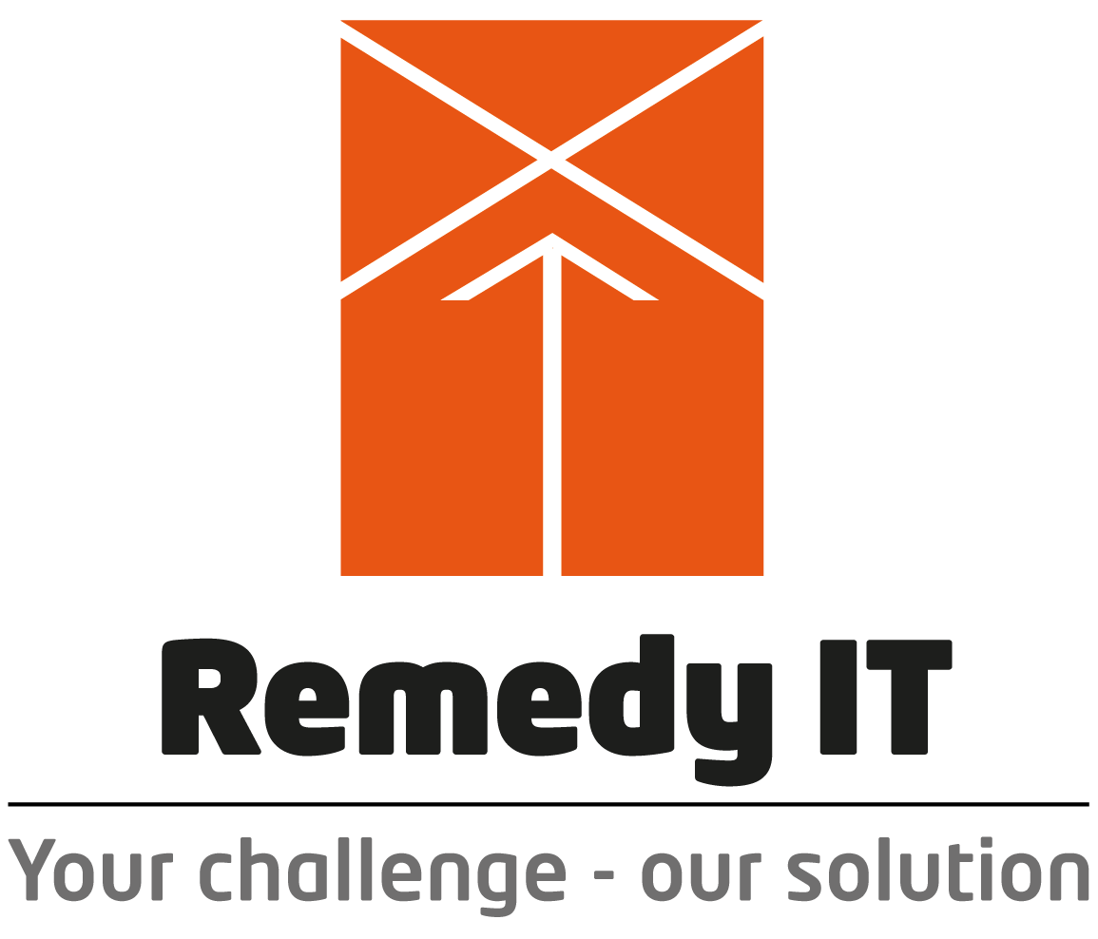

Company URL | http://www.remedy.nl
Main Product URL | http://www.remedy.nl
Company Overview | Remedy IT is a software company specialized in developing and supporting communication middleware and component technologies. We supply software solutions and support to many industry domains (including banking, chips manufacturing, chemical industry, traffic control, telecommunications, defense, etc.) based (whole or partly).
Product Category | Distributed-Data
Product/Service Description | Remedy IT provides commercial support and services for Data Distribution Service (DDS) and has has build up a lot of knowledge about DDS and the various implementations on the market. With the addition of DDS to the suite of supported open- standards/source products, Remedy IT is a total provider for CORBA, DDS, CCM, and D&C, all Object Management Group® (OMG) standards
Sales Contact | Johnny Willemsen
Sales Contact Email | mailto:sales@remedy.nl
Sales Contact Phone | +31-88-0530000
Downloads Page
Tutorial Page
Sample / Demo Code
DISCLAIMER: Listings are the sole responsibility of the posting company and are provided as a resource “as is” to anyone using the directory. OMG in no way, explicitly or implicitly, warrants or endorses any of the claims, products, services or organizations listed. OMG does not accept any liability for the veracity of the postings, or for actions taken by users of the directory based on the information provided by the participating vendors/service providers. Please direct questions about the content of the listings to the vendor/service provider of that listing.

