Client-Server
The Client-Server model helped developers address the scalability issues of the Point-to-Point communication model. Client-server networks designate one special server node that connects simultaneously to many client nodes, as illustrated below. Client-server is a “many-to-one” communications architecture.
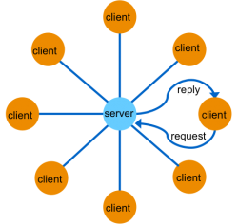
Client-Server Communication
The client-server network architecture works best when information is centralized, such as in databases, transaction processing systems, and file servers. However, if information is being generated at multiple nodes, a client-server architecture requires that all information are sent to the server for later redistribution to the clients. This approach is inefficient and precludes deterministic communications, since the client does not know when new information is available. The time between when the information is available on the server, and when the client asks and receives it adds a variable latency to the system. Example of Client-Server Communication
Ordering pizza over the phone is an example of client-server communication. Clients must know the phone number of the pizza parlor to place an order. The parlor can handle many orders without knowing ahead of time where people (clients) are located. After the order (request), the parlor asks the client where the response (pizza) should be sent. In the client-server model, each response is tied to a prior request. As a result, the response can be tailored to each request. In other words, each client makes a request (order) and each reply (pizza) is made for one specific client in mind.
Provided by: https://community.rti.com/glossary/client-server

