Service Plugin Interface (SPI)
Return to Glossary
Service Plugin Interface (SPI)-> This specification defines five SPIs that when combined together provide Information Assurance to Data Distribution Service (DDS) systems:
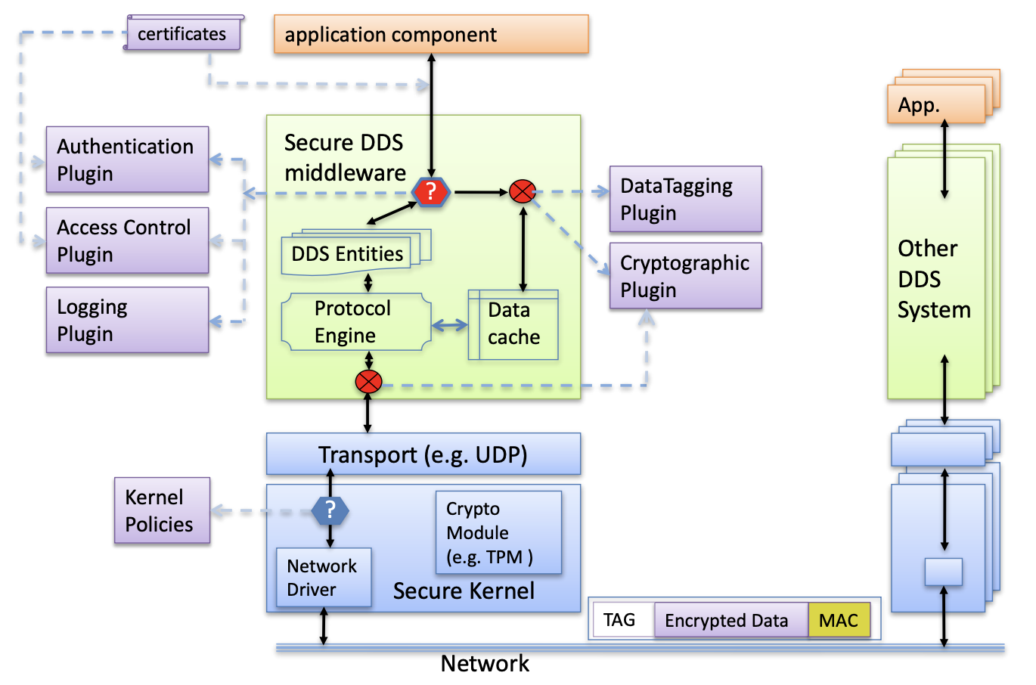
Authentication Service Plugin. Provides the means to verify the identity of the application and/or user that invokes operations on DDS. Includes facilities to perform mutual authentication between participants and establish a shared secret.AccessControl Service Plugin. Provides the means to enforce policy decisions on what DDSrelated operations an authenticated user can perform. For example, which domains it can join, which Topics it can publish or subscribe to, etc.Cryptographic Service Plugin. Implements (or interfaces with libraries that implement) all cryptographic operations including encryption, decryption, hashing, digital signatures, etc. This includes the means to derive keys from a shared secret.Logging Service Plugin. Supports auditing of all DDS security-relevant events.Data Tagging Service Plugin. Provides a way to add tags to DDS Sample data.
Overall architecture for DDS Security
Source: Chapter 11: Security

