Welcome to DDS Foundation WIKI
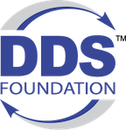

Contact Us:
Emailmailto: DDSFoundation@omg.org

About
The Object Management Group® (OMG®) is an international, open membership, not-for-profit technology standards consortium, founded in 1989. OMG standards are driven by vendors, end-users, academic institutions and government agencies The OMG Data-Distribution Service for Real-Time Systems (data_distribution_service_dds) is the first open international middleware standard directly addressing publish-subscribe communications for real-time and embedded systems. DDS Family of Standards, or DDS™, has successfully integrated data-driven applications that demand the highest levels of performance, scalability, reliability and security in business and mission-critical internet_of_things_iot environments.
With this in mind, the Object Management Group (), working in conjunction with the DDS special_interest_group, has launched the DDS Foundation. The mission of the Foundation is to drive the adoption, interoperability and success of DDS.
The Foundation governs a global community of vendors, users, government institutions and universities to realize the potential of the DDS standard in all industries. By testing conformance and interoperability with the DDS standard, defining industry-specific data models, promoting industry-specific adaptations and implementations of DDS, developing user case libraries and launching educational initiatives, the Foundation members will ensure the ongoing and long-term growth and success of DDS.DDS Foundation Website

What is the DDS Foundation
The DDS Foundation combines DDS users, government institutions, universities, and DDS software suppliers to realize the potential and benefits of DDS standards Vendor-neutral task force team focused on:Growing awareness-preference-adoption of DDS standardsProviding feedback to the DDS SIG for improvementsManaged by the Object Management Group (), in parallel to the current DDS Special Interest Group (DDS ). Founded in March 2019.

Organization
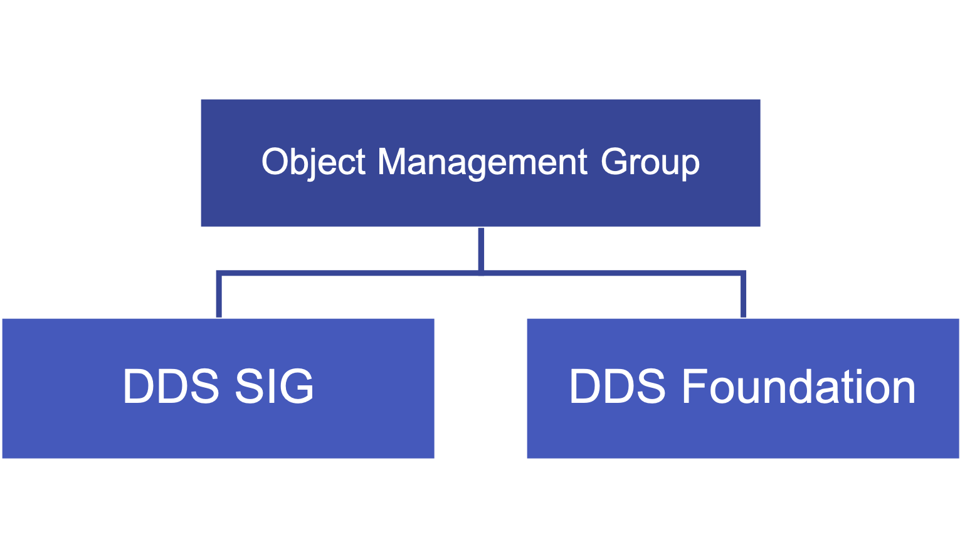
DDS Foundation Organizational Chart

WIKI Organization
The DDS Foundation WKI site is organized into a private and a public area.
private area is for internal use only and is never intended for migration from the sitepublic area is a sandbox/development area. The information here is ultimately intended for public consumptionNoteFollow this link to the official DDS Foundation site.

