User Scenario: Active Outdoors Organization (AOO)
Return to User Scenarios
NOTE: At the time of this writing, Active Outdoors Organization (AOO) does not exist. However, the following scenario describes this organization as if it does exist.

Overview
Return to Top
The Active Outdoors Organization (AOO) is a Non-Profit Organization (NPO) that matches Outdoor Adventure providers throughout the world with outdoor adventurers that come from around the world. The AOO wants to offer outdoor adventurers a loyalty program that gives points to adventures that participate in outdoor adventures offered by the outdoor adventure providers. Some examples of the Outdoor Adventures included in the program are:
HikingBikingSailingCanoeingKayakingSky DivingCampingSurvival TrainingWater SkiingSurfingWind SurfingSnow SkiingSnow BoardingSnow ShoeingThe Adventure providers can be found on all seven continents and are hosted in countries that speak different languages and have different laws concerning PII, liability, insurance, healthcare, etc. The Adventures similarly come from all over the world and have varying degrees of protection from their host countries.
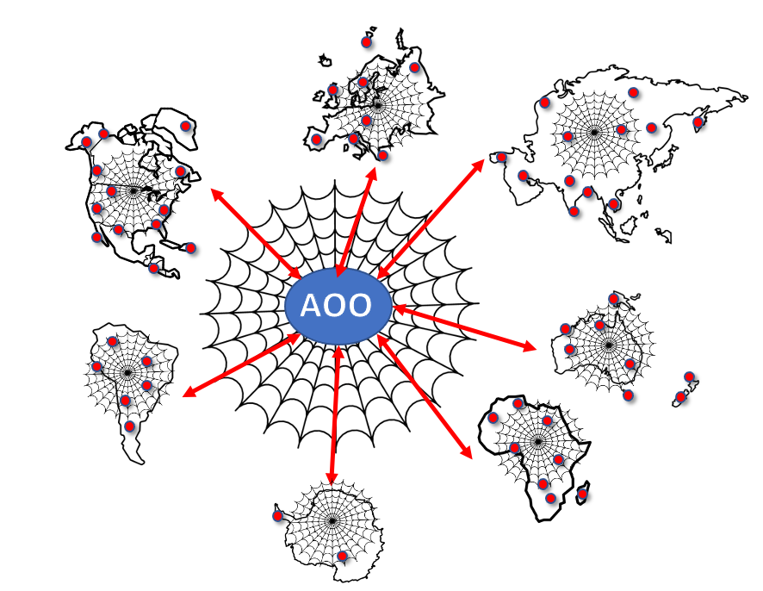
Overview of the Distributed Active Outdoors Organization (DAOO)

Functional Requirements
Return to Top
Functional Requirements define the basic system behavior. Essentially, they are requirements stating what the system does or must not do and can be thought of in terms of how the system responds to inputs. Functional requirements usually define if/then behaviors and include calculations, data input, and business processes. (See: 4.2 Functional Requirements.
The DIDO-RA provides some guidance in how to access the functional requirements for a DIDO implementation: See 4.4.1 Functional Requirements Assessment

Platforms
Return to Top
Functional Requirements
Platforms | List of supported Platforms
Hardware Platforms | Embedded Systems Hand Held Devices Desktop Computers Servers
Operating System Platforms | AndroidiOSMacOSRed Hat Enterprise Linux (RHEL)Windows Server
Runtime Platforms | Portable Operating System Interface (POSIX) The Java® Virtual Machine Specification JVM C/C++ Libraries Ethereum Virtual Machine (EVM)
Network Platforms | Wired Network using Network CablingUniversal Serial Bus (USB)Wireless Network using Wireless Fidelity (Wi-Fi)BluetoothZigBeeNear-Field-Communication (NFC)
Virtural Platforms | Virtual Machines (VMs) Application Containers (Docker) Orchestration(Kubernetes)

Access Control
Return to Top
The AOO is a Permissionless Networks and Private Network. In other words, it is a public and closed network. That is the network is publicly available to all but it is only available to those that have the permission to use it. See 2.3.2 Network Access Control Taxonomy

Network Composition
Return to Top
Table provides the summary of the kinds of nodes that will operate within Distributed Active Outdoors Organization (DAOO) network.
Actors in the Distributed Active Outdoors Organization (DAOO)
Actor | Number | Ethereum Nodes
AAO Member Organization | 20 | Archival Nodes
Number of Facilitators | 5 | Mining Nodes
Number of sites | 50 | Pruned Nodes
Number of Nodes | 100 | Full Nodes
AAO Adventeres | 1000 | Wallet Nodes

Problem Statement
Return to Top
The AOO represents is a Non-Profit Organization (NPO) that acts as the DIDO Ecosphere Community. The AOO is responsible for creating the Legal Documents required to support the Ecosphere itself, and the Ecosystems, and Domains that participate within the AOO.
The following is a breakdown of the AOO DIDO Communities of Interest (CoI):
AOO (dido:public:ra:xapend:xapend.a_glossary:d:dido_ecosphere_community | Ecosphere]])Common ( Ecosystem)Identity Management ( Domain)Payments ( Domain)Loyalty Program ( Domain)Adventure Providers ( Ecosystem)Course Tracking ( Domain)Activities ( Domain)Adventurer Registration ( Ecosystem)Medical ( Domain)Emergency Contact ( Domain)Insurance ( Domain)

Definitions
Return to Top
Adventurer - This is the individual who is going on an adventureAOO - This is an abbreviation for Active Outdoor OrganizationAP - This is an abbreviation for Activity ProvidersCourse Tracking - This involves check-ins, check-outs, and possible geo-location tracking during the outdoor eventIdentity Management - This is used to mean verification that the traveler checking-in and out is who they say they areInsurance - This includes both travel, and medicalLoyalty Program - This involves the loyalty program of the AOO, if the adventurer just uses the Adventure Provider, it can also be used to reference that Medical - This means any physical exams the adventure needs to take by a licensed medical professional before they can do the activity

Existing Active Outdoors Organization Flow
Return to Top
The existing Active Outdoors Organization work flow is ....
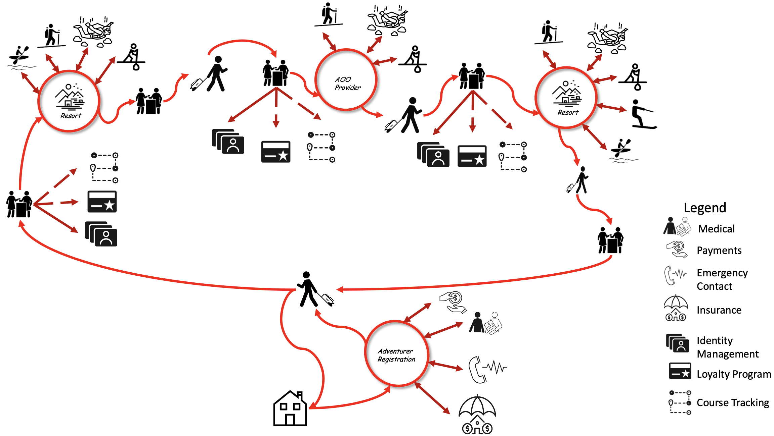

Activities
Return to Top
The following are a list of the activities associated with the Active Outdoors Organizationworkflow:
A. Pearson (adventurer) is interested in going on an outdoor adventure using Active Outdoor Organization (AOO) to plan and coordinate their trip with various adventure providers (AP).Before the adventurer goes on the adventure they register with the AOO, selecting which events they want to experience and Next selecting where among the AOO partnered APs they would like to go.Once the activities and destinations have been chosen, the adventurer needs to provide their relevant medical physicals, insurance emergency contact information, course tracking (optional), and loyalty program number (optional)After everything has been selected the adventurer then pays on checkout and waits for their adventure to beginOnce on the adventure, they will check-in at the AP and verify they are who they say they are(Optional) If the adventurer chose to do course tracking, the AP will add the adventurer check-in, check-out, and possible geo-location tracking during the activity onto the blockchain. Provide a workflow diagram for Outdoor_adventures
The existing workflow for Active Outdoors Organization

Issues
Return to Top
The following issues are associated with the existing Active Outdoors Organization workflow:
Provide a list of issues associated with the existing Active Outdoors Organization workflow

Theoretical Flow using DIDO
Return to Top

Activities
Return to Top The following are a list of the activities associated with a theoretical DIDO Active Outdoors Organizationworkflow:
Provide a series of activities associate with the workflow Provide a workflow diagram for theoretical Active Outdoors Organization
The theoretical workflow for Active Outdoors Organization

Issues
Return to Top
The following issues are associated with the theoretical DIDO Active Outdoors Organization workflow:
Provide a list of issues associated with the theoretical DIDO Active Outdoors Organization workflow

