Reference Architecture (RA)
Return to Public Area OR View this document in the Wiki

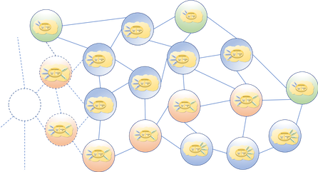
<center style="font-size:30px"> <b>DISTRIBUTED IMMUTABLE DATA OBJECT</b> </center> <center style="font-size:30px"> (DIDO) </center> <center style="font-size:30px"> Reference Architecture (RA) </center> <center style="font-size:15px"> for </center> <center style="font-size:20px"> Cryptocurrencies, Blockchains, Distributed Ledgers and Tangles </center> <center> <i>Version 4.0</i> </center> <center> <i>March 2022</i> </center> <center style="font-size:12px"> R. W. “Nick” Stavros<br/> Ian T. Stavros<br/> Bryan Turek <br/> Char Wales <br/> Ian Murphy </center> <center style="font-size:10px"> <b><i>Jackrabbit Consulting</i></b> </center>

Abstract
The excitement, expansion, and advancement in Distributed Computing resulting from Satoshi Nakamoto’s paper “Bitcoin: A Peer-to-Peer Electronic Cash System”1) highlights the need for a Reference Architecture (RA) focused on Distributed Immutable Data Objects (DIDOs), where it is understood that DIDOs include, but are not limited to cryptocurrencies, the original blockchain, and distributed ledger technologies. This paper, an OMG Discussion paper, presents an RA for DIDOs.

Book Contents
AppendicesAppendix A: Glossary of Terms Related to DIDO Appendix B: Standards OrganizationsAppendix C: Hardware ArchitecturesAppendix D: Operating SystemsAppendix E: ToolsAppendix F: DDS Quality Of ServiceAppendix G: TestsAppendix H: AcronymsAppendix I: Cognitive ModelAppendix J: Governance Model

PDFs
The following are provided for those readers who would like to download a printable albeit static copy of this RA, current as of the month/date shown.
This is a “slimmed down” version of the RA: it does not include the full content of Appendices A through F. For Appendices A and C to F, just the first pages; for Appendix B, these three pages: “Appendix B”, “Technical Standards Bodies”, and “de facto Standards Bodies”. Any links to entries in these six Appendices will direct the reader back to the DIDO Wiki. DIDO-RA 3.0 PDF (Compact Version - June 2021)
This version is much larger but still not the whole. It contains a truncated version of Appendix B, i.e., three pages only: “Appendix B”, “Technical Standards Bodies”, and “de facto Standards Bodies”. Any links to pages in Appendix B other than these three pages will direct the reader back to the DIDO Wiki.

1) S. Nakamoto, “Bitcoin: A Peer-to-Peer Electronic Cash System,” 24 May 2009. [Online]. Available: https://bitcoin.org/bitcoin.pdf.

