1.2 Purpose
return to Introduction
The goals of a Reference Architecture (RA) as expressed in this paper are derived from the Office of the Assistant Secretary of Defense for Networks and Information Integration (OASD/NII)1) , which are:
Provide a common language for the various stakeholders Provide consistent implementation of technology to solve problems Support validation and comparison of implementationsEncourage adherence to common standards, specifications, and patternsAchieving these goals will enhance the likelihood that DIDOs and networks will be engineered correctly. DIDOs are intended to cover the entirety of distributed computing, including improvements in data storage and computing that are now used to support DIDO processes, but were not considered in Nakamoto’s paper2) and the consequent highly successful launch of Bitcoin cryptocurrency. Nakamoto’s paper proposed a “ledger” for storing data and a collection of transactions, captured in a block. Blocks of transactions are verified and validated using a Consensus Algorithm. Bitcoin relies on Proof-of-Work (PoW) consensus. This solution, although usable, has proven to be expensive, making widespread ubiquitous adoption difficult3). Other implementations such as Ethereum were built upon the Bitcoin blockchain concept, which replaced the costly PoW with Proof of Stake (PoS). The DIDO RA is extensible to evolving and emerging blockchain technologies. For example, Boyen4) notes that:
Our blockchain-free proposal shifts onto the transactions themselves the task of affirming prior transactions. Verification no longer results in a chain of transactions blocks, but in a lean graph comprised only of transactions… 5)The DIDO RA concerns distributed, Peer-to-Peer (P2P) computing including blockchains and cryptocurrencies, but also covers domains that have little or nothing to do with currencies. For example, DIDOs can be blockchains, distributed ledgers, or graphs. Blockchains may use any consensus algorithm such as PoW or PoS. Cryptocurrencies are used as a placeholder for any of the other domains that can be supported using DIDO: supply chains, government records, scientific data, medical records, escrows, swaps, etc.
The explosion in cryptocurrencies is well known and documented. An example is presented extremely well in Figure for the animation provided by Jeff Desjardins6).
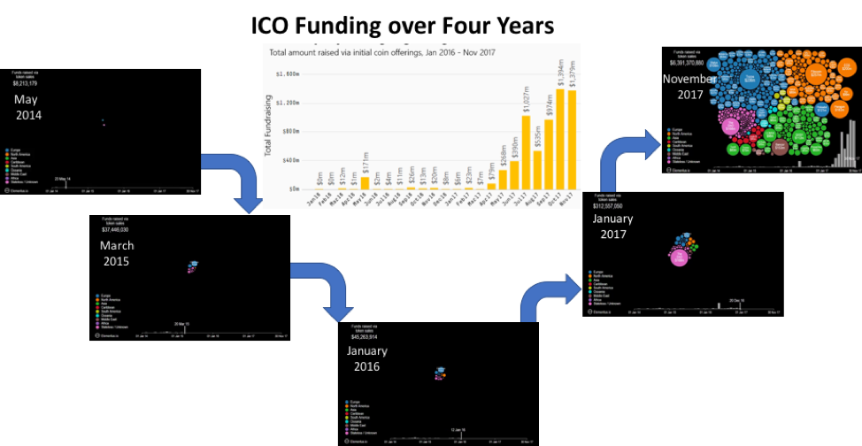
Note “ICO funds raised” went from zero in 2014 to about $6.5 billion in November 2017.
The explosive growth of Initial Coin Offering (ICO) over four years
CoinDesk used data from CoinGeko, see Figure , to highlight the extraordinary growth in the Cryptocurrency world by plotting the number of Initial Coin Offerings over time.
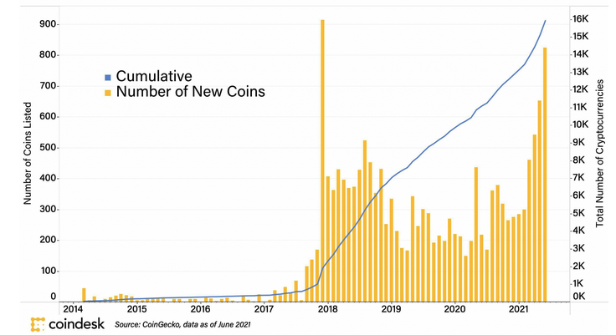
Roughly 16,000 Cryptocurrencies were created between 2014 and 2021.
In addition to the explosion in cryptocurrencies, two different crypto-related concepts have emerged: Memecoins and Non-Fungible Tokens (NFTs). When Memecoins are listed on exchanges, they are just classified as a cryptocurrency. There is no way of knowing how many non-listed Memecoins there are.
However, NFTs use existing DIDO platforms such as Ethereum and smart contracts, but instead of representing Fungibility 7), such as Bitcoin, or an Eth. NFTs represent a one-off entity that is unique from any other entity.
There appears to be a decline in the interest of NFTs, but still, as of July 2021, there was still a lot of interest.
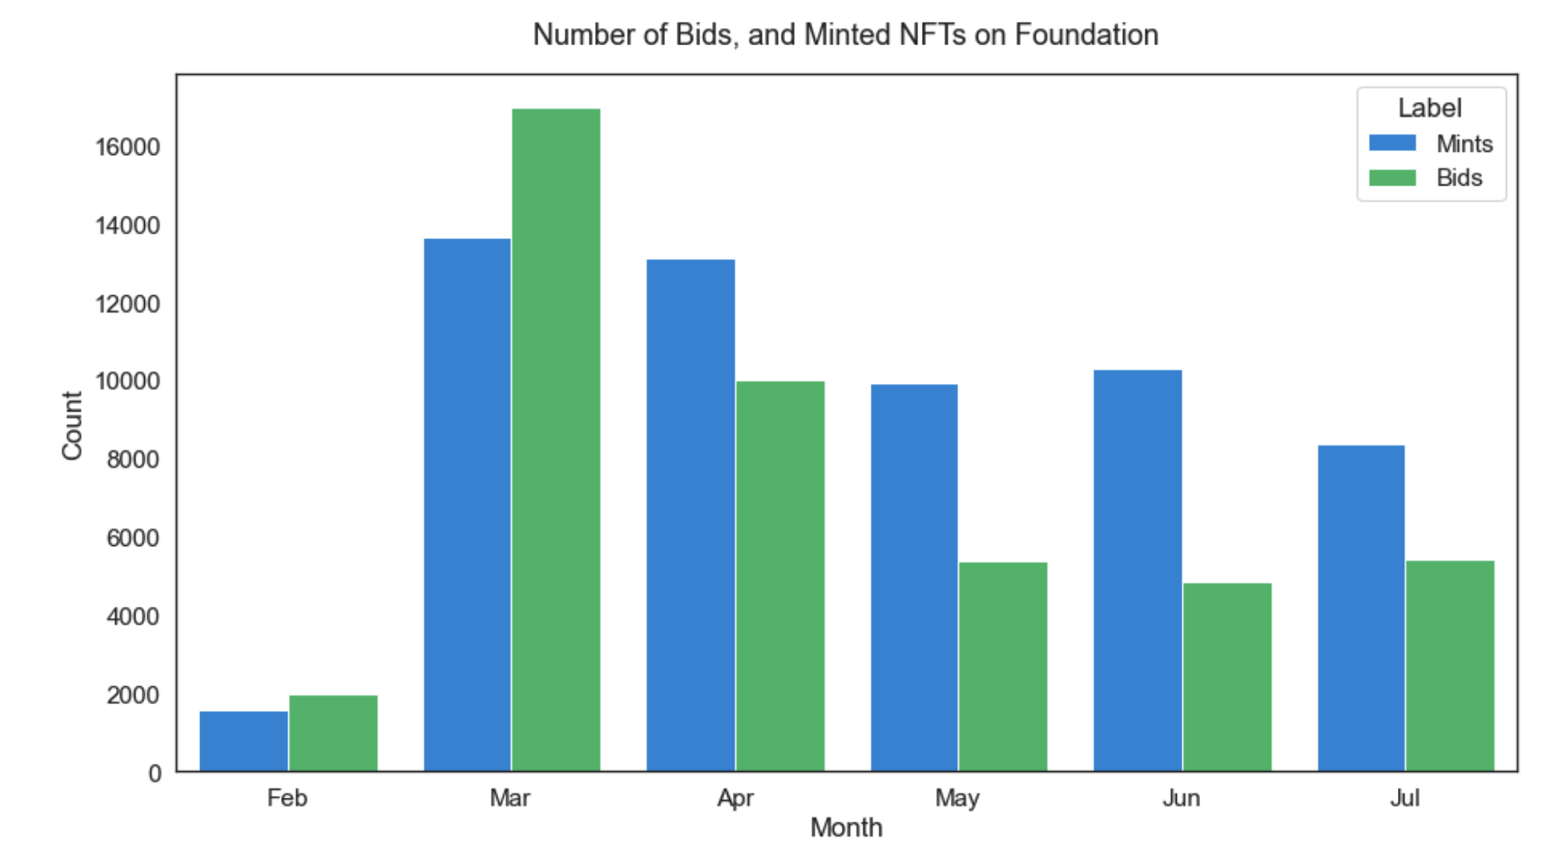
Another interesting fact about figure 1 is that, while the number of bids has significantly dropped from the first months of 2021, the number of NFTs minted by creators has not seen a drastic decline. This contrast between minting and bidding activities could suggest that even though art collectors are now less inclined to buy NFTs on Foundation than in the first months, digital art creators have not lost hope in selling their artworks on Foundation. 8)
Number of Bids, and Minted NFTs on the Foundation marketplace 8)
Looking beyond the Crypto-World, there are other uses of the Distributed technologies. These are not necessarily referred to as Blockchains, but often as Distribute Ledger Technologies (DLT). Figure provides the results of a survey conducted in Singapore on the use cases of Blockchains within the very active Singapore community. Every respondent could select any number of the use cases.
Approximate break down of “block chain” use cases. | 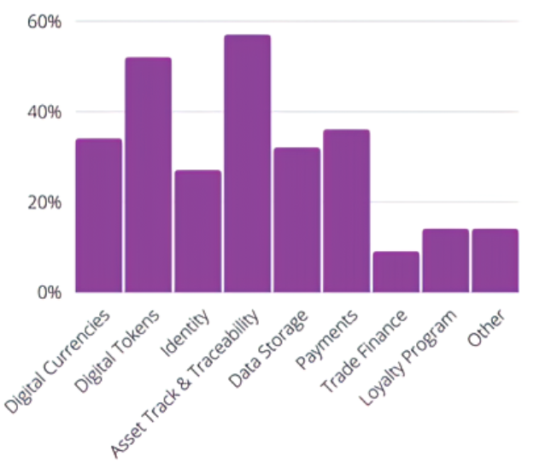  Results of Singapore’s blockchain ecosystem Survey9)
  Area of Interest | Approximate Percent
  Digitial Currencies | 35%
  Digital Tokens | 50%
  Identity | 24%
  Asset Track and Traceability | 55%
  Data Storage | 30%
  Payments | 35%
  Trade Finance | 8%
  Loyalty Programs | 10%
  Other | 10%
To provide a common language for stakeholders, the DIDO RA describes the components of a distributed network of peers supporting distributed data and computation. It is comprised of a collection of peer nodes that operate within a virtual distributed network. Each node in the architecture selects the set of architectural components, and the relationships between the components, required by their stakeholders to solve the specific requirements (e.g., blockchains, cryptocurrencies, distributed ledgers, graph databases). The individual nodes synchronize via distributed software communicating over a secure messaging infrastructure. All computations and operations could be executed redundantly on all the nodes within the DIDO network of peers. DIDO components are virtual representations of functionality found in DIDO products. In addition to identifying and defining the components and their inter-relationships, the RA associates each component with existing standards (refer to Section 2.1.7).

1) G. Doyle and B. Wilezynski, “Reference Architecture Description,” U. S. DoD, Washington, DC, 2010.
2) S. Nakamoto, “Bitcoin: A Peer-to-Peer Electronic Cash System,” 24 May 2009. [Online]. Available: https://bitcoin.org/bitcoin.pdf.
3) S. Lee, “Bitcoin's Energy Consumption Can Power An Entire Country -- But EOS Is Trying To Fix That,” 2018 Aoril 2018. [Online]. Available: https://www.forbes.com/sites/shermanlee/2018/04/19/bitcoins-energy-consumption-can-power-an-entire-country-but-eos-is-trying-to-fix-that/#7a0603931bc8. [Accessed 11 June 2018].
4) Gartner, “Gartner Hype Cycle,” [Online]. Available: https://www.gartner.com/technology/research/methodologies/hype-cycle.jsp#. [Accessed April 2018].
5) C. C. T. H. Xavier Boyen, “Blockchain-Free Cryptocurrencies, A Framework for Truly Decentralized Fast Transactions,” December 2017. [Online]. Available: https://eprint.iacr.org/2016/871.pdf. [Accessed 17 December 2017].
6) J. Desjardins, “Business Insider - Visual Capitalist,” 13 December 2017. [Online]. Available: http://www.businessinsider.com/animation-shows-the-explosion-in-ico-funding-over-the-last-four-years-2017-12. [Accessed 17 December 2017].
7) Fungibility is the interchangeability of a good or asset with other specific goods/assets of the same type, simplifying trade and exchange processes. https://www.investopedia.com/terms/f/fungibility.asp
8) Mohammad Amin Fazil, Ali Owfi, and Mohammad Reza Taesiri, Preprint, arXiv, Under the Skin of Foundation NFT Auctions, 28 September 2021, Accessed: 9 June 2022, https://www.researchgate.net/publication/354950127_Under_the_Skin_of_Foundation_NFT_Auctions/fulltext/6155b879a6fae644fbafdb2a/Under-the-Skin-of-Foundation-NFT-Auctions.pdf
9) Sam Bourgi, Singapore's blockchain industry cites supply chain management as biggest DLT use case, Cointelegraph, 7 December 2020, Accessed: 9 June 2022, https://cointelegraph.com/news/singapore-s-blockchain-industry-cites-supply-chain-management-as-biggest-dlt-use-case

