1.1 Problem
return to Introduction
As of June 12, 2018, there were 1,628 Cryptocurrencies available, with a total market cap around $300 Billion1),2). DIDO implementations and interest in them are currently in the technology Hype Cycle as defined by Gartner.

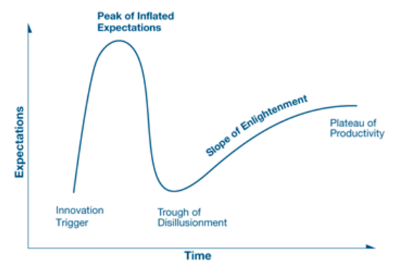
Gartner Group Hype Cycle
A major concern and part of the motivation behind the creation of a Reference Architecture (RA) is the lack of a comprehensive mechanism to evaluate all the risks associated with DIDO implementations (especially cryptocurrencies). Many of the risks to DIDOs are common to distributed computing and have already been identified and addressed using risk mitigators in existing processes, procedures, and standards. An example is vulnerabilities in source code. unfortunately, no statistics are available on how rigorously these risk mitigators are applied to DIDOs, if at all. Specifying a Reference Architecture and cross-referencing its components to a set of existing standards establishes the following:
An actuarial framework for assessing risks associated with existing productsMetrics for evaluating, comparing, and selecting existing productsA roadmap for future standard implementation, enhancement, and development

1) Coin Market Cap, “Cryptocurrency Market Capitalizations,” 3 December 2017. [Online]. Available: https://coinmarketcap.com/all/views/all/. [Accessed 3 December 2017].
2) D. Palmer, “Market Cap Hits All-Time High,” 23 August 2017. [Online]. Available: https://www.coindesk.com/150-billion-total-cryptocurrency-market-cap-hits-new-time-high/. [Accessed 20 November 2017].

