2.1.1 Platform View
return to Stakeholder Views
A Platform has a community of interest (CoI) that is responsible for the DIDO infrastructure that resides on each Node in the Node Network. Direct involvement within a platform covers the gamut from observers, to passive users of the software, and significant contributors to the community or de facto standards (see: 2.3.3 Node Taxonomy. As a general rule, domains, ecosystems, and ecospheres participate in platform communities rather than sponsor them. For the most part, platforms are already existing, self-contained communities with well established governance. Common CoI activities are bug tracking, collaboration and voting on resolutions of problems and future directions.
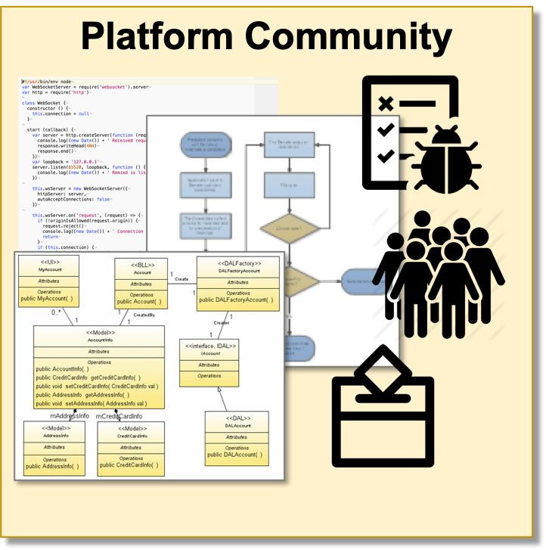
Platform Community
Some examples of platforms (see: 4.2.1 Platforms) are:

Standards

Technical Standards

de facto Standards

