2.1.4 Ecosphere View
return to Stakeholder Views
The concepts of a Ecosphere View are captured within the DIDO Ecosphere Community. The Ecosphere has legal requirements, see 3.2 Legal Documents.
The Ecosphere View comprises the set of all known Ecosystems within the Ecosphere and the interactions of the Ecosystems. Outside of a limited set of use cases, a DIDO cannot function independently, especially when a DIDO is ultimately meant to be part of an enterprise. The description of the DIDO Ecosystem Community works well when everything is defined as a DIDO using greenfield development. However, greenfield development for an enterprise probably will not happen, nor should it happen, given the large amount of legacy data information and processes held outside of the Ecosystem. Often, this type of development is referred to as brownfield development. This external data, referred to as ancillary data, is the immutable data object.
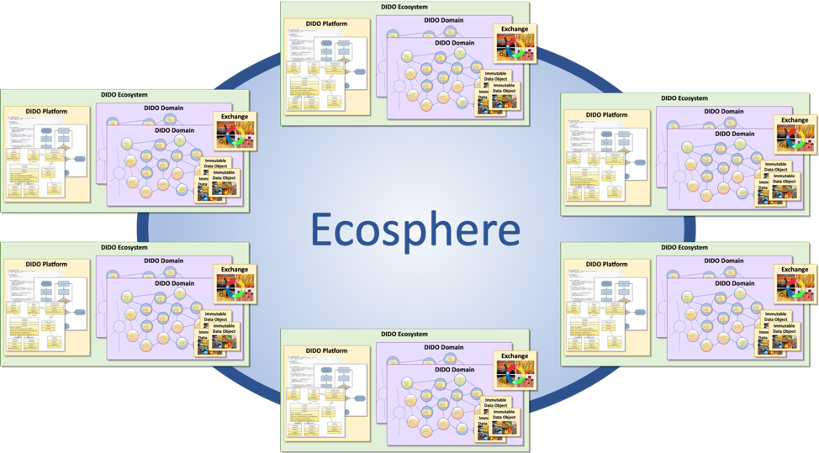
The high-level Ecosphere context
The Ecosphere concept is a way to encapsulate the Ecosystem and external ancillary data required to make the individual Domains within the Ecosystem functional. An individual DIDO Domain Community can access other data sources outside its Domain or, for that matter, even within its Ecosystem.
NOTE: Refer to 2.1.7 Relevant Community Standards for this view.

