2.1.6 Enterprise View
return to Stakeholder Views
Referring to the figure in Section 2.1 Stakeholder Views, one can observe that enterprises roughly map to an ecosphere; however, the enterprise does not necessarily control the ecosystems, platforms, or domains it now encompasses. From a DIDO perspective, all the ancillary data (i.e., external data) is accessed through the use of an oracle. There can be any number of oracles available to the node within a domain; these oracles can access data from centralized, decentralized, or other DIDOs. Some examples of oracles1):
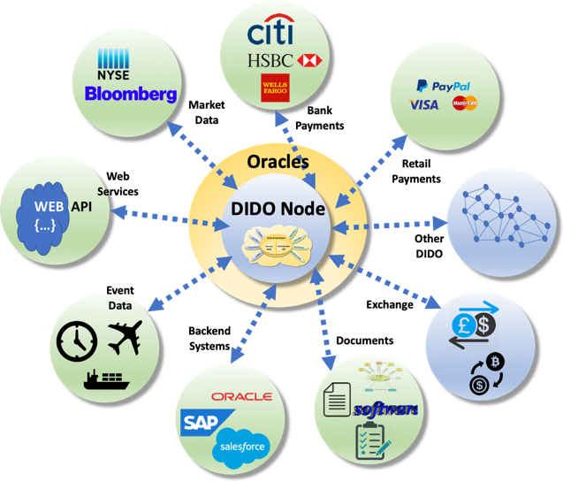
Another domain within the same ecosystemDocumentsRelational databasesNoSQL databasesFlat filesWeb servicesApplication servicesEvent logsRetail transactionsBank account recordsStock market streams
Oracles
One very important aspect of an enterprise with DIDO implementations is the heavy reliance on computer networks. These networks span all kinds of devices and operate in all kinds of environments, many of which rely on Disadvantaged Intermittent Links (DILs). Some examples are: nodes on mobile devices such as cell phones; submarines that are out of contact for long periods of time; nodes hit by natural and/or man-made disasters such as storms, earthquakes, or fire; devices that sleep to save power.

1) This term should not be confused with the DBMS product from the Oracle Corporation; it is merely a term referring to something that is a good source of information.

