2.2.1.5 Quality
return to Fundamental Views
The ISO/IEC 25010 standard provides consistent terminology for “specifying, measuring and evaluating system and software product quality”.1) The Consortium for Information & Software Quality (CISQ) 2) provides the following diagram, highlighting eight ISO defined software quality characteristics and their associated sub-characteristics.3) These ISO defined characteristics must be applied to both DIDO software and coinage organizations (e.g., Bitcoin, Ethereum, IOTA), especially Reliability, Performance Efficiency, Security, and Maintainability, since these are candidates for automation.
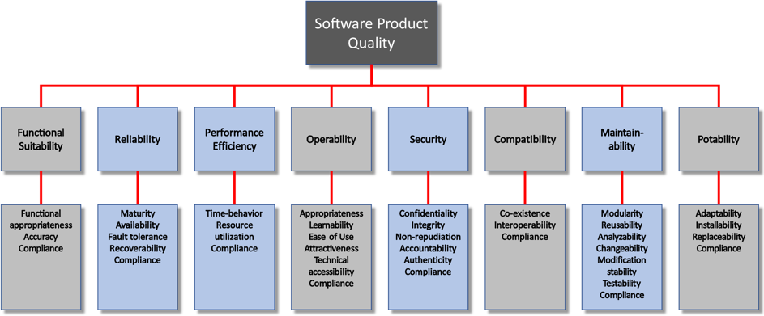
Quality Characteristics and Measures Specifications

Management
Management is part of SQuaRE and defines all common models, terms, and definitions referenced by all other standards from the SQuaRE series.

Modeling
Modeling is part of SQuaRE and provides detailed quality models for computer systems and software products, quality in use, and data.

Measurement
Measurement is part of SQuaRE and includes a software product quality measurement reference model, mathematical definitions of quality measures, and practical guidance for their application.

Requirements
Requirements are part of SQuaRE and help specify quality requirements. These quality requirements can be used in the process of quality requirements elicitation for a software product to be developed, or as input for an evaluation process.

Evaluation
Evaluation is part of SQuaRE and provides requirements, recommendations, and guidelines for software product evaluation.

1) International Association of Risk and Compliance Professionals (IARCP), “Dodd Frank Act Text Section 1034,” 2010. http://www.dodd-frank-act.us/Dodd_Frank_Act_Text_Section_1034.html.
2) International Standards Organization (ISO), “The ISO/IEC 25000 series of standards,” http://iso25000.com/index.php/en/iso-25000-standards?limit=4&start=4.
3) Consortium for Information & Software Quality (CISQ) http://it-cisq.org/.

