2.2.2.2 Node View
return to Node Network View
The Node View represents the internals of any particular node within the node network. As represented in the figure below, it is comprised of five layers; however, the layers are not set in stone -- each implementation of a node within a domain may be organized differently.
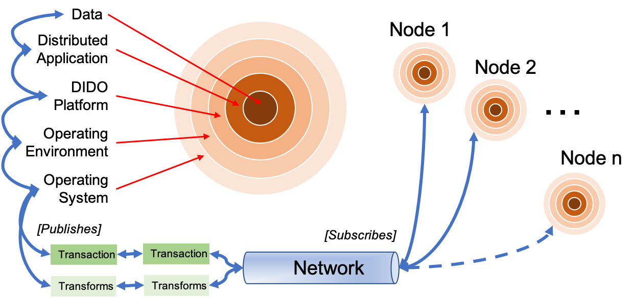
The idealized five layers of a Node.
At the boundary between each layer there is an interstitial layer formed by an Application Programming Interface (API), which is usually defined by one or more technical or de facto standards.
As each transaction, transform, or stream of data flows to or from a node over the network, it must travel through and/or interact with the:

