2.2.2 Node Network View
return to Technical Views
There are slightly different variations for the definitions of a Node Network, Node, Full Node, Light Node, and Miner Node depending on the DIDO Platform.1),2),3),4)
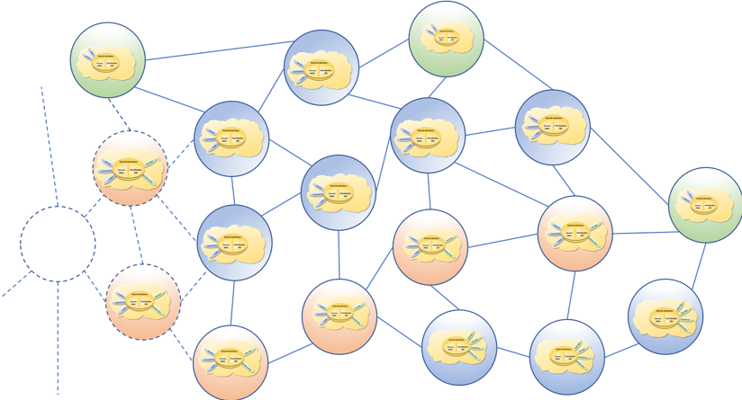
The Node Network is a collection of interconnected computers communicating over a network of equally privileged computers (i.e., there are no central authoritative computers). The node network is sometimes referred to as a peer-to-peer (P2P) network. A Node is an individual computer that participates as an equal within the node network. A node is sometimes referred to as a peer. Nodes receive input, perform one or more operations on those inputs, and returns an output.
Node Network of Nodes.

1) “What is a Bitcoin node?”, Nate Eldredge, 14, December 2013, https://bitcoin.stackexchange.com/questions/18736/what-is-a-bitcoin-node
2) “What are Ethereum Nodes And Sharding?”, Ameer Rosic, 2017, https://blockgeeks.com/guides/what-are-ethereum-nodes-and-sharding/
3) “IOTA Full Node — That’s Why a Full Node Is Important for IOTA!”, Marko Vidrih, February 2019, https://medium.com/altcoin-magazine/iota-full-node-thats-why-a-full-node-is-important-for-iota-1c46280d7712
4) “Introduction to IPFS: Run Nodes on Your Network, with HTTP Gateways”, Ross Bulat, 3 December 2018, https://medium.com/@rossbulat/introduction-to-ipfs-set-up-nodes-on-your-network-with-http-gateways-10e21ea689a4

