2.3.1.3 Distributed Network Topology
return to Network Topology Taxonomy
In the distributed network topology, all nodes are equal peers within the system, with each acting as a redundant copy of other nodes. This provides for extremely high fault tolerance, tied to the number of nodes. The more nodes, the greater the tolerance to faults. Since each node is an equal peer, there is no single point of failure and there is no one master copy of the data. As a result, the distributed system becomes almost infinitely scalable.
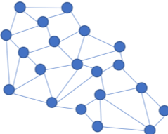
Distributed Network Topology
However, all nodes are not really considered “equal” in the truest sense. Some nodes are used simply to create a simple transaction, others record all the information within the blockchain, and others go on to validate transactions by mining.
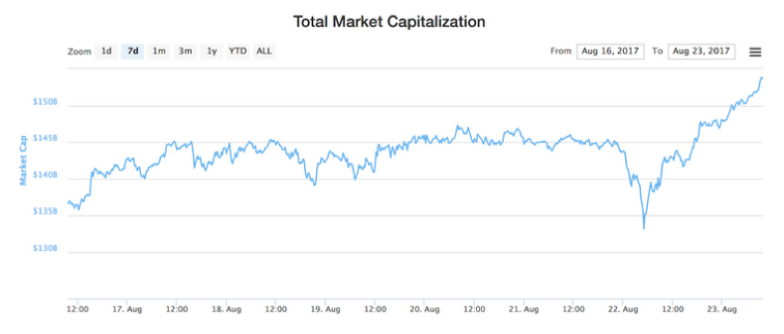
Market Cap of Cryptocurrencies ($ Billions)

