2.3.2 Network Access Control Taxonomy
return to Taxonomic Views
Network access control taxonomy classifies the types of access individuals (i.e., nodes) have from outside and from within the node network. The two main classes of access control are permissionless and permissioned.1)
Within each of these two classifications it is possible to have public and private access. Public and private access define who is able to write data onto a network or ledger. In contrast, open (i.e., permissionless) and closed (i.e., permissioned) determine who is able to read the data. Networks are classified as1):
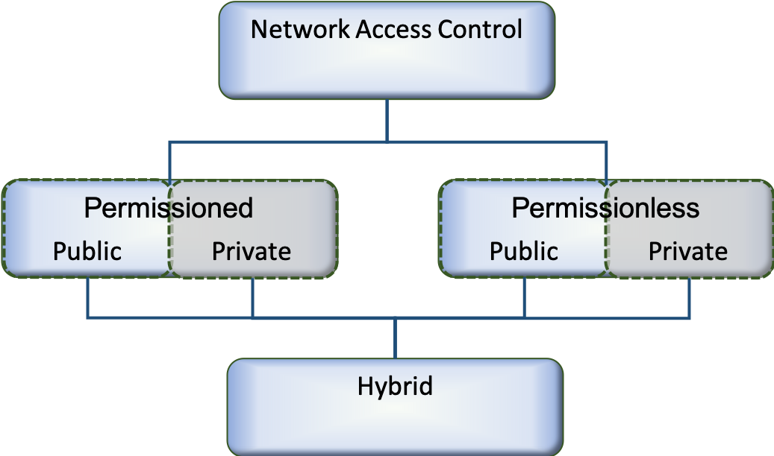
public and openpublic and closedprivate and openprivate and closed
The Node Network Access Taxonomy
Another category of networks is a hybrid network, which makes it possible to restrict the visibility of information on the network using a combination of public, private, permissionless and permissioned networks. Therefore, hybrid networks are appealing to regulated markets because they offer the benefits of public blockchain and private blockchain together.2)
Taxonomy of DIDO Access Control
Permissionless Networks | Permissioned Networks
Public Networks | Private Networks
Hybrid Networks

1) “Public Vs Private Blockchain In A Nutshell”, Demiro Massessi, 12 December 2018, https://medium.com/coinmonks/public-vs-private-blockchain-in-a-nutshell-c9fe284fa39f
2) “Hybrid Blockchain: Decentralized Option for Highly Regulated Markets - Few players in highly regulated markets have adopted blockchain technology. However, hybrid blockchain will change this.”, Mina Down, 14 November 2018 https://blog.goodaudience.com/hybrid-blockchain-decentralize-highly-regulated-markets-900f30a37903

